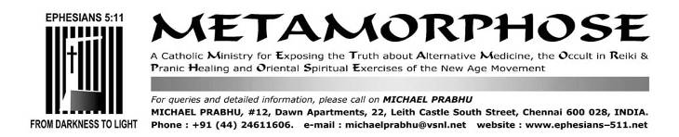
FEBRUARY 10, 2013

Bharatanatyam dance at Holy Mass at the National Shrine of St. Thomas in Madras-Mylapore

Traditional welcome
The Mylapore Times, February 2-8, 2013

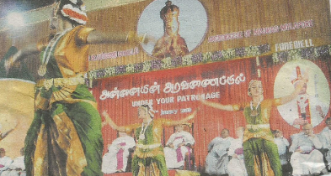

Students of a school in the city suburbs perform Bharatanatyam at last Sunday’s event to welcome the new Archbishop of the Madras-Mylapore diocese, Most Rev. George Antonysamy and to say thank you to the outgoing Archbishop, Rev. Dr. A.M. Chinnappa. The event was held after concelebrated Holy Mass at St. Bede’s School ground, San Thome at which many bishops participated. Below, nuns and lay people offer traditional welcome.

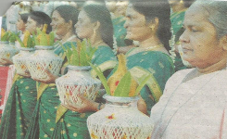

By viewing the picture immediately above one would never guess that it was taken at a Catholic church celebration. The kalasams and coconuts smeared with sandalwood paste and red kumkum powder are decidedly Hindu, not Indian. It is claimed by the Mylapore Times reporter that this is a "traditional" welcome, but in a land that is known for its diverse cultures, the above depicted ceremony is conducted exclusively by Hindus in South India. Why is it that anything that is claimed to be "Indian" or "traditional" is invariably of the HINDU religion? The Bharatanatyam dance is unarguably a Hindu temple dance.
For a through exposé of this Hindu dance form, see
BHARATANATYAM-I
http://ephesians-511.net/docs/BHARATANATYAM-I.doc
DANCING AND BHARATANATYAM IN THE MASS
http://ephesians-511.net/docs/DANCING_AND_BHARATANATYAM_IN_THE_MASS.doc

