
“INCULTURATION” ⇨ ⇨ ⇨ “ACCOMODATION” ⇨ ⇨ ⇨ “CAPITULATION”

FATHER CLEOPHAS DOMINIC FERNANDES
DIRECTOR OF THE NATIONAL BIBLICAL, CATECHETICAL AND LITURGICAL CENTRE [NBCLC], BANGALORE

WEARS A HINDU MARK IN THE CENTER OF HIS FOREHEAD

THIS MARK, CALLED “TILAK” IS OF RELIGIOUS SIGNIFICANCE TO HINDUS.
IT IS NEVER APPLIED BY MUSLIMS OR CHRISTIANS [ESPECIALLY PROTESTANTS].
MANY CATHOLIC WOMEN HOWEVER COMMONLY FLAUNT A STYLISED “BINDI”.
NOW THERE IS AN ALARMING TREND OF THE MARK’S INCREASING USE BY NUNS
AND BY CATHOLIC MEN - NOT AMONG THE LAITY,
BUT AMONG PRIESTS, BISHOPS, CARDINALS, AND EVEN THE APOSTOLIC NUNCIO

Bangalore: NBCLC Celebrates St Cleophas Feast
http://www.daijiworld.com/news/news_disp.asp?n_id=66215&n_tit=Bangalore%3A+NBCLC+Celebrates+St+Cleophas+Feast

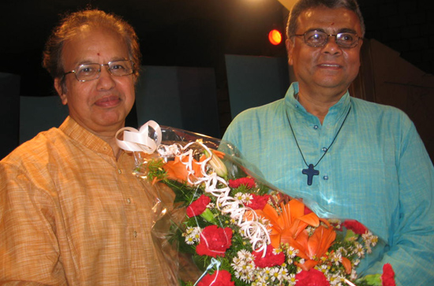

News & Pics: Jessie Rodrigues
Daijiworld Media Network – Bangalore (SB) September 28, 2009: It was a joyous moment for the religious, staff of NBCLC and faithful to join in the celebration of St Cleophas feast, the birthday of the director of NBCLC, the first celebration in the centre here recently.
Fr Antony Kalliath, assistant director of NBCLC in his welcome address appreciated Fr Cleo [Fr Cleophas Dominic Fernandes] for his friendly approach with everyone in the centre.
The programme began with the Holy mass with Fr Cleo as main celebrant and Fr Antony along with Fr Vijay Shanthraj as co-celebrants. This was followed by a cultural programme to felicitate Fr Cleo.

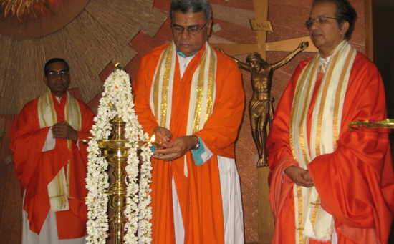

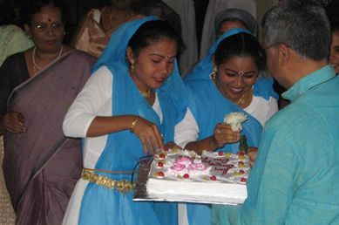

I have scoured the internet and my research library seeking information, any information which says that the bindi or tilak is a purely Indian cultural phenomenon. While I didn’t find a shred of evidence that says that, I found tons of evidence to the contrary. My findings are compiled in a separate article titled, "BINDI OR TILAK MARK ON THE FOREHEAD-INDIAN OR HINDU?"
http://ephesians-511.net/docs/BINDI_OR_TILAK_MARK_ON_THE_FOREHEAD-INDIAN_OR_HINDU.doc
MAY 15, 2012

