
“INCULTURATION” ⇨ ⇨ ⇨ “ACCOMODATION” ⇨ ⇨ ⇨ “CAPITULATION”

FATHER THOMAS D’SA
[FORMER] DIRECTOR OF THE NATIONAL BIBLICAL, CATECHETICAL AND LITURGICAL CENTRE [NBCLC], BANGALORE

WEARS A HINDU MARK IN THE CENTER OF HIS FOREHEAD

THIS MARK, CALLED “TILAK” IS OF RELIGIOUS SIGNIFICANCE TO HINDUS.
IT IS NEVER APPLIED BY MUSLIMS OR CHRISTIANS [ESPECIALLY PROTESTANTS].
MANY CATHOLIC WOMEN HOWEVER COMMONLY FLAUNT A STYLISED “BINDI”.
NOW THERE IS AN ALARMING TREND OF THE MARK’S INCREASING USE BY NUNS
AND BY CATHOLIC MEN - NOT AMONG THE LAITY,
BUT AMONG PRIESTS, BISHOPS, CARDINALS, AND EVEN THE APOSTOLIC NUNCIO

The Indian Rite of the Mass
http://www.traditioninaction.org/RevolutionPhotos/A216rcHinduMass.html*

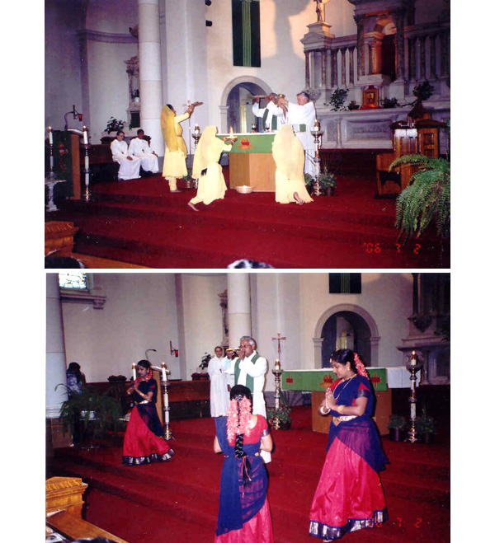

You are at St. Ann's Church, Toronto, Canada. It is July 2, 2006 during Sunday Mass. The co-celebrating priests are … Fr. Thomas D'Sa from India and … the parish priest of St. Ann's. Fr. D'Sa is the Director of the National Biblical Catechetical Liturgical Centre, NBCLC, a department of the Conference of Catholic Bishops in India, which officially endorses and promotes this Indian Rite of the Mass.
In the first part of the Mass, equivalent to the Prayers at the Foot of the Altar, the girls dance and sing in honor of the Holy Trinity, the Father, Son and Holy Spirit... However, the chant features the mantra "OM", the supreme vibration in Hinduism. OM also represents the Hindu trinity Brahma, Vishnu and Shiva.
During the Mass both priests sport a white dot between their eyebrows. The most common meaning of this dot is to proclaim oneself Hindu. *A traditionalist site
I have scoured the internet and my research library seeking information, any information which says that the bindi or tilak is a purely Indian cultural phenomenon. While I didn’t find a shred of evidence that says that, I found tons of evidence to the contrary. My findings are compiled in a separate article titled, "BINDI OR TILAK MARK ON THE FOREHEAD-INDIAN OR HINDU?"
http://ephesians-511.net/docs/BINDI_OR_TILAK_MARK_ON_THE_FOREHEAD-INDIAN_OR_HINDU.doc
MAY 15, 2012

