
“INCULTURATION” ⇨ ⇨ ⇨ “ACCOMODATION” ⇨ ⇨ ⇨ “CAPITULATION”

SR. DR. HERMAN JOSEPH
RELIGIOUS SISTER OF BHOPAL ARCHDIOCESE, MADHYA PRADESH

WEARS A HINDU MARK IN THE CENTER OF HER FOREHEAD

THIS MARK, CALLED “TILAK” IS OF RELIGIOUS SIGNIFICANCE TO HINDUS.
IT IS NEVER APPLIED BY MUSLIMS OR CHRISTIANS [ESPECIALLY PROTESTANTS].
MANY CATHOLIC WOMEN HOWEVER COMMONLY FLAUNT A STYLISED “BINDI”.
NOW THERE IS AN ALARMING TREND OF THE MARK’S INCREASING USE BY NUNS
AND BY CATHOLIC MEN - NOT AMONG THE LAITY,
BUT AMONG PRIESTS, BISHOPS, CARDINALS, AND EVEN THE APOSTOLIC NUNCIO

She Witnessed Jesus and He Healed Them
http://persecutedchurch.info/2012/03/20/mp-house-church-disrupted-and-clergyman-arrested-she-witnessed-jesus-and-he-healed-them/
http://www.franand.com/Page.aspx?AID=167

From: mppro2@gmail.com To: undisclosed-recipients: Sent: Saturday, March 17, 2012 11:02 PM
Subject: She Witnessed Jesus and He Healed Them
Fr Anand Muttungal, PRO and Spokesperson, Bhopal archdiocese

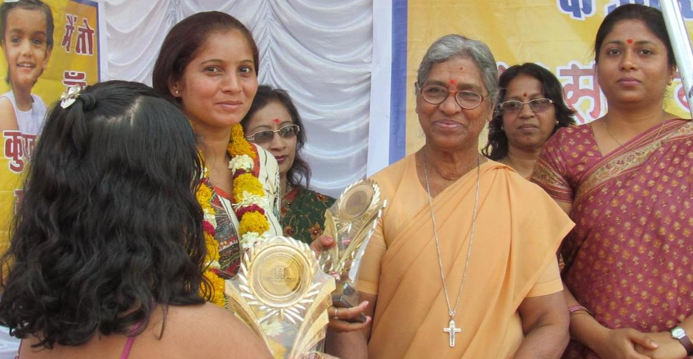

I have scoured the internet and my research library seeking information, any information which says that the bindi or tilak is a purely Indian cultural phenomenon. While I didn’t find a shred of evidence that says that, I found tons of evidence to the contrary. My findings are compiled in a separate article titled, "BINDI OR TILAK MARK ON THE FOREHEAD-INDIAN OR HINDU?"
http://ephesians-511.net/docs/BINDI_OR_TILAK_MARK_ON_THE_FOREHEAD-INDIAN_OR_HINDU.doc
MAY 15, 2012

