
“INCULTURATION” ⇨ ⇨ ⇨ “ACCOMODATION” ⇨ ⇨ ⇨ “CAPITULATION”

AGNELO GRACIAS
AUXILIARY BISHOP OF BOMBAY ARCHDIOCESE, MAHARASHTRA

WEARS A HINDU MARK IN THE CENTER OF HIS FOREHEAD

THIS MARK, CALLED “TILAK” IS OF RELIGIOUS SIGNIFICANCE TO HINDUS.
IT IS NEVER APPLIED BY MUSLIMS OR CHRISTIANS [ESPECIALLY PROTESTANTS].
MANY CATHOLIC WOMEN HOWEVER COMMONLY FLAUNT A STYLISED “BINDI”.
NOW THERE IS AN ALARMING TREND OF THE MARK’S INCREASING USE BY NUNS
AND BY CATHOLIC MEN - NOT AMONG THE LAITY,
BUT AMONG PRIESTS, BISHOPS, CARDINALS, AND EVEN THE APOSTOLIC NUNCIO

Mumbai: Inter-Religious Dialogue Held at St Joseph Church
http://www.daijiworld.com/news/news_disp.asp?n_id=127505

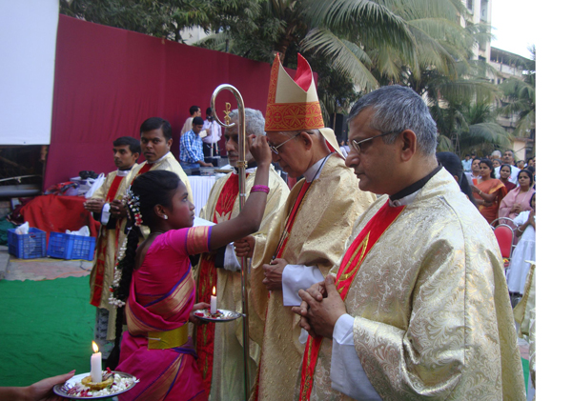

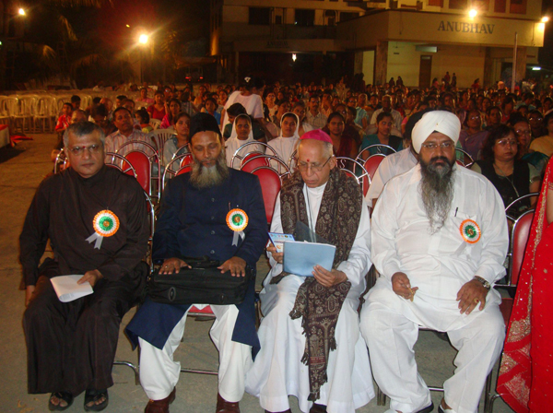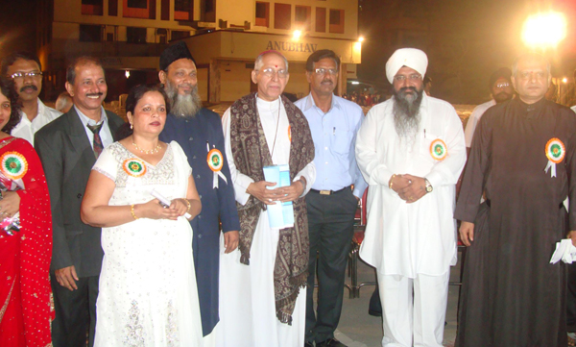

Rons Bantwal, Daijiworld Media Network – Mumbai, January 16, 2012
The lively and dynamic St Joseph Church Celebrated the Infant Jesus feast and conducted an Inter-Religious Dialogue session at the Church Grounds here on Sunday January 15 at 6.30 pm.

Auxiliary Bishop of Bombay Dr Agnelo Gracias presided over the solemn festal Eucharistic celebration along with more than eight priests.

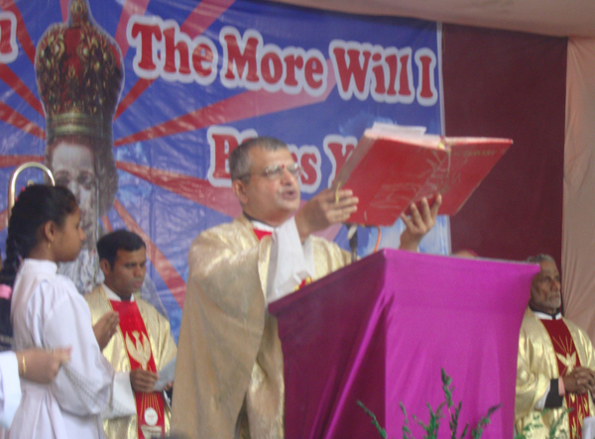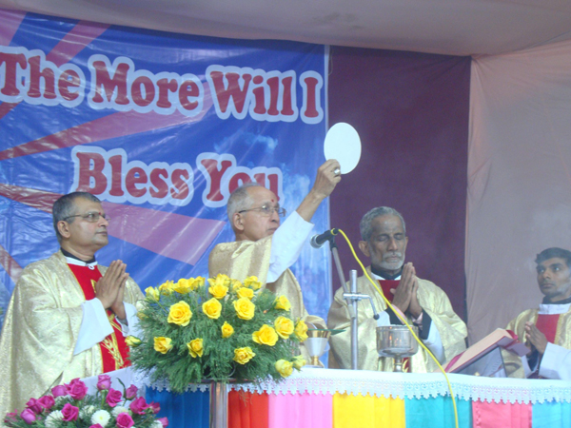

Soon after the mass the Inter-religious dialogue session began with a prayer dance by Holy Cross School children.
Dr Agnelo Gracias presided over the event with various speakers from across the religious spectrum.
Dignitaries like Bhagvati Kripa Devi Dasi from Bhakti Vedanta, Islamic Vision Research Center director Dr Ahamad M H Shaikh, secretary of Gurudwara, Paramjit Singh Matharu were present for the event.
The parish priest Fr Dominic Vas OCD welcomed the dignitaries and felicitated them with a bouquet.
The programme was conducted to bring together the members of different religions in order to have communal harmony and to build a peaceful Mira Road.
SELECTED COMMENT: Alwyn Fernandes, Mangalore Monday, January 16, 2012
Bishop of Bombay Dr Agnelo Gracias looks very handsome with tilak.

MY COMMENTS
In the first picture on the previous page, we see Bishop Agnelo Gracias and some of the other priest concelebrants receiving the tilak on their foreheads. They then proceed to commemorate the sacrifice of the Body and Blood of Jesus while still wearing the Hindu mark, all this presumably in the name of Interreligious Dialogue and maintaining communal harmony, pictures 4 and 5 on this page.
However, the representatives of the Muslim and Sikh faiths flanking Bishop Agnelo Gracias in photographs 2 and 3 do not deem it necessary to either play pretend at being even a little bit "Christian" in the name of the very same Interreligious Dialogue and communal harmony promo hosted by the Catholics, or to accept the Hindu mark on their foreheads. They are attired as proper Muslim and Sikh leaders are expected to. They dress as Muslim/Sikh to a church in Mumbai, and they would the same if hosted by the Vatican in Rome.
As always, it’s the Catholics who bend over backwards to compromise and appease, but with little success.
In my opinion, Bishop Agnelo looks ridiculous in his attempt to balance his Roman cassock and pectoral cross with a shawl, the only person to be seen wearing one at the event. I see it as another crude Catholic attempt at "Indianisation". [I have selected just the six photographs out of over two dozen put up by daijiworld.]
Below is the Bhakti Vedanta representative, Bhagvati Kripa Devi Dasi, in her trad. Hindu attire, tilak et al.

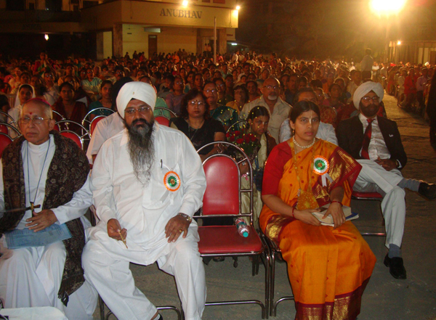

Incidentally, the Carmelite [OCD] priests of St. Joseph’s Church are promoters of yoga and the martial arts.
I have scoured the internet and my research library seeking information, any information which says that the bindi or tilak is a purely Indian cultural phenomenon. While I didn’t find a shred of evidence that says that, I found tons of evidence to the contrary. My findings are compiled in a separate article titled, "BINDI OR TILAK MARK ON THE FOREHEAD-INDIAN OR HINDU?"
http://ephesians-511.net/docs/BINDI_OR_TILAK_MARK_ON_THE_FOREHEAD-INDIAN_OR_HINDU.doc
MAY 15, 2012

