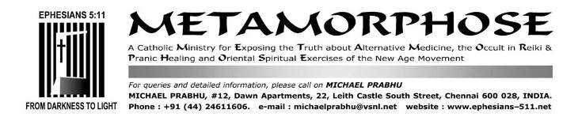
NOVEMBER 25, 2015

Kerala parish celebrates church feast jointly with Hindu temple festival

Feast and festival in harmony; goodness of religious tolerance in Ayiroor.
By Sijo Painadath
Translated from the daily Malayalam newspaper Deepika of November 24, 2015

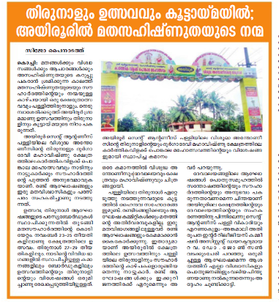

At a time when religions, beliefs and cults are tarnished with the allegations of intolerance, here is an example of harmony, tolerance and fellowship. A church feast and a temple festival are being celebrated together with great fervor and enthusiasm. The joyful hue of fellowship is provided to the Christian feast and the Hindu festival at Ayiroor village near Nedumpassery.
For the village and the people at large, this novel experience of fellowship is provided by the St. Anthony’s feast of Ayiroor parish and the Karthikavilaku Ponkala festival of Durgadevi Mahavishnu temple of the same village. The two events are being celebrated in unison and co-operation by the believers of both the religions.
The hoisting of the flag of harmony and tolerance started with the combined advertising boards and publicity materials being displayed all over the region. The temple festival is to be held between Nov. 23 and 25, while the church feast will be held between Nov. 27 and 29. The arches and flex boards give the details of both the celebrations side by side. In this way, the images of St. Anthony and the church as well as those of Lord Vishnu and the temple appear on the same arch.
There are many Hindu brethren among the sponsors of the church feast. There is no religious demarcation among the organizing committee members of the two festivals. The followers of both religions are bent on making both celebrations a great success. The people of Ayiroor say that this is for the first time that the two communities have joined hand to celebrate the feast and the festival together. They are sure that the number of devotees attending the two celebrations will be much higher this year than the previous years.

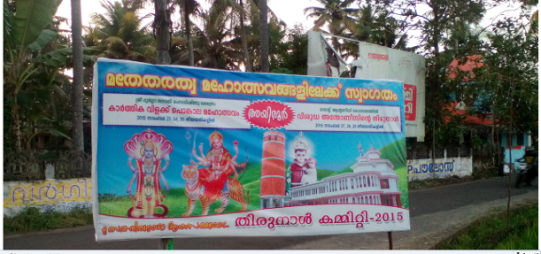
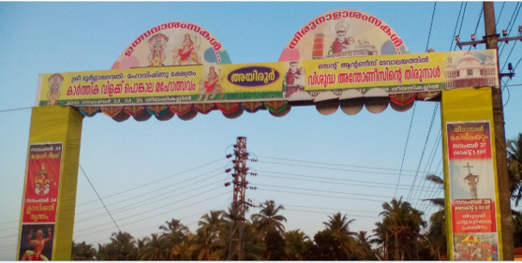

Rev. Dr. Johnson Vadakkumcherry, the parish priest of St. Anthony’s Church who is also the Assistant Director of the Ernakulam-Angamaly diocese said, “It is the thought that the celebrations of the churches should give experiences of joy and friendship to the common society which is behind the cooperation of the church and the temple in Ayiroor.” He pointed out that all the faithful and people at large are giving great support to the idea of a unified celebration.

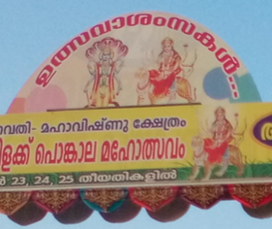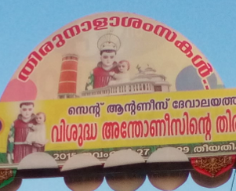

From the New American Bible:
…you will be lured into following them. Do not inquire regarding their gods, “How did these nations worship their gods? I too would do the same.” –Deuteronomy 12:30

SOME RELATED FILES
ARATI IN THE LITURGY-INDIAN OR HINDU
http://ephesians-511.net/docs/ARATI_IN_THE_LITURGY-INDIAN_OR_HINDU.doc

BHARATANATYAM AT HOLY MASS AT CATHEDRAL OF ST THOMAS IN MADRAS-MYLAPORE ARCHDIOCESE
http://ephesians-511.net/docs/BHARATANATYAM_AT_HOLY_MASS_AT_CATHEDRAL_OF_ST_THOMAS_IN_MADRAS-MYLAPORE_ARCHDIOCESE.doc

BISHOP THOMAS DABRE CONSORTS WITH THE ENEMY-THE BHARATIYA SANSKRITI PEETHAM AND THE BEDE GRIFFITHS SANGHA
http://ephesians-511.net/docs/BISHOP_THOMAS_DABRE_CONSORTS_WITH_THE_ENEMY-THE_BHARATIYA_SANSKRITI_PEETHAM_AND_THE_BEDE_GRIFFITHS_SANGHA.doc

CARDINAL IVAN DIAS LIGHTS A LAMP FOR THE HINDU DEITY GANESHA
http://ephesians-511.net/docs/CARDINAL_IVAN_DIAS_LIGHTS_A_LAMP_FOR_THE_HINDU_DEITY_GANESHA.doc

CARDINAL OSWALD GRACIAS ENDORSES YOGA FOR CATHOLICS
http://ephesians-511.net/docs/CARDINAL_OSWALD_GRACIAS_ENDORSES_YOGA_FOR_CATHOLICS.doc

CHURCH MOUTHPIECE THE EXAMINER ACCUSED OF PROMOTING HERESY
http://ephesians-511.net/docs/CHURCH_MOUTHPIECE_THE EXAMINER_ACCUSED_OF_PROMOTING_HERESY.doc

DANCING AND BHARATANATYAM IN THE MASS
http://ephesians-511.net/docs/DANCING_AND_BHARATANATYAM_IN_THE_MASS.doc

FR JEGATH GASPAR RAJ-IN PRAISE OF SHIVA-PRIEST INVESTS RS 15 MILLION, FLOATS COMPANY WORTH RS 100 CRORES
http://ephesians-511.net/docs/FR_JEGATH_GASPAR_RAJ-IN_PRAISE_OF_SHIVA-PRIEST_INVESTS_RS_15_MILLION_FLOATS_COMPANY_WORTH_RS_100_CRORES.doc

HABEMUS PAPAM INDIANUM-WE HAVE AN INDIAN PONTIFF
http://ephesians-511.net/docs/HABEMUS_PAPAM_INDIANUM-WE_HAVE_AN_INDIAN_PONTIFF.doc

HINDU FLAG POLE AT CATHEDRAL OF ST THOMAS IN MADRAS-MYLAPORE ARCHDIOCESE
http://ephesians-511.net/docs/HINDU_FLAG_POLE_AT_CATHEDRAL_OF_ST_THOMAS_IN_MADRAS-MYLAPORE_ARCHDIOCESE.doc

INDIAN CLERGY OBSESSED WITH THE HINDU DEITY GANESHA
http://ephesians-511.net/docs/INDIAN_CLERGY_OBSESSED_WITH_THE_HINDU_DEITY_GANESHA.doc

IS HOLY COMMUNION EQUIVALENT TO PRASADAM-IS IT SAFE FOR CATHOLICS TO CONSUME PRASADAM
http://ephesians-511.net/docs/IS_HOLY_COMMUNION_EQUIVALENT_TO_PRASADAM-IS_IT_SAFE_FOR_CATHOLICS_TO_CONSUME_PRASADAM.doc

IS THE SYRO MALABAR CHURCH NOW OPENLY PROMOTING ITS HINDUISATION?
http://ephesians-511.net/docs/IS_THE_SYRO-MALABAR_CHURCH_NOW_OPENLY_PROMOTING_ITS_HINDUISATION.doc

LITURGICAL ABUSES IN THE SYRO-MALABAR CHURCH-ORIGINS
http://ephesians-511.net/docs/LITURGICAL_ABUSES_IN_THE_SYRO-MALABAR_CHURCH-ORIGINS.doc

LOTUS AND THE CROSS-THE HINDUISATION OF THE CATHOLIC CHURCH IN INDIA
http://ephesians-511.net/docs/LOTUS_AND_THE_CROSS-THE_HINDUISATION_OF_THE_CATHOLIC_CHURCH_IN_INDIA.doc

MAY CATHOLICS CELEBRATE THE FESTIVAL OF HOLI?
http://ephesians-511.net/docs/MAY_CATHOLICS_CELEBRATE_THE_FESTIVAL_OF_HOLI.doc

MAY CATHOLICS CELEBRATE THE HARVEST FESTIVAL OF PONGAL?
http://ephesians-511.net/docs/MAY_CATHOLICS_CELEBRATE_THE_HARVEST_FESTIVAL_OF_PONGAL.doc

MOTHER TERESA AT PRAYER IN A BUDDHIST TEMPLE
http://ephesians-511.net/docs/MOTHER_TERESA_AT_PRAYER_IN_A_BUDDHIST_TEMPLE.doc

NBCLC-HARBINGER OF THE INDIAN RITE MASS AND LITURGICAL ABUSE
http://ephesians-511.net/docs/NBCLC-HARBINGER_OF_THE_INDIAN_RITE_MASS_AND_LITURGICAL_ABUSE.doc

NEW COMMUNITY BIBLE 27-CARDINAL OSWALD GRACIAS STILL IN DENIAL OF RESPONSIBILITY FOR ITS ERRORS
http://ephesians-511.net/docs/NEW_COMMUNITY_BIBLE_27-CARDINAL_OSWALD_GRACIAS_STILL_IN_DENIAL_OF_RESPONSIBILITY_FOR_ITS_ERRORS.doc

PAGANIZATION OF THE CHURCH IN INDIA 01
http://ephesians-511.net/docs/PAGANIZATION_OF_THE_CHURCH_IN_INDIA_01.doc

PAGANIZATION OF THE CHURCH IN INDIA 02
http://ephesians-511.net/docs/PAGANIZATION_OF_THE_CHURCH_IN_INDIA_02.doc

PILAR PRIEST FR PETER CARDOZO VENERATES THE HINDU DEITY GANESHA
http://ephesians-511.net/docs/PILAR_PRIEST_FR_PETER_CARDOZO_VENERATES_THE_HINDU_DEITY GANESHA.doc

PILAR SEMINARY, GOA-SYNCRETISM AND NEW AGE
http://ephesians-511.net/docs/PILAR_SEMINARY_GOA-SYNCRETISM_AND_NEW_AGE.doc

TAMIL NADU CLERGY VENERATE THE HINDU DEITY GANESHA
http://ephesians-511.net/docs/TAMIL_NADU_CLERGY_VENERATE_THE_HINDU_DEITY_GANESHA.doc

THE GOLDEN SHEAF-A COLLECTION OF ARTICLES DEALING WITH ECCLESIASTICAL ABERRATIONS
http://ephesians-511.net/docs/THE_GOLDEN_SHEAF-A_COLLECTION_OF_ARTICLES_DEALING_WITH_ECCLESIASTICAL_ABERRATIONS.doc

THE HINDUISATION OF MUSIC IN THE CATHOLIC CHURCH
http://ephesians-511.net/docs/THE_HINDUISATION_OF_MUSIC_IN_THE_CATHOLIC_CHURCH.doc

THE HINDUISATION OF THE CATHOLIC CHURCH-IMAGES
http://ephesians-511.net/docs/THE_HINDUISATION_OF_THE_CATHOLIC_CHURCH-IMAGES.doc

THE ONGOING ROBBERY OF FAITH-FR P K GEORGE
http://ephesians-511.net/docs/THE_ONGOING_ROBBERY_OF_FAITH-FR_P_K_GEORGE.doc

THE PAGANIZED CATHOLIC CHURCH IN INDIA-VICTOR J F KULANDAY
http://ephesians-511.net/docs/THE_PAGANIZED_CATHOLIC_CHURCH_IN_INDIA-VICTOR_J_F_KULANDAY.doc

THE PAGANISATION OF THE LITURGY IN INDIA-C B ANDRADE
http://ephesians-511.net/docs/THE_PAGANISATION_OF_THE_LITURGY_IN_INDIA-C_B_ANDRADE.doc

THE TWELVE POINTS OF ADAPTATION FOR THE INDIAN RITE MASS-WAS A FRAUD PERPETRATED ON INDIAN CATHOLICS?
http://ephesians-511.net/docs/THE_TWELVE_POINTS_OF_ADAPTATION_FOR_THE_INDIAN_RITE_MASS-WAS_A_FRAUD_PERPETRATED_ON_INDIAN_CATHOLICS.doc

THE ST PIUS X SEMINARY CELEBRATES HINDU DEITY GANESHA
http://ephesians-511.net/docs/THE_ST_PIUS_X_SEMINARY_CELEBRATES_HINDU_DEITY_GANESH.doc

WHY INDIAN CATHOLICS DO NOT WANT AN INDIAN POPE
http://ephesians-511.net/docs/WHY_INDIAN_CATHOLICS_DO_NOT_WANT_AN_INDIAN_POPE.doc

YOGA AND THE BRAHMA KUMARIS AT A CATHOLIC COLLEGE IN THE ARCHDIOCESE OF BOMBAY
http://ephesians-511.net/docs/YOGA_AND_THE_BRAHMA_KUMARIS_AT_A_CATHOLIC_COLLEGE_IN_THE_ARCHDIOCESE_OF_BOMBAY.doc

INTERRELIGIOUS DIALOGUE 01-POPE BENEDICT XVI
http://ephesians-511.net/docs/INTERRELIGIOUS_DIALOGUE_01-POPE_BENEDICT_XVI.doc
INTERRELIGIOUS DIALOGUE 02-GOA CATHOLICS OPPOSE
http://ephesians-511.net/docs/INTERRELIGIOUS_DIALOGUE_02-GOA_CATHOLICS_OPPOSE.doc
INTERRELIGIOUS DIALOGUE 03-THE FALSE KIND
http://ephesians-511.net/docs/INTERRELIGIOUS_DIALOGUE_03-THE_FALSE_KIND.doc

