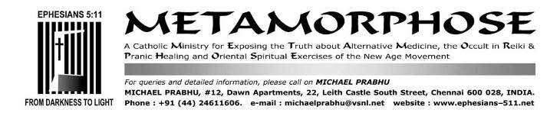
MARCH 28/APRIL 13, 2017

Quo Vadis, Papa Francisco?
50-ABOLITION OF THE SOLEMN TRAPPINGS OF THE PONTIFICAL OFFICE

Pope Francis’ dropping of Papal trappings a sign of humility?
See THE SHOCKING INITIATIVES OF POPE FRANCIS
http://ephesians-511.net/docs/THE_SHOCKING_INITIATIVES_OF_POPE_FRANCIS.doc

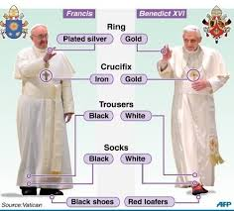
https://followingfeet.com/2014/03/21/shoe-leather-evangelism-the-significance-of-pope-francis-style/

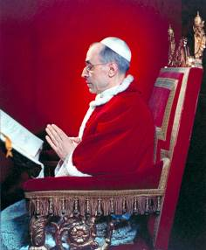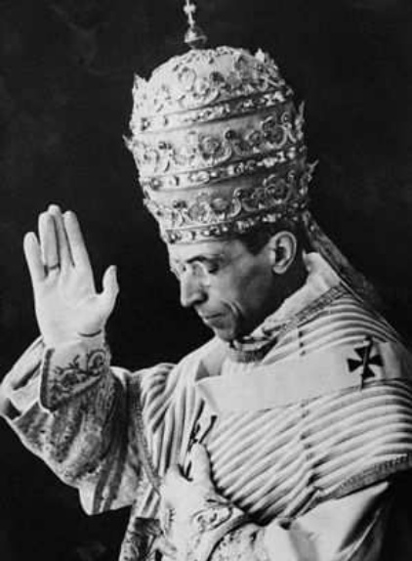
Pope Pius XII

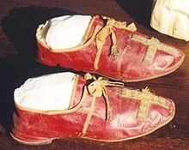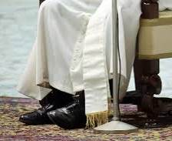
The shoes worn by Pope Pius VII/The shoes worn by Pope Francis

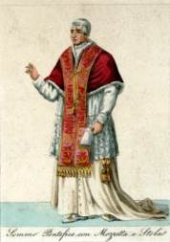
A Pope with mozzetta and stole

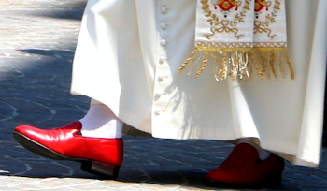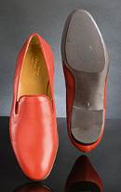
Pope Benedict XVI wore red Prada shoes

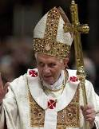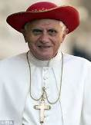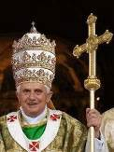
Pope Benedict XVI; centre, wearing a “Saturno”; right, wearing a tiara

Since being elected, this pope has broken from tradition by adopting a simple style of dress. Arguably, most notable are his black shoes. Rather than donning traditional red slippers, which symbolize the blood of Christ and Catholic martyrs, Pope Francis wears basic black leather shoes with a smooth toe and no decorations.
Papal shoes have been made in red satin and embroidered in gold thread since the 16th century.
Pope Francis's austere attire is a sharp contrast to his predecessor, Pope Emeritus Benedict XVI, who was known in Italian media as the 'Prada Pope' because of his custom-made red slippers.
The mozzetta is a short, elbow-length cape-shaped garment covering the shoulders, with an open front fastened by a row of small buttons, similar to a hood. The mozzetta is a sign of authority. The winter mozzetta -- made of red velvet trimmed in ermine fur -- fell into disuse during the pontificate of John Paul II (1978-2005), but was briefly restored by Pope Benedict XVI from 2005 to 2013. It was discontinued again by Pope Francis.

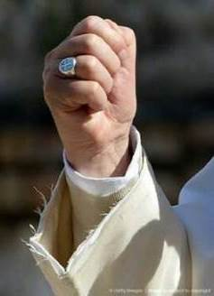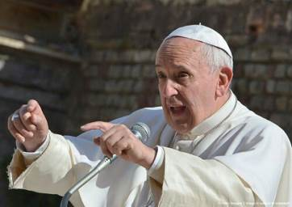
In 2015, Pope Francis appeared in public wearing a threadbare white cassock
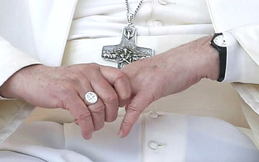 The egalitarian symbols of Pope Francis: An iron cross, a pewter ring and a plastic wrist-watch
Pope Francis has the option of having a ring called "The Fisherman's Ring" or Episcopal ring (traditionally set in gold and originally serving both as a symbol of the papacy and a seal of the reigning pope) made specifically for him, but he declined.
Pope Francis also wears a pectoral cross, which is worn by popes, cardinals, and bishops on a chain or cord necklace. However, he eschews the traditional gold cross, adorned with jewels and precious stones, instead, choosing an unadorned silver cross that he received as a gift from a friend when he was anointed an auxiliary archbishop of Bueno Aires, Argentina, in the early 1990s.
Source: http://www.nj.com/entertainment/index.ssf/2015/09/pope_francis_fashion_papal_visit_us.html

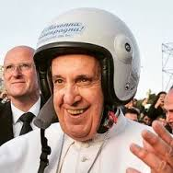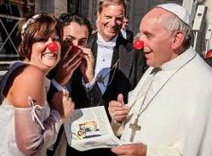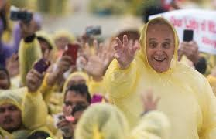

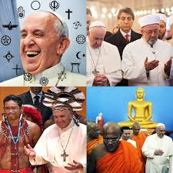

In chronological order
Pope Francis belied all traditional hopes and expectations. Nay, he crushed and discarded them.
Pope Benedict: his true legacy is his fashion sense
https://www.theguardian.com/fashion/fashion-blog/2013/mar/03/pope-benedict-true-legacy-fashion-sense
By Henry Conway, March 3, 2013 (Article written after Benedict’s abdication and before Francis’ accession)

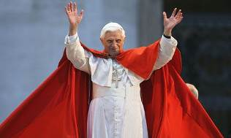
Something truly extraordinary is unfolding in Rome. For the first time in 600 years, a pope has stepped down; and not just any pope, but the extremely fashion-forward Pope Benedict XVI. For all the problems the Catholic Church faces in the 21st century, the pope emeritus has at least provided the Vatican with a strong sartorial voice.

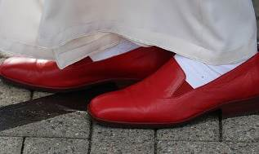

At the beginning of his papacy, Benedict was caught in a small media storm over a supposed weakness for red Prada papal slip-ons. The Vatican denied it, saying: "The pope is not dressed by Prada but by Christ" (who as we all know is somewhat less well regarded for his shoe design). Whoever made them, the red shoes tell a much bigger story. Benedict's predecessor, John Paul II, wore plain brown lace-ups with his vestments – hardly papal magnificence. With this reintroduction of red Moroccan leather, Benedict's shoes represented his politics as much as his good taste in cobblers.
The root of his need to rediscover some of the more traditional, even baroque, elements of papal dressing can be traced back to the great liturgy gear-change of 1965, when the phase known as Vatican II, a period of modernisation aimed at reconnecting the Vatican to Catholics worldwide, came to an end. Latin mass, for example, was abandoned in favour of churches delivering services in their own language. The pope wanted to be seen to be more in touch with the people.
This meant the dumping of all tassels, trimmings and most decoration on vestments. Highly theatrical robes were considered too outré. Out went anything that made church leaders look like Cardinal Richelieu. As a priest friend of mine puts it: "The Church processed into the second Vatican council in cloth of gold and watered silk, and shambled out of the other end in drip-dry horse blankets and polyester." Pope Paul VI even sold off the papal tiara, a three-tiered, egg-shaped adornment that made our imperial state crown look like something from Lidl.
Benedict's desire to recapture the Church's traditional liturgy and doctrine goes hand in hand with what he wore as pope. On his election in 2005, he wore Ming the Merciless-style vestments left over from John Paul's administration, and after getting rid of his first master of ceremonies, Piero Marini, who had subjected him to a sort of blue dust-sheet for his first papal mass in Austria, he turned to Guido Marini (no relation) – an MC who understood the power of tradition. At a time of global economic uncertainty, and with the Church struggling to retain its flock in an increasingly secularised world, reinforcing tradition and underlining the continuity of ritual was a bold and, Benedict felt, necessary direction.

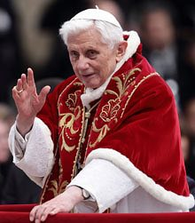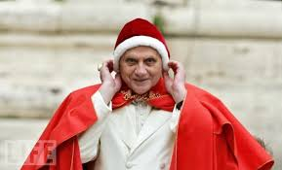

After this, his sartorial choices coaxed the Church out of a 1970s time warp. My favourite item from his wardrobe is a short cape known as a mozzetta, the winter version of which is fur-lined, ermine-trimmed and made of crimson silk. Equally glamorous is the papal pallium, a thick band that encircles the neck with pendants at the end, which is traditionally made of white wool from sheep raised by Trappist monks. Papal rings, diamond, sapphire and ruby pectoral crosses, the all-important golden mitres (with more jewels): he was a truly bling pope. A young priest told me a story about when, before celebrating mass at St Peter's, he had the honour of preparing his vestments in the presence of His Holiness. Pope Benedict came down to the sacristy in a lift, as usual, and had three sets of vestments and mitres set out to choose from. He went straight for the most elaborate. This love of gothic vestments was about more than basic vanity; beauty and dignity reflect the splendour and mystery of liturgy. To Benedict this is God-focused rather than community-centred, as was favoured by the 1968 generation.
Though not usually in sync with the fashion world, the Vatican is currently bang on trend. A return to quality, an interest in heritage, and support of artisanal craftsman could not be more now – look to Chanel, McQueen, Valentino for examples. Lace and velvet are everywhere – from the pope to Paris, they are the height of chic.
Despite this, Benedict wisely stayed clear of actual designers. In 2007 the Italian film director Franco Zeffirelli offered his services as a consultant to the Vatican. Having previously designed the staging for mass ceremonies under John Paul II, it was suspected that Zeffirelli wanted to play down Benedict's "showy" image. The Vatican politely declined. Perhaps they had learned from a state visit to Paris in 1997, when quirky designer Jean-Charles de Castelbajac (France's answer to Vivienne Westwood), persuaded John Paul II, 5,000 priests and 500 bishops to dress in rainbow cross motif vestments in what the designer later explained was a symbol of "God's promise of peace to Noah". When Castelbajac pointed out that the vestments clearly used the international symbol of gay liberation, the rainbow flag, the Vatican responded that no one had a copyright on the rainbow.
So what can we expect from the next pope, both the man and the wardrobe? […]

What does a Pope like to wear? Francis keeps it simple
https://www.washingtonpost.com/world/what-does-a-pope-like-to-wear-francis-keeps-it-simple/
By Jason Horowitz, March 18, 2013
On Monday afternoon, Massimiliano Gammarelli, the head tailor of the family that has been dressing pontiffs for centuries, ran a lint brush over the white cassock that Pope Francis will wear at his installation Mass on Tuesday. He clipped stray threads with shears and yelled at a priest who bent down to kiss the hem. (“Don’t dirty it!”) As his cousins checked their watches, he meticulously folded the frock, wrapped it in tissue paper and packed it into a silver box for delivery to the Vatican.
In his first week as pope, Francis’ inclination toward simple cassocks has led the Vatican, cardinals and church watchers to see substance in his pared-down style and insist that the clothes really do make the infallible man. But while some of the church’s leaders have cheered his humbler fashion sense, Francis’s preference for dressing down could be bad news for some of the prelates who like to dress up — not to mention the vestment purveyors who clothe them.
“He’s like a king. He decides and we obey,” Gammarelli said as he leaned against shelves stocked with expensive violet, pink, green and red fabrics. “If the cardinals start coming in asking for new clothes, we’ll know that he has asked them to add things. But if he wants them to remove things, how will I know?”
Gammarelli said he had heard rumors that the pope wanted a simpler dress code for his cardinals, but wouldn’t allow himself to get too concerned unless an edict was issued. “If so, we’ll adapt,” he said. “There’s no choice.”

A full-dress predecessor
Benedict XVI, who last month became the first pontiff to resign in 600 years, was a proponent of the restoration of the church’s older rites, and he reached deep into the church’s closet of vestments and regalia to emphasize its rich tradition.
He wore violet copes; blue, full-cut chasubles with abstract designs; and furry white Easter mozzettas for the spring season. He donned an assortment of hats, including the camauro, a Santa Claus-esque red wool cap with an ermine trim that dated back to the 12th century; a red Saturno, a full-brimmed number named for ringed Saturn; and a precious mitre studded with jewels.
The emeritus pope, as Benedict is now known, is not the church’s only fashion plate. Cardinal Raymond Burke, as archbishop of St. Louis, has also earned a reputation for operatic regalia. He is one of the few cardinals who dons cappa magnas, the long trains of watered silk that can look like scarlet lava flowing down from his throne. His velvet gloves and extravagant brocades prompted Vatican officials to ask him to “tone it down a bit,” according to noted religion reporter David Gibson.
“The vestments, everything, are part of a tradition,” Burke told Gibson. “We need to understand that and not just discard it and say, ‘Well, it was all just an ugly accretion.’ ”
(“I’m sorry,” Burke said when reached by phone. “I won’t be able to respond.”)
There have been other signs that the fans of high-church trappings might be losing influence.

‘Carnival time is over!’
Vatican reporters buzzed during Francis’s first Mass as pope when he was caught on video seeming to have cross words for Monsignor Guido Marini, the Master of Pontifical Liturgical Celebrations, as they proceeded into the Sistine Chapel. According to the BBC, in the minutes after his election, Pope Francis rejected a red cape with ermine trim presented to him by Marini, who is famously more fastidious about liturgical details than his predecessor. “No, thank you, Monsignore,” Francis, 76, is reported to have said. “You put it on instead. Carnival time is over!” The Vatican, which has made simplicity its new watchword, said they could not confirm or deny the report.
But it does seem in keeping with Francis’s past statements. After the 2005 conclave, when he was still Cardinal Jorge Mario Bergoglio, archbishop of Buenos Aires, he bemoaned vanity in the church to an Italian reporter, saying “look at the peacock; it’s beautiful if you look at it from the front. But if you look at it from behind, you discover the truth. . . . Whoever gives in to such self-absorbed vanity has huge misery hiding inside them.”
The pope’s new style has been well received. Sister Mary Ann Walsh, the head of media relations for the American bishops’ conference, wrote in a newsletter on March 14, the day after the pope’s election, that “Instructions for what to wear for upcoming meetings suggest that the simple style he is known for continues. Today, the cardinals were advised to wear the black house cassock rather than the more formal red choir robes with white surplice.”
That invitation delighted Cardinal Roger Mahony of Los Angeles, who, after finding himself in the center of a priestly sex-abuse scandal, needed some good news. “At our meeting today with Pope Francis, I noted that [he] is still wearing his older black shoes,” Mahony tweeted on March 15. “I pray that he keeps them as a sign for us all.” The next day he added, “So long Papal ermine and fancy lace! Welcome simple cassock, and hopefully, ordinary black shoes! St. Francis must be overjoyed!!” His new look also pleased the critics in the front row. Vatican blogger Rocco Palmo noted approvingly that the new pope’s black pants were visible underneath his white cassock.
In an interview, Cardinal Donald Wuerl, the archbishop of Washington, said that the trappings in themselves were not bad for the church.
“Symbols are still very important, but it’s how you use the symbols that make them work for you as opposed to getting too caught up in them,” Wuerl said. Francis, he added, “indicated just by stepping out onto the balcony in a white cassock that ‘yes, I will still be a pope, but there’s also going to be some simplicity to this.’ ”

Of the Pope’s mozzetta…
http://wdtprs.com/blog/2013/03/of-the-popes-mozzetta/
By Fr. John Zuhlsdorf, March 19, 2013
I read on an Italian blog (and so this is at the level of rumor for now) that the Roman ecclesiastical tailor shop Gammarelli sent a mozzetta over the Apostolic Palace. A mozzetta is the elbow length red cape, often trimmed in ermine, worn by the Roman Pontiff over his white cassock.
Tuesday, today, is the Mass of the “inauguration” of Francis’ pontificate.
Tomorrow the Pope has an audience with delegations of Christian ‘churches’. Were the Pope to put on the mozzetta, that would be a good occasion. That would be the apt thing to do. It would be a sign of respect. The Pope will also soon have an audience with the diplomatic corps. The Pope, a head of state, should dress his part. The rest of the diplomats will.
This leads to “the point”, in case some of the enthusiasts run to the combox having missed it.
Remember, a mozzetta, in itself, is nothing. Popes don’t have to wear a mozzetta all the time. There are, however, occasions in which such trappings and signs of office, solemn and traditional, have their proper place. They send signals. The non-use of these symbols also sends signals.
People who say that these things are not important, or are bad, or that they should be eliminated are just plain wrong. That is a naive, shallow, approach to who we are. Catholics are not “either/or” when it comes to the dynamic interplay of the humble and the lofty. We are “both/and”, in proper measure, time and place.

Archbishops should live in palaces
http://www.patheos.com/blogs/standingonmyhead/2014/04/an-archbishop-should-live-in-a-palace.html
By Fr. Dwight D. Longenecker, April 4, 2014
This blog is called Standing on My Head, so while everybody is pouting and posturing about the houses of Archbishops and Bishops I’m going to strike a topsy turvy perspective, yea a discordant note.
I think the Pope should live in the Apostolic Palace and I think Archbishop Wilton should live in his brand new $2.2m home. I think Bishops should live in these grand homes–but they should do so like one of those impoverished English aristocrats who can’t afford to heat their vast Downton Abbey, and so live in one room in the attic wearing three sweaters and eating cat food casseroles that they cook in a microwave.
They should live there in community with other priests or brothers if they are religious. They should open up the West Wing as a hostel for recovering addicts and open up the East Wing as a women’s shelter and bring in some Mother Teresa nuns to run the place.
This would be a far more significant sign of contradiction than simply moving out to a mean little room somewhere because it would say something more profound about worldly wealth and property.
See, what troubles me about the Franciscan embrace of Lady Poverty is that it is too easily misunderstood. People then come to think that there is something good about poverty and that it is somehow good to be poor. It’s not good to be poor. It’s bad to be poor. Neither is a poor person good just because he’s poor.
Neither is it bad to own property or wealth. It’s good to have nice things. It’s good to enjoy life. It’s good to enjoy God’s blessings.
That’s why I’m Benedictine in temperament and commitment, and not Franciscan. The Benedictine monk does not take a vow of poverty and the Benedictine monasteries may have great property and wealth. However, the Rule of St Benedict does insist that the monk has no personal possessions. There’s a good balance. The monastery may own property and goods, but the individual monk does not.
This principle applied to church life teaches us that property and wealth is to be used for the common good. It is not to be distributed to all in some sort of socialistic solution or communist utopia, but it is to be used for the common good. When we’re tempted to tootle off to some sentimental idea of Franciscanism in which poverty is good for its own sake (and by implication property and wealth is bad just because its bad) we should step back and analyze what property and wealth is for.
When Jesus says “Sell all that you have and to the poor” did he really mean that or was it hyperbole? Of course it was hyperbole just like “Cut off your hand if it offends you” and “you must hate your mother and father and sister and brother to enter the kingdom”. But beneath the hyperbole is a principle which applies: that you are to be personally liberated and unbound from your wealth. You own property for the common good.
The social teaching of the church is that property is a human right. It is the just reward of labor. It is, however, to be used for the common good, not for the aggrandizement of the individual. Using wealth for the common good means that we use the wealth firstly for the common good of our families, then of our community and our world. What would the world be like if that was really our aim?
I’d like to see the Pope live in the Apostolic Palace within a simple religious community of sisters and brother priests–serving the church in personal poverty from within property rather than the simplistic solution of either giving away all the wealth or even worse–forced distribution of other people’s wealth.
Readers have left 79 comments

Should Pope Francis have abandoned the trappings of his office?
The media image now is of a Pontiff rejecting the traditions of the Church
http://www.catholicherald.co.uk/commentandblogs/2014/04/11/should-pope-francis-have-abandoned-the-trappings-of-his-office-the-media-image-now-is-of-a-pontiff-rejecting-the-traditions-of-the-church/
By William Oddie, April 11, 2014
Pope Benedict was no less a pontiff of profound personal humility because he wore red shoes and lived in the papal apartments
Father Longenecker has an amusing blog (above) this week, headlined “Archbishops should live in palaces”. “I think the Pope should live in the Apostolic Palace”, he says, “and I think Archbishop Wilton [Archbishop Wilton Gregory of Atlanta, who is moving out three months after moving in] should live in his brand new $2.2m home. I think Bishops should live in these grand homes–-but they should do so like one of those impoverished English aristocrats who can’t afford to heat their vast Downton Abbey, and so live in one room in the attic wearing three sweaters and eating cat food casseroles that they cook in a microwave.”
I think the bit about the cat food could be a joke: but Fr Dwight is serious enough about the rest. He thinks that bishops should live in these grand buildings in community with other priests or brothers if they are religious, and should open them up as hostels for recovering addicts and the other end of the buildings maybe as women’s shelters and that they should bring in some Mother Teresa nuns to run these now possibly over-ambitious establishments. You get the idea. This, he says, would “be a far more significant sign of contradiction than simply moving out to a mean little room somewhere because it would say something more profound about worldly wealth and property.” I agree with all that. Cardinal Bergoglio lived alone in a small flat in Buenos Aires and cooked for himself, but wasn’t that because he actually preferred to live like that? And I don’t see there’s anything wrong, either, with a bishop living in a certain degree of modest comfort: after a hard day on the stump, why shouldn’t he have somewhere decent to come back to, and why shouldn’t he have a hot meal waiting for him when he gets there, and his bed turned down and maybe a sweetie on his pillow?
Fr Dwight goes on to argue that there’s nothing intrinsically good about poverty. I agree with that, too, but I think that when a bishop moves out of his “palace” and a pope refuses to move into the papal apartments, they’re making a point not about poverty but about humility (their own). And though Pope Francis may indeed be a genuinely humble person what I object to particularly in the media coverage of his pontificate is that because of the way he has chosen to live in the Vatican, in a flat in the Casa Santa Marta rather than where popes are supposed to live, he is ipso fact a lot more humble than previous popes, who after all simply surrendered themselves to the way things had always been done, as a way of identifying themselves with the traditions their predecessors had always embodied, as a visible indication of a hermeneutic of continuity.
Nothing I say now, with one or two minor exceptions, is intended as a major criticism of the current pontiff: I think he is playing a blinder, and I am not one of those reactionaries who interprets his frisky ways as an indication that he is some kind of liberal: I am, rather, one of those reactionaries who thinks that in spite of all those spontaneous remarks that have to be corrected later, he is just as reactionary as I am. He’s giving the Vatican a considerable shakeup, which was long overdue: and I am confident, or at least hopeful, that in the end, he will leave the institution he now governs in better heart than he found it, and no less faithful to the Magisterium Pope John intended Vatican II to articulate and not to undermine (remember his opening words to the Council fathers? “The Councils–both the twenty ecumenical ones and the numberless others … all prove clearly the vigour of the Catholic Church and are recorded as shining lights in her annals.”
Pope John’s intentions were wilfully betrayed: and I have no doubt that attempts will be made to betray those of Pope Francis, too. These are uncertain times. But I agree with Fr Z’s analysis, that Pope Francis is himself endorsing, even embodying, Pope Benedict’s ideas on the hermeneutic of continuity.

I mentioned an exception to my declaration that I do not intend in this post to criticise Pope Francis: it is this. That by refusing to move into the papal apartments, and by all the other ways in which he rejects what his predecessors did (including the red shoes and the scarlet velvet mozzetta) he SEEMS to be (though of course he is not) indicating a superior humility to that of his more lofty predecessors: in particular, the media seem to think that he is obviously more humble, more identified with the poor and marginalised, than reactionary pope Benedict—who in fact simply attempted to convey the lofty character not of himself but of his sacred office, by dressing and behaving according to papal custom.
Pope John, after all, was crowned with the papal tiara, and allowed himself to be carried aloft on a sedia gestatoria. Does anyone really think—has anyone ever remotely suggested—that that meant that he wasn’t after all a humble and holy father of all Catholics, a true Vicar of Christ? In the early days, Fr Z (like I and many others did) still lived in hopes that the present pope would dress and ceremoniously comport himself as popes have always done.

On the day of his inauguration mass, Fr Z (Fr. John Zuhlsdorf, previous page) wrote this:
Tomorrow the Pope has an audience with delegations of Christian “churches”. Were the Pope to put on the mozzetta, that would be a good occasion? That would be the apt thing to do. It would be a sign of respect. The Pope will also soon have an audience with the diplomatic corps. The Pope, a head of state, should dress his part. The rest of the diplomats will.
This leads to “the point”, in case some of the enthusiasts run to the combox having missed it.
Remember, a mozzetta, in itself, is nothing. Popes don’t have to wear a mozzetta all the time. There are, however, occasions in which such trappings and signs of office, solemn and traditional, have their proper place. They send signals. The non-use of these symbols also sends signals.

People who say that these things are not important, or are bad, or that they should be eliminated are just plain wrong. That is a naive, shallow, approach to who we are. Catholics are not “either/or” when it comes to the dynamic interplay of the humble and the lofty. We are “both/and”, in proper measure, time and place.
I agree with all of that. And I end with one or two simple questions. Firstly, does anyone seriously think, because he wore the scarlet mozzetta and red shoes, and went to his duties driven in a white Merc (by a driver who wept at his final departure) that Pope Benedict was NOT the profoundly humble and holy man he clearly was, for all that he didn’t consciously project humility?
My final questions are these: does Pope Francis’s abolition of what Fr Z calls the “trappings and signs of office, solemn and traditional” not carry a certain danger: that of making his own papacy appear to be a projection of his own engaging personality and of the ways of doing things that he personally finds come naturally to him?
And when all that is snuffed out by death, is there not the danger that what he will leave behind him will be what will be for a time a simple vacuum, rather than a sede vacante capable of being occupied reasonably soon as a going concern?

UPDATE
Bergoglio’s devastation of Papal symbols
http://www.traditioninaction.org/Questions/B603_List.html#symbols
April 2, 2013

I received from some friends this very encompassing list of the disastrous effects of the 10 first days of Pope Francis. It seems that this list was made by some conservative Benedictines in Minnesota who, like many of us, are not happy with the direction things are taking in the Church.
After his election, he came down from the platform to greet the cardinal electors, rather than have them come up to his level to offer obedience.
He appeared on the loggia without the red cape. (The BBC report, unconfirmed, is that he said to his aide, “No thank you, Monsignore. You put it on instead. Carnival time is over.”)
In his greeting he referred to himself only as “bishop,” not as "pope."
He referred to Benedict as “bishop emeritus,” not “pope emeritus.”
He appeared without the stole, only putting it on to give the blessing. He then took it off in public (!) as if he couldn’t wait to get it off.
He asked for the people’s blessing before he blessed them.
He doesn’t wear red shoes.
Or white stockings.
Or cuff links.
He rode the bus back to the residence with the cardinals rather than take the papal limousine.
When he went to St. Mary Major to pray, he declined the papal Mercedes and took a Volkswagen Passat.
On his way back from Mary Major, he stopped at his pre-conclave hotel to get his luggage and pay his own bill.
Though he has taken possession of the apostolic palace, he continued to receive guests at St. Martha’s House rather than the palace.
He drank Argentinian tea in public when receiving the Argentinian president – protocol is that popes are seen publicly consuming no food or drink except the Eucharist.
His first Mass with cardinals was celebrated facing the people. (Pope Benedict started this way, but then did a “reform of the reform” and celebrated at the old high altar in the Sistine Chapel facing away from the congregation. Apparently this has been reversed.)
He doesn’t chant the prayers, he recites them – but this could be because of an impaired lung or his singing ability.
The wall of candles between celebrant and congregation, another of Pope Benedict’s “reform of the reform,” was moved away and replaced with three candles on each side of the altar.
At his inauguration Mass, photos show that the candles were originally set up across the front of the altar, but by Mass time they had been moved to the side.
The crucifix on the altar was a small one at his first Mass.
He wore his own simple miter from Argentina, not the papal miter.
He preached from the ambo without the miter – rather like a simple parish priest. (The concelebrating cardinals gradually realized what was going on and had to remove the miters they had started to put on after the Gospel reading.)
He brushed aside the prepared Latin homily and preached in Italian without text.
In general, less lace.
His hands are folded during the liturgy, not the pious (some say prissy) way with palms together.
He didn’t genuflect at the Supper Narrative of the Eucharistic Prayer – is this really because of bad knees?
He asked the cardinals not to wear their red cardinals’ robes, but black.
He stood on the floor of the Clementine Hall to greet the cardinals rather than sit on the throne on the platform.
He called them “brother cardinals” rather than “Lord cardinals.”
He bent to kiss the ring of a cardinal who kissed his ring.

At his meeting with over 5,000 journalists, after Archbishop Celli introduced him, he got up to walk over to him (popes don’t do that) and thanked him.
He didn’t bless the journalists like popes do, since not all of them are Catholic or believers. Instead he prayed for them in silence, then simply said “God bless you.”
After the meeting with journalists, he waved away the papal limousine and walked to the Vatican residence.
When he saw the papal apartments he said, “There’s room for 300 people here. I don’t need all this space.” He has yet to move into the apartments, and some wonder whether he will.
At Mass Sunday morning at the Vatican parish, he gave the Kiss of Peace to the deacons and Master of Ceremonies, not just the concelebrants. This is breaking the rules – but perhaps also a nice show of support for MC Marini, who must be reeling from all the sudden changes.
The deacon didn’t kneel before Pope Francis for the blessing before the gospel (as they did for John Paul II and Benedict XVI).
He doesn’t wear the dalmatic. Pope Benedict revived the practice, not foreseen in the reformed liturgical books, of wearing this deacon’s vestment under his papal vestments.
He doesn’t distribute Communion as the missal foresees of the celebrant, but is seated while others do so.
He listened to the words of the Patriarch of Constantinople seated on an armchair rather than the throne that is customarily used in the Clementine Hall. When he thanked Bartholomew I, he called him “my brother Andrew.”
He has simplified his coat of arms, keeping the miter rather than tiara (as Benedict also did) but removing the pallium from it.
He is wearing a second-hand pallium.
He has chosen a simple ring, re-using a ring once made for Paul VI’s secretary.
Pope Benedict recently began wearing a fanon under the pallium for big feasts, but Francis did not wear it at the inauguration Mass.
He undid Pope Benedict’s decision that all the cardinals would come up to pay obedience to the Pope at his inauguration, and decided that six representatives would be enough.
Rather than being seated while the cardinals came up to pay him obedience, he stood and greeted them informally.
Contrary to protocol, he has given a phone call to the Jesuit superior general, the people holding a prayer vigil outside the Buenos Aires cathedral, and the guy in Argentina who sold him his daily paper (to cancel his delivery).
When he met the Jesuit general, he apologized for not keeping protocol and insisted on being treated like any other Jesuit with the “tu” informal address, rather than “Your Holiness” or “Holy Father.”
He is not celebrating Holy Thursday Mass of the Lord’s Supper in St. Peter’s Basilica (he hasn’t yet taken possession of his cathedral, John Lateran), but in a juvenile prison.
He celebrated an unannounced Mass at St. Martha’s with hotel workers, Vatican gardeners, and people who clean St. Peter’s square. He showed up before Mass and sat in the back row to pray a bit.
In his official photograph, he signs his name simply “Franciscus” without “PP” (“pontifex pontificum”) used by previous popes.

The symbolism of the Papal red and white
http://www.traditioninaction.org/religious/i015_RedCope.htm
May 22, 2013
As it was widely reported by the BBC, after Pope Francis was elected he turned down the red cape with ermine, saying, “No thank you, Monsignor. You put it on, instead. Carnival time is over!”

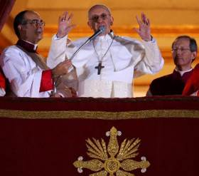
Pope Francis refuses the red cope: "The carnival is over"

The Vatican said it could not confirm or deny the report, which is already a half-confirmation. But whether Francis said those words or not, the fact remains that he turned down the traditional red cape and made his first appearance before the people in just the white cassock.
Many persons assumed this was just a personal whim of the new Pope, “no big deal” to make a fuss about. I do not think they realize the symbolism of the red cope, which goes back for many centuries. Both the red mantle and the white cassock have an important significance regarding the understanding and function of the Papacy.
Meaning of the red mantle
Already in the 11th century St. Peter Damian described the cappa rubea donned by the Pope at his election as a distinctive garb unique to the Pope. (1) Because it stood for the supremacy of the spiritual sphere over the temporal, St. Gregory VII (1073–1085) warned that “only the Pope may use the red cape as a sign of imperial authority and martyrdom.”(2)
According to tradition, that cape derived from the clamide purpurea, a large cloak worn over the shoulders that was part of the insignia granted to the Pope in the Donation of Constantine. Therefore, it signified the temporal as well as spiritual authority the Pope had over the Papal States.
During the medieval period wearing the red papal mantle signified the papal office. To take on the cloak of imperial red was a sign of the dual identity of the new Pope: “a royal Priest and an imperial Bishop.” (3) This is why the anti-pope Victor IV tried to seize the mantle - and thus the papacy - from Alexander III at the conclave of 1159.
As the reader can see, donning the red cape after the election is not just a quirk to follow or not follow. It is a highly symbolic act that stands for the Pope assuming the full authority of his office. When Francis refused to don it, he was in effect rejecting the temporal authority that accompanies the spiritual office, as well denying the imperial or royal character of the Papacy. It seems likely that in fact he was referring to this when he emphasized, “The carnival is over.”
The Pope in white is not an invention of St. Pius V
To justify Pope Francis’ desire to deprive himself of the traditional papal red cope, some commentators are pointing to St. Pius V (1566-1572) as being likewise innovative after his election.

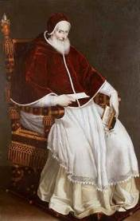
Pope Pius V - not the first to wear the white cassock

According to this legend, St. Pius V, a Dominican, chose to wear his same white Dominican habit and thus introduced the custom of the Pope wearing white. Now, if St. Pius V decided to be original, the new Pope’s defenders say, then who can deny the same prerogative to Francis?
This legend, however, is not accurate. We know from early ceremonial books that the Pope dressed in white and red centuries before Pius V. The first formal record we have of the Pope’s dress being white is in the Ordo, or ceremonial book, of Pope Gregory X (1272-1273), almost three centuries before Pius V.
It describes the red cope and white garments (alba Romana) as standing for the Pope’s universal power over the Church and his temporal power over the Papal States: the red symbolizing the former, and the white, the latter. The two colors also represented Christ as they were “symbols of martyrdom and divinity.” (4)
Another formal description of the Pope in white – reported as if it were already a longstanding tradition - is found in the Rationale Divinorum Officiorum (1286) of Guillaume Durand. Explaining the symbolic meaning of the papal robes, the 13th century Dominican states:
"The Supreme Pontiff always appears wearing a red mantle on the outside; but underneath he is dressed in a bright white garment. For whiteness symbolizes innocence, and the red on the outside symbolizes charity and compassion, that is to say, to show that he is always ready to lay down his life for his sheep because, indeed, the Pope represents the person of the One who, for our sake, stained his own garment red.” (5)

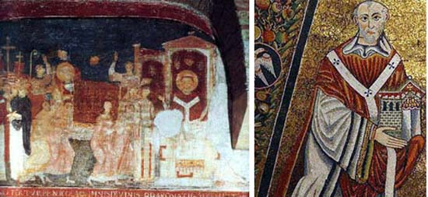
Above left, an 11th century painting of Nicolas II, right, a mosaic of Innocent II, c. 1140

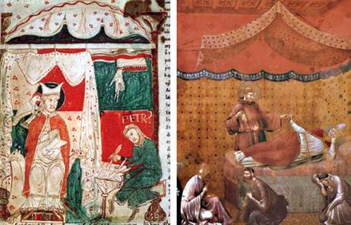
Above left, St. Gregory the Great pictured in the 12th c; right, Gregory IX painted by Giotto in the 14th c.; Below, Boniface VIII depicted in red and white in a 14th c. manuscript

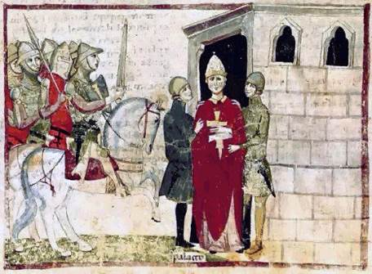

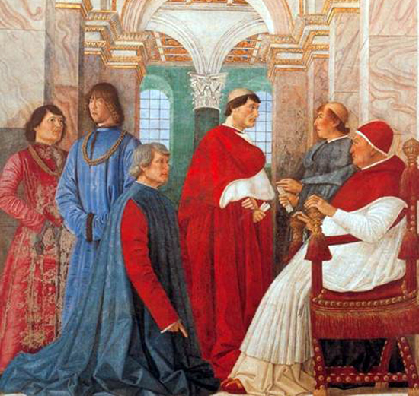
Sistus IV, Vatican Collection, painted in a 1477 manuscript

Durand’s statement was reaffirmed by Patrizio Piccolomini who, in his ceremonial book of 1484-1492, stressed that the Pope always wore white or red, even in his clothing that is not sacred. Thus the introduction of the papal red shoes, also abandoned by Francis… (6)
We are told that when Pius II was elected in 1458 – a century before Pius V was chosen – “he cast off his old garments and put on the white tunic of Christ.” (7) From this it is clear that the custom of the Pope wearing white was in place long before the election of Pius V in 1566.
In the pictures above you can see a brief iconographic history of Popes before St. Pius V wearing white, amassed by Francesco Colafemmina on the website Fides and Forma.
No, St. Pius V did not make a ceremonial innovation after his election. Yes, Francis did, and the act had meaning.
Since the donning of the red is an important sign of the Pope's spiritual and temporal powers over the Universal Church, the refusal of Francis to don that symbolic cope signifies something more than a personal preference. It is a symbolic denial of the papal role.
At least one journalist got this symbolism right. In the Corriere Della Sera, Italian editorialist Massimo Franco said this about the action of Francis refusing the cope: "The era of the Pope-King and of the Vatican court is over."

Footnotes
1. Peter Damian, Epist., book 1, 20 (1073) in Carol M Richardson, The Cardinal’s Red Hat, The Open University, UK, p. 6
2. “Descriptio sanctuarii Lateranensis ecclesiae”, in ibid., p. 7.
3. Paravicini-Bagliani, The Pope’s Body, in ibid., p. 5.
4. Liber III, Chapter XIX, in ibid., p. 5.
5. Pius II, Commentaries, vol.1, 198–99, in ibid.
6. Dykmans, L’Oeuvre de Patrizi Piccolomini, in ibid.

RELATED FILES
QUO VADIS PAPA FRANCISCO 01-WASHING THE FEET OF WOMEN ON MAUNDY THURSDAY
http://ephesians-511.net/docs/QUO_VADIS_PAPA_FRANCISCO_01-WASHING_THE_FEET_OF_WOMEN_ON_MAUNDY_THURSDAY.doc
QUO VADIS PAPA FRANCISCO 01A-WASHING THE FEET OF WOMEN ON MAUNDY THURSDAY
http://ephesians-511.net/docs/QUO_VADIS_PAPA_FRANCISCO_01A-WASHING_THE_FEET_OF_WOMEN_ON_MAUNDY_THURSDAY.doc
QUO VADIS PAPA FRANCISCO 01B-FRANCIS LEGITIMIZES WASHING THE FEET OF WOMEN AFTER VIOLATING RUBRICS
http://ephesians-511.net/docs/QUO_VADIS_PAPA_FRANCISCO_01B-FRANCIS_LEGITIMIZES_WASHING_THE_FEET_OF_WOMEN_AFTER_VIOLATING_RUBRIC.doc
QUO VADIS PAPA FRANCISCO 01C-MAUNDY THURSDAY FOOT WASHING 4.0-MORE REACTIONS
http://ephesians-511.net/docs/QUO_VADIS_PAPA_FRANCISCO_01B-MAUNDY_THURSDAY_FOOT_WASHING_4.0-MORE_REACTIONS.doc

QUO VADIS PAPA FRANCISCO 01D-MAUNDY THURSDAY FOOT KISSING
http://ephesians-511.net/docs/QUO_VADIS_PAPA_FRANCISCO_01D-MAUNDY_THURSDAY_FOOT_KISSING.doc
QUO VADIS PAPA FRANCISCO 02-MEDJUGORJE
http://ephesians-511.net/docs/QUO_VADIS_PAPA_FRANCISCO_02-MEDJUGORJE.doc
QUO VADIS PAPA FRANCISCO 03-HOMOSEXUALITY THE SEX ABUSE CRISIS AND THE GAY LOBBY http://ephesians-511.net/docs/QUO_VADIS_PAPA_FRANCISCO_03-HOMOSEXUALITY_THE_SEX_ABUSE_CRISIS_AND_THE_GAY_LOBBY.doc
QUO VADIS PAPA FRANCISCO 04-COMPROMISED BY NEW AGE ALTERNATIVE MEDICINE?
http://ephesians-511.net/docs/QUO_VADIS_PAPA_FRANCISCO_04-COMPROMISED_BY_NEW_AGE_ALTERNATIVE_MEDICINE.doc
QUO VADIS PAPA FRANCISCO 05-BAPTISM OF ALIENS
http://ephesians-511.net/docs/QUO_VADIS_PAPA_FRANCISCO_05-BAPTISM_OF_ALIENS.doc
QUO VADIS PAPA FRANCISCO 06-ENDORSEMENT OF A NEW AGE HEALER FROM INDIA?
http://ephesians-511.net/docs/QUO_VADIS_PAPA_FRANCISCO_06-ENDORSEMENT_OF_A_NEW_AGE_HEALER_FROM_INDIA.doc
QUO VADIS PAPA FRANCISCO 08-CONSULTOR TO THE PONTIFICAL COUNCIL FOR CULTURE PRACTISES NEW AGE ADVOCATES THE HERESY OF WOMEN PRIESTS
http://ephesians-511.net/docs/QUO_VADIS_PAPA_FRANCISCO_08-CONSULTOR_TO_THE_PONTIFICAL_COUNCIL_FOR_CULTURE_PRACTISES_NEW_AGE_ADVOCATES_THE_HERESY_OF_WOMEN_PRIESTS.doc
QUO VADIS PAPA FRANCISCO 09-THE POPE UNDERGOES NEW AGE TREATMENTS
http://ephesians-511.net/docs/QUO_VADIS_PAPA_FRANCISCO_09-THE_POPE_UNDERGOES_NEW_AGE_TREATMENTS.doc
QUO VADIS PAPA FRANCISCO 10-NEW AGE CONSULTOR TO THE PONTIFICAL COUNCIL FOR CULTURE NOW DENIGRATES THE EUCHARIST
http://ephesians-511.net/docs/QUO_VADIS_PAPA_FRANCISCO_10-NEW_AGE_CONSULTOR_TO_THE_PONTIFICAL_COUNCIL_FOR_CULTURE_NOW_DENIGRATES_THE_EUCHARIST.doc
QUO VADIS PAPA FRANCISCO 11-PRESIDENT OF THE PONTIFICAL COUNCIL FOR CULTURE JOINS IN RELIGIOUS RITUAL OF NEW AGE CULT
http://ephesians-511.net/docs/QUO_VADIS_PAPA_FRANCISCO_11-PRESIDENT_OF_THE_PONTIFICAL_COUNCIL_FOR_CULTURE_JOINS_IN_RELIGIOUS_RITUAL_OF_NEW_AGE_CULT.doc
QUO VADIS PAPA FRANCISCO 12-CATHOLIC CRITICISM OF ENCYCLICAL LAUDATO SI’
http://ephesians-511.net/docs/QUO_VADIS_PAPA_FRANCISCO_12-CATHOLIC_CRITICISM_OF_ENCYCLICAL_LAUDATO_SI’.doc
QUO VADIS PAPA FRANCISCO 13-SOME QUESTIONABLE ECCLESIAL APPOINTMENTS OF POPE FRANCIS
http://ephesians-511.net/docs/QUO_VADIS_PAPA_FRANCISCO_13-SOME_QUESTIONABLE_ECCLESIAL_APPOINTMENTS_OF_POPE_FRANCIS.doc
QUO VADIS PAPA FRANCISCO 14-A DANGEROUS POPE CHALLENGING THE CHURCH?
http://ephesians-511.net/docs/QUO_VADIS_PAPA_FRANCISCO_14-A_DANGEROUS_POPE_CHALLENGING_THE_CHURCH.doc
QUO VADIS PAPA FRANCISCO 15-THE POPE SPEAKS ON CLIMATE CHANGE AIR POLLUTION AND A HERETICAL PRIEST EVADES PROLIFE ISSUES
http://ephesians-511.net/docs/QUO_VADIS_PAPA_FRANCISCO_15-THE_POPE_SPEAKS_ON_CLIMATE_CHANGE_AIR_POLLUTION_AND_A_HERETICAL_PRIEST_ EVADES _PROLIFE_ISSUES.doc
QUO VADIS PAPA FRANCISCO 16-CARDINAL DANNEELS REVEALS THAT HIS CLERICAL MAFIA STRIVED FOR BERGOGLIO AS POPE
http://ephesians-511.net/docs/QUO_VADIS_PAPA_FRANCISCO_16-CARDINAL_DANNEELS_REVEALS_THAT_HIS_CLERICAL_MAFIA_STRIVED_FOR_BERGOGLIO_AS_POPE.doc
QUO VADIS PAPA FRANCISCO 17-HOW WILL TRADITION VIEW POPE FRANCIS’ PAPACY?
http://ephesians-511.net/docs/QUO_VADIS_PAPA_FRANCISCO_17-HOW_WILL_TRADITION_VIEW_POPE_FRANCIS_PAPACY.doc
QUO VADIS PAPA FRANCISCO 18-CATHOLIC CRITICISM OF POPE FRANCIS’ MOTU PROPRIOS ON MARRIAGE ANNULMENT
http://ephesians-511.net/docs/QUO_VADIS_PAPA_FRANCISCO_18-CATHOLIC_CRITICISM_OF_POPE_FRANCIS_MOTU_PROPRIOS_ON_MARRIAGE_ANNULMENT.doc
QUO VADIS PAPA FRANCISCO 19-CRACKDOWN ON THE FRANCISCAN FRIARS OF THE IMMACULATE
http://ephesians-511.net/docs/QUO_VADIS_PAPA_FRANCISCO_19-CRACKDOWN_ON_THE_FRANCISCAN_FRIARS_OF_THE_IMMACULATE.doc
QUO VADIS PAPA FRANCISCO 20-ATHEIST PAPAL ADVISOR BELIEVES IN NEW AGE GODDESS
http://ephesians-511.net/docs/QUO_VADIS_PAPA_FRANCISCO_20-ATHEIST_PAPAL_ADVISOR_BELIEVES_IN_NEW_AGE_GODDESS.doc

QUO VADIS PAPA FRANCISCO 21-AWARDED 2015 PERSON OF THE YEAR BY ANTICHRISTIAN PETA
http://ephesians-511.net/docs/QUO_VADIS_PAPA_FRANCISCO_21-AWARDED_2015_PERSON_OF_THE_YEAR_BY_ANTICHRISTIAN_PETA.doc
QUO VADIS PAPA FRANCISCO 22-THE CONTRACEPTION AND RABBITGATE CONTROVERSIES
http://ephesians-511.net/docs/QUO_VADIS_PAPA_FRANCISCO_22-THE_CONTRACEPTION_AND_RABBITGATE_CONTROVERSIES.doc
QUO VADIS PAPA FRANCISCO 23-THE LUTHERANIZATION OF THE CATHOLIC CHURCH
http://ephesians-511.net/docs/QUO_VADIS_PAPA_FRANCISCO_23-THE_LUTHERANIZATION_OF_THE_CATHOLIC_CHURCH.doc
QUO VADIS PAPA FRANCISCO 24-APOSTOLIC DECEPTION AMORIS LAETITIA
http://ephesians-511.net/docs/QUO_VADIS_PAPA_FRANCISCO_24-APOSTOLIC_DECEPTION_AMORIS_LAETITIA.doc
QUO VADIS PAPA FRANCISCO 25-SHAME AND SCANDAL IN THE FAMILY
http://ephesians-511.net/docs/QUO_VADIS_PAPA_FRANCISCO_25-SHAME_AND_SCANDAL_IN_THE_FAMILY.doc
QUO VADIS PAPA FRANCISCO 26-THE DECENTRALIZATION OF DOCTRINAL AUTHORITY (SYNODALITY AND COLLEGIALITY)
http://ephesians-511.net/docs/QUO_VADIS_PAPA_FRANCISCO_26-THE_DECENTRALIZATION_OF_DOCTRINAL_AUTHORITY.doc
QUO VADIS PAPA FRANCISCO 27-THE CHIEF DRAFTER OF AMORIS LAETITIA AND THE ART OF KISSING
http://ephesians-511.net/docs/QUO_VADIS_PAPA_FRANCISCO_27-THE_CHIEF_DRAFTER_OF_AMORIS_LAETITIA_AND_THE_ART_OF_KISSING.doc
QUO VADIS PAPA FRANCISCO 28- QUO VADIS PAPA FRANCISCO 28-DID GERMAN PELF INFLUENCE THE SYNOD ON THE FAMILY?
http://ephesians-511.net/docs/QUO_VADIS_PAPA_FRANCISCO_28-DID_GERMAN_PELF_INFLUENCE_THE_SYNOD_ON_THE_FAMILY.doc
QUO VADIS PAPA FRANCISCO 29-PROTESTANT ALPHA COURSE ENDORSED BY POPE FRANCIS
http://ephesians-511.net/docs/QUO_VADIS_PAPA_FRANCISCO_29-PROTESTANT_ALPHA_COURSE_ENDORSED_BY_POPE_FRANCIS.doc
QUO VADIS PAPA FRANCISCO 30-ECUMENISM WITH PROTESTANTS
http://ephesians-511.net/docs/QUO_VADIS_PAPA_FRANCISCO_30-ECUMENISM_WITH_PROTESTANTS.doc
QUO VADIS PAPA FRANCISCO 31-AMORIS LAETITIA-CONTINUING FALLOUT
http://ephesians-511.net/docs/QUO_VADIS_PAPA_FRANCISCO_31-AMORIS_LAETITIA-CONTINUING_FALLOUT.doc
QUO VADIS PAPA FRANCISCO 32-PONTIFICAL COUNCIL FOR THE FAMILY UNVEILS DIABOLICAL SEX-ED PROGRAMME
http://ephesians-511.net/docs/QUO_VADIS_PAPA_FRANCISCO_32-PONTIFICAL_COUNCIL_FOR_THE_FAMILY_UNVEILS_DIABOLICAL_SEX-ED_PROGRAMME.doc
QUO VADIS PAPA FRANCISCO 33-POPE FRANCIS DECLINES DONATION BECAUSE OF 666 FIGURE
http://ephesians-511.net/docs/QUO_VADIS_PAPA_FRANCISCO_33-POPE_FRANCIS_DECLINES_DONATION_BECAUSE_OF_666_FIGURE.doc
QUO VADIS PAPA FRANCISCO 34-POPE FRANCIS AND THE HAMMER AND SICKLE CRUCIFIX
http://ephesians-511.net/docs/QUO_VADIS_PAPA_FRANCISCO_34-POPE_FRANCIS_AND_THE_HAMMER_AND_SICKLE_CRUCIFIX.doc
QUO VADIS PAPA FRANCISCO 35-RESURREXIFIXES AND A STRANGE CROZIER
http://ephesians-511.net/docs/QUO_VADIS_PAPA_FRANCISCO_35-RESURREXIFIXES_AND_A_STRANGE_CROZIER.doc
QUO VADIS PAPA FRANCISCO 36-THE BENT CROSS CONTROVERSY
http://ephesians-511.net/docs/QUO_VADIS_PAPA_FRANCISCO_36-THE_BENT_CROSS_CONTROVERSY.doc
QUO VADIS PAPA FRANCISCO 37-A BEACH BALL BEFORE THE TABERNACLE
http://ephesians-511.net/docs/QUO_VADIS_PAPA_FRANCISCO_37-A_BEACH_BALL_BEFORE_THE_TABERNACLE.doc
QUO VADIS PAPA FRANCISCO 38-CONFESSIONAL ABSOLUTION WITHOUT A SHRED OF REPENTANCE
http://ephesians-511.net/docs/QUO_VADIS_PAPA_FRANCISCO_38-CONFESSIONAL_ABSOLUTION_WITHOUT_A_SHRED_OF_REPENTANCE.doc
QUO VADIS PAPA FRANCISCO 39-SILENT ON ISLAMIST TERRORISM CONCEDING TO ISLAM
http://ephesians-511.net/docs/QUO_VADIS_PAPA_FRANCISCO_39-SILENT_ON_ISLAMIST_TERRORISM_CONCEDING_TO_ISLAM.doc
QUO VADIS PAPA FRANCISCO 40-THE PURGE OF THE CONGREGATION FOR DIVINE WORSHIP
http://ephesians-511.net/docs/QUO_VADIS_PAPA_FRANCISCO_40-THE_PURGE_OF_THE_CONGREGATION_FOR_DIVINE_WORSHIP.doc
QUO VADIS PAPA FRANCISCO 41-LIBERATION THEOLOGIAN BANNED EX-PRIEST BOFF SAYS FRANCIS IS ONE OF US
http://ephesians-511.net/docs/QUO_VADIS_PAPA_FRANCISCO_41-LIBERATION_THEOLOGIAN_BANNED_EX-PRIEST_BOFF_SAYS_FRANCIS_IS_ONE_OF_US.doc
QUO VADIS PAPA FRANCISCO 42-PRO-SOCIALISM, ANTI-CAPITALISM
http://ephesians-511.net/docs/QUO_VADIS_PAPA_FRANCISCO_42-PRO-SOCIALISM_ANTI-CAPITALISM.doc

QUO VADIS PAPA FRANCISCO 43-FIRST-EVER ANGLICAN SERVICE IN VATICANS ST PETERS BASILICA
http://ephesians-511.net/docs/QUO_VADIS_PAPA_FRANCISCO_43-FIRST-EVER_ANGLICAN_SERVICE_IN_VATICANS_ST_PETERS_BASILICA.doc
QUO VADIS PAPA FRANCISCO 44-ARE THESE RUMOURS OR ARE INTERRELIGIOUS MASSES NEXT
http://ephesians-511.net/docs/QUO_VADIS_PAPA_FRANCISCO_44-ARE_THESE_RUMOURS_OR_ARE_INTERRELIGIOUS_MASSES_NEXT.doc
QUO VADIS PAPA FRANCISCO 45-CRITICISM OF TRADITIONAL RELIGIOUS ORDERS AND THE TRIDENTINE MASS
http://ephesians-511.net/docs/QUO_VADIS_PAPA_FRANCISCO_45-CRITICISM_OF_TRADITIONAL_RELIGIOUS_ORDERS_AND_THE_TRIDENTINE_MASS.doc
QUO VADIS PAPA FRANCISCO 46-CLIMATE OF FEAR IN THE VATICAN
http://ephesians-511.net/docs/QUO_VADIS_PAPA_FRANCISCO_46-CLIMATE_OF_FEAR_IN_THE_VATICAN.doc
QUO VADIS PAPA FRANCISCO 47-CRASS COMMENTS AND AD HOMINEM ATTACKS ON FAITHFUL CATHOLICS
http://ephesians-511.net/docs/QUO_VADIS_PAPA_FRANCISCO_47-CRASS_COMMENTS_AND_AD_HOMINEM_ATTACKS_ON_FAITHFUL_CATHOLICS.doc
QUO VADIS PAPA FRANCISCO 48-THE DESECRATION OF SACRED SPACES IN ROME
http://ephesians-511.net/docs/QUO_VADIS_PAPA_FRANCISCO_48-THE_DESECRATION_OF_SACRED_SPACES_IN_ROME.doc
QUO VADIS PAPA FRANCISCO 49-LITTLE REVERENCE FOR THE BLESSED SACRAMENT
http://ephesians-511.net/docs/QUO_VADIS_PAPA_FRANCISCO_49-LITTLE_REVERENCE_FOR_THE_BLESSED_SACRAMENT.doc

INFALLIBILITY OF THE POPE, COUNCILS, PAPAL AND VATICAN DOCUMENTS
http://ephesians-511.net/docs/INFALLIBILITY_OF_THE_POPE_COUNCILS_PAPAL_AND_VATICAN_DOCUMENTS.doc
OBEDIENCE TO THE BISHOPS-RON SMITH
http://ephesians-511.net/docs/OBEDIENCE_TO_THE_BISHOPS-RON_SMITH.doc
CAN A CATHOLIC CRITICIZE THE POPE?
http://ephesians-511.net/docs/CAN_A_CATHOLIC_CRITICIZE_THE_POPE.doc
WHEN PUBLIC CORRECTION OF A POPE IS URGENT AND NECESSARY
http://ephesians-511.net/docs/WHEN_PUBLIC_CORRECTION_OF_A_POPE_IS_URGENT_AND_NECESSARY.doc
A CLOSED LETTER TO POPE FRANCIS NOW OPEN-FR CONRAD SALDANHA
http://ephesians-511.net/docs/A_CLOSED_LETTER_TO_POPE_FRANCIS_NOW_OPEN-FR_CONRAD_SALDANHA.doc
AN OPEN LETTER ON THE CRISIS IN THE CHURCH-ARCHBISHOP PAWEL
http://ephesians-511.net/docs/AN_OPEN_LETTER_ON_THE_CRISIS_IN_THE_CHURCH-ARCHBISHOP_PAWEL.doc
AN OPEN LETTER TO POPE FRANCIS-FR GEORGE DAVID BYERS
http://ephesians-511.net/docs/AN_OPEN_LETTER_TO_POPE_FRANCIS-FR_GEORGE_DAVID_BYERS.doc
AN OPEN LETTER TO POPE FRANCIS-FR RICHARD CIPOLLA
http://ephesians-511.net/docs/AN_OPEN_LETTER_TO_POPE_FRANCIS-FR_RICHARD_CIPOLLA.doc
AN OPEN LETTER TO POPE FRANCIS-RANDY ENGEL
http://ephesians-511.net/docs/AN_OPEN_LETTER_TO_POPE_FRANCIS-RANDY_ENGEL.doc
IS POPE FRANCIS UNDERGOING TREATMENT WITH NEW AGE ALTERNATIVE THERAPIES?
http://ephesians-511.net/docs/IS_POPE_FRANCIS_UNDERGOING_TREATMENT_WITH_NEW_AGE_ALTERNATIVE_THERAPIES.doc
CARDINAL OSWALD GRACIAS INTERPRETS POPE FRANCIS PERSONAL REMARK ON HOMOSEXUALS AS CHURCH TEACHING
http://ephesians-511.net/docs/CARDINAL_OSWALD_GRACIAS_INTERPRETS_POPE_FRANCIS_PERSONAL_REMARK_ON_HOMOSEXUALS_AS_CHURCH_TEACHING.doc
THE FRANCIS EFFECT & WHO AM I TO JUDGE-THE SPIRIT OF VATICAN COUNCIL II?
http://ephesians-511.net/docs/THE_FRANCIS_EFFECT_&_WHO_AM_I_TO_JUDGE-THE_SPIRIT_OF_VATICAN_COUNCIL_II.doc
AMORIS LAETITIA AND THE CURRENT CRISIS IN THE CHURCH
http://ephesians-511.net/docs/AMORIS_LAETITIA_AND_THE_CURRENT_CRISIS_IN_THE_CHURCH.doc
AMORIS LAETITIA AND THE GAY MAFIA IN THE VATICAN 01
http://ephesians-511.net/docs/AMORIS_LAETITIA_AND_THE_GAY_MAFIA_IN_THE_VATICAN_01.doc
AMORIS LAETITIA-THE SSPX ANALYSIS AND CRITICISM
http://ephesians-511.net/docs/AMORIS_LAETITIA-THE_SSPX_ANALYSIS_AND_CRITICISM.doc
THE DUBIA OR DOUBTS ABOUT AMORIS LAETITIA-FOUR CARDINALS ASK FIVE QUESTIONS
http://ephesians-511.net/docs/THE_DUBIA_OR_DOUBTS_ABOUT_AMORIS_LAETITIA-FOUR_CARDINALS_ASK_FIVE_QUESTIONS.doc

POPE FRANCIS APOSTOLIC EXHORTATION AMORIS LAETITIA ACCUSED OF HERESY BY 45 THEOLOGIANS
http://ephesians-511.net/docs/POPE_FRANCIS_APOSTOLIC_EXHORTATION_AMORIS_LAETITIA_ACCUSED_OF_HERESY_BY_45_THEOLOGIANS.doc
AN INDICTMENT OF POPE FRANCIS-ANTONIO SOCCI
http://ephesians-511.net/docs/AN_INDICTMENT_OF_POPE_FRANCIS-ANTONIO_SOCCI.doc
WE ACCUSE POPE FRANCIS
http://ephesians-511.net/docs/WE_ACCUSE_POPE_FRANCIS.doc
INTERVIEW WITH JOHN VENNARI ON AMORIS LAETITIA AND SEX EDUCATION-RANDY ENGEL http://ephesians-511.net/docs/INTERVIEW_WITH_JOHN_VENNARI_ON_AMORIS_LAETITIA_AND_SEX_EDUCATION-RANDY_ENGEL.doc
2016-THE YEAR POPE FRANCIS FINALLY SHOWED HIS HAND
http://ephesians-511.net/docs/2016-THE_YEAR_POPE_FRANCIS_FINALLY_SHOWED_HIS_HAND.doc
THE LANGUAGE OF POPE FRANCIS IS AT TIMES TRYING FOR CATHOLICS-EVANGELII GAUDIUM
http://ephesians-511.net/docs/THE_LANGUAGE_OF_POPE_FRANCIS_IS_AT_TIMES_TRYING_FOR_CATHOLICS-EVANGELII_GAUDIUM.doc
THE POPE FRANCIS LITTLE BOOK OF INSULTS AND NAME-CALLING
http://ephesians-511.net/docs/THE_POPE_FRANCIS_LITTLE_BOOK_OF_INSULTS_AND_NAME-CALLING.doc
THE CATHOLIC CHURCH UNDER POPE FRANCIS IN SCHISM
http://ephesians-511.net/docs/THE_CATHOLIC_CHURCH_UNDER_POPE_FRANCIS_IS_IN_SCHISM.doc
THE SHOCKING INITIATIVES OF POPE FRANCIS
http://ephesians-511.net/docs/THE_SHOCKING_INITIATIVES_OF_POPE_FRANCIS.doc

