
JUNE 3, 2016
Salesians promote contraception, masturbation, sexual role play as “sex education” for children

Salesian Missions Promote Masturbation, Contraception
http://www.lepantoinstitute.org/crs/salesian-missions-promote-masturbation-contraception/
Also at How to Sin, Courtesy of Salesian Missions
http://sunesispress.com/2015/10/27/how-to-sin-courtesy-of-salesian-missions/, and
http://www.churchmilitant.com/news/article/salesian-missions-promote-masturbation-contraception
By Michael Hichborn, President. Lepanto Institute, October 27, 2015

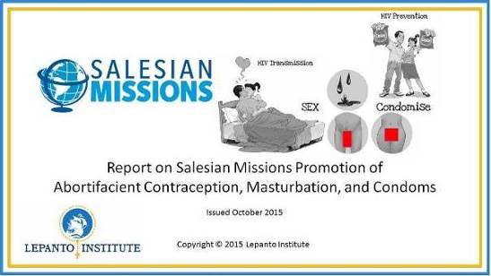

The Lepanto Institute was recently asked by a supporter if the Salesian Missions was a “safe charity” to donate to. Not knowing the answer, Lepanto Institute conducted an investigation of the Salesian Missions’ program called “Life Choices,” and discovered that this program is quite similar to just about anything Planned Parenthood [a pro-choice, pro-abortion organization] would publish.
The program recommends masturbation, encourages condom use, employs emotionally dangerous “role-play” exercises, promotes contraception (including abortifacients like the morning after pill), and even provides contact information for teens to acquire condoms and contraception.
According to the Salesian Missions’ website, over 375,000 kids have been exposed to this program.
Click here for the full report in PDF format: http://www.lepantoinstitute.org/wp-content/uploads/2015/10/Salesian-Missions.pdf (see some extracts on pages 7 through 9)
The Salesian Mission Office http://www.salesianmissions.org/about-us/mission-office, under the guidance of the Eastern USA and Canadian Salesian Province, seeks to provide for the material and spiritual needs of poor and abandoned individuals, especially the young. The Salesian Missions belong to the order started by St. John “Don” Bosco, the Society of St. Francis de Sales, commonly referred to as “Salesians http://www.salesianmissions.org/about-us/our-history. Given what has been discovered, imagine what St. John Bosco would think with the order he founded contributing, not to the sanctification of youth, as was his own mandate, but to their corruption with these immoral programs.
In 2007, PEPFAR [the President’s Emergency Plan for AIDS Relief] reported granting the Salesian Missions $56,599 for HIV prevention programs. Page 259 of this report (now NOT OPENING!) shows that the Salesian Missions were responsible for providing information on condom use.

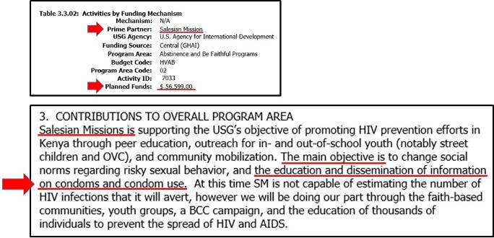

The Salesian Mission website verifies the implementation of the “Life Choices” program, focusing on reducing teen pregnancy, HIV/AIDS, substance abuse and violence, http://www.salesianmissions.org/our-work/country/south-africa.

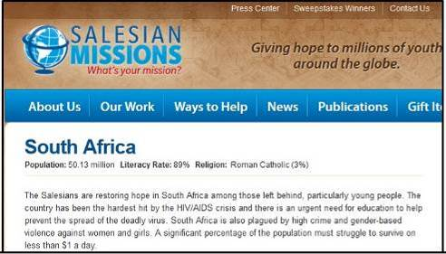

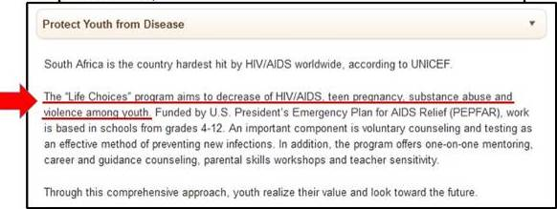

The Life Choices website for the Salesian Life Choices program in South Africa indicates that the Salesian Life Choices organization is operating “under the Salesian priests and brothers” http://www.lifechoices.co.za/news/wear-st-john-bosco-your-heart. In fact, one of the board members (Fr. Edmund O’Neill) is a Salesian priest who is also the “Property Administrator of the Archdiocese of Cape Town, South Africa,” http://www.lifechoices.co.za/meet-board.

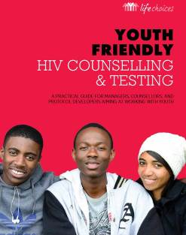

The following information will come directly from the Salesian Life Choices, “Youth Friendly HIV Counseling & Testing” manual. In this 65 page manual http://www.lepantoinstitute.org/wp-content/uploads/2015/10/LIFE-CHOICES-HTC-MANUAL-EMAIL1.pdf the word “condom” is mentioned 71 times, and always in promotion of condom use.
Page 9 of the Youth Friendly HIV Counseling and Testing manual makes the intention of the manual clear with regard to the promotion of condoms, saying that “it is crucial that counselors change the stigma around condom use.”
Page 36 calls on teens to “condomise,” which means to use a condom every time they have sex, including “anal, oral, vaginal, male-to-male, and female-to-female.” Note the word “choice” on the pictures of condoms. On the same page, a note says they encourage youth to use condoms, “not based on moral reasoning,” but “purely good sense.” It also encourages dental dams for oral sex and finger condoms for mutual masturbation.

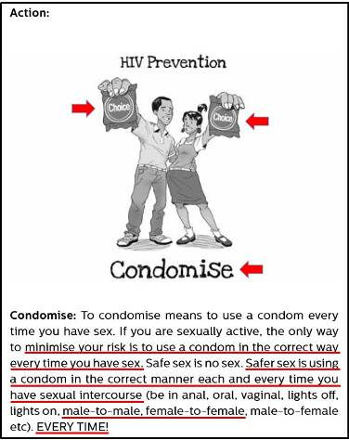

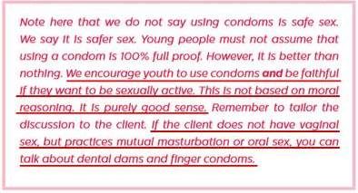

Page 37 explains that the Life Choices program includes condom demonstrations. The note goes so far as to instruct counsellors to inform teens where they can obtain condoms. There are many other references to condom use in this manual, but these examples suffice to show an immoral encouragement coming from an organization attached to a religious order.

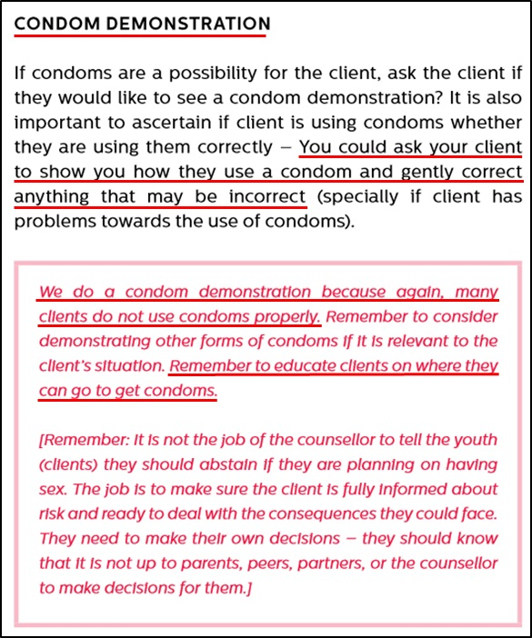

Now, we’ll switch to the Salesian Life Choices, “Dream 2 Be” manual for 9th grade peer-educators. In this manual, not only are condoms advocated for, but so also are abortifacient birth control pills, injectables, and the morning after pill. On page 16 is an extremely dangerous role-playing exercise where a 9th grade boy is paired with a 9th grade girl, and the two are supposed to have a discussion on whether or not to have sex, specifically stating that they should NOT discuss the morality of having sex outside of marriage. The danger in an exercise like this is that strong adolescent emotions will be evoked by this kind of role-play, potentially engaging immoral thoughts and out-of-class curiosity. But that’s not the worst of it.

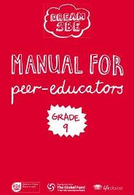

On page 17 (page 31 in the pdf) of Dream 2 Be http://www.lepantoinstitute.org/wp-content/uploads/2015/10/DREAM2B_MANUAL-_PEER_EDUCATORS_3-1.pdf, boys are encouraged to masturbate in order to satisfy sexual urges, and then to use condoms if they choose to have sex.

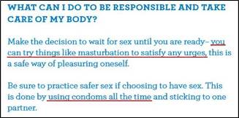

On page 18 (page 33 in the pdf), in a discussion about HIV/AIDS, is a near pornographic image and young teens are told to “use condoms at all times.”
There are many other serious problems with this manual, but these examples suffice to show the gravely immoral nature of this program.

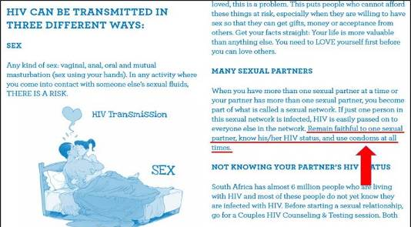

Foregoing Catholic moral teaching altogether, rather than telling these kids that sexual intercourse is an act designed by God to be reserved for marriage, page 19 tells young adolescents that they should wait to have sex until “they are ready.” It also encourages them to use contraception, including abortifacients like the birth control pill and injectable contraception along with a condom. It also tells them where they can get condoms and contraception, and even suggests obtaining abortifacient “emergency contraception” if they ever have “unprotected” sex.
On the next page are phone numbers indicating where to obtain contraceptives, including emergency contraception.
In addition to promoting contraception and abortifacients in their program manuals, The Salesian Life Choices program publishes a youth newsletter http://www.lifechoices.co.za/, distributing about 15,000 copies to targeted schools. Several of these newsletters include STRONG support for contraception, including abortifacients.
Salesian Life Choices’ Youth newsletter #1 includes a flow-chart illustrating that using a condom can help to avoid contracting HIV/AIDS.
Youth newsletter #3 warns that “unprotected sex” or sex without a condom, increases the risk of contracting HIV/AIDS.
Youth newsletter #4 has an entire article devoted to encouraging the use of all forms of contraception, including abortifacients.
The website of the Salesian Missions indicates that, with funding from USAID, it has exposed 375,000 to the Life Choices program http://www.salesianmissions.org/about-us/office-international-programs.

Conclusion
The project of the Salesian Missions called “Life Choices” is clearly not in line with Catholic moral teaching, however this report illustrates an even greater issue that merits further attention. It should be noted that the Salesian Life Choices program was only made possible through the donations from and partnerships with the U.S. Agency for International Development (USAID), the Centers for Disease Control (CDC), the President’s Emergency Plan for AIDS Relief (PEPFAR), and the Global Fund.
This isn’t the first time Catholic moral teaching has been compromised by Catholic aid agencies after receiving funds from organizations that promote contraception and abortion. Catholic Relief Services (CRS) has been caught time and again implementing programs against Catholic moral teaching through the funding of such organizations. After receiving funds from PEPFAR, CRS implemented a condom-promoting video series and a contraception-promoting curriculum in Kenya. In Rwanda, CRS tested a Planned Parenthood-style sex education program with funding from USAID. The problem is obvious: Funding from agencies intent on spreading immoral behaviors always come with a cost.
At this time, it is clearly not safe to contribute funds to the Salesian Missions until they divorce themselves from funding provided by government and immoral organizations. This report serves as further evidence that the mandate of Pope Benedict XVI in his 2012 motu proprio, On the Service of Charity, MUST be obeyed. Pope Benedict said that the “Bishop is to ensure that charitable agencies dependent upon him do not receive financial support from groups or institutions that pursue ends contrary to Church’s teaching.” Let us pray that Catholic aid agencies follow this mandate, providing for authentic charitable works that pew-sitting Catholics can be proud to fund.
This report has been sent to both the Salesian Order and the Salesian Missions six days prior to publication and no response was received.
Michael Hichborn is the president of the Lepanto Institute. Formerly, Michael spent nearly eight years as American Life League’s Director of the Defend the Faith project. He has researched and produced countless articles and reports on the funding of abortion, birth control, homosexuality and Marxism by Catholic Relief Services and the Catholic Campaign for Human Development (CCHD).

Selected comments (Many Catholics wrote that they have discontinued donating money to the Salesians)
1. I see the influence of the secular – humanist programs on the Salesians. Our culture has been inundated by that movement for decades and it has found fertile soil. May God help us all!
2. Evidently they have not read “Dreams and Visions of St John Bosco”.
3. God bless you, Lepanto, for speaking out the truth about their big lie.
I will be putting this exposé up on my Catholic web site www.ephesians-511.net in India.
As a Salesian-educated man, I have witnessed the Salesian downslide into secular humanism.
In our country they are the absolute leaders in promotion of New Age psychology in the Catholic Church, putting up institutions to practise and disseminate these false and dangerous pseudo-psychospiritual techniques all across the sub-continent.
Michael Prabhu, Catholic apologist, michaelprabhu@vsnl.net

Salesian Missions
http://www.lepantoinstitute.org/wp-content/uploads/2015/10/Salesian-Missions.pdf EXTRACTS
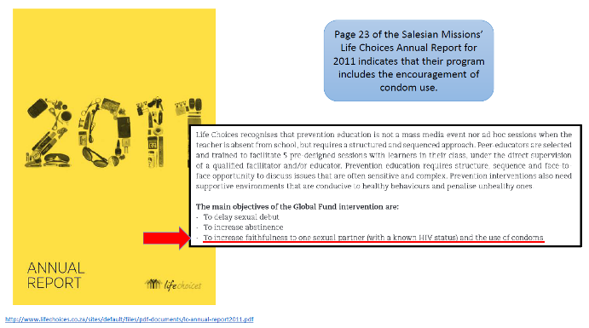
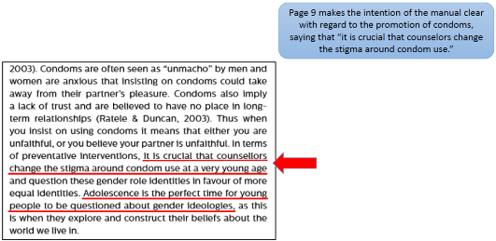

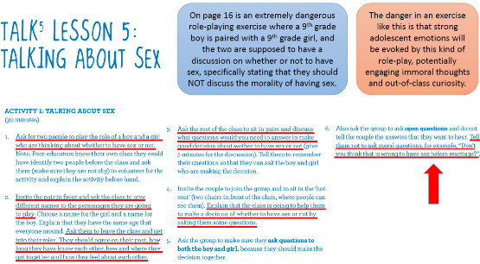

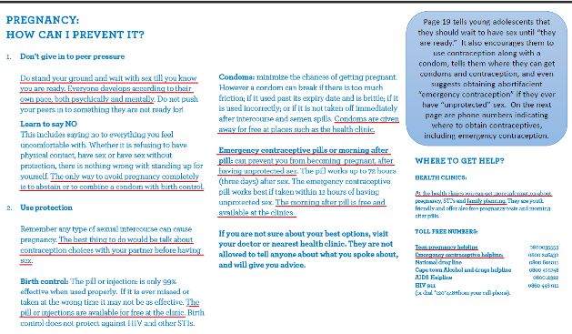

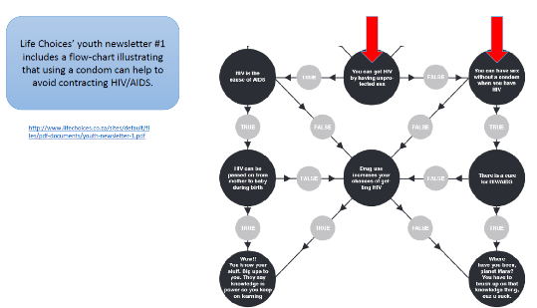

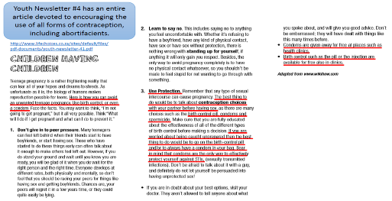

Conclusion
The project of the Salesian Missions called “Life Choices” is clearly not in line with Catholic moral teaching, however this report illustrates an even greater issue that merits further attention. It should be noted that the Life Choices program being implemented by the Salesians was only made possible through the donations from and partnerships with the U.S. Agency for International Development (USAID), the Centers for Disease Control (CDC), the President’s Emergency Plan for AIDS Relief (PEPFAR), and the Global Fund.
This isn’t the first time Catholic moral teaching has been compromised by Catholic aid agencies after receiving funds from organizations that promote contraception and abortion. Catholic Relief Services (CRS) has been caught time and again implementing programs against Catholic moral teaching through the funding of such organizations. After receiving funds from PEPFAR, CRS implemented a condom-promoting video series and a contraception-promoting curriculum in Kenya. In Rwanda, CRS tested a Planned Parenthood-style sex education program with funding from USAID. The problem is obvious: Funding from agencies intent on spreading immoral behaviors always come with a cost.
At this time, it is clearly not safe to contribute funds to the Salesian Missions until they divorce themselves from government and immoral organizations. This report serves as further evidence that the mandate of Pope Benedict XVI in his 2012 motu proprio, On the Service of Charity, MUST be obeyed. Pope Benedict said that the “Bishop is to ensure that charitable agencies dependent upon him do not receive financial support from groups or institutions that pursue ends contrary to Church’s teaching.” Let us pray that Catholic aid agencies follow this mandate, providing for authentic charitable works that pew-sitting Catholics can be proud to fund.
This report has been sent to both the Salesian Order and the Salesian Missions prior to publication, and no response was received.

Religious order founded by St. John Bosco pushes masturbation and condoms in sex ed program
https://www.lifesitenews.com/news/religious-order-founded-by-st.-john-bosco-pushes-masturbation-and-condoms-i
By Lisa Bourne, Washington D.C., November 2, 2015
The mission office of the religious order founded by St. John Bosco has a program in place that promotes immoral and risky sexual practices for South African youth similar to that of Planned Parenthood, a new report (pages 7-9) states.
The Salesian Missions’ “Life Choices” program endorses masturbation, uses emotionally unsafe role-play exercises for young people, promotes condom and contraception use, including abortifacients, and goes so far as to provide contact information for teens to obtain condoms and contraception, according to The Lepanto Institute.
The Salesian Missions are under the auspices of the Salesians, the Society of St Francis de Sales, a religious order founded by St. John Bosco. St. John Bosco’s vocation to the priesthood was based upon a dream he had at an early age that inspired him to save young men through their sanctification. Among the components of the Salesian Mission Office’s stated purpose, according to its website http://www.salesianmissions.org/about-us/mission-office, is to raise funds for its missionaries to assist poor youth and families in more than 130 countries, and to promote and encourage prayer and the principles of St. John Bosco, which are reason, kindness and religion.
Contraception, including condom use, is against the teaching of the Catholic Church, as is sexual activity outside the lifelong sacramental bond of matrimony between one man and one woman.
LifeSiteNews contacted the Salesian Mission Office for comment on the report via phone and email, and the office responded by requesting a regular mailing address to send a forthcoming statement. In its email reply, the Salesian Missions said the Lepanto Institute report made “false allegations” and made claims that have “absolutely no merit.”
LifeSiteNews provided a mailing address, but also requested an electronic copy of the statement, and communicated to the Salesian Missions Office that publishing deadline constraints would not accommodate the wait for a mailed statement, but received no further response.
LifeSiteNews later located a statement http://www.salesianmissions.org/statement on the Mission website from Salesian Missions Director Father Mark Hyde. (See pages 11, 12)
Without dealing with any specifics or naming the Lepanto Institute, Father Hyde’s statement said, “These claims are without merit, as with many other claims made by this organization.”
The statement went on to speak of the Mission’s allying with other Catholic organizations that have also been the object of “false claims” and “misleading attacks.”
The Salesian Mission statement addresses none of the charges, Lepanto Institute President Michael Hichborn told LifeSiteNews.
“The Salesian Missions' statement follows the same exact formula used by Catholic Relief Services, the Catholic Campaign for Human Development and other social justice organizations,” Hichborn said. “Deny any wrongdoing, assert a nebulous motive for these ‘attacks,’ completely fail to address the facts, and then talk about the good work they do.”
Hichborn said as well that it's completely incomprehensible for the Salesian Missions to claim that the allegations are false, when the information came from their own website and was verified by PEPFAR, USAID, and the Life Choices program in South Africa that they established.
“This is just another example of what happens to good organizations that take government money,” stated Hichborn. “If you take the king's coin, you will do the king's bidding. It's that simple.”
The Salesian Missions would have done better to have admitted fault and then promised to rectify the situation, he told LifeSiteNews, but they can't do that as long as they want to receive government funding.

“So now, the Salesian Missions has sullied the good works of the Salesian Order,” he continued, “and provided yet one more example of a corrupted Catholic charity that Catholics can't donate to in good conscience.”
Among the charges in the Lepanto Institute report is that the U.S. Governmental initiative PEPFAR (The U.S. President's Emergency Plan for AIDS Relief) gave the Salesian Missions a $56,599 grant in 2007 for HIV prevention programs in Kenya.
The 2007 PEPFAR grant to the Life Choices program resulted in the Salesian Missions providing information on condom use.
“Salesian Missions is supporting the USG objective of promoting HIV prevention efforts in Kenya …” the PEPFAR report states. “The main objective is to change social norms regarding risky sexual behavior, and the education and dissemination of information on condoms and condom use.”
The Salesian Missions’ Life Choices program also received funding from PEPFAR and USAID (U.S. Agency for International Development) for implementation in Kenya, Tanzania and South Africa.
The Lepanto report (see pages 1 through 6) details instances of condom promotion, explicit information on various sexual activities, and encouragement of contraception use in the Salesian Missions’ Life Choices program in South Africa, without mention of Catholic teaching on sexuality or marriage.
Hichborn told LifeSiteNews since the report was issued he has discovered additional information showing that the Salesian Life Choices program actually distributed more than 100,000 condoms in 2008.
The Salesian Mission website confirms its implementation of the Life Choices program in South Africa http://www.salesianmissions.org/our-work/country/south-africa, and the website http://www.lifechoices.co.za/news/wear-st-john-bosco-your-heart for the Salesian Life Choices program in South Africa shows that the Salesian Life Choices organization is operating “under the Salesian priests and brothers.”
The Salesian Missions website http://www.salesianmissions.org/about-us/office-international-programs states as well that with the USAID funding it has subjected 375,000 youth to the Life Choices program.
Hichborn told LifeSiteNews he inquired with the Salesian Mission Office, sharing the report and asking for a response, five days prior to his publishing it.
However, in lieu of responding to him they took other action. “The access to the manuals on the Salesian Life Choices in South Africa website suddenly became inaccessible after I published the report,” Hichborn said. “This falls under the old saying that ‘only the guilty run from the law.’”
The fact that the Salesian Life Choices office in South Africa immediately closed down a key portion of its website once his report was published, speaks volumes, Hichborn told LifeSiteNews.
“Rather than responding to me or the evidence, the Salesian Missions decided instead to issue a blanket denial,” he said. “It would have been better for them to respond to me to clarify matters before the report was published.”
“The Salesian Missions must answer the charges,” said Hichborn. “They have an obligation to either prove the information wrong, or admit fault and make restitution.”
He encouraged Catholics to pray and fast for the Salesians, and to consider contacting the Salesian Missions and the Salesian Order.
Contact:
Salesian Missions
2 Lefevre Lane
New Rochelle, NY 10801-5710
Phone: 914.633.8344
Fax: 914.633.7404
info@salesianmissions.org
Salesian Society
148 E. Main St. – PO Box 639
New Rochelle, NY 10802-0639
914-636-4225
sdbsue@aol.com
Salesian Society of Canada
11991 Pierre Baillargeon Street
Montreal Québec H1E 2E5
514-648-4348
richardsylc@hotmail.com

Salesian Missions Promote Masturbation, Contraception
http://www.onepeterfive.com/salesian-missions-promote-masturbation-contraception/
November 12, 2015
Editor’s note: this report originally appeared at the website of the Lepanto Institute [as on pages 1 through 6]. We have agreed to republish it to assist in sharing information about this important story.
UPDATE: The Salesian Missions have responded with a categorical denial, even in the face of irrefutable evidence.
You can read the response of the Lepanto Institute here (see page 13).
Readers’ comments
There were 53 comments to the OnePeterFive post, and most of them were from persons who have left the Catholic Faith due to the steep deterioration of morals, doctrine and Tradition under Pope Francis.

The Salesians (which incidentally is the second largest religious order in the Catholic Church) denied all charges against them (and so did Catholic Relief Services) despite the preponderous evidence:
1. Statement from Salesian Missions
http://www.salesianmissions.org/statement
This is intended to be a response to donors who may be concerned about accusations against Salesian Missions that have appeared online. These attacks are malicious in nature and contain absurd information.
Unfortunately, anyone can publish anything on the Internet and there is little recourse when something is not accurate. Therefore, we all have to exercise caution to try and determine what is legitimate and what is not. We are thankful for this opportunity to clarify things.
Please be assured that the program in question is in line with Catholic teachings, as are all Salesian programs around the globe. (Emphasis theirs)
Salesian missionaries do operate an NGO in Cape Town, South Africa called Life Choices. Salesian Missions is a separate U.S.-based nonprofit organization that raises funds and secures grant funding for Salesian-run programs around the globe. In 2005, the Salesian Missions Office for International Programs began working to help secure funding for Life Choices from the U.S. President’s Emergency Plan for AIDS Relief (PEPFAR). This is the limit to the connection between Life Choices and Salesian Missions. No donor contributions have ever been distributed to this program.
As the HIV/AIDS spread to epic proportions, the South African government invited the Salesians to participate in prevention programs. The reason their inclusion was sought was because of their proven model of abstinence education. Without the involvement of the Salesians, it is quite possible that this message would not have been made available to young people. However, the “reports” that have been attacking Life Choices do not capture the true nature of the program. They also contain fabrications such as placing a Salesian Missions logo where it does not belong—which is not only deceitful but violates trademark law.
The information presented in both the so-called “reports" and the subsequent online articles is misleading and contain serious inaccuracies. One error was caused by a data defect in a 7-year-old government document cited by the critic. Life Choices never distributed condoms. The number on the table in question is actually the number of youth who received abstinence education. Here is a letter from the Human Sciences Research Council in South Africa (who authored the government document) indicating it was a data entry error and apologizing for the harm it has caused.
The intent of the critic seems to be to alarm rather than inform. As a result, the Life Choices program is purposely mischaracterized to fabricate a scandal. For example, there are also a number of instances where the critic’s report states a behavior is being “promoted” in an educational material or training manual, when in fact it simply states a medical or other fact from a third-party source. For counselors working with at-risk populations in a country that has been hardest hit by HIV/AIDS, this information is not only essential, but a matter of life or death. They work with young people to encourage them to make better decisions. The goal is to move them toward morality and abstinence, which is the best line of defense against contracting the horrifying disease plaguing their country. To carry out this work effectively, these counselors must first gain the trust of the youth, which means listening and talking about a variety of concerns they may have. This educational approach not only conforms with Catholic ethos, but is also in line with the true spirit of our founder St. John “Don” Bosco—with its focus on reason, religion and loving kindness.
The critic’s reports use content from a specific training manual to launch attacks against the Salesians. The curriculum in this manual was developed by the Center for the Support of Peer-Education, an institution linked to Harvard University. This manual itself belongs is a product of the Department of Health, Global Fund and 14 other service providers (NGOs). Between 2011 and 2012, Salesian Life Choices became the abstinence partner for this initiative. The training manual was then customized by the Life Choices program, to make sure it was in adherence with not only their approach but also Catholic teachings. In light of concerns, the content of the manual as well as all other program collateral is being carefully reviewed and edited (if deemed necessary) to prevent future misunderstandings.
These are only some examples of how the online attacks against the Salesians are full of inaccuracies and exaggerations.
We are not alone in our concern over the matter. The U.S. Conference of Catholic Bishops published a warning about the group behind these attacks. The statement included:
"We want to make it clear that those making these public critiques, albeit, we hope, in good faith, do not speak for the Catholic Church and we advise the Catholic faithful to exercise caution … before endorsing or giving credence to the groups' critiques.”
The full statement can be found on the U.S. Conference on Catholic Bishops website.
Additionally, here are two examples of articles from trustworthy Catholic news sources* that also expressed concern:
National Catholic Reporter*: Bishops Must Respond to Attacks (http://ncronline.org/blogs/distinctly-catholic/bishops-must-respond-attacks-crs-cchd-ccusa)
American Magazine** (American Catholic Review): When the righteous attack (http://americamagazine.org/content/all-things/when-righteous-attack)
We join with these concerns and warn our benefactors to use caution when making donations or reviewing information presented on the Internet. Bishops Must Respond to Attacks
We urge our donors to be very vigilant and always make sure an organization is an accredited source of news and information and, when donations are involved, to make sure they are legitimate nonprofit organization. We are informing our donors that Guidestar.org is a great source to research the legitimacy of an organization’s nonprofit status. To research Catholic news sites, the Catholic Press Association member lists an excellent resource.
*The National Catholic Reporter (NCR) is NOT trustworthy. It is not even Catholic. It is an anti-life publication

**Was the error intentional? Because it is not “American” but “America” magazine, a heretical, dissenting Jesuit left-wing publication which, like NCR, is also anti-life, pro-women’s ordination pro-LGBT, etc.
Both NCR and America have regularly been in the news for all the wrong reasons, disciplined by their local ordinaries and by Rome (Pope Benedict XVI). And Salesian Missions appeals to them for vindication?!
Their opinions are not worth the paper on which they are printed! By the way, the NCR article is of August 2013 and the America one of July 2012 and have no bearing on the present Salesian Missions controversy.
NATIONAL CATHOLIC REPORTER CONDEMNED BY BISHOPS
http://ephesians-511.net/docs/NATIONAL_CATHOLIC_REPORTER_CONDEMNED_BY_BISHOPS.doc
CRITICISM OF THIS MINISTRY BY THE NATIONAL CATHOLIC REPORTER
http://ephesians-511.net/docs/CRITICISM_OF_THIS_MINISTRY_BY_THE_NATIONAL_CATHOLIC_REPORTER.doc

SPECIAL MESSAGE FROM OUR DIRECTOR
Salesian Missions takes any concerns about its work seriously, including that which questions our commitment to working in accord with Catholic teaching. Our Catholic identity is the heart of our mission work, and we are committed to ensuring that the programs we support are faithful to the teachings and morals of the Church as well as the vision of our founder, St. John (Don) Bosco. Allegations that programs we support are not in adherence with this are investigated. Salesian Missions has concluded these claims are without merit, as with many other claims made by this organization.
Salesian Missions is not alone in being the target of false claims from “reports” published by critics with a sole purpose to launch misleading attacks. We join the Vatican and other respected Catholic organizations who, like us, have been attacked in this manner — and who, like us, are tirelessly dedicated to doing work that helps people in need. We join them in standing up to ongoing false allegations that seek to damage our work.
While it is important that we respond in some way, it is more important that we not let our energy and focus be compromised, because it is needed elsewhere. The work that is done by more than 30,000 Salesian missionaries around the globe saves lives and provides hope to millions of children in some of the poorest places on the planet. We are saddened that any attempts would be made to attack the work being done by not only these missionaries but thousands of local staff, in places like Africa which is plagued with unrest and disease. These brave people work alongside Salesians often risking their own lives to help those in need. While they work to protect children and families, we will work to protect them so that their work may continue.
Salesian Missions remains committed to supporting the tireless work of Salesian missionaries in more than 130 countries, while continuing to ensure that the work is in line with Catholic teachings and morals. We invite you to explore our website to learn more about this inspirational work.
We are thankful to our dedicated supporters who believe in our work, as it truly makes life better for some of the world’s poorest and neediest children and families. We are one of the founding members of the National Catholic Development Conference (NCDC) and we are also proud to have a Gold level in the Guidestar Exchange, one of the leading online sources for trustworthy information about nonprofits.
Be assured of my prayers and kindly keep us in your prayers during this difficult time.
Sincerely yours,
Father Mark Hyde, S.D.B.
Director, Salesian Missions
Fr. Hyde only seems to be concerned about the loss of donors to the Salesian Missions because of the exposé.

2. Catholic Salesian Missions affirms pro-abstinence stance in HIV/AIDS education
Says claims that it distributed condoms ‘absurd’ and ‘malicious’
http://www.washingtontimes.com/news/2015/nov/11/catholic-salesian-missions-affirms-pro-abstinence-/?page=all
By Cheryl Wetzstein, November 11, 2015
An international Catholic charity has affirmed its dedication to abstinence education in HIV/AIDS prevention, noting that recent claims about it distributing condoms are “absurd” and “malicious.”
Salesian Life Choices was invited by the South African government to participate in an HIV/AIDS prevention program because of its “proven model of abstinence education,” the service organization said in a statement to donors posted on its website Wednesday.
The recent online attacks on Salesian Missions “are malicious in nature and contain absurd information,” the statement said.
The Salesian Missions statement was in response to two critical reports released in recent weeks by a Virginia-based research group called Lepanto Institute for the Restoration of All Things in Christ.
One report faulted Salesian Missions for condom distribution while the other criticized use of a program that urged youth to use birth control and engage in safer-sex activities.
In response to the claim about condom distribution, the Salesian Missions statement said that a 2008 South African government report — which indicated Salesian Missions distributed more than 100,000 condoms to South African youth — contained a significant “data entry error.”
“The number on the table in question is actually the number of youth who received abstinence education,” Salesian Missions said.

The mission group, which cares for at-risk children and families in 130 countries, posted a letter from a South African program official, who explained the error and apologized to Salesian Missions for any “harm caused by our misrepresentation in the report.”
In Lepanto Institute’s other report, it focused on a Life Choices training manual, which was written by international health and nongovernmental agencies and used by Salesian Missions. This manual appeared to promote contraception and other activities deemed immoral in Catholic teaching.
However, the Lepanto report did not mention that when Life Choices was used in Salesian programs, it was “customized” to “make sure it was in adherence with not only their [the authors’] approach but also Catholic teachings,” the mission statement said.
Salesian Missions, which is part of the Don Bosco Network and Salesians of Don Bosco, the second largest order in the Roman Catholic Church, ended its statement by urging its donors to exercise caution about Catholic groups that make public critiques about other Catholic groups — but do not speak for the Catholic church.
Michael Hichborn, president of Lepanto Institute — which says it monitors Catholic organizations to find “those who have sold out to the world” — said Wednesday the “manuals indeed promote immoral activities.”
“If they don’t want to be connected to the stuff we found in the manuals they claim to have ‘customized,’ like telling boys to masturbate in order to satisfy sexual urges, then they need to stay away from government funding. It’s that simple,” Mr. Hichborn said in a statement to The Washington Times.
He called an earlier response by Father Mark Hyde, director of Salesian Missions, to the first report “unfortunate and disappointing.”
Some people who saw the Lepanto reports on the institute’s website and left a comment said they were so alarmed by the documents, they planned on ending their donations to Salesian Missions.
Mr. Hichborn has said he is preparing a list of Catholic mission groups that he believes have remained faithful to the church and its teachings.
Earlier this year, Lepanto Institute and another organization issued a report critical of Catholic Relief Services’ HIV-prevention activities with children and teens in Africa; that report claimed the relief charity was promoting contraception use.
Catholic Relief Services (CRS) rejected those claims as “misleading, exaggerated and untrue,” and on Wednesday, its chairman, Archbishop Paul S. Coakley of Oklahoma City, reiterated their view that Catholics would be wise to reserve judgment when they hear critical reports about mission activities.
“Catholic Relief Services helps 100 million people in 93 countries each year, so it is disappointing and disturbing that this fund-raising group continues to mislead the faithful in an attempt to breed discontent and distract from the wonderful work Catholics are accomplishing around the world​,” Archbishop Coakley said in a statement to The Washington Times.
​”As the Administrative Committee of the U.S. Conference of Catholic Bishops said in 2013, these groups ‘do not speak for the Catholic Church​​ and we advise the Catholic faithful to exercise caution and consult the CRS website for clarification before endorsing or giving credence to the groups’ critiques.’
​”​We stand by this counsel” the archbishop said.

Another religious order to avoid
https://veneremurcernui.wordpress.com/2015/11/04/another-religious-order-to-avoid-salesian-missions/ TRADITIONALIST

Salesian Missions Distributed Over 100,000 Condoms
http://www.lepantoinstitute.org/faith-and-life/salesian-missions-distributed-over-100000-condoms-2/
By Michael Hichborn, November 10, 2015. All emphases theirs except where indicated as mine
A week ago, the Lepanto Institute published a report showing that the Salesian Missions received federal funding for the implementation of a program called Life Choices. A few days later, the Salesian Missions published a statement (pages 11, 12) denying the entire report without addressing any of the facts. (My emphasis :) The statement reads as if it was lifted from the Catholic Relief Services “denial of wrong-doing playbook,” as it follows the same model:
1) Declare that they take all concerns seriously
2) Deny any wrongdoing without addressing the facts
3) Accuse the reporting party of malicious intent
4) Fill the page with the organization’s good works. In part, the Salesian Missions statement says (our comments in red):
Allegations that programs we support are not in adherence with this are investigated. Salesian Missions has concluded these claims are without merit, as with many other claims made by this organization. (If the claims are without merit, then the Salesian Missions should have no problem illustrating how the information contained in the report is false.)
Salesian Missions is not alone in being the target of false claims from “reports” published by critics with a sole purpose to launch misleading attacks. (Still no actual rebuttal. Please explain where the report is either false or misleading) We join the Vatican and other respected Catholic organizations who, like us, have been attacked in this manner — and who, like us, are tirelessly dedicated to doing work that helps people in need. We join them in standing up to ongoing false allegations that seek to damage our work.

While it is important that we respond in some way, it is more important that we not let our energy and focus be compromised, because it is needed elsewhere. (In other words, “we’re not going to address the facts in the report.”) The work that is done by more than 30,000 Salesian missionaries around the globe saves lives and provides hope to millions of children in some of the poorest places on the planet. We are saddened that any attempts would be made to attack the work being done by not only these missionaries but thousands of local staff, in places like Africa which is plagued with unrest and disease.
In addition to this statement, after ChurchMilitant.com republished our initial report, the Salesian Missions Newswire service asked Google to suppress the story in their search rankings. The Salesian Missions Newswire did the same thing after Life Site News published an article on the same story, calling Life Site News a “pseudo news site” and our report an “inaccurate ‘news’ story tied to a group that is known for issuing false reports.”

Let’s review the facts of the report:
Documents from both USAID (page 72 of this document) and PEPFAR (page 259 of this document) show that the Salesian Missions received government funding, beginning in 2005, in order to implement the Life Choices program.
USAID and PEPFAR both indicate that the money received by the Salesian Missions included the promotion of condom use.
The Salesian Missions website confirms the reception of USAID and PEPFAR funding for the implementation of the life choices program in Kenya, South Africa, and Tanzania.
Documents obtained from the Salesian Life Choices program in South Africa (Youth Friendly HIV Counseling and Testing manual and Manual for Peer-Educators Grade 9) all include promotion of condom use and more.
The Salesian Life Choices for South Africa website indicates that it was started in 2005 by the Salesian Order through grants from PEPFAR and USAID.
The Salesian Life Choices organization shares the same address (312 Imam Haron Road) as Our Lady Help of Christians parish, which is operated by the Salesians.
The youth newsletters produced through the Salesian Life Choices program include the promotion of condoms and abortifacient contraception. In fact, some of the same exact language used to promote all forms of contraception in youth newsletter #4’s article titled, “Children Having Children” is found on page 19 of the Manual for Peer-Educators Grade 9.
In order for the statement by the Salesian Missions to be true, then the USAID and PEPFAR documents which indicate that Life Choices included condom promotion must be false. Furthermore, the manuals listed on the Salesian Life Choices website must be false, and the newsletters produced by children going through the Salesian Life Choices program must also be false. But there’s more to this story which was not included in the initial report.
After the first report on the Salesian Missions was published last week, the Salesian Life Choices website closed public access to the program manuals we cited. Here is what the resources page looked like prior to publication of our report:

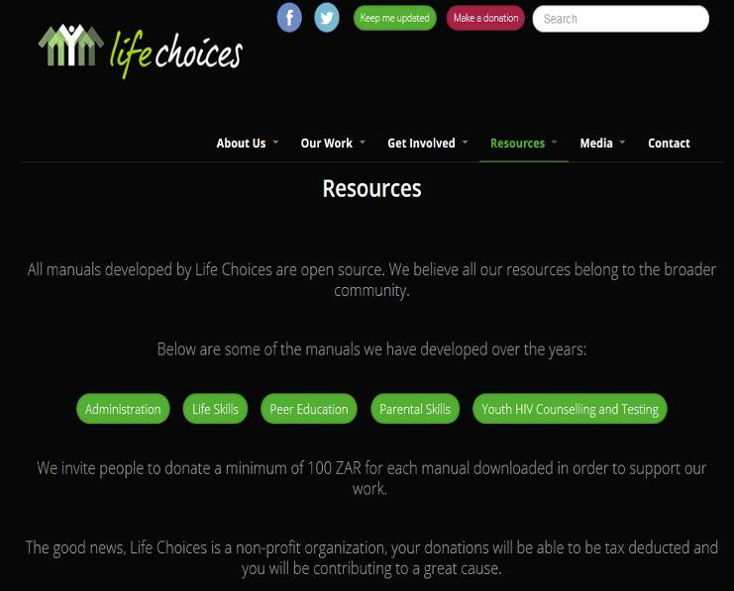

And here is what the resources page looks like now:

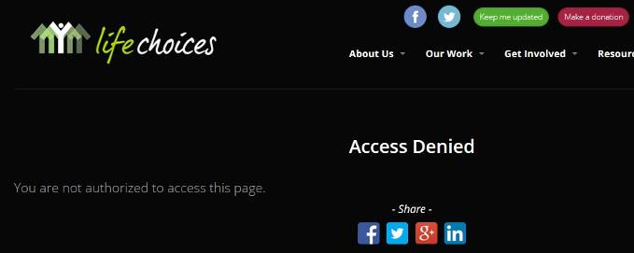

(My emphasis :) Just as a note, if the Salesian Missions is innocent of the facts we have presented, then there should be no need to hide the information mentioned in our report. But attempting to cover-up the facts we’ve previously presented isn’t even the worst of it.
The Salesian Life Choices program distributed over 100,000 condoms to kids in 2008!
In March of 2010, a document titled, “KNOW YOUR HIV PREVENTION RESPONSE (KYR) ANALYSIS REPORT FOR COMPONENT 3: WESTERN CAPE PROVINCIAL REPORT” was published by several government agencies. The acknowledgements section on page four of this document gives a “special thank you” to the non-profit and non-government organizations that provided researchers with the requested information:
This review of HIV prevention policies and programmes was researched and compiled by a team of researchers from the Human Sciences Research Council (HSRC) and Health Policy Initiative (HPI), under the guidance and direction of the United Nations AIDS Programmes (UNAIDS), the World Bank and the South African National AIDS Council (SANAC). Acknowledgement is also expressed to programme implementers who provided participated in the national workshop in providing relevant contact details of HIV programmes and interventions in the nine provinces. To the government departments and the non-profit organisations, private and non-governmental organisations in the Western Cape, a special thank you is extended to these organisations for providing the researchers with the necessary information requested.
This is to say that all statistics and organization-based information was provided directly by the organization sited in the document. Page 14 of the document verifies this fact. Page 14 provides a table of organizations that participated in the study, and the years for which data was collected. The table includes Salesian Life Choices and gives data for years 2006, 2007, and 2008.

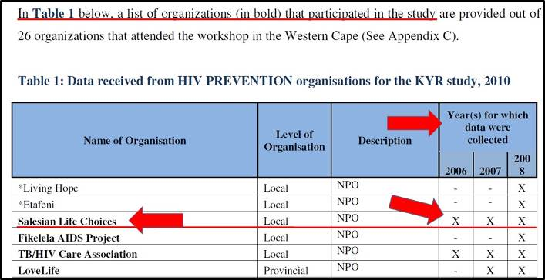

On the same page, the document indicates that the information collected from the Salesian Life Choices came in the form of both worksheets and annual reports:
“Besides the worksheets that were completed, organizations also submitted annual reports where additional data was extracted by the researchers for the purpose of the study.”
This is all important to establish because this shows that the information indicated in this report came directly from the organizational source. In short, what this report says about the Salesian Missions came directly from the Salesian Missions itself.
Page 24 of the report gives a chart for the number of condoms that were distributed to children age 15-19 for the year 2008. The chart indicates that the Salesian Life Choices was responsible for nearly half of all condoms distributed to children that year, and then says, “For the year 2008, Salesian Life Choices distributed 114,546 condoms to in-school youth.”

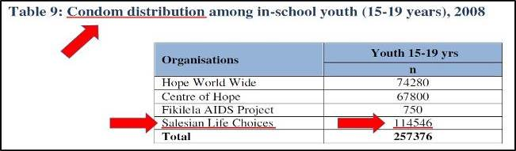

The next chart on the same page shows that Salesian Life Choices distributed hundreds of condoms to “Most-At-Risk-Populations” (people in prisons and young women 20-24 years old).

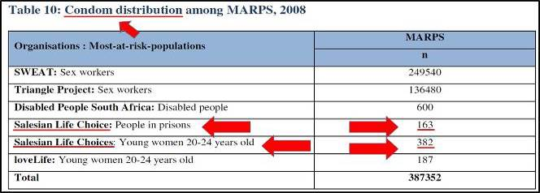

Page 55 of this document is the beginning of Appendix D, “Summary of Partner Activities in Western Cape PEPFAR (US President’s Emergency Plan for AIDS Relief Activities in Western Cape Province, FY 2009). Under this appendix, on page 67, the entry “Salesian Missions” is an explanation of the Life Choices program, including this statement:
“Life Choices also run programs with the stakeholders in their lives – teachers and parents. Each year Life Choices chooses different themes in order to ensure that youth aged 10 -14 delay sexual debut, older youth 15 -24 practice secondary abstinence and those who are sexually active stay faithful to one partner, know their HIV status and are given full information on consistent and correct use of condoms.”
And just in case this information isn’t enough to confirm the condom-promoting elements of the Salesian life Choices program founded by the Salesian Missions in South Africa, this video from 2006 should remove all doubt.

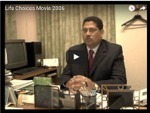

This video was produced by the Salesian Life Choices program, and at the very end of the video is this screen which says, “A project of the Salesians of Don Bosco,” while accompanying the logo of the Salesian Order. At 3 minutes and 3 seconds in the video, the camera pans down a list of risky behaviors, and included in the list is “sex without a condom.” Here is a side-by-side look at what will be seen in the video:

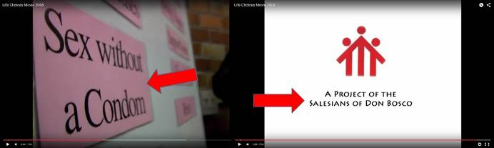

Just to be clear, this is a video produced by Salesian Life Choices, hosted on Salesian Life Choices own YouTube channel, reinforcing the fact that condom promotion is indeed a factor in the Salesian Life Choices program, which was implemented by the Salesian Missions.

Conclusion
The statement from the Salesian Missions is both unfortunate and disappointing. It would have been much better for the Salesian Missions to have carefully examined the facts as we have discovered and presented them and responded to our email prior to publication. It would have been best if the Salesian Missions had expressed the same kind of concern we’ve had regarding this information, followed by a promise to immediately rectify the matter. Instead, the reaction was to deny the facts and then attempt to bury the report.
(My emphasis :) The denial statement issued by Fr. Mark Hyde, director of the Salesian Missions is completely inadequate. More seriously, in the face of the facts, the denials simply aren’t even plausible.
It is very important that this information reach the Rector Major of the Salesian Order. Contact the Office of the Rector Major:
Fr. Horacio Lopez hlopez@sdb.org
Fr. Antonino Zingale azingale@sdb.org

Selected comments (Many Catholics wrote that they have discontinued donating money to the Salesians)
1. I received a two page letter from them similar to the response you published. I had given them many thousands of dollars over the last few years. Sad to see them, Coraid of Netherlands and CRS go so far away from the faith. Government money corrupts even alleged Catholic agencies. No more money for them ever again.
How sad to see them engage in such denial and snide comments about faithful groups. A sad day for the faithful who gave the money in good faith for use by poor people.
2. Well, you are right, they promote contraception and the use of condoms. But it is much worse: it give full sexual lessons (the manual); and neither of the documents of these missionaries name Jesus, or God. The “manual” says “christian” once. It is outrageous. I only spent 10 minutes reviewing it, and ended up disgusted: it was enough…
3. If you go to the Life Choices YouTube channel, you can see that currently posted videos (some from 2006) were added to the site in December 2013 and they are still up. The fact that the head of the Salesians does not prove the charges are wrong seems pretty damning.
4. A few weeks ago we got an appeal letter from Salesian Missions with some Christmas cards enclosed. We were going to use the cards until we saw this report. I have since shredded the cards and will not donate to the organization.
5. I received a letter from the Salesians saying they did not do anything wrong….it sure looks like they lied.
6. Michael Hichborn: If they did nothing wrong, it should be pretty easy to explain away the information that was presented. The fact that they refuse to address even one of the facts in these reports speaks volumes.
7. Thank you for exposing more impostors in our Church, pretending to be Catholic clergy, while “doing un-Catholic things.” They must be- all of them – confronted, flushed out and driven out. We have scores of them in Detroit. They are actually a global plague right now. Now that they have their buddies/comrades, like Kasper and others, in high places they are crawling out from the woodwork.

Salesian Missions, CRS Defend Evil Program
http://www.lepantoinstitute.org/catholic-relief-services/salesian-missions-crs-defend-evil-program/
By Michael Hichborn, November 12, 2015. All emphases theirs

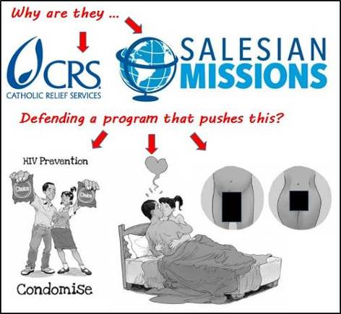

Salesian Missions has called our reports a “malicious attack” that contain “absurd information.” One would not see from reading this statement that we tried to reach out to them six days before releasing our report to try to start a conversation about our findings before going public; and that all of the information presented – which we agree is absurd, or worse – was taken from their own and their partners’ documents. In fact, the Life Choices documents in question were removed from the program’s web site without acknowledging this in their statement.
We won’t enter into the character assassination that the Salesians and, very sadly, Archbishop Paul Coakley, have leveled upon us. As most will recognize, this is a distraction, and intentionally so, in addition to being unjust. The Salesians have accused us of publishing reports that contain “serious inaccuracies,” yet the only attempt they make to justify this slander is by pointing to a “data entry error” of their partner’s doing. Since we tried to reach them privately before publication, how can they blame us for this confusion? More importantly – that is some error!
Yesterday’s statement by the Salesian Missions, defending the Life Choices program, says that the program … as written … “conforms with Catholic ethos” and is “in line with the true spirit of our founder St. John “Don” Bosco.” To claim such a thing is not only perverse, it is evil, and anyone paying attention knows why!
What follows is the full statement issued by the Salesian Missions, with my comments in red:

This is intended to be a response to donors who may be concerned about accusations against Salesian Missions that have appeared online. These attacks are malicious in nature and contain absurd information. If our intentions were malicious, we wouldn’t have given the Salesian Missions six days to look over our information and respond before publishing. Furthermore, the information came directly from original sources, so if the information is absurd, then so is the source.)
Unfortunately, anyone can publish anything on the Internet and there is little recourse when something is not accurate. Therefore, we all have to exercise caution to try and determine what is legitimate and what is not. We are thankful for this opportunity to clarify things.
Please be assured that the program in question is in line with Catholic teachings, as are all Salesian programs around the globe. (So, the program manuals, the youth newsletters, and the Salesian Life Choices video from 2006 … all of which promote condoms … are in line with Church teaching?)
Salesian missionaries do operate an NGO in Cape Town, South Africa called Life Choices. Salesian Missions is a separate U.S.-based nonprofit organization that raises funds and secures grant funding for Salesian-run programs around the globe. In 2005, the Salesian Missions Office for International Programs began working to help secure funding for Life Choices from the U.S. President’s Emergency Plan for AIDS Relief (PEPFAR). This is the limit to the connection between Life Choices and Salesian Missions. No donor contributions have ever been distributed to this program. (PEPFAR paid them to implement the program. Therefore, they are responsible for what the program does. They took money to implement it, they own it.)

As the HIV/AIDS spread to epic proportions, the South African government invited the Salesians to participate in prevention programs. The reason their inclusion was sought was because of their proven model of abstinence education. Without the involvement of the Salesians, it is quite possible that this message would not have been made available to young people. However, the “reports” that have been attacking Life Choices do not capture the true nature of the program. They also contain fabrications such as placing a Salesian Missions logo where it does not belong—which is not only deceitful but violates trademark law. (Apparently, the Salesian Missions is unfamiliar with “Fair Use” law. The logo was inserted in the opening image in order to make a point about the article being written. But more to the point, there was nothing fabricated in the reports. Everything came from original source documents and links were provided to show the original sources in full context.)
The information presented in both the so-called “reports” and the subsequent online articles is misleading and contain serious inaccuracies. (What, exactly, is misleading or inaccurate about faithful Catholics being concerned about program manuals being used by ostensibly Catholic institutions that push condom use and masturbation on teens?) One error was caused by a data defect in a 7-year-old government document cited by the critic. Life Choices never distributed condoms. The number on the table in question is actually the number of youth who received abstinence education. Here is a letter from the Human Sciences Research Council in South Africa (who authored the government document) indicating it was a data entry error and apologizing for the harm it has caused. (The convenience of this mistake brings to mind the convenient “mistake” PEPFAR allegedly made regarding Catholic Relief Services‘ contraception-promoting program in Kenya called Healthy Choices 2. However, even if we grant that there truly was a mistake, it was on the part of the Human Sciences Research Council, not the Lepanto Institute. Again, the Salesian Missions had the opportunity to discuss this in private and clarify matters, but they chose not to respond to the information we sent them in private.)
The intent of the critic seems to be to alarm rather than inform. (Again, if that was our intent, we would not have gone to them in private six days before publishing) As a result, the Life Choices program is purposely mischaracterized to fabricate a scandal. (“Mischaracterized?”) For example, there are also a number of instances where the critic’s report states a behavior is being “promoted” in an educational material or training manual, when in fact it simply states a medical or other fact from a third-party source. (Seriously?! First of all, the Salesian Life Choices website is not a third party source. That is where the manual came from. Secondly, immoral behaviors are most definitely being “promoted” in the material, and they are NOT medical “facts.” Here, it is appropriate to remind readers of what the Salesian missions is claiming is not promoted, but is mere medical fact.

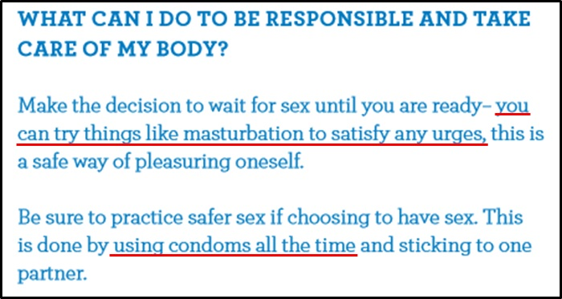

Telling young boys that they can “try masturbating to satisfy any urges” and to “be sure to practice safer sex” by “using condoms all the time” is most definitely “promotion” of immoral behavior, and it is certainly not “medical fact.”

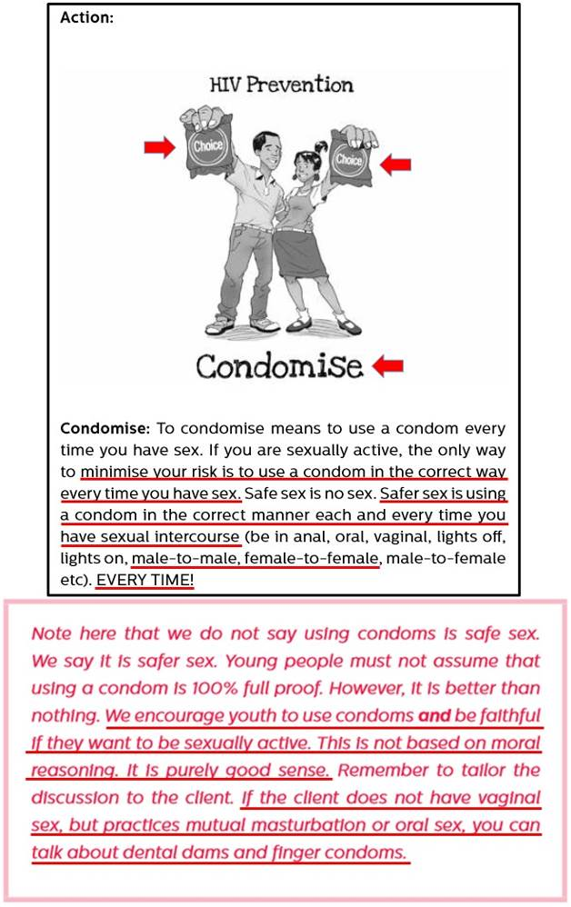

The manual explicitly states, “We encourage youth to use condoms” under the … *ahem* …”medical term” “Condomize!” That is the very definition of promotion!
Continuing with the Salesian Missions statement …)
For counselors working with at-risk populations in a country that has been hardest hit by HIV/AIDS, this information is not only essential, but a matter of life or death. (Telling boys to try masturbating and giving condom demonstrations is a matter of life or death? Ok, the death of the soul, perhaps …) They work with young people to encourage them to make better decisions. (Like masturbate and use condoms?) The goal is to move them toward morality and abstinence (???), which is the best line of defense against contracting the horrifying disease plaguing their country. To carry out this work effectively, these counselors must first gain the trust of the youth, which means listening and talking about a variety of concerns they may have. This educational approach not only conforms with Catholic ethos, but is also in line with the true spirit of our founder St. John “Don” Bosco—with its focus on reason, religion and loving kindness. (Woe to those who call evil good and good evil!)
The critic’s reports use content from a specific training manual to launch attacks against the Salesians. The curriculum in this manual was developed by the Center for the Support of Peer-Education, an institution linked to Harvard University. This manual itself belongs is a product of the Department of Health, Global Fund and 14 other service providers (NGOs). Between 2011 and 2012, Salesian Life Choices became the abstinence partner for this initiative. The training manual was then customized by the Life Choices program, to make sure it was in adherence with not only their approach but also Catholic teachings. (I’d really hate to see what it looked like before the manual was “customized”! Since when is telling kids where they can obtain emergency contraception in line with Catholic teaching?) In light of concerns, the content of the manual as well as all other program collateral is being carefully reviewed and edited (if deemed necessary) to prevent future misunderstandings. (But … you just said that the whole thing was “customized” to bring it in line with Catholic teaching. What good is this “review” going to do for the 375,000 kids the Salesian Missions claims credit for exposing to this program? Furthermore, what about the 15,000 kids that received the Youth Newsletters that were published by the Salesian Life Choices program that echoed the manual’s promotion of abortifacient contraception and condom use? Did those kids “misunderstand” the information contained in the manuals as well?)
These are only some examples of how the online attacks against the Salesians are full of inaccuracies and exaggerations. (The only inaccuracies and exaggerations found here are the uses of the words, “misunderstand,” “mischaracterize,” “fabrication,” “exaggeration,” and “fact” by the Salesian Missions in their statement.)
We are not alone in our concern over the matter. The U.S. Conference on Catholic Bishops published a warning about the group behind these attacks. The statement included:
“We want to make it clear that those making these public critiques, albeit, we hope, in good faith, do not speak for the Catholic Church and we advise the Catholic faithful to exercise caution … before endorsing or giving credence to the groups’ critiques.”
The full statement can be found on the U.S. Conference on Catholic Bishops website.
Additionally, here are two examples of articles from trustworthy Catholic news sources* that also expressed concern (So … the two single greatest sources of published heresy and dissent in the entire United States, especially on sexual matters, are “trustworthy Catholic news sources” according to the Salesian Missions? Really?):
National Catholic Reporter*: Bishops Must Respond to Attacks
American Magazine* (American Catholic Review): When the righteous attack
*See my comments on pages 11, 12 -Michael
We join with these concerns and warn our benefactors to use caution when making donations or reviewing information presented on the Internet.
We urge our donors to be very vigilant and always make sure an organization is an accredited source of news and information and, when donations are involved, to make sure they are legitimate nonprofit organization. We are informing our donors that Guidestar.org is a great source to research the legitimacy of an organization’s nonprofit status. To research Catholic news sites, the Catholic Press Association member lists an excellent resource.

Adding their voice in defense of the Salesian Life Choices program in South Africa, Catholic Relief Services shows its true colors as well. Archbishop Coakley, the current chairman for the Catholic Relief Services Board, told the Washington Times that our reports on the Salesian Missions Life Choices program were “misleading, exaggerated and untrue.” He went on to say that it is “disappointing” that the Lepanto Institute “continues to mislead the faithful in an attempt to breed discontent and distract from the wonderful work Catholics are accomplishing around the world​.” As can be seen above, there was nothing misleading, exaggerated or untrue in our reports regarding the Salesian Life Choices program. All of the information came directly from original source documents obtained by government sources, the Salesian Missions website, and the Salesian Life Choices in South Africa website. Rather than paraphrase what was contained in their own documents, we published screen captures, links and quotes directly to the information itself.

Do the Salesian Missions or the folks over at Catholic Relief Services have no fear of God? Do they not believe that Hell exists and that souls guilty of mortal sins go there for all eternity? St. Don Bosco, the founder of the Salesians sure believed in Hell. In fact, he had a vision of Hell, where he described in detail the horrible fate of those who go there. This is the reality of those who go to Hell, as witnessed by St. Don Bosco:

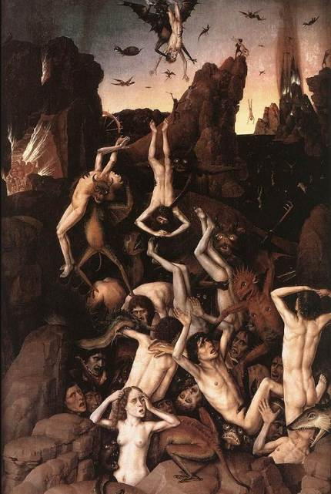

“In this lower cavern I again saw those Oratory boys who had fallen into the fiery furnace. I drew closer to them and noticed that they were all covered with worms and vermin which gnawed at their vitals, hearts, eyes, hands, legs, and entire bodies so ferociously as to defy description. Helpless and motionless, they were a prey to every kind of torment. Hoping I might be able to speak with them or to hear something from them, I drew even closer but no one spoke or even looked at me. I then asked my guide why, and he explained that the damned are totally deprived of freedom. Each must fully endure his own punishment, with absolutely no reprieve whatever.”
St. Don Bosco also saw the names of the sins which caused his boys to fall.
I found myself suddenly transported into a magnificent hall whose curtained glass doors concealed more entrances. Above one of them I read this inscription: The Sixth Commandment. Pointing to it, my guide exclaimed, “Transgressions of this commandment caused the eternal ruin of many boys.”
And while St. Don Bosco worked feverishly to guide his boys away from committing sins against the sixth commandment, the program the Salesian Missions was paid by the federal government to implement was designed specifically to lead kids to this very hall of Hell.
It is simply unconscionable that this program was even set into motion by an organization claiming to be Catholic. But for this and other ostensibly Catholic organizations to defend it, even in the face of undeniable facts showing the sheer wretchedness of the program itself is nothing short of evil.
St. Don Bosco, pray for our Church, pray for your Salesians, and most especially, please pray for us!

Selected comment (Many Catholics wrote that they have discontinued donating money to the Salesians)
1. Thank you. The next time I receive a letter from them I will send it back with request to apologize for what they have done, information how they changed, and assurance that they repented, and went to confession. I will also request to have all non-Catholics to be let go. By a Catholic I mean one who believes what the Catholic Church teaches. We are supposed serve the world, not to hire the world to pay them money.

*

Open Letter to Fr. Hyde of the Salesian Missions
http://www.lepantoinstitute.org/salesian-missions/open-letter-to-fr-hyde-of-the-salesian-missions/
Also posted at http://www.pagadiandiocese.org/2016/05/17/church-militant-headlines-may-17-2016/
By Michael Hichborn, May 11, 2016
The following information was sent to Fr. Mark Hyde (Director) on Monday, May 9, explaining that we wrote him “in order to provide [him] the opportunity to address and correct the situation before we publish the information we have obtained. Our scheduled publishing date and time is noon on Wednesday, however we are open to suspending publication given a timely and reasonable response.” The Lepanto Institute did not receive a response from Fr. Hyde.

Dear Fr. Hyde,
As you may recall, last fall, the Lepanto Institute published a report regarding the Life Choices program implemented through the Salesian Missions’ Office of International Programs, whose director is Jaime Correa-Montalvo. In that report, (see pages 1 through 6), we illustrated training manuals found on the Salesian Life Choices website showing that the program promoted abortifacient contraception, masturbation and condom use. We also provided saved copies of Salesian Life Choices newsletters, proving that students were not only taught this information, but that they repeated what they learned about abortifacient contraception and condom use in their own articles, which were published by the Salesian Life Choices program and distributed to over 15,000 other youths. As a reminder, here is a clip from Youth newsletter #4.

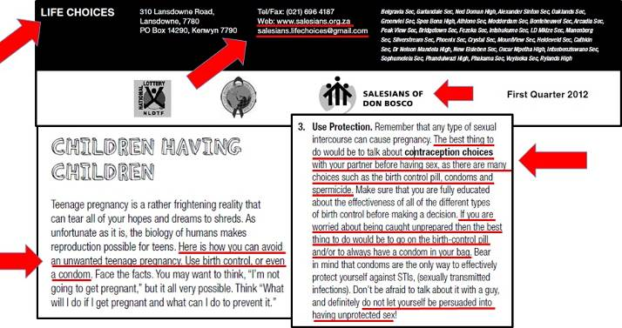

Since the publication of our report on this program, I have communicated by email with Fr. Francois Dufour, Provincial Superior of the Salesians of Don Bosco in Southern Africa. Fr. Dufour confirmed that the information I obtained regarding the Salesian Life Choices training manuals was correct and accurate. Fr. Dufour, in his own words said that he was “duly horrified when [he] got to examine the full training manual” and ordered that it be destroyed. He admitted that “I did not, when I took over as provincial in 2007, monitor the program – there never was any complaint against it that called more attention to it.” He also assured me that the training manuals the Lepanto Institute reported as having been implemented by the Salesian Missions in South Africa “have been banned from use by Life Choices henceforth.”
Unfortunately, the statement issued by your office is in direct conflict with Fr. Durfour’s admission as well as the facts contained in our initial report.

Related to all of this, some new and greatly disturbing information has come to light regarding your director of the Office of International Programs, Jaime Correa-Montalvo. As mentioned earlier, Mr. Correa-Montalvo was the one responsible for the Life Choices program implemented in South Africa. What we have discovered is that Mr. Correa-Montalvo has engaged in highly inappropriate activity on LinkedIn, calling into immediate question his ability to discern and commit to Catholic moral teaching. The main page of Mr. Correa-Montalvo’s LinkedIn profile indicates that he is a member of the LinkedIn group, “Human Rights Campaign,” (the most prominent same-sex “marriage” lobbyists in the country).

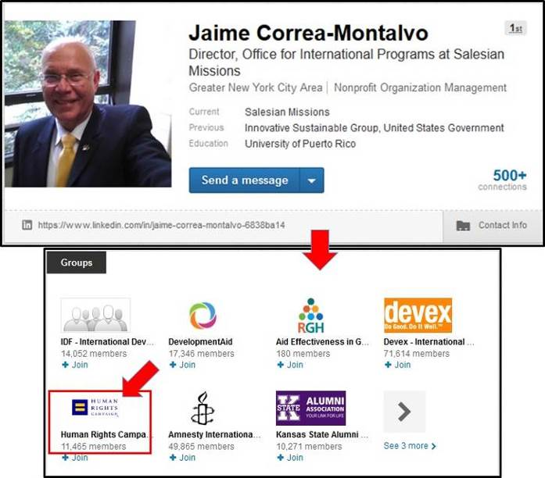

In addition to this, Mr. Correa-Montalvo’s activity on LinkedIn includes “liking” advertisements for male homosexual bondage accessories and images of mostly nude, male models. What follow are screen captures of Mr. Correa-Montalvo’s activity on LinkedIn.

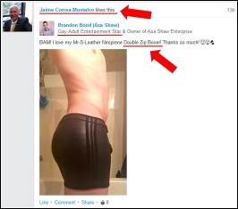

With regard to this post, “Mr. S Leather” is a male homosexual and bondage accessories shop. Please do not google this, it is extremely graphic and disturbing. (I have omitted several of the images –Michael)

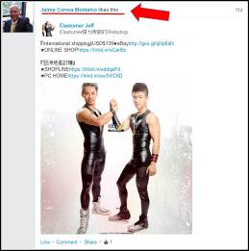

The link provided in the above post, which Mr. Correa-Montalvo “likes,” is to a male homosexual-bondage accessories store.

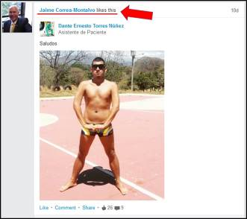
(I have omitted several more of the images –Michael)

Fr. Hyde, it is difficult to see how an individual engaged in this kind of activity online can in any way be committed to Catholic moral teaching. Furthermore, when we consider this activity, the fact that Mr. Correa-Montalvo was the one responsible for the implementation of the Life Choices program in South Africa, and that the Life Choices program there most definitely included education on abortifacient contraception and masturbation, becomes all the more upsetting.
I am writing to you now in order to provide you the opportunity to address and correct the situation before we publish the information we have obtained. Our scheduled publishing date and time is noon on Wednesday, however we are open to suspending publication given a timely and reasonable response.
Sincerely yours in Christ,
Michael Hichborn
There was no response from Fr. Hyde -Michael

Selected comments (Many Catholics wrote that they have discontinued donating money to the Salesians)
1. Please contact the Salesians and ask them to become Catholic.
2. I stopped trusting Salesians a long while ago.
3. In the upcoming revision of my will, I will have to remove Salesian Missions as a residuary legatee if their response to your letter is not quick and appropriately thorough.
4. Thanks for exposing the Salesian Mission’s misuse of our donations. I’ve supported them for years but will not give them another dime until they prove their loyalty to God and His Church by immediately removing instigators like Jaime Correa-Montalvo and any enablers who failed to stop the writing, editing, printing, and distribution of such intrinsically evil ideas. This is especially abhorrent because of the poisoning of minds of at least 15,000 souls and the subsequent failure of the Salesian Mission to respond to your clarification request.
5. Things have gone from bad to worse under Pope Francis.
6. Fr. Alan B. Maria Wharton: When an organization is approached with a serious concern, such as that which Lepanto Institute has brought to the attention of the Salesians, and the organization offers no response, one should ask, “Why is that?”

Two possibilities suggest themselves to my mind: either a) the organization doesn’t take your concern seriously (not enough to even respond!)–where you see a problem, they don’t; or b) they are so compromised as an organization that they prefer to let you do their job of policing internal conflicts of interest. One could even give the Salesians the benefit of the doubt and see in their passive non-response an intention to facilitate the needed exposure, which they themselves, due to internal obstacles, may not be able to bring about. (This speculation, however, requires the assumption that there has been a change of heart at the Salesian Missions since the time of their earlier denials of Mr. Hichborn’s findings and conclusions.)
Maybe there are other possibilities that haven’t occurred to me–but by keeping silent as to their true position when confronted with a problem, the Salesians leave themselves open to such speculations.
I hope the Salesians will now respond in a way respectful of the facts exposed by Lepanto Institute. It would be truly inadequate, and an insult to the public, to simply say–“you misunderstand” the clear evidence that has been presented–and that everything is perfectly in accord with the Church’s teaching.
The Salesian Missions owe the believing Catholic public (not the CINO public) one of two things: either 1) an apology and a promise to discontinue supporting programs that are contaminated with doctrines incompatible with Catholic teaching, or 2) (speaking facetiously) they need to provide a convincing Catholic defense of their support of “abstinence” programs that encourage condom use (that is basically what they have claimed–that these programs exposed by Lepanto Institute are actually “abstinence” programs!) and explain how identifying with the virulently pro-homosexual-agenda, anti-Christian Human Rights Campaign is compatible with directing the Office of International Programs which oversees their youth formation programs in Africa.
If it is truly the Salesian Missions’ intention to help the youth of South Africa to live a healthy, moral life, and discover the goodness and beauty of Catholic moral teaching, they should meticulously disassociate their programs and materials from any government-funded programs that promote a secular humanist agenda of LGBT normalization, and decontaminate their programs from any influences that undermine Catholic teaching. There is no way, within the current scheme of US governmental policy, to cooperate with that secular agenda, accept those conditional funds, and simultaneously maintain a truly Catholic operation.

Canadian Congregation of Nuns Funding, Promoting LGBT Activism
http://www.lepantoinstitute.org/congregation-of-notre-dame/canadian-congregation-of-nuns-funding-promoting-homosexuality/
By Michael Hichborn, May 5, 2016

THE SALESIANS, OSWALD CARDINAL GRACIAS AND NEW AGE PSYCHOLOGIST CARL ROGERS
http://ephesians-511.net/docs/THE_SALESIANS_OSWALD_CARDINAL_GRACIAS_AND_NEW_AGE_PSYCHOLOGIST_CARL_ROGERS.doc

