
NOVEMBER 27, 2017

US citizen Bruce Phillipowsky exposes “Doctor” Dominic Dixon

The contents of this web page https://www.dominicdixon.net/falseprophets (EXPOSING FAKE "CATHOLIC APOLOGIST" & FRAUD, Michael Prabhu and his illicit partner & false prophet Francis Sunil Lobo!) of Dominic Dixon has also been seen by me on WhatsApp. It is a feeble attempt by the fake doctorate and jailed pedophile to defend his name and image by maligning me and one of the many individuals, (they include his own relatives), who of their own accord approached me and helped me expose Dixon.
Dixon doesn’t name Bruce Phillipowsky, the U.S. relative whose minor son he sexually molested and for which crime he was expatriated to the US from Canada, jailed in the US and deported from Canada. It is Phillipowsky who provided this ministry with court records. It is Phillipowsky, not us, who wrote to the U.N. and whose response we published categorically denying Dixon’s purported affiliation with the UN*.
His ramblings are truly not worth rebutting point by point as we have already done so WITH DOCUMENTATION in our earlier exposés and reports.
For a claimed several-times-over “doctorate” with multiple Masters degrees, his English continues to be atrocious and pitiable beginning with the headline (“illicit partner”…? “perpetrators in the Catholic Church”?) Dixon cannot produce even a high school leaving certificate leave alone a graduate certificate or that of a Master’s or a Doctorate. He is not only a sexual deviant but also a highly-evolved con artiste.
I repeat that all the logos (U.N., Oxford, Harvard, etc.) used by Dixon are fake; they are sourced from the Internet by Dixon and pasted on his web pages. Ken Gnanakan, a Protestant whose letter Dixon reproduces on the referred web page, is the only real person among those whose letters are published by Dixon in support of him, and that too is in retaliation for my having exposed his (Gnanakan’s) association with Dixon.
*The letter from the UN is on page 4, pages 6-8 of my report http://ephesians-511.net/docs/UNITED_NATIONS_AGENCY_DISTANCES_ITSELF_FROM_DOMINIC_DIXON.doc.
On the video at the above-referred web page of Dixon’s, every image shown -- our photographs against a newspaper background -- is painstakingly arranged and doctored by Dixon to give credibility to his spin. The photograph of me is copy-pasted by him from a file on my own web site.
All of the other testimonials criticizing/condemning me are anonymous. They are written by Dixon. In the past too, he could never furnish a single name of those whom he quoted concerning me.
He talks about taking me to court and filing cases against me. If he was worth taking legal action against (he is reportedly broke), we can do the same on just two of several counts:
-His claim that I faked my own death and that my wife made money (Rs. 11 lakhs) out of it;
-His claim that Francis Sunil Lobo was asked by TCS to resign from his service there because of a cybercrime case filed against him by Dixon.
Lobo was not asked to leave TCS. He simply changed his employer, VERY LONG AFTER Dixon contacted TCS to complain that Lobo was guilty of contributing to “communal disharmony” on https://ephesians511blog.com/, his blog. TCS simply ignored the calls made to them by Dixon.
As for my faking my death on my web site, there isn’t and never was any mention of my death on www.ephesians-511.net which is the link to my web site. If it wasn’t ever there, how could it be modified as Dixon claims. The referred item was posted on the ephesians511 blog on April 1, 2017, and was never modified or edited as Dixon falsely claims. For those who don’t know, the First of April is April Fools’ Day. The original post along with a few readers’ comments still stands as far as I know.
On the above-referred web page Dixon claims that my wife collected “over 11 lakhs” towards my fake funeral expenses (pretty expensive “funeral” that!)
For details, see
CONVICTED PEDOPHILE DOMINIC DIXON TRIES TO SILENCE THIS MINISTRYS EXPOSES OF HIM 03
http://ephesians-511.net/docs/CONVICTED_PEDOPHILE_DOMINIC_DIXON_TRIES_TO_SILENCE_THIS_MINISTRYS_EXPOSES_OF_HIM_03.doc

The present file is an update of the chronicles of “Doctor” Dixon.
To: Alex.MEJIA@unitar.org CC: Estrella.MERLOS@unitar.org, Nicolas.PLOUVIEZ@unitar.org, Jessica.HANEY@unitar.org
Subject: DOMINIC DIXON, UNITAR, BANGALORE, INDIA Date: Fri, 17 Nov 2017 09:34:04 +0530
To: Alex Mejia
Senior Manager
Decentralized Cooperation Programme
United Nations Institute for Training and Research (UNITAR)
Palais des Nations
Geneva 10, Switzerland
www.unitar.org

Dear Mr. Mejia,
Concerning one Dominic Dixon, on May 12, 2017, you had written to Mr. Bruce Phillipowsky in the USA:
Please note that Mr. Dixon is not an employee, is not professionally associated to, and is not affiliated in any way with, the United Nations Institute for Training and Research (UNITAR). Our Institute has not granted any authorisation to Mr. Dixon to represent us or to present himself as affiliated to us.
Also, it is our understanding that Mr. Dixon has no formal or legal relationship with our affiliated training centre CIFAL in Bengaluru. We have also alerted them of this matter and they have informed us that he was an honorary adviser in the past with no remuneration or contractual relationship, and that they are no longer interacting with him since he moved to Vienna.
Nevertheless, we will request our affiliated training centre in Bengaluru to ensure that Mr. Dixon does not associate himself to our institutions, as we do not have a relationship with him and find the information shared as disconcerting and not suitable of a person that would like to work with the United Nations. We uphold the highest human values and our staff members are only persons of integrity. I do not know about Mr. Dixon's past and do not want to issue judgment on him, but will certainly conduct a thorough investigation on this matter.
However, even after six months, he is still there proudly posing on the CIFAL-UNITAR site flaunting all his fake doctorates; he is not even a middle-school pass, apart from being a convicted pedophile (USA) and deportee (Canada). He has the full support of the Gnanakan family who run CIFAL-UNITAR
Could you kindly ensure that the Bangalore UNITAR unit immediately removes Dixon from this http://www.cifal-bangalore.org/team.html and any other of its web pages?
Michael Prabhu, Chennai, India

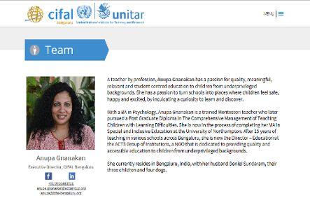


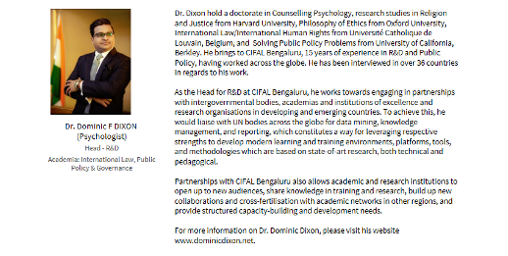

From: Nicolas.PLOUVIEZ@unitar.org
Subject: Automatic reply: DOMINIC DIXON, UNITAR, BANGALORE, INDIA Date: Fri, 17 Nov 2017 04:04:24 +0000
Thank you for your message. I will be out of the office for several weeks beginning Wednesday, 4 October 2017. Please contact my colleagues Ms. Angela Montaño (angela.montano@unitar.org) and Ms. Calliopé Lemattre-Gontcharoff (calliope.lemattre-gontcharoff@unitar.org).
Best regards,
Nicolas Plouviez

I present here the latest communications/complaints received from Mr. Bruce Phillipowsky, the U.S. relative of Dominic Dixon whose minor son was molested by the latter resulting in his being jailed and deported:
From: Bruce Phillipowsky <bruce.phillipowsky@gmail.com>
To: delpol@vsnl.com <delpol@vsnl.com>
CC: Michael Prabhu <michaelprabhu@vsnl.net>, fsunillobo@gmail.com <fsunillobo@gmail.com>
Subject: "Dr." Dominic Dixon
Date: Thu, 23 Nov 2017 16:39:47 -0600
To whom it may concern:
I am writing to formally file a complaint with you for the actions of “Dr.” Dominic Dixon.
Dominic Dixon has committed illegal actions by doing conducting illegal background checks and putting it on the internet. On his website (https://www.dominicdixon.net/testimony) [SEE FURTHER BELOW] he has disclosed my personal information, including my age, address, full name, etc. Also he has made numerous false accusations against my family and myself. This man claims to be a member of the Bangalore UN (United Nations), which I find hard to believe given he is a convicted pedophile in the US and Canada.
Attached is a copy of the official complaint I have submitted to the United States FBI. Please take action and stop this criminal who is posing as a priest to get money from his parishioners.
List of Complaints: https://ephesians511blog.com/2013/04/24/criminal-acts-of-mr-dominic-dixon-of-moreloveethos-institute-bangalore-archdiocese-letter-to-archbishop-of-bangalore/
Thank you,
Bruce Phillipowsky
(214)436-2672
bruce.phillipowsky@gmail.com
IC3 Complaint Referral Form.html
IC3 Logo
Complaint Referral Form
Internet Crime Complaint Center

Thank you for submitting your complaint to the IC3. Please save or print a copy for your records. This is the only time you will have to make a copy of your complaint.
Victim Information Name: Bruce Phillipowsky

Business Name:
Age: Over 60
Address: 6316 Fall River Drive
Address (continued):
Suite/Apt./Mail Stop:
City: The Colony
County:
Country: United States of America
State: Texas
Zip Code/Route: 75056
Phone Number: 2149987266
Email Address: bruce.phillipowsky@gmail.com
Business IT POC, if applicable:
Other Business POC, if applicable:
Description of Incident - Provide a description of the incident and how you were victimized. Provide information not captured elsewhere in this complaint form.
To whom it may concern:
My family and myself have been victim to a series of false allegations and slander online by a man that claims to work for the United Nations. He is a convicted pedophile in the United States and Canada and has been deported from Canada to India. "Dr." Dominic Dixon has been masquerading as a Christian faith healer and collecting money from elderly followers for years. In January 1995, Dominic Dixon molested my eldest son (who was 8 years old) in Des Moines, Iowa.
Upon discovering what he had done, a police report was filed, in the meantime he had moved back to Canada. He was extradited back to the US for trial, where he was convicted and fined.
The US deported him after 6 months in custody and Canada then in turn deported him to India. (Court records available) Recently, some of his parishioners found out about his pedophilia through a series of complaints from other children.
He tried to expunge his criminal record in Canada and failed. This has led him to now try to justify his innocence to his parishioners (from whom he takes money) to make my family and me the bad guys. He has invented numerous false stories about my family and me to prove his point, without a shred of documentation.
He has accredited himself with numerous doctorates from Harvard, Cambridge, Oxford, UCLA, etc. When in reality since he failed 6th grade in India, I was the one who got him into a printer apprenticeship. He has also been illegally posing as a doctor and UN Ambassador, which I have reported to the UN, they have denied any knowledge of him being a part of the organization.
He also claims he is working for the Australian Secret Service.
He has accused my son of being a sleeper cell terrorist and rapist online.
He has illegally obtained background checks of my family and I and has made it public on the internet. (This includes my address, employment history, date of birth, etc.) He has illegally conducted background checks of my family and me and published it on the internet.
I am a 70 year old man with a pacemaker/defibrillator and cannot take this kind of abuse in my condition. Could you please help stop this criminal from spreading any more lies that endanger my family and myself.
Thank you,
Bruce Phillipowsky (214)998-7266 bruce.phillipowsky@gmail.com

Which of the following were used in this incident? (Check all that apply.) ☐ Spoofed Email ☐ Similar Domain ☐ Email Intrusion
☑ Other Please specify:
youtube.com
Law enforcement or regulatory agencies may desire copies of pertinent documents or other evidence regarding your complaint.
Originals should be retained for use by law enforcement agencies.
Information about the Subject(s) Who Victimized You
Name: Dominic Dixon
Business Name: MoreLove/Ethos Institute
Address:
Address (continued):
Suite/Apt./Mail Stop:
City: Bangalore
Country: India
State:
Zip Code/Route:
Phone Number:
Email Address:

Website: https://www.dominicdixon.net/
IP Address:
Other Information - If an email was used in this incident, please provide a copy of the entire email including full email headers.
YouTube: https://youtu.be/VyotnDfLvoc - https://ephesians511blog.com/2013/04/24/criminal-acts-of-mr-dominic-dixon-of-moreloveethos-institute-bangalore-archdiocese-letter-to-archbishop-of-bangalore/
Are there any other witnesses or victims to this incident?
Bruce Phillipowsky, Natalie Phillipowsky, Wayne Glenn, Nicholas Glenn
If you have reported this incident to other law enforcement or government agencies, please provide the name, phone number, email, date reported, report number, etc.
United Nations, kennedyinstitute@georgetown.edu, Alex MEJIA <Alex.MEJIA@unitar.org>, Estrella MERLOS <Estrella.MERLOS@unitar.org>, Nicolas PLOUVIEZ <Nicolas.PLOUVIEZ@unitar.org>, Jessica HANEY <Jessica.HANEY@unitar.org>, croydon@parliament.sa.gov.au, "Wood, Michael J" <WoodMJ@state.gov>, info@cifal-bengaluru.org
Who Filed the Complaint Were you the victim in the incident described above?
Yes
Digital Signature
By digitally signing this document, I affirm that the information I provided is true and accurate to the best of my knowledge. I understand that providing false information could make me subject to fine, imprisonment, or both. (Title 18, U.S. Code, Section 1001)
Digital Signature:
Bruce Phillipowsky
Thank you for submitting your complaint to the IC3. Please save or print a copy for your records. This is the only time you will have to make a copy of your complaint Thank you for submitting your complaint to the IC3. Please save or print a copy for your records. This is the only time you will have to make a copy of your complaint. Thank you for submitting your complaint to the IC3. Please save or print a copy for your records. This is the only time you will have to make a copy of your complaint. Thank you for submitting your complaint to the IC3. Please save or print a copy for your records. This is the only time you will have to make a copy of your complaint. Bottom of Form

The web page content of Dominic Dixon referred to in Bruce Phillipowsky’s complaint:
https://www.dominicdixon.net/testimony

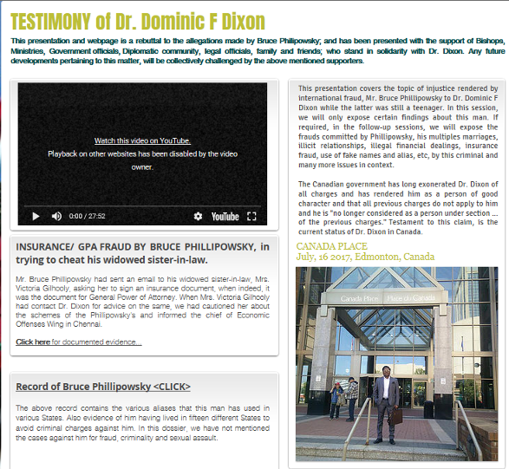

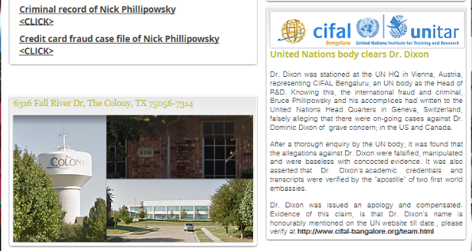

One is hard put to figure out why Dixon calls this his “Testimony”.
At the top of that page (and many places else including the video) we find this header:
Dr. Dominic F. Dixon
Nation Building & Public Policy
His claim that some “United Nations body clears Dr. Dixon” is pure hogwash; in a previous report we have published a letter in which UNITAR Switzerland disowns having any truck with him. CIFAL-UNITAR Bangalore is an ancillary body that, having associated with him (their response also published by me), are now in denial. It is only a matter of time that he will be disowned by them too.
Phillipowsky accuses Dixon of photoshopping and criminal intimidation. Dixon has already attempted the latter with me and has also made a number of allegations that are a product of his criminal mind.
What’s next?
In the YouTube video at around 24:25, he states, “What the opinion of other people about me is none of my business”, then wastes his time trying to get across to viewers that Phillipowsky is himself a criminal. Phillipowsky has refuted the lies of Dixon who is with his back against the wall. He calls Phillipowsky “evil” while describing himself as “the apple of God’s eye”.
He claims that “This presentation and webpage is a rebuttal to the allegations made by Bruce Philipowsky (sic); and has been presented with the support of Bishops, Ministries, Government officials, Diplomatic community, legal officials, family and friends; who stand in solidarity with Dr. Dixon. Any future developments pertaining to this matter, will be collectively challenged by the above mentioned supporters.” Really?!?

From: Wulfeman <bruce.phillipowsky@gmail.com>
To: michaelprabhu@vsnl.net, anupa.gnanakan@actsgroup.org, anupa@cifal-bengaluru.org, Alex.MEJIA@unitar.org
CC: Estrella.MERLOS@unitar.org, Nicolas.PLOUVIEZ@unitar.org, Jessica.HANEY@unitar.org
Subject: Dr. Dominic F​ ​DIXON​ ​
Date: Mon, 27 Nov 2017 11:17:12 -0600
Anupa,
I am writing this to you as “Dr” Dominic Dixon has mentioned you as a colleague on his website .I would like you to know the truth about “Dr” Dominic Dixon who has published a fictitious expose YouTube about me and my family. This is a revenge move because I have exposed him as a religious Con Man who has neither any qualifications or does he know all the people he pretends to know. He is related to my wife so I know him very, very well.

In 1995 Dominic Dixon was in the United States living in my house in Des Moines, Iowa, where he molested my eldest son, who was 8 years old at the time. He was extradited from Canada to stand trial in the United States, where he was convicted, sentenced to 6 months and deported back to Canada. Canada in turn deported him back to India. He now claims Canada has forgiven him and he is now living in Canada. (Please refer to the videos & Documents attached.) As this was hurting his pretense of being a Religious Con man he tried to get his record in Canada expunged. The Canadian Government refused to do this. (Document Attached). This is his revenge against me and my family!

Right now, he claims to be a Doctor with degrees from Harvard, UCLA, Cambridge and Oxford. In reality, he did not complete 6th Standard in St. Marys School, Chennai. As a Pedophile he cannot enter the US, Canada or UK so where did he get his Doctorates? So many of them????? I helped him to get an Apprenticeship in Siga Printing Press, Chennai. In the videos, he has made a number of false claims against my family and me as well as putting our lives in danger by releasing private information such as name, date of birth, address, and a photograph of my home on the internet. Also as this is a gross misuse of the Internet he should be stopped. His videos about cows in India will tell you about his moral character. He claims to know every Minister in India, the United Nations who have no knowledge of him, emails attached. He claims to know everyone in Australia as he is an Honorary MP in the Australian Cabinet. Nobody knows him … emails attached. He is a Con Man! We are trying to make his crimes known and to keep him from molesting other children in the disguise of a holy man who is a Doctor in 6 – 8 faculties. We are trying to prevent any future injuries to children by this criminal.

I have expressed my dismay that the United Nations would employ any convicted pedophile. He claims that his crimes are forgiven but you can see from the 2017 file records he has been refused to remove his criminal records. How can you forgive a pedophile that has ruined the life of a child? As you can see from the documentation below I have informed the Canadian Government, the FBI and the Investigations Division, Office of Internal Oversight Services (ID/OIOS). He is just a Conman who has photo shopped documents to accuse my family and myself of fictitious allegations against my family and me to hide his crimes and make a show for his congregation who are contributing to his existence.

You can see my proof is all based on actual verifiable Court Records. He should NOT be affiliated with the United Nation Training Center where he has access to children or adolescents.
His information:
Dominic Fabian Dixon
DOB: 09/14/1975
Deportation Case Number: IMM-916-98
His website and video claiming to live in Canada:
https://www.dominicdixon.net/
https://www.dominicdixon.net/testimony
https://www.youtube.com/watch?v=CkwaEVOXXEY
Criminal Complaints against Dominic Dixon:
https://ephesians511blog.com/2017/03/11/moreloves-and-ethos-institutes-dominic-dixon-of-bangalore-convicted-sentenced-and-fined-in-the-usa-deported-from-canada-for-sexual-molestation-of-relatives-minor-son/
Canadian Governments Court Records:
http://decisions.fct-cf.gc.ca/fc-cf/decisions/en/item/47307/index.do?r=AAAAAQANZG9taW5pYyBkaXhvbgE
FBI Complaint filed:
file:///C:/Users/Wulfeman/Documents/Bruce%20Documents/Dominic%20Dixon/IC3%20Complaint%20Referral%20Form.html

Please feel free to call me for any more information.
Thanks!
Bruce Phillipowsky
Senior IT Data Analytics Consultant (ITIL Certified)
Cell: 214.436.2672
Home Office: 214.303.9938

ATTACHED DOCUMENT
Docket: IMM-916-98
BETWEEN:
DOMINIC FABIAN DIXON
Applicant
- and -
THE MINISTER OF CITIZENSHIP AND IMMIGRATION

Respondent
REASONS FOR ORDER
RICHARD J.:
[1] The applicant has applied for a stay of execution of a deportation order which is to be executed on March 18, 1998.
[2] The applicant was landed in Canada on July 23, 1994.
[3] The applicant was ordered deported on March 19, 1997, at Edmonton, Alberta, due to his criminal conviction. The deportation order was issued pursuant to subsection 32(2) of the Immigration Act, because the adjudicator found the applicant to be a person described in sub-paragraph 27(1)(a)(i) of the Act because he is a permanent resident who has been convicted of an offence that, if committed in Canada, constitutes an offence that may be punishable under any Act of Parliament by a maximum term of imprisonment of 10 years or more.
[4] The applicant was born on September 14, 1975, in India. He resides in Edmonton, Alberta. On October 30, 1995, he was convicted of Indecent Contact with a Child and received a suspended sentence of two years and fined $500.00. It was this offence that led to his deportation order. The offence occurred in February 1995.
[5] The legality of the deportation order is not challenged.
[6] The applicant appealed to the Immigration Appeal Division based on the grounds that, having regard to all the circumstances of the case, he should not be removed from Canada under paragraph 70(1)(b) of the Immigration Act. The applicant was represented by counsel at the hearing held on December 2, 1997. The panel heard the testimony of three witnesses including the applicant. The applicant and respondent submitted several documents into evidence.
[7] In a decision dated January 28, 1998, the Appeal Division dismissed the appeal as follows:
The Appeal Division is of the opinion that the appellant has not been able to show why, in all the circumstances of this case, he should not be removed from Canada. The Appeal Division finds that there are insufficient mitigating circumstances in this case that warrant its exercise of special relief in this case. Accordingly, the appeal pursuant to paragraph 70(1) of the Act is dismissed both in law and in equity.
[8] The applicant filed an application for leave and for judicial review of the IAD decision on March 3, 1998.
[9] The IAD's decision is well-reasoned and deals with all relevant issues.
[10] In order to grant a stay, the applicant must satisfy the tripartite test.
[11] Even if I were to accept that there is a serious issue to be tried, and in my view, the applicant has a major hurdle to establish this, the applicant has not established that he would suffer irreparable harm if the relief was not granted. The dislocation occasioned by his removal may result in inconvenience or even in some hardship, but it does not establish irreparable harm.
[12] The respondent has an interest in seeing to the effective and timely implementation of a deportation order under section 48 of the Immigration Act.

[13] The application for a stay of the execution of the deportation order is accordingly dismissed.
__________________________
Judge
Ottawa, Ontario
March 9, 1998

ATTACHED DOCUMENT
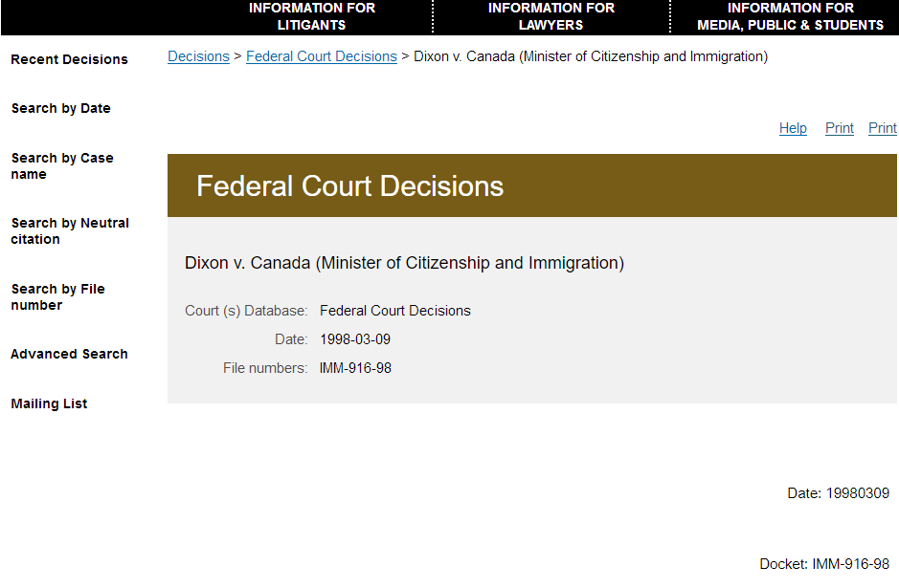

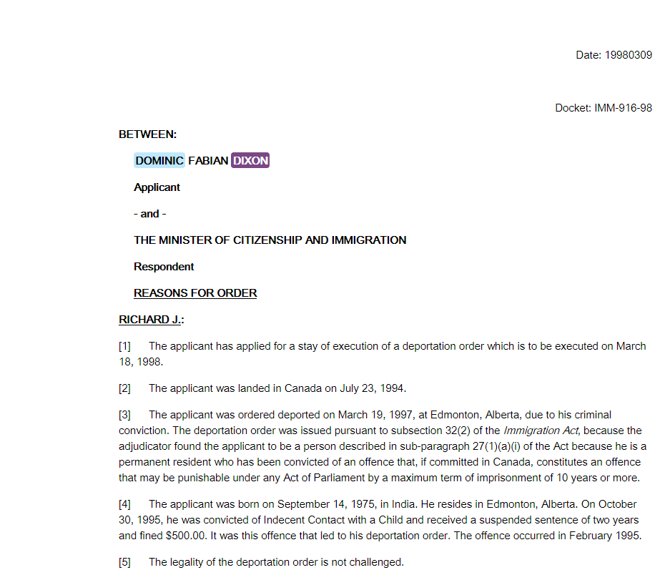

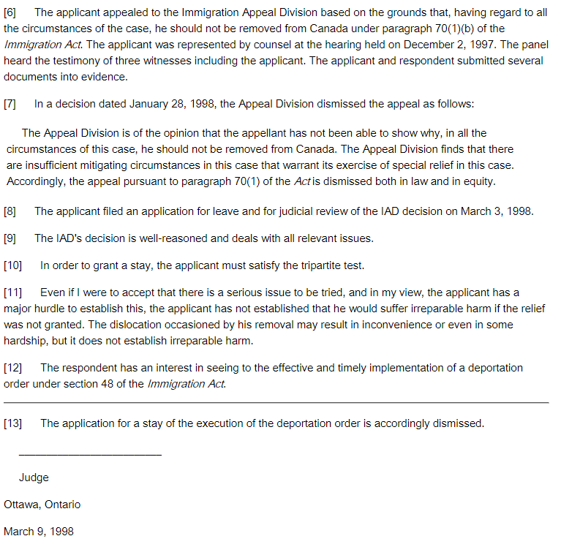

ATTACHED DOCUMENT
croydon@parliament.sa.gov.au
frome@parliament.sa.gov.au
davenport@parliament.sa.gov.au
Franks.office@parliament.sa.gov.au
bragg@parliament.sa.gov.au
australia@un.int
unny.mission.gov.au
Alex MEJIA Alex.MEJIA@unitar.org
Estrella MERLOS Estrella.MERLOS@unitar.org
Nicolas PLOUVIEZ Nicolas.PLOUVIEZ@unitar.org
Jessica HANEY Jessica.HANEY@unitar.org
Dr. Dominic Fabian Dixon (MP – Parliament House, Canberra AU)
As you can see to verify your statements on our email we have copied your UN colleagues and other Members of Parliament that you claim you work for and be an integral part of.
If your email was not so stupidly funny it would be pathetic. You claim to be a Member of the Australian Parliament, the United Nations International Civil Servant' with the UN & IOs and the International law (CIA? FBI? NSA?) You claim to be a senior member of the Australian Parliament, A Member of the United Nations with special security clearances, and law all rolled into one. You are a legend in your own mind and a convicted Pedophile. I do not believe, that any of these organization employ Pedophiles. I am still do not understand how you were elected to Parliament in Australia when you are not even a citizen, and even if you were I don’t believe that the Australians allow child molesters into Parliament. You were deported from Canada so you still have an Indian Passport and would require a visa to enter Australia attend Sessions of Parliament. Amazing!
However, bear these points in mind. (I have attached court and other documentation to prove my claims)
- You are a convicted Pedophile in the US and Canada for sexually abusing my brother. In civilized countries they don’t Expunge Pedophile Records, instead, you are expected to report to the Police every time you change your address. As Americans we take this very seriously.

- As recently as last year your own sister complained to the Priest in India that you had molested her child… Your own Sisters Child… Really?

- According to the Church there were child molestation charges against you from your “Congregation” in Dubai when you were posing as a holy man and using this disguise to “Mentor” children and enrich yourself at the same time.

- You have made numerous videos on YouTube Mentoring the Church Children on a variety of Sexual Topics ranging from SEXTING to early sex for young minor boys and girls. Really? A Sexual Predator and convicted Pedophile mentoring children in Church with the blessings of Church authorities in Bangalore

- We have been trying to stop you from molesting more children but you are hiding in Chennai, India although you told UNITAR that you were moving to Vienna. Perhaps to find some Viennese Choir boys to “Mentor”. We are trying to get the International Community to stop you from moving around further violating young children. You have done enough damage to someone you molested in my family.

- Your FAKE degrees are also being stripped away as we contact each of the Universities you claim to have attended. Auburn University has already denounced your claims. I will forward the emails to you. WE are now trying to verify how and when you achieved your Doctorate.

- The United Nations have told us that you never worked there. I am just confirming it.

- The Church in Bangalore no longer wants to know you after I revealed what you really were

- When you buy information from the Internet remember you are only buying 10 percent is fact and the rest is fiction created for sale and slander to fools like you. It’s how they make money on the Internet… scams! The references you made to our family are not even correct but in fact the creation of the figment of someone’s fertile imagination or has the wrong person identified. We do not have any Perverts or Con men in our family. We don’t reside at the address you mentioned and I own none of those cars. Not sure where you got your information. If you wish to make these allegations at least research your facts. Very easily done in the US from Public Records. Also, just the name is not enough to get an accurate report. You need an accurate DOB and an SSN and even then it may not be accurate due to identity theft. You are so stupid it is unbelievable. Considering your position in the FBI, CIA & NSA you should know that…

- Those race/religion baiting video tapes on your Websites that you made to make money, ridiculing the Hindus worshipping the Cow and not eating beef along with ridiculing their God Shiva at your speech to the Muslim Council will also be appearing in India at the correct interested media outlets.
Please do not bother to reply to this email as, from now all emails from you go directly into my Spam folder where they belong along with you.

Also, please ask your sister why she is so mad at me. Is it because of our business visit to Bangalore? Tell her to relax - she has no reason to be mad….Tell her to please stop burning up my phone line...I won’t talk about it…
ATTACHED DOCUMENT
From: Wulfeman <bruce.phillipowsky@gmail.com>
To: Alex MEJIA' <Alex.MEJIA@unitar.org>
Subject: RE: Dominic F. Dixon
Date: Thu, 23 Nov 2017 17:10:29 -0600
Mr. Mejia,
As you can see from the website (http://www.cifal-bangalore.org/team.html) Dominic Dixon, the convicted pedophile has been re-listed as an employee of the UN. I don’t know what is going on in the Bangalore CIFAL, but I have also filed a complaint against Dominic Dixon with the FBI. Could you please assure me that the United Nations has not hired this convicted pedophile?
Thanks!
Bruce Phillipowsky
Senior IT Data Analytics Consultant (ITIL Certified)
Cell: 214.436.2672
Home Office: 214.303.9938
bruce.phillipowsky@gmail.com

-----Original Message-----
From: Alex MEJIA [mailto:Alex.MEJIA@unitar.org]
Sent: Friday, May 12, 2017 2:54 PM
To: bruce.phillipowsky@gmail.com
Cc: Estrella MERLOS; Nicolas PLOUVIEZ; Jessica HANEY
Subject: Re: Dominic F. Dixon
Dear Mr. Phillipowsky:
This is to acknowledge receipt of your message alerting us about Mr. Dominic Fabian Dixon. We appreciate that you have taken time to let us know about someone that uses our name and claims is affiliated to us.

Please note that Mr. Dixon is not an employee, is not professionally associated to, and is not affiliated in any way with, the United Nations Institute for Training and Research (UNITAR). Our Institute has not granted any authorisation to Mr. Dixon to represent us or to present himself as affiliated to us.

Also, it is our understanding that Mr. Dixon has no formal or legal relationship with our affiliated training centre CIFAL in Bengaluru. We have also alerted them of this matter and they have informed us that he was an honorary adviser in the past with no remuneration or contractual relationship, and that they are no longer interacting with him since he moved to Vienna.

Nevertheless, we will request our affiliated training centre in Bengaluru to ensure that Mr. Dixon does not associate himself to our institutions, as we do not have a relationship with him and find the information shared as disconcerting and not suitable of a person that would like to work with the United Nations. We uphold the highest human values and our staff members are only persons of integrity. I do not know about Mr. Dixon's past and do not want to issue judgment on him, but will certainly conduct a thorough investigation on this matter.

Sincerely,

Alex Mejia (Mr.)
Senior Manager
Decentralized Cooperation Programme
United Nations Institute for Training and Research (UNITAR)Palais des Nations Geneva 10, Switzerland www.unitar.org

-------- Original Message --------
Subject: "Doctor" Dominic F. Dixon
From: "Bruce Phillipowsky" <bruce.phillipowsky@gmail.com>
Date: Thu, February 02, 2017 11:18 pm
To: <info@cifal-bengaluru.org>

To whom it may concern:

My name is Bruce Phillipowsky, I recently came across Mr. Dominic Dixon’s website (http://domdix.wixsite.com/dominic)in which he claims some affiliation to all of you. I am very offended that you would encourage a convicted pedophile who was deported from Canada on child molestation charges and portray him as a hero and example to young children. Dominic Dixon is not a doctor, nor has he ever attended any the prestigious universities he claims. (Harvard, Oxford, Berkeley, etc.) In fact, he never even completed sixth standard at St. Mary’s Anglo-Indian School in Madras, India. I helped him in 1995 to try and find a life in the United States, instead a couple of months later he repaid my kindness by molesting my nine year old son, for which he was deported from Canada. (See Attached Documents) I am told he attempted the same thing in Australia with a relation as recently as last month. The reason I am writing to you is because all of Mr. Dixon’s “research” seems to be on pornography and children. Do you think that fits the profile of a pedophile? Should he be in continuous contact with young children? (Even in the disguise of a very educated psychiatrist/counselor blessed by the Catholic Church.) Judging by his website and the results obtained, he seems to be a very gifted con artist. He is enriching himself in the name of the Lord.
This madness must stop, he must be held accountable for his actions and prevented from corrupting the minds of young children under the guise of counseling them.

Link to his deportation from the Canadian Government:
http://decisions.fct-cf.gc.ca/fc-cf/decisions/en/item/47307/index.do?r etc. etc.
For further details, feel free to contact me at any time.
Thanks!
Bruce Phillipowsky
Senior ITSM / SACM Consultant (ITIL Certified) etc. etc.

OTHER ATTACHED DOCUMENTS HAVE BEEN PRESENTED IN OUR EARLIER REPORTS

RELATED FILES
Our files on or related to Dominic Dixon in chronological order:
1. MORELOVE-HOLYSPIRITINTERACTIVE-SOUL TIES AND ETHOS INSTITUTE 31 JANUARY/ 12/15/17/18/22/23 MARCH, 6/8/16/26/29 APRIL/JULY/DECEMBER 2013/UPDATED 18 NOVEMBER 2015
http://ephesians-511.net/docs/MORELOVE-HOLYSPIRITINTERACTIVE-SOUL_TIES_AND_ETHOS_INSTITUTE.doc
2. HOLYSPIRITINTERACTIVE ANEEL ARANHA AND NEW AGE 9 MAY 2013
http://ephesians-511.net/docs/HOLYSPIRITINTERACTIVE_ANEEL_ARANHA_AND_NEW_AGE.doc
3. HOLYSPIRITINTERACTIVE-WARNING ALERT ISSUED BY CATHOLICCULTURE.ORG 19 MAY/5 JUNE 2013
http://ephesians-511.net/docs/HOLYSPIRITINTERACTIVE-WARNING_ALERT_ISSUED_BY_CATHOLICCULTURE.ORG.doc
4. THE PRAKASH LASRADOS, THE JOHNSON SEQUEIRAS AND THE DOMINIC DIXONS 28 JULY 2013
http://ephesians-511.net/docs/THE_PRAKASH_LASRADOS_THE_JOHNSON_SEQUEIRAS_AND_THE_DOMINIC_DIXONS.doc
5. DOMINIC DIXON AND MORELOVE-MORE UNHOLINESS 4 AUGUST 2013
http://ephesians-511.net/docs/DOMINIC_DIXON_AND_MORELOVE-MORE_UNHOLINESS.doc
6. DOMINIC DIXON CONTINUES TO DECEIVE CATHOLICS 24 OCTOBER 2014
http://ephesians-511.net/docs/DOMINIC_DIXON_CONTINUES_TO_DECEIVE_CATHOLICS.doc
7. FLAME MINISTRIES INTERNATIONAL YOGA AND ANEEL ARANHA 29 JANUARY 2016
http://ephesians-511.net/docs/FLAME_MINISTRIES_INTERNATIONAL_YOGA_AND_ANEEL_ARANHA.doc
8. DOMINIC DIXON CONVICTED IN USA DEPORTED FROM CANADA FOR SEXUAL MOLESTATION OF BOY 15/22 FEBRUARY 2017
http://ephesians-511.net/docs/DOMINIC_DIXON_CONVICTED_IN_USA_DEPORTED_FROM_CANADA_FOR_SEXUAL_MOLESTATION_OF_BOY.doc
9. BANGALORE DELIVERANCE MINISTRY CHRISTOPHER CORREYAS NOTORIOUS ASSOCIATE DANNY DANZ 31 OCTOBER 2016
http://ephesians-511.net/docs/BANGALORE_DELIVERANCE_MINISTRY_CHRISTOPHER_CORREYAS_NOTORIOUS_ASSOCIATE_DANNY_DANZ.doc
10. UNITED NATIONS AGENCY DISTANCES ITSELF FROM DOMINIC DIXON 12/13 JUNE 2017
http://ephesians-511.net/docs/UNITED_NATIONS_AGENCY_DISTANCES_ITSELF_FROM_DOMINIC_DIXON.doc

11. DOMINIC DIXON CONVICTED IN USA DEPORTED FROM CANADA FOR SEXUAL MOLESTATION OF BOY 02 13 JUNE 2017
http://ephesians-511.net/docs/DOMINIC_DIXON_CONVICTED_IN_USA_DEPORTED_FROM_CANADA_FOR_SEXUAL_MOLESTATION_OF_BOY_02.doc
12. CONVICTED PEDOPHILE DOMINIC DIXON TRIES TO SILENCE THIS MINISTRYS EXPOSES OF HIM 16/17 JUNE 2017
http://ephesians-511.net/docs/CONVICTED_PEDOPHILE_DOMINIC_DIXON_TRIES_TO_SILENCE_THIS_MINISTRYS_EXPOSES_OF_HIM.doc
13. CONVICTED PEDOPHILE DOMINIC DIXON TRIES TO SILENCE THIS MINISTRYS EXPOSES OF HIM 02 7 AUGUST 2017
http://ephesians-511.net/docs/CONVICTED_PEDOPHILE_DOMINIC_DIXON_TRIES_TO_SILENCE_THIS_MINISTRYS_EXPOSES_OF_HIM_02.doc
14. CONVICTED PEDOPHILE DOMINIC DIXON TRIES TO SILENCE THIS MINISTRYS EXPOSES OF HIM 03 31 OCTOBER/15 NOVEMBER 2017
http://ephesians-511.net/docs/CONVICTED_PEDOPHILE_DOMINIC_DIXON_TRIES_TO_SILENCE_THIS_MINISTRYS_EXPOSES_OF_HIM_03.doc

