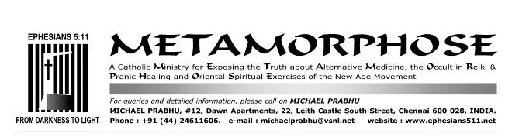
NOVEMBER 28, 2012
Vassula Ryden: The Reasons of the Church
http://www.catholicculture.org/Culture/Library/SpecialItems/dermine.pdf
By François-Marie Dermine, O.P.

Francois-Marie Dermine, a Dominican priest of Canadian origin, is a professor of moral theology at FTER (the Faculty of Theology of Emilia-Romagna, Bologna, Italy), a member of the executive council of GRIS (Group of Research and Social-Religious Information), consultant to the Italian Bishops’ Conference for questions on alternative religions, co-director of the review Religioni e Sette nel mondo [Religions and Sects in the World], and official exorcist for his own diocese. He is author of numerous articles on alternative religions and of the following publications, of particular importance for the subject of the present investigation: Vassula Ryden – Indagine critica [Vassula Ryden – A Critical Examination] (Elle di Ci, 1995) and Mistici, veggenti e medium – Esperienze dell’aldilà a confronto [Mystics, Visionaries and Mediums – Comparison of after-life experiences] (Libreria editrice vaticana, 2002). Co-author of L’estasi [Ecstasies] (Libreria editrice vaticana, 2003).

Introduction
Vassula Rydén, born in Egypt of Greek parents in 1942, married in 1966 to an official of F.A.O. with whom she had two sons, is of the Greek Orthodox religion. From November 1985, she has claimed to be receiving private revelations dictated by an entity which she identifies with Jesus. The contents of the revelations refer essentially to the ecumenical movement, the Hearts of Jesus and Mary, the conversion of both the mankind and the Church. Such revelations produced a widespread impact, and, thanks also to the open support of certain world-wide known theologians such as René Laurentin, they were well accepted by many lay people and priests as well as some bishops and cardinals.

The messages, available in 10 to 12 volumes (depending on which of the 40 different language editions one refers to), present some contents capable of stirring feelings close to the heart: they in fact denounce the process of apostasy underway in the Christian world and the rationalism which has considerably contributed to rendering our faith boring, cold and insignificant. The messages reaffirm the existence of Satan and hell, and the dramatic aspect of the struggle between good and evil. They condemn abortion, New Age, reincarnation. They preach a message of radical conversion, fidelity to the Pope, the need to receive the sacraments and the importance of fast. They spread the devotion to the Sacred Hearts of Jesus and Mary, the practice of the Rosary also among the Orthodox followers, and encourage ecumenism by exhorting the Orthodox to unite with Rome. Last but not least, they refer to the "fruits" of the messages, namely to thousands of conversions and even some miracles (although not scientifically documented).

Yet these undeniable positive aspects are not sufficient to obtain the approval or at least not to be objected by the Church, and one spontaneously wonders why. My claim here, that is completely personal, is to offer some elements of the answer, given the tendency of a certain number of misinformed Catholics to believe in the aforementioned messages.
In the first part (1), I present the chronology of the Church’s substantially negative official reactions in regard to the revelations, and also the useless attempts of Mrs. Ryden and several of her collaborators to modify these reactions to their advantage.
In the second part (2), I consider and review the main reasons for which, always in my opinion, the Catholic Church (and also the Orthodox Church) refuses to attribute a supernatural dimension to the messages in question. These reasons can be summarized in the following points:
(2a) The disappearance of the messages received by Ms Ryden during the first 10 months of revelations, as well as the cancellation, censuring or modification of several of them. Such facts are probably the main reason that, in the most definite manner, contributes toward discrediting the revelations.
(2b) «The suspect nature of the ways in which these alleged revelations have occurred» (words of the 1995 Vatican Notification), namely, as a result of automatic writing.
(2c) The ambiguous attitude of the protagonist toward the Church.
(2d) The Vassula-centrism of the messages.
(2e) The theological errors.

My investigations cover only the first six volumes of the Italian edition of True Life in God, which is more than enough to get a good idea of the revelations. Someone might object that many things have changed since then: the messages, they say, have acquired a more calm approach, the terminology has evolved and is cleaned up from what lends itself to confusion. However, these factors are of little or no convincing value, because the messages of the most recent volumes are also attributed to God, and there is nothing that forbids one from thinking that the changes result from the kind of auto-censorship that Mrs. Ryden would have done by herself.

Chronology of the Church's official reactions
(1) The relationship between the Church and Vassula Ryden oscillates between the official judgment of the Church, substantially negative and still confirmed until today, and the numerous initiatives of Vassula (and of those acting on her behalf) aimed at reversing that judgment.
The first official reaction of the Catholic Church came by means of the Notification of the Congregation for the Doctrine of the Faith on the writings of Mrs. Vassula Ryden (October 6, 1995). Here is the complete text:

Sacred Congregation for the Doctrine of the Faith
Many Bishops, priests, religious and lay people have sought an authoritative judgment from this Congregation on the activity of Mrs. Vassula Ryden, a Greek Orthodox residing in Switzerland, who in speech and in writing is spreading in Catholic circles throughout the world messages attributed to alleged heavenly revelations.
A calm, attentive examination of the entire question, undertaken by this Congregation in order to “test the spirits to see whether they are of God” (cf. 1 Jn 4:1), has brought out -- in addition to positive aspects -- a number of basic elements that must be considered negative in the light of Catholic doctrine.
In addition to pointing out the suspect nature of the ways in which these alleged revelations have occurred, it is necessary to underscore several doctrinal errors they contain.
Among other things, ambiguous language is used in speaking of the Persons of the Holy Trinity, to the point of confusing the specific names and functions of the Divine Persons. These alleged revelations predict an imminent period when the Antichrist will prevail in the Church. In millenarian style, it is prophesied that God is going to make a final glorious intervention which will initiate on earth, even before Christ’s definitive coming, an era of peace and universal prosperity. Furthermore, the proximate arrival is foretold of a Church which would be a kind of pan-Christian community, contrary to Catholic doctrine.
The fact that the aforementioned errors no longer appear in Ryden’s later writings is a sign that the alleged “heavenly messages” are merely the result of private meditations.
Moreover, by habitually sharing in the sacraments of the Catholic Church even though she is Greek Orthodox, Mrs. Ryden is causing considerable surprise in various circles of the Catholic Church. She appears to be putting herself above all ecclesiastical jurisdiction and every canonical norm, and in effect, is creating an ecumenical disorder that irritates many authorities, ministers and faithful of her own Church, as she puts herself outside the ecclesiastical discipline of the latter.
Given the negative effect of Vassula Ryden’s activities, despite some positive aspects, this Congregation requests the intervention of the Bishops so that their faithful may be suitably informed and that no opportunity may be provided in their Dioceses for the dissemination of her ideas. Lastly, the Congregation invites all the faithful not to regard Mrs. Vassula Ryden’s writings and speeches as supernatural and to preserve the purity of the faith that the Lord has entrusted to the Church.
Vatican City, 6 October 1995.

As we see, the double reference to «some positive aspects» takes nothing away from «a number of basic elements that must be considered negative. [...] Given the negative effect of Vassula Ryden’s activities». The highlighted aspects are essentially concerning with the way the messages are transmitted, doctrinal errors, and disciplinary problems.
Mrs. Rydén’s supporters immediately challenged the validity of the Notification, especially because it was published without the signature of the Prefect of the Congregation. Someone even said it had been written without Cardinal Ratzinger’s knowledge or without his permission, perhaps by some member of the "Vatican Freemasonry".
A confirmation of these allegations seemed to be reflected in the words addressed by Cardinal Ratzinger to a group of Mexican supporters on May 10, 1996: «On the basis of what you have told me in your letter about testimonies and conversions, that is very good, we only want you to proceed with discernment, - do not take as the word of God what is considered, for the moment, only human and personal. What we have said is that Vassula should not present her testimony in churches (inside the church) because she is an Orthodox and her marital status is not yet clear, since she was divorced. We are studying all this. You may continue promoting her writings, but always with discernment».
However, these words do not diminish the validity of the Notification, which was obvious given the authoritative style of the text and its publication in L’Osservatore Romano, the official and ordinary means for the dissemination of Church documents.
To cut short the discussions and interpretations, the Congregation had to intervene on November 29, 1996 with a press release, the full text of which is as follows:

I. The Congregation for the Doctrine of the Faith has received various questions about the value and authority of its Notification of 6 October 1995, published in L'Osservatore Romano on Monday/Tuesday, 23/24 October 1995, p. 2 (L'Osservatore Romano English edition, 25 October 1995, p. 12), regarding the writings and messages of Mrs. Vassula Ryden attributed to alleged revelations and disseminated in Catholic circles throughout the world.
In this regard, the Congregation wishes to state:
The Notification addressed to the Pastors and faithful of the Catholic Church retains all its force. It was approved by the competent authorities and will be published in Acta Apostolicae Sedis, the official organ of the Holy See, with the signatures of the Prefect and the Secretary of the Congregation.
Regarding the reports circulated by some news media concerning a restrictive interpretation of this Notification, given by His Eminence the Cardinal Prefect in a private conversation with a group of people to whom he granted an audience in Guadalajara, Mexico, on 10 May 1996, the same Cardinal Prefect wishes to state:
as he said, the faithful are not to regard the messages of Vassula Ryden as divine revelations, but only as her personal meditations;
these meditations, as the Notification explained, include, along with positive aspects, elements that are negative in the light of Catholic doctrine;
therefore, Pastors and the faithful are asked to exercise serious spiritual discernment in this matter and to preserve the purity of the faith, morals and spiritual life, not by relying on alleged revelations but by following the revealed Word of God and the directives of the Church's Magisterium.
II. Regarding the circulation of texts of alleged private revelations, the Congregation states:
1) The interpretation given by some individuals to a Decision approved by Paul VI on 14 October 1966 and promulgated on 15 November of that year, in virtue of which writings and messages resulting from alleged revelations could be freely circulated in the Church, is absolutely groundless. This decision actually referred to the "Abolition of the Index of Forbidden Books", and determined that - after the relevant censures were lifted-the moral obligation still remained of not circulating or reading those writings which endanger faith and morals.
2) It should be recalled however that with regard to the circulation of texts of alleged private revelations, canon 823 §1 of the current Code remains in force: "the Pastors of the Church have the ... right to demand that writings to be published by the Christian faithful which touch upon faith or morals be submitted to their judgement".
3) Alleged supernatural revelations and writings concerning them are submitted in first instance to the judgement of the diocesan Bishop, and, in particular cases, to the judgement of the Episcopal Conference and the Congregation for the Doctrine of the Faith.”

The conclusions to be drawn from this press release leave no room for doubt: the Notification is valid and, moreover, explicitly validated by the Prefect. The messages of Vassula Ryden continue to be considered «only as her personal meditations» and the moral obligation neither to spread them nor read them remains.

In 1998, Cardinal Ratzinger said in an interview: «...the Notification is a warning, not a condemnation. From the strictly procedural point of view, no person may be condemned without a trial and without being given the opportunity to express her/his views first. What we say is that there are many things which are not clear. There are some debatable apocalyptic elements and ecclesiological aspects which are not clear. Her writings contain many good things but the grain and the chaff [or darnel, "loglio" in Italian] are mixed up. That is why we invited the Catholic faithful to view it all with a prudent eye and to measure it by the yardstick of the constant faith of the Church» (30 Giorni, Italian edition).
Although the presence of unclear elements and even of "chaff" in a phenomenon described as supernatural is not reassuring, the Church refrains from any condemnation: Mrs. Ryden was not contacted directly by the Congregation and, as a Greek Orthodox, does not fall under its jurisdiction.
However, after Vassula Ryden expressed a desire to establish a direct relationship with the Congregation, one of its consultants, Fr Prospero Grech O.S.A., submitted five questions related to the reservations of the Notification. The answers provided by Vassula, written in a clever and theologically developed manner (including quotations of Cardinal Ratzinger) take up thirty pages. The initiative is highlighted in the following letter from the Congregation (July 10, 2004):

To the Presidents of the Bishops’ Conferences of France, Switzerland, Uruguay, Philippines, Canada
CONGREGATIO PRO DOCTRINA FIDEI
10 July 2004
Prot N. 54/92-19631 Eminence/Excellence,
As you know, this Congregation published a Notification in 1995 on the writings of Mrs. Vassula Ryden. Afterwards, and at her request, a thorough dialogue followed. At the conclusion of this dialogue, a letter of Mrs. Ryden dated 4 April 2002 was subsequently published in the latest volume of “True Life in God”, in which Mrs. Ryden supplies useful clarifications regarding her marital situation, as well as some difficulties which in the aforesaid Notification were suggested towards her writings and her participation in the sacraments (cf. Attachment).

Since the aforementioned writings have enjoyed a certain diffusion in your country, this Congregation has deemed it useful to inform you of the above. Concerning the participation in the ecumenical prayer groups organised by Mrs. Ryden, the Catholic faithful should be called to follow the dispositions of the Diocesan Bishops.
In communicating to you the above, I use the occasion to assure you of my lasting and profound esteem».
Yours Eminences/Excellencies, Most Devout
Joseph Card. Ratzinger
Prefect

This letter is quite well balanced and does not really commit itself: it makes mention of some clarifications on some of the difficulties, with explicit reference to those related to discipline, and, in particular, to the marital situation of the protagonist, who got married in 1966 in the Greek-Orthodox Church, then divorced and remarried on June 13, 1981. Finally, she regularized her situation in her Church five years after the beginning of the revelations, on October 31st, 1990. These clarifications are described as "useful", but without intending them to be sufficient to "clear" the situation. Then, even though the matter does not appear in a way that is completely obvious, it seems to grant individual diocesan bishops greater autonomy in managing any events promoted in favor of the protagonist.
However, can we really say, as the supporters do, that the situation has now been modified (words attributed to Cardinal Ratzinger), to such an extent as to induce the Vatican to withdraw the Notification from its website?
With regard to this last point, we must specify that the text can not have been removed from the website for the simple reason that it never appeared there: the same happens with about half of the 60 documents of the Congregation listed on the webpage, which were almost all written before the creation of the website and were not available in the electronic format.

The Notification still remains the point of reference for the Congregation in regard to Mrs. Ryden, as can be deduced from the following two events.
In January 2006, Msgr. Kevin Kostelnik, pastor of the Los Angeles cathedral, with the support of the city’s Archbishop, Cardinal Roger M. Mahony, withdrew permission for a conference on Christian Unity under the auspices of Vassula Ryden of True Life in God. Msgr. Kostelnik wrote that the statements by the organizers, claiming that the Vatican had already given the green light to Mrs. Ryden’s writings, constituted «a serious misrepresentation of the current Vatican view of Mrs. Ryden’s speeches and writings» and that the 1995 and 1996 Vatican warnings remained «in full force».
The second event dates back to January 25, 2007, and has universal significance for the Catholic Church, since it is a letter of the prefect of the Congregation for the Doctrine of the Faith addressed to all the Presidents of the Bishops’ Conferences. Its full text is as follows:

CONGREGATION FOR THE DOCTRINE OF THE FAITH 25th January 2007
Prot. N.: 54/92 – 24945
Your Eminence / Your Excellency,
The Congregation for the Doctrine of the Faith continues to receive requests for clarification in relation to the writings and activities of Mrs. Vassula Ryden. These requests address in particular the import of the Notification of 6 October 1995, and the criteria to be considered by the local Church in judging whether the writings of Mrs Vassula Ryden may appropriately be disseminated.
1) The Notification of 1995 remains valid as a doctrinal judgment of the writings examined (see Enclosure 1).
2) Mrs. Vassula Ryden, however, after dialogue with the Congregation for the Doctrine of the Faith, has offered clarifications on some problematic points in her writings and on the nature of her messages which are presented not as divine revelations, but rather as her personal meditations (see Enclosure 2: Letter of 4 April 2002, published in True Life in God, vol. 10). From a normative point of view therefore, following the aforementioned clarifications, a case by case prudential judgment is required in view of the real possibility of the faithful being able to read the writings in the light of the said clarifications.
3) Finally, it remains inappropriate for Catholics to take part in prayer groups established by Mrs. Ryden. Concerning the question of ecumenical meetings, the faithful are to follow the norms of the Ecumenical Directory, of the Code of Canon Law (canons: 215; 223 §2 and 383 §3) and of Diocesan Ordinaries.
Yours sincerely in Christ
Cardinal William LEVADA
Prefect

This letter makes it clear that after more than ten years of talks and a continual giving and recalling, nothing in substance has changed for the Congregation: no supernatural value is attributed to Vassula Ryden’s messages, and while allowing a greater autonomy to individual dioceses, the Congregation advises against the participation of Catholics in her prayer groups and reaffirms the universal value of the provisions of canon law regarding ecumenical meetings.

In other words, the above mentioned clarifications, as already stressed, were not enough to lift the reservations regarding "a number of basic elements that must be considered negative in the light of Catholic doctrine" (Notification of 1995), nor to allow a recognition, in spite of all the good will manifested by the then Prefect of the Congregation.
This also means that the official declarations of the Congregation for the Doctrine of the Faith regularly signed by its present or previous Prefects prevail over the unofficial declarations that were given to some journalists and persons, who rushed to conclusions.

If the Congregation continues to refrain from an explicit condemnation, it is for the reasons already mentioned: Mrs. Rydén, a Greek Orthodox, does not fall under the jurisdiction of the Church. One may also reckon that the Congregation is trying not to aggravate nor scandalize those Catholics still involved and unaware of the real reasons for the lack of recognition.

In a letter of August 2007, Mrs. Ryden protested against the position taken by Cardinal Levada, for failing to take into account the apparently positive balance of the referred dialogue. Moreover she denies having ever said that the messages «are presented not as divine revelations but rather as her personal meditations». Now, even if we must recognize a certain ambiguity in the wording of the letter, it only takes up again what was affirmed by the Notification of 1995 and the press release of 1996.

The very fact that, as Father Prospero Grech wrote to the protagonist, «your latest books, too, seem to have laid aside some ambiguous expressions contained in your earlier ones» (March 21, 2003), does not change anything, since the Notification had already pointed that: «The fact that the aforementioned errors no longer appear in Rydén’s later writings is a sign that the alleged "heavenly messages" are merely the result of private meditations» (while the protagonist, for obvious reasons, considers that the revelations are true and real).

I will now examine some of the reasons that, from my personal point of view, may explain why the Church has maintained its fundamentally negative judgment: I do it in the most concise way, hoping that this will contribute to enlighten those for whom the attraction of the extraordinary still prevents them from opening their eyes.

Disappearance, cancellation, censuring and modification of the messages
(2a) The pages that follow are taken mostly from one of my articles published in the Italian magazine Jesus of October 1996 and entitled Quando Dio si fa correggere [When God is corrected]. They deal with a point that is not mentioned in the Notification but which is serious enough, in my opinion, for the revelations to lose any credibility whatsoever; I am referring to destructions, deletions, and corrections that Mrs. Ryden introduced into her very own messages:

1. Destructions
The messages of the first ten months are in fact completely missing. It is an astounding gap when one considers that the first revelations always represent the introduction and the first fruits of an extraordinary supernatural phenomenon. Mrs. Ryden explains: «Generally I burned them because I really had so many of them» written on loose sheets and not yet in notebooks. This is a rather irreverent way of treating messages that she regarded as divine revelations... René Laurentin, while defending his protégée, does not hesitate to contradict her: «According to her accusers, Vassula had destroyed the messages received in the first months with the sole determination of hiding the gross errors which they contained. In truth Vassula did not destroy anything! She did not publish these first messages, but has plans to do so». These contradictory explanations do not predispose towards trust, and all the more so when after ten years, their announced publication is still supposed to come.

2. Omitted or deleted messages
When we compare the photocopies of the manuscripts which, in the beginning, the protagonist had freely circulated, with the facsimile editions (also known as the "handwriting edition") printed later on, some cuttings show up. The most obvious cuttings are explained as: «At Vassula’s request portions of page X have been deleted».
This discovery has to be attributed to Father Philip Pavich O.F.M., an American of Croatian origin. In September 1991, during a five year stay in Medjugorje, where he was carrying out the ministry of reconciliation, Fr. Pavich received a copy of the original messages that had been corrected by the "seer" herself with the help of her collaborator Erwin Schlacher, and where the many deletions and modifications could be seen. The Franciscan priest made public these photocopies by circulating them and comparing them with the printed "handwriting edition".
These photocopies were sent to Elena Carvalho - the Brazilian translator of the revelations into Portuguese. She was disconcerted by these photocopies and requested explanations. Mrs. Rydén wrote a fax to her on October 14, 1993, in which she justified herself by asserting that the passages:
"were taken out with God's guidance. In two words, God gives me private messages plus very symbolic ones. In the beginning I photocopied ALL things out. Later, when God's work had to be printed, God made me understand that the private messages and the very symbolic that people might not understand, should not be printed. (...) I have 2 notebooks, one I call the private notebook (...). Then I have what I call the 'official' notebook, the one that should be printed. God removes from the private notebook all what should be diffused and re-writes the message in the official notebook."

She also states that at the beginning, she had made everything public, but God did not want that. At the end of the fax (photocopy 1 shows one a passage of the fax), Mrs. Rydén announced that René Laurentin would give a detailed response to all the "calumnies". However, Laurentin did not write this response, and Mrs. Rydén had to take the matter into her own hands, formulating argumentations that, according to our opinion, complicate even further her already precarious situation and clash with indisputable facts.
A close examination of the complete original photocopies (extracts reproduced hereunder, each one indicated with the number of the notebook, the page and the date of the message) allows one to verify that the parts removed from the printed edition normally correspond to some unfulfilled prophecy or to some fact resulting in disappointment for the protagonist. In photocopy 2, for example, the original version of the message dated April 14, 1988, asks Vassula and her "entourage" to write to Don Stefano Gobbi of the Marian Movement of Priests. In photocopy 3, the cuttings appear clearly. The same treatment was reserved to the message of June 10, 1988 (photocopies 4 and 5), where the "Virgin Mary", intending to perform a consolidation between her messages to Don Gobbi and those of Jesus to Vassula Rydén, announces that she had arranged a meeting between the two. This meeting, because of Don Gobbi’s reluctance, did not take place. The same procedure of “cutting” was applied to a part of the message dated July 29, 1988 that mentions a meeting to take place in Switzerland with Fr. Schwitzer S.J. The "Virgin Mary" had directed Vassula, her "most beloved one", to him for spiritual direction. In the meantime, the priest did not want to assume such a responsibility because he attributed the messages to a «spirit of dubious origin».

There were also other messages that were either partially or totally removed (cf. November 8-18, 1987; December 6-12-28-31, 1987; January 7 10-18-31, 1988; February 3-26, 1988; May 4, 1988, etc.). In these messages Vassula Rydén and her two « witnesses » are told to seek a private audience with the Pope, to go to him barefooted to wash his feet, then to do the Way of the Cross together with him and present to him these heavenly revelations which the Pope will already have known about and be waiting to receive. Photocopies 6, 7 and 8 document this request. The sentences struck through are those that were removed from the printed version of the messages.
This event, which Jesus himself is said to have foretold through a certain prophecy of Pope John XXIII as can be seen in photocopy 9 with the usual cancellations, was never fulfilled. At the very most, the protagonist, while being a part of the crowd during two public audiences (August 3, 1988 and November 6, 1993), succeeded in inserting a letter behind the sash of the Pope and handing him some of her publications.
Later on she tried to give a purely symbolic value to these messages, thereby completely contradicting both the letter and the spirit of them. In fact, several times the "heavenly" entity had explicitly demanded her to try to get a private audience. Even the demand to go barefoot can only be understood in the literal sense. It is connected, in fact, with the messages (deleted) of October 14 and 15, 1987, of November 18, 1987, of February 26 and May 7, 1988 (photocopies 10, 11, 12 and 13) where "Jesus" binds his well-beloved with a vow to walk barefoot at the appointed time. He therefore habitually calls her «my barefoot bearer». In sections (also deleted) of the messages of October 15-16, 1987 and reported in photocopy 12, we read the following words of Jesus: «I will remind you to pull away your shoes ». To avoid any misunderstanding, the message concretely emphasizes the penitential character of the request by adding: « seek no comfort, whether you will walk on snow or hot sands, you will rid of your shoes are you willing to do this? ». In the message of November 8, 1987, the entity says explicitly to the frightened protagonist: « do not refuse Me this! I want! I want to do it». He exhorts her not to fear (photocopy 15, cancelled). It is affirmed that John Paul II will recognize the messenger when she will present herself before him (photocopy 16, cancelled). Without doubt we are faced with some proper and real prophecies, to be understood literally and that never came true.

3. Compromising and obvious changes of some messages
Here are two very significant examples. In photocopy 17 the astute and rudimental treatment inflicted on the message of April 18, 1988 is all too painfully clear. In the top section the sentence reads as it was in the original text: « O come Peter! Take My Hand, Satan has digressed you from the Truth! Take My Hand and I will guide you... ». In the middle section, arrows indicate on the original how the words should be moved around for correction. At the bottom the final "corrected" version appears for publication: « Satan has digressed many of you from the Truth! Take My Hand Peter and I will guide you ». Now being misled by Satan no longer refers to the Pope, but to others.

So then, we have to ask ourselves, would the second Person of the Holy Trinity have used a language so improper or even so wrong? Moreover, the reader will have noticed that the corrections and additions have been made with writing that the sympathizers of the protagonist call "hieratic" or holy or divine. In other words, God would have corrected himself with his own writing...
In a lengthy note published in Belfast in 1994 (A Note from Vassula Ryden), the visionary attempts to respond to some objections regarding these changes, by referring them back to a most disturbing message of October 12, 1986 in which the "Eternal Father" says literally: «Peace be with you. Every word that you feel is not right and that bothers you, feel free to correct it. I, God, give you that feeling. Vassula, are you happy?» This message (and also another one of March 5, 1987) shows an "Eternal Father" subject to accidental inaccuracies, errors or second thoughts and practically hands over the revelations to the "feelings" and arbitrariness of the visionary. Moreover, it contradicts another message of July 14, 1992: «Repeat only the words that I myself have given you; do not add nor subtract; be dedicated to Me».

Conclusion
At this point we may conclude that the reason behind the modifications is simple: the True Life in God messages, particularly in their initial phase, did indeed contain some non-fulfilled prophecies as well as obvious errors, including theological ones. These errors, which betray the presence of an undivine spirit, were corrected or removed, not on the basis of a supernatural feeling, but rather thanks to the intervention of a person that was called in to revise the messages together with the protagonist. In favour of this interpretation or hypothesis, we refer for instance to photocopy 18. Above the struck through word "worship", the word "venerate" has been written with a handwriting that is neither Mrs. Rydén's nor the "hieratical" one...

Automatic writing
(2b) Another reason for which the revelations remain unacceptable is «the suspect nature of the ways in which these alleged revelations have occurred» (Notification). I summarize hereunder what I wrote in my book on the subject.
How does the transmission of the messages take place?
The beginning of the revelations is described by Mrs. Ryden herself in a videotape that reports one of her meetings in Switzerland in 1991 with a group of Canadian pilgrims:
«I was making a list of expenses for a new cocktail party the same evening. At that moment I had this sheet of paper and I was writing what I had to buy for the afternoon. While I placed my hand with the pencil on the paper, all of a sudden I felt throughout my whole body some electricity that was coming into me through my fingers and especially on my right hand. Everything I held seemed like it was glued. The pencil no longer detached itself from my fingers. Even if I wanted to get rid of it, I could not lift it up anymore; I could not open my hand anymore. And the sheet of paper became like a magnet again. As if my hand was glued, I could not lift it anymore, as if my hand weighed 100 kilos, I could no longer lift it. All of a sudden an invisible force pushed my hand. I was not afraid, I do not know why. I relaxed my hand to see what would happen, and some words came, it was no longer my writing, and they said: "I am your angel [...]. My name is Dan (Daniel)"». He was soon replaced by Jesus Christ, by the Father, by the Virgin Mary or by other saints.
This first phase, characterized by the phenomenon of the hand that writes by itself without the concourse of intelligence – nor even at times, of the will - is later followed by a second phase in which the protagonist hears an interior locution, a voice that pronounces the words that her hand is writing on its own, generally without her controlling it.

A mediumistic or mystical phenomenon?
These modes of transmitting messages are and remain typical of the forms of mediumship (medium activity) present both in spiritistic circles, often disguised as "prayer groups" that make the claim of communications with the afterlife, and in neo-spiritistic New Age circles where they speak of channeling or communicating with "higher" spirits.
Mrs. Ryden’s supporters talk about her writing as "hieratic", "inspired", "guided", and the same "Jesus" would seem to have bothered himself to reassure his prophetess by telling and showing her «that this is not automatic writing» (cf. R. LAURENTIN, When God Manifests, ed. Dehoniane, Rome, 1993, p. 51).
However the ways in which the messages are transmitted correspond exactly to the definition of automatic writing offered by a New Age representative: writing that takes place «without conscious control, the source of which apparently is not the person who is writing» (J. KLIMO, CHANNELING - Investigations on Receiving Information from Paranormal Sources, 1987).
Whether the phenomenon occurs with or without interior locution, whether the perceiver gives her assent and remains conscious during the dictation, changes nothing about the fact that, in the initial phase, she was forced to write by a higher power, and that, in any case, her hand moved by itself, with a handwriting totally different from the writer’s normal one.
She admits herself several times: «But I know very well that I cannot control my hand and that I lose all power when God takes it» (From L’Informateur Catholique of April 9, 1992). Elsewhere she says that "Jesus" told her to try again to control her hand: «I had in mind to write my own thing controlling my hand myself. (...) I was struggling to write but couldn’t, then He wrote: "write" and He forced my hand down writing four times "Love" while I was struggling to stop my hand» (September 4, 1987); «to remind you of My Presence, I remove your capacity to control your hand» (December 19, 1989).
To justify and explain the phenomenon, Vassula Ryden and some theologians close to her want to refer to the suspension of faculties typical of an ecstasy where the person actually loses control over its inferior faculties and some of its members. In response to the first question of Fr P. Grech, the protagonist declares: «known mystics such as Teresa of Avila experienced raptures of her body or sometimes part of her body. I believe that this is a mitigated form of rapture of my hand and trust that the Lord has his own purpose in this».

Spontaneous act or violent act?
The combination, certainly seductive, still denotes enormous confusion and superficiality in as much as it ignores the essential distinction between a vital or spontaneous (and therefore a human and free) act and a violent act.
The vital act obviously recalls the idea of life which, in turn, refers to the spontaneous, immanent and proper movement of a being «to which belongs, according to its nature, the faculty to move spontaneously, or at least to resolve to an action» (THOMAS AQUINAS, Summa theologica Ia, q.18, a.2) The more the nature of a being is endowed with knowledge, the more it is able to move by itself; the plant occupies the lowest level of living beings because, lacking any cognitive faculty, it has movements completely preset and largely determined by external conditions. At one level the higher animal, endowed with sense knowledge, is capable of identifying and, therefore, of pursuing certain objects with a greater autonomy of movements.

Human beings, however, have the advantage of a clearly higher conscious life, resulting from their spiritual knowledge, which enables them to choose the goal to be achieved and the appropriate means with an "indifference" or freedom absent in animals, whose instinct obey only stimuli identified through sense knowledge.
However, each of these living beings has a capacity of movement proportionate to its proper nature and which has its principle in the subject itself that moves. In plants movement comes down to preset bio-chemical processes; in animals it is an instinctive response to the stimulus identified through sense knowledge, in human beings it is an expression of a free choice mediated and directed by reason and the will.
The violent or at least mechanical movement instead has its principle outside of the subject that moves and, in the case of human beings, does not stem from reason and the will which are precisely bypassed. And it is exactly what happens to Mrs. Ryden, not only at the beginning of the phenomenon when the violence was evident, but even afterwards, every time that the hand, whether or not accompanied by the interior locution, moves anyway not by virtue of an internal principle, namely an impulse coming from the mind, but rather by virtue of a mechanical movement coming from outside.
But, someone could object, all this is irrelevant and even understandable, granted that our protagonist has become an instrument of God, to whom – after the initial violence – she has freely and spontaneously submitted and surrendered the control of her own hand...
Now, to prove the inconsistency and the unfounded nature of the objection, it is sufficient to recall that when He uses one of His creatures, the Creator does not ever deny Himself; He always chooses a suitable instrument, He respects its inner nature and - in the case of a human being - the vitality or the capacity of self-determination. As Karol Wojtyla rightly says,
«It is never allowed to treat the person as a means. This principle has a totally universal scope. No one has the right to take advantage of a person, to use a person as a means, not even God its Creator. From God this is, on the other hand, absolutely impossible, because by endowing the person with a rational and free nature, He has granted him the power to assign by himself the purpose of his actions, thereby excluding every possibility of reducing him to being nothing more than a blind instrument to be used for the purposes of others» ("Love and responsibility" in Metaphysics of the person-All essays and integrative philosophical works, Bompiani, Milan 2003, p.478).
We must point out that it would be precisely contradictory on the part of God to override the reason of a human being just at the moment when He is communicating with him. In the case that concerns us, the protagonist is not the "secretary of God" as she defines herself, in so far as she is not found transcribing a dictation grasped by her own mind; at most, she is his typewriter or telex activated from the outside.

Regarding the above mentioned reference to the suspension or rapture of the faculties in mystical saints, that has nothing in common with the phenomenon of Vassula Ryden’s writing. It is not a case of a force or a paralysis imposed on the faculties or members from outside, since the suspension of the faculties here comes from an intense absorption of the consciousness or of the mind in things divine. It is the hyper-activation of her spiritual faculties to cause the hypo-activation of her lower faculties. It is a little more like what happens when a distracted person stops spellbound and whose limbs act in a disconnected way because the mind is absorbed elsewhere... Once again, we are faced with vital acts, which have their origin in the intrinsic principle of the spontaneous movement of its members which is the mind. The words of Saint Teresa of Avila leave no room for doubt: «While the soul is searching so much for her God, she feels like fainting from the power of a most sweet enjoyment: she loses her breath, her bodily powers disappear, to such an extent that without a great effort she cannot even move her hands, etc» (Autobiography, c.18, 10).

Vassula: another Catherine of Siena?
Contrary to what is affirmed by some of Mrs. Ryden’s supporters, the ways of the transmission of these messages do not have any precedent in the history of spirituality and mysticism. There are no similarities with Teresa of Avila or other mystical saints.
Furthermore, an attempt at trying to identify the writing of Vassula Rydén with that of Catherine of Siena is out of place. Despite being illiterate, St. Catherine wrote some letters in her own handwriting. In both cases, according to the protagonist’s followers, we would have the writing “guided” by a hand that would move by itself... Nothing could be more mistaken, since the Saint (as also happened to Rose of Lima) started to write and read in an instant, as if she had always been able to do so without her hand needing to be continually “guided” by an external movement. Like the lame man healed by Jesus, who started walking on his own two feet, moving them by himself as if he had always been walking: he was not transformed into a puppet that walks by virtue of the extrinsic action of someone who is pulling ropes...

In conclusion, it seems to me that the phenomenon placed under examination here would have a lot to share with mediumship in its New Age version of channeling. As Allan Kardec (1804-1869), the theoretician and popularizer of spiritism and mediumship in the West, said: «the medium [. . .] is the instrument of a foreign intelligence; he is passive, and what he says does not come from him» (Le livre des médiums, p. 2, c. 14, par. 172). I have no doubt whatsoever that our protagonist gets her messages from a «foreign intelligence». Just as I also entertain no doubts about its identity, strengthened by the admissions of Mrs. Ryden who recognizes that the devil has the ability to take over the phenomenon, using the same writing called "hieratic", that is, holy, divine, inspired, to slip in errors or to add inappropriate words (cf. messages of January 8, 1987, February 19, 1987, March 6, 1987, April 17, 1987, July 22, 1987, September 9, 1987. We include hereunder photocopy n.20 as an example).
These are very disturbing and disarming admissions. How can you call holy and divine, a writing that can be used indiscriminately both by God and by the devil?

The ambiguous attitude of Mrs. Rydén toward the Church
(2c) Another reason that could explain the substantially negative attitude of the Congregation derives from the fact that the protagonist seems to flutter over and above the Church, be it the Greek Orthodox Church or the Catholic Church.
The Orthodox Church
For instance in August 2005, His Eminence Abba Seraphim, Metropolitan of Glastonbury, stated in a General Memorandum to the clergy of the British Orthodox Church [http://www.britishorthodox.org/113b.php] that:
«In receiving the sacraments at altars other than those of the Orthodox Church [justifying this by quoting the Decree Orientalium Ecclesiarum of Vatican II], Mrs. Ryden is disregarding canonical Orthodox discipline which forbids it. Mrs. Ryden should seek the permission and blessing of the local Orthodox hierarch having jurisdiction in each place, prior to addressing public meetings, rather than act in the face of their sometimes expressed opposition and criticism (cf. www.britishorthodox.org)». This means that she does not obey the rules of her Church.
Moreover in 2001, the Committee for heresies of the Synod of the Greek Orthodox Church concluded that the pseudo-visionary has estranged herself (or was she expelled?) from the Orthodox Church, even if she continues officially to be a part of it. Mrs. Rydén denounced the Rev. Dr Kyriakos Tsouros, Secretary of the Committee for heresies for defamation, but decided later on to forgo legal action.
Always referring to her participation in the Catholic Church’s sacraments, it is useful to stress how far-fetched is her justification which mentions ecclesiastical documents such as Vatican II’s decree Orientalium Ecclesiarum, John Paul II’s encyclical Ut Unum Sint and the Catechism of the Catholic Church (n.1399). In fact all these documents insist on the exceptional nature of this participation, which has nothing of normal or customary. This orientation has been emphasized by Benedict XVI in his apostolic exhortation Sacramentum Caritatis of February 22, 2007.
Therefore, the following declaration of the 1995 Notification does nothing less than asserting the consolidated teaching of the Church:
«By habitually sharing in the sacraments of the Catholic Church even though she is Greek Orthodox, Mrs. Ryden is causing considerable surprise in various circles of the Catholic Church. She appears to be putting herself above all ecclesiastical jurisdiction and every canonical norm, and in effect, is creating an ecumenical disorder that irritates many authorities, ministers and faithful of her own Church, as she puts herself outside the ecclesiastical discipline of the latter.»
A declaration, needless to say, that shows towards the Orthodox Church a respect and a sensitivity we would like to see in the protagonist herself.

The Catholic Church
As for the Catholic Church, neither Vassula’s words nor behavior are reassuring, despite her actual incitement to recognize the primacy of the Bishop of Rome.
1. First of all because she does not speak at all about the nature of this primacy:
«Although the message confirms the primacy of Peter, the Bishop of Rome, known in both Orthodox and Catholic tradition, it does not speak of questions of jurisdiction. I believe I have not been called to speak on this issue and so I refrain from doing so in any way» (letter of response to father P. Grech). We are then back to the starting point, in as much as this position reflects that of the Orthodox Churches, ready to recognize in the Bishop of Rome a primacy not of jurisdiction but only of honor.

2. It must also be reminded that the Church presented in the messages is in a way deprived of her institutional dimension:
«you will be nourished directly by Me» (August 29, 1989); «Yes, indeed, My Spirit of Grace will be poured out on all mankind, and your generation shall be fed directly by Me, you shall be taught and guided by Me and even My saints and My angels from above shall meet you at each street-corner» (December 4 or 6, 1989, depending on the editions). It is as if human authority was overcome: «I have chosen you to show the world that I need neither authority nor holiness» (February 21, 1987) (and before, one needs to ask, from whom was the authority coming?). It even suggests that the Church, so far, was not in the hands of God: «My vineyard is being cared by My Own Hand now» (August 22, 1989)... Converts «will be called priests of the Living God, priests of the Amen, and in this priesthood I shall rebuild My Church» (October 29, 1991)

3. Moreover, the figure of the Pope is not at all intended as that safe and unshakable reference point willed by Christ and typical of the Catholic tradition:
And here I am not referring primarily to the message of April 18, 1988, later on corrected, in whom it is said: «Peter, take My Hand, Satan has digressed you from the truth!» I am referring rather to every time doubts are expressed about the loyalty of Pope John Paul II, a loyalty we read between the lines, linked to his opening or less to the messages of Mrs. Ryden: «Beloved, I, the Lord am standing at your door, knocking, will you hear Me calling, will you open the door (...)?» (October 27, 1987); «Peter, be My echo! Feed My lambs Peter. Do not deny Me again beloved» (December 1, 1987). «To Peter I will give entirely back his Seat enthroning him», and asks him: «I, the Lord [...] am at your door knocking, will you let Me in?» (May 7, 1988).

4. Finally, several messages from this same period, spoke of the Pope’s imminent death:
«Peter is trapped and stands helpless in their midst. [...] Peter’s end is near» (July 26, 1988). As if it were not enough, writings and rumors go around in the circles close to our protagonist regarding the existence of a conspiracy led by the Vatican entourage and by prelates linked to Freemasonry, whose scope is to neutralize the Pope and his nearest collaborators. It is said that this conspiracy has clashed with the openness towards Vassula of John Paul II and Cardinal Ratzinger, now Pope, imposing on them the ecclesiastical documents hostile to her.
In this regard, an article quite spread in TLIG circles bears an emblematic title: Why Is The Vatican Afraid of This Woman? What does this woman reveal that scares certain Vatican bureaucrats that they even defy the Pope in order to silence her?
The thesis is taken forth by a series of questions: «Is there something contained within True Life in God concerning the Vatican, that both Pope John Paul II and Cardinal Ratzinger are willing to give their endorsements and support for it, hoping that others would discover it as well, but would not dare mention anything in public themselves?». Are the persons responsible for this plot «the same men within this institution that covered up the criminal, immoral, and outright evil sexual abuse of innocent people by members of their own clergy around the world for many years?» These men are said to act with deceit and in open disobedience to the Pope.
As already mentioned, they are said to be the authors of the 1995 Notification and also of the 1996 press release referred to in the following assertion: «Whether out of fear of losing their control of the situation or just trying to save face, those behind the first Notification against Vassula and True Life in God attacked once again by publishing a second Notification [sic!], which claimed to reinforce the validity of the original Notification», therefore inducing to believe that cardinal Ratzinger fully endorsed it cleared its publication in the Holy See’s official organ Acta Apostolicae Saedis with his signature and that of the Secretary of the Congregation. Regarding the Congregation’s January 2007 letter, it is asserted that «not only does Cardinal Levada defy what Cardinal Ratzinger has said and done in this situation, the new Prefect for the Congregation even defies and contradicts Pope John Paul II».
As the reader may ascertain, the authors of this theory attribute to the Vatican conspirators to have a gigantic power, capable of muzzling the Pope and the Prefect, and of inventing or producing official documents signed in their place. But these same authors contradict themselves when they attribute to cardinal Ratzinger the authorship of the 2004 letter, which they consider a recognition capable of cancelling the ill-famed Notification of 1995. In regard to cardinal Levada, they forget to what extent he is a "creature" of the present Pope who, taking everyone off guard, chose him personally as his successor at the head of the Congregation for the Doctrine of the Faith.
These theories, always present in circles close to Mrs. Rydén and whose scope is to demonize her adversaries, do not appear by accident or out of the blue, but find their foundation in the protagonist’s behavior and in the very messages of True Life in God, representing one of its most visible "fruits".
This demonization is applied first of all to any kind of objection expressed inside the TLIG organizations. In this case, the protagonist or the priests instructed by her, accuse the dissidents of belonging to the "clan of Cain" or of being the instruments of the "spirit of Jezebel", linked to idolatry, or of the "spirit of Ahab" which, according to them, is a spirit of cowardice and confusion. The remedy prescribed to these dissidents dragged by Satan to the gates of hell, consists in deliverance or healing prayers accomplished by at least two or three priests during a whole year.
The fate of external adversaries is not more enviable. The smallest criticism is considered as «lacking any Christian charity whatsoever»; those were the words of Fr O’Carroll – one of the main theologians who defend Vassula together with René Laurentin – to father Mitch Pacwa, an American Jesuit to whom the seer had requested to make a theological assessment of her revelations. Fr. Pacwa had expressed a negative judgment which was published in the magazine Catholic Twin Circle in August of 1993.
But in most cases, the opponents’ activities are directly attributed to the demon, eventually through the mediation of freemasonry. In photocopy n.1 we read that «Satan (...) uses father Philip Pavitch [sic] who collaborated with father Mitch Pacwa» and who is guilty of having circulated the original version of the messages with all the modifications. Father O’Carroll considered that it was his duty to send a letter to the Minister General of the Friars Minor asking him to take measures against father Pavich in order to silence him.
A crowded Mass of reparation was celebrated in a church of Milan after the publication of one of my critical interventions in the Italian magazine Il Sabato of October 24, 1992. The "Sacred Heart" in person took the trouble to once again thunder against his "secretary’s" accusers in a threatening message of March 2, 1993: «My Justice will rise at its peak with these traders, for indeed they are those traders who apostatized My Church». In the footnote n.3 [n.4 in some editions of the messages], Mrs. Rydén defines the word "traders" as her: «Canadian accusers (...) persecutors of the Holy Spirit (...) symbolically meaning: 'the jackals' working by 'night' (...) can represent the second beast of the Apocalypse 13, meaning ecclesiastical freemasonry (...) the rationalistic spirit, apostatized and dry».

Who are these "traders" of apocalyptic dimension and instigators of apostasy? Perhaps Fr Signori, ex-professor at the Major Seminary of Montréal and then generous minister of one of the city’s parishes? Or Marie-France James, author of several books that expose the deception of esotero-occultism, New Age and freemasonry? For many years a prestigious collaborator of the Informateur Catholique, Mrs. James became the victim of a journalistic lynchage after taking a critical stand on True Life in God, and especially after the publication of her book Le phénomène Vassula (Nouvelles Editions Latines, Paris 1992). Or Mrs. Daria Klanac, a housewife in charge of the Croatian community of Montréal and responsible for the Corporation des Messages pour la Paix (which at that time spread the Medjugorje messages in Canada)?

She too was the victim of a "scorched-earth" campaign after her courageous interventions on our protagonist. Finally, considering my nationality and the message’s date – scarcely five days after my intervention on the Italian broadcasting station Radio-Maria – I too probably belong to the ill-famed club of the "Canadian traders" instigators of apostasy.
But obviously, the only victim is Mrs. Rydén, on whom "God" Himself bestows the aureole of the martyrized prophetess: «Was there any prophet who was not persecuted, threatened or attacked?» (June 30, 1990). "Jesus" goes as far as to declare that: «If they persecute you, they will be persecuting Me, if they mock you, they will be mocking Me» (September 13, 1987); «Your accusers are in reality My accusers, your condemnors are My condemnors, your persecutors are My persecutors» (September 13, 1989). In reality, very little is needed to deserve the title of persecutor. A simple objection is sufficient: «So if anyone has objected, he has not been objecting to you, but to Me, I who have given you My Holy Spirit of Truth» (October 24, 1991).

All this is truly ridiculous, particularly if one considers the definition of the word "persecution" given by any dictionary: «unfair and cruel treatment inflicted with rage»... So one must consider as pertinent the comment written by the journalist of Il Sabato in answer to the complaints of a Mrs. Rydén's supporter: «Please do tell us, do explain publicly to us: Has Vassula been imprisoned? Tortured? Exiled? Sentenced to deportation? Is she pursued by the secret services? The only news we have about her, tell us that she lives peacefully in Switzerland as the wife of a FAO officer, that her books are published by important Catholic editors, that she travels all over the world, welcomed and venerated as a saint by enthusiastic churchmen (including bishops) and crowds of fans» (A.SOCCI, in Il Sabato of December 5, 1992).
Since none of the critics mentioned above have ever worked for a Roman Congregation, they cannot belong to the deprecated "Vatican masonry". One can therefore assert without fear of error that the opposition to Vassula originated from simple churchmen and faithful, therefore from the base of the Church and not from its top, and that this opposition did not wait for the 1995 Notification to start acting. The sensus fidelium truly exists!
But the messages insist on giving the protagonist more "noble" and highly placed adversaries: «My church is filled up with Cains enthroning themselves in My sanctuary» (May 13, 1989); «the Enemy would be enthroned, in the end of times, into My Sanctuary» (January 24, 1991).
It seems that these highly placed enemies are to be connected with some satanic or Masonic sect: «These idols are placed, with the power of the dragon, into high places; then they appointed priests out of their own number for the high places who officiate today in the heart of My Sanctuary: and they are not worshipping Me; they pretend to do so; they go out masqueraded as high priests, worshipping and serving the beast itself and its production which is conformed to the world; they are worshipping alien and lifeless gods.» (August 1990); in a footnote the seer comments: «Power obtained by the power of black masses; Here Jesus is referring to the false prophet masked as an angel (Rev 13.11; 16.13)».
And above all a particularly important figure stands out within the Church: «Oh, Cain! (...) here you come masquerading and dressed up as a High Priest, you have garbed yourself in My clothes, in gold and silver, to hide your dark-robes, given to you by the Black Beast. [...] He will deceive many and people will be blinded, blinded because of the imposter’s garments[...] With his glorious disguise, he will bring a Great Apostasy upon all My Church, he will bring desolation, but everything will be disguised by miracles, by great portents and signs in the skies» (January 30, 1989).
We are not dealing here with symbolic language, as we can deduce from the messages themselves: «This Rebel and his clan are thriving now, concealed in robes of High Priest, concealed as lamb, concealed as the Truth, to deceive many and lead them all to their death; I am not speaking in parables now but in direct words; the Times are here, those Times foretold in Scripture, when My enemies will be conferring a title that does not belong to Me and is not Me.» (September 12, 1990). But, then, who is that rebel concealed as the High Priest? Without doubt it refers to a bishop, since he «ordained [himself] as priest as well as others » (August 1990).
In an interview published in The Sign of the Supernatural in November 1994 p.32, the journalist, a certain Dante Scolari says: «Vassula makes us understand that the world is already governed by Freemasonry, which has by now knit strong ties with many eminent personalities of the Church. I tell her, because of what I heard in a prayer centre linked to a visionary that I know, that in the Vatican there are already some thirty cardinals registered in masonry. "Oh non, bien plus!" ("No, many more") was her answer, calm, but determined».
In the same magazine in January 1995 comes the denial that Mrs. Ryden herself wanted to publish. After attributing the misunderstanding to the fact that «Both I and my interviewers were speaking in a foreign language», she asserts, among other things, «The Lord has never provided me with names or numbers, about the serious situation facing the Church today. Therefore, I cannot have spoken of "bien plus" than thirty cardinals entered into masonry, much less has the Lord ever provided me with data to identify "the high personalities of the Church" linked to Freemasonry, nor has he ever specified whether these personalities live and work in the Vatican or elsewhere». This denial, only partial since it does not cover all contents of the interview, is not reliable. First of all, because the linguistic problem did not exist. Mrs. Ryden – for years a resident in the French-speaking part of Switzerland – as well as Scolari –through his very long residence in Lausanne – know well French (the language used during the conversation). And secondly, because some of her statements («the Lord has never given me... names, ...data "to identify high personalities of the Church" linked to Freemasonry») are in open contradiction with note number 3 of the already quoted message of August 29, 1990 which reads literally: «God revealed their names to me». [In some language editions, this footnote appears as number 5 of the message of August 5-29, 1990.] Even though here the protagonist does not openly use the term "cardinal", it is obvious that it refers to them, since the "High Priests" are «enthroned», have «highly placed positions»; and that is how her followers understand it. At this point, it becomes impossible to suppress the spontaneous reaction of the mind, suspiciously reviewing the list of cardinals...

Always from the interview cited above, we learn that «at the death or disappearance of this Pope, the Antichrist will begin to reign». At a distance of almost 13 years after this prophecy, someone might feel compelled to ask if the Antichrist is not Pope Ratzinger himself...

The Vassula-centrism of the messages
(2d) In this setting, it is Vassula Rydén who occupies the main role: against a "weak" Church, or, anyway, weakened, almost adrift, with a disoriented, isolated and neutralized Pope, the messages set up a strong Vassula Ryden, who becomes a protagonist.
1. Some extraordinary powers are given to her:
«All acts will be done by Me, through her, I will speak through her, act through her» (November 10, 1987); «Having you exposed in Hades many souls are healing. (Vassula's note: My soul is 'exposed' in purgatory) I have taught you to love Me, your love for Me is healing them. I use your love as a remedy to cure them. Heal them, Vassula, heal them. You are bearing My Cross with Me» (February 10, 1987).
2. She is invested with an extraordinary and unique mission, of vital importance for the Church and the world:
She is promoted to the rank of the apostles, almost inheriting succession from them: «Fisherman of men, spread My Net of Peace and Love all over the world. [...] When I was in flesh on earth, I taught a small group of men to become fishermen of men. I left them in the world to spread My Word to all mankind. I, the Lord Jesus, will instruct you and show you how this work was done» (April 26, 1987); also to the rank of priestess: «My priest, for My priest you are, you will walk with Me, never will I abandon you» (March 17, 1987).
3. The messages and the attitude they take consolidate a certain position of superiority in regard to the Church and to any ecclesiastical authority:
«But Vassula of course you do not belong to them, you belong to Me, I am your Creator and Holy Father, you belong under My Authority. [...] Tell the Holy See that it is I who sends you to them, hear Me, if they ask in which community you belong, tell them that you belong to Me and that you are under My Authority» (October 27, 1987). Another message says: «Arise daughter! ecclesia needs you» (March 29, 1988) (it is the Church that needs her, and not vice versa). And elsewhere: «Vassula embellish My Church. [...] walk with Me. Ecclesia will revive and into your Father’s House you will assemble them blessing them» (March 3, 1988). She is the prophetic conscience of the Churches, the horrors and errors of which she denounces; she is the pivot around which will take place the unification of Churches (especially the Catholic and Greek Orthodox Churches): «Vassula, for My sake, will you unite My Church?» (July 3, 1987).
And what sign of credibility, what seal of guarantee does "Jesus" offer to authenticate the mission of his messenger? Nothing less and nothing more than the messenger herself: «Vassula many will ask Me for a sign, that this guidance comes from Me, but the sign that I will give is you» (January 30, 1987); «All that I will give them is you yourself, child» (September 1, 1987). However this is really not enough for her to take the liberty to address her adversaries in the way of Jesus-Christ...
4. Even more symptomatic of this position of superiority is Mrs. Ryden’s recent letter (August 2007) written in response to Cardinal Levada’s, and where she shrewdly asks, among other things, how can one can discourage the faithful to participate in prayer meetings, something which (she says) is «truly against God’s Will». In reality, cardinal Levada clearly has nothing to object against prayer, but does object to the participation in «prayer groups established by Mrs. Rydén», where the pseudo-seer’s writings are the point of reference.
But the most interesting part of Mrs. Rydén’s letter is the following: «With the new conclusion in Cardinal Levada’s letter he is thus rejecting the study and the dialogue that the then Cardinal Ratzinger (now Pope), and Cardinal Bertone (now Secretary of State) had with me during a period of two and a half years, during which time many inspectors, theologians, Bishops and Cardinals, after study, had to give their final opinion as well and that, as you all know, was positive. [...] So my dear friends, I leave it up to you to choose: You can either follow the positive result after the dialogue I had with the then Cardinal Ratzinger, which gave us our freedom to continue reading TLIG (True Life in God) and evangelizing with love for love, guiding God’s people back to his church and to union in the church, or follow the dispositions of the letter signed by Cardinal Levada that does not say "yes" or "no" and is confusing at best».
This letter indicates once again a profound ignorance about the functioning of the Church, as if the Prefect of the Congregation for the Doctrine of the Faith could have written what he wrote without the assent of the Supreme Pontiff; we seem to go 12 years back, when it was suggested that the Notification published on L’Osservatore Romano with all the characteristics of officiality had been written without the consent of the then Prefect, Cardinal Ratzinger. Basically, the intent was to create the impression of a division among those at the head of the Church: the Pope, the Secretary of State, the Prefect of the Congregation and the bishops seem to go each on their own.
Vassula Ryden’s response has nothing of hasty or impulsive, since it took place several months after Cardinal Levada’s letter, and betrays the "spirit" hidden behind the phenomenon. By appealing, in fact, to her own authority and influence, she, in fact, places her followers with their backs to the wall: either they follow the preceding provisions she considered (arbitrarily) as a semi-recognition, or follow the letter of Cardinal Levada «which says neither yes or no» (but in reality says "no", let us clarify). In so doing, the seer has seriously or permanently compromised her relationship with the Congregation which, in the Catholic Church, has an authority superior to that of any visionary or charismatic person.

The theological errors
(2e) The other reason why the Church is not giving the green light to the messages of True Life in God is without doubt the content of the messages.
Platitudes and mawkishness
In addition to the above-mentioned Vassula-centrism of the messages, I do not consider negligible their banal content, sometimes close to a "novelette".
As for the platitudes:
«I suddenly saw interiorly with the eyes of my soul the Lord sitting at table with me watching me eat. He said, "Is it good?" I said: "Yes Lord it is, thank You Lord."» (May 25, 1988).
There are episodes in which the "visionary" shows herself quite bored or thinking about household matters while "Jesus" is visibly in her presence:
«Jesus, I think we will have to rush!
-Where to?
-Downstairs, check the oven.» (May 16, 1987).
«Time is a rival for Me, when you look at your watch and I am with you. (I had offended Him because I looked at my watch)» (May 25, 1987); «At this point I got distracted. Jesus interrupted, saying to me: "Flower, overcome your apathy"» (June 3, 1989 - This part of the message appears in some linguistic versions as a footnote). «I suddenly remembered my household work» (July 8, 1989; during a dialogue with "Jesus").
And as for the mawkishness:
«-Do you know how much I love you? -Yes I do Jesus. -Why then do you refuse My kiss? [...] Vassula, have I not told you before not to refuse Me anything? And what have you answered me? -That I’ll never refuse you anything.
-Yes, why then refuse My kiss; Vassula, never refuse Me; if I ask you something it is out of love, allow Me to kiss you, allow Me to do it! Will you let Me now? Come to Me and feel My kiss, a heavenly kiss on your forehead, are you ready?”
Jesus kissed my forehead. He left me in an ecstatic state of mind. How can I explain it? For the following 2 days I felt hollow, transparent, like clear glass, He gave such a tremendous feeling of peace of the soul; my breathing seemed to go through my lungs and fill into my entire body, thus having this feeling of being air.» (March 19, 1987).
Or elsewhere:
-«And you are showing me Your dimples when You smile - I love you - I love You Lord» (October 12, 1987).

Doctrinal errors
But, again regarding the contents of the messages, the most significant obstacle remaining is the doctrinal errors, openly mentioned in the Notification. For reasons of space, I will not dwell long on that question, by now almost superfluous after all that has been said. Moreover it would become impossible not to get unto the slippery and inextricable subject, not of the text of the messages in themselves, but of their interpretations: in the letter of response to Fr. Grech’s questions, Mrs. Ryden in fact puts her hands forward entrenching herself behind the style of «poetic and mystical language»; «this is all symbolic imagery language as well as poetic». Then she expresses gratitude for the «opportunity to clarify and shed light on certain expressions that might appear unclear as they are written in imagery and poetic or symbolic style» not to be taken literally. One is assured that «gradually any non-official terminology was being crystallized with time so if anyone might have had any confusion it became clearer later on».
I do not know to what extent these words and clarifications are successful in convincing the Congregation to reconsider the heavy judgments of the 1995 Notification.
As an example let us cite the millenarianism mentioned therein. The seer denies the presence of this error in her messages, always appealing to the symbolic and poetic style in which they are expressed and interpreting them in a totally spiritual and non-temporal sense: yes, there will be a New Pentecost (as John XXIII said), or something like the triumph of the Immaculate Heart of Mary, but all that will happen on a personal and interior level. It has nothing to do, then, claims the messenger, with millenarianism, a heresy condemned since the beginning of the Christian era because it projected towards the coming of a reign of prosperity and universal peace, a kind of earthly paradise, perhaps with an interim and glorious coming of Jesus Christ here on earth, and all that before the end of the world.
Now the messages seem to go much further than that: «The hour has come to sort out and pull out all who are not Mine, sort out from those who acknowledged Me, all those who have not willed to comply with My Law; sort out from those who allowed and welcomed My Holy Spirit [...] all those who rebelled in their apostasy against Me, sort out from those who are branded on the forehead with the Lamb’s Seal, from all those with the name of the beast or with the number 666» (July 20, 1992). This separation of the darnel from the good wheat, that Jesus Christ did not place here on earth nor before the end of the world, will be followed by a cosmic upheaval and will introduce humanity to a realm of universal peace: «A universal peace is soon to come, Peace is about to be born» (December 24, 1989). The evil one will disappear, «when My Day comes, I shall withdraw all evil and have it locked I, the Lord of Love, will let this New Earth sprout with seeds of Love. [...] Love will reign in every heart and Virtue will be worn as a crown for all My people of My New Earth» (November 10, 1988).
It is not apparent that these descriptions intend to be a mere symbolic representation of the future kingdom of heaven, in as much as the prophesied events do not announce the sic et simplicitur end of the world, but the end of a world, this current world of sin and death: «These signs are to be observed, they are the signs of the end of Times, they are not the signs of the end of the world, they are the signs of the end of an era» (January 31, 1990). In a lecture delivered in Ottawa on July 9, 1994, the protagonist spoke of the «end of these dark times».

It should be pointed out that the earthly interpretation and, therefore, not at all symbolic, is not so far off since it is found to be shared, for instance, by two of Vassula Ryden’s public defenders and supporters, both authors of works with a symptomatic title and sprinkled with quotations from the messages. I am referring to the now deceased Msgr. Aldo Gregari, author of The Intermediate Coming of Jesus and to Paul Bouchard (the director of L’Informateur catholique in Montréal, also instrumental in launching the protagonist), who wrote Le Règne de Dieu sur la terre: utopie ou réalité? [The Kingdom of God on earth: utopia or reality?].
If Mrs. Ryden was "misunderstood" by her closest supporters and colleagues, then how could the trap of millenarianism be avoided by the simple readers of True Life in God?
In other words, the messages present some contents that are at least ambiguous, which the Church can only look at with suspicion. While it is Revelation itself, namely the New Testament, that explains with a "heavenly" key the "ambiguous" texts of the Old Testament about an earthly kingdom of peace and of universal prosperity, in Mrs. Ryden’s case instead, it is necessary to resort to theological explanations and reassurances that do not transpire from the messages themselves.

Conclusion
There are literally thousands of cases of people who claim to speak with God, Jesus or the Madonna, even though few of them reach Mrs. Rydén’s worldwide fame. However, this fame cannot constitute in itself a criterion for divine authenticity.
The unusual way of transmission of TLIG clearly contributed to this fame, much more than the messages’ contents (which are common to other similar and lesser known "revelations"). Here we are not only confronted with the marvelous and the extraordinary (locutions and visions), but most of all with the mediumistic and the paranormal (a hand that moves on its own), to which some have wanted to confer a supernatural status ("hieratic", "holy", etc.), in a superficial way from my point of view.
Let us add to these elements a most opportune observation of Marie-France James: «In the wake of the New Age movement, the phenomenon Vassula aims at reviving the heresy/utopia of a "Third Reign" or "Reign of the Spirit": a vision of the future, the acme of a historical process which is vague and deceitful, but able to galvanize the crowds and the collective imaginary. This revival is not new. As early as the 2nd century A.D., this same idea had made its way into the heresy of Montanism. From the 12th century on, the germination of this darnel has regained speed and vigor under the impulse of Joachim of Fiore» (Le Phénomène Vassula, p.84).
But, it will not be stressed enough: the explicit support given to the phenomenon by some worldwide famous theologians, among which René Laurentin stands out, has been a decisive factor. In any case, there is nothing impressive in the argument of the "fruits": all one needs to remember is that the Testimonies of Jehovah resort to it, referring to the many persons that have indeed changed their life by following their teachings.
A valid discernment requires instead an ensemble of necessarily positive elements: conformity with the doctrine and the morals taught by the Church, the seer’s credibility (background, sincerity, self-denial, humility and submission to the ecclesiastical authority, physical health and mental balance, temperance, openness and clearness in the exposal of the facts or of the messages, profoundness, coherence, etc.), the fulfilment of the prophecies and the signs that go with the revelations (physical, psychical and spiritual healings, etc.)
I hope that the above pages are sufficient to document the absence of many of these positive elements in the phenomenon Vassula.

Published in January 2008 on www.infovassula.ch (original article in Italian)
The above is also available at:
http://web.archive.org/web/20100414124154/http://www.infovassula.ch/dermine.htm
http://web.archive.org/web/20100115092532/http://www.infovassula.ch/dermine2.htm
http://web.archive.org/web/20090501235154/http://www.infovassula.ch/dermine3.htm
http://web.archive.org/web/20090501235131/http://www.infovassula.ch/dermine4.htm

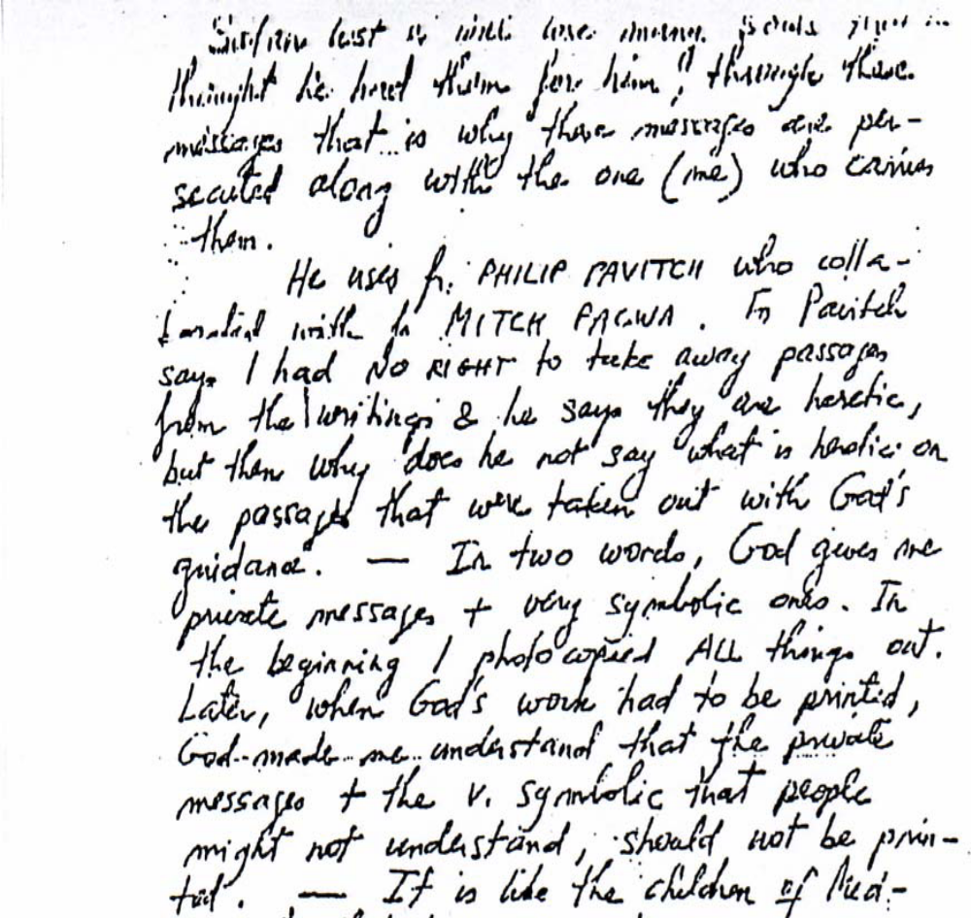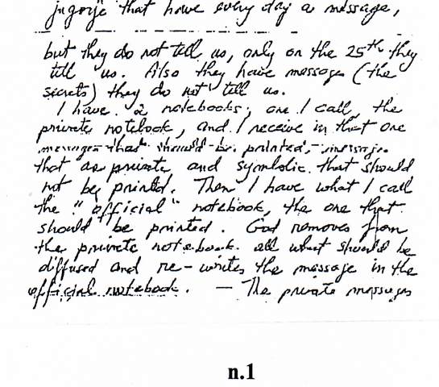
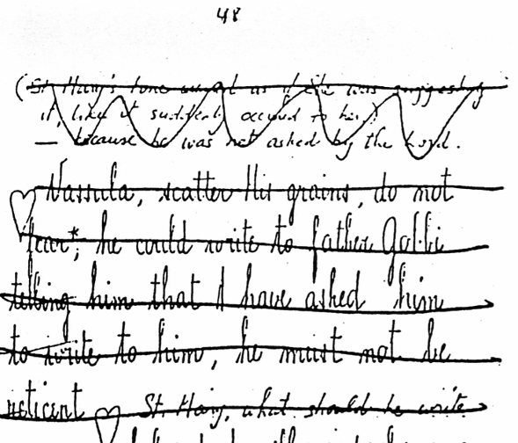
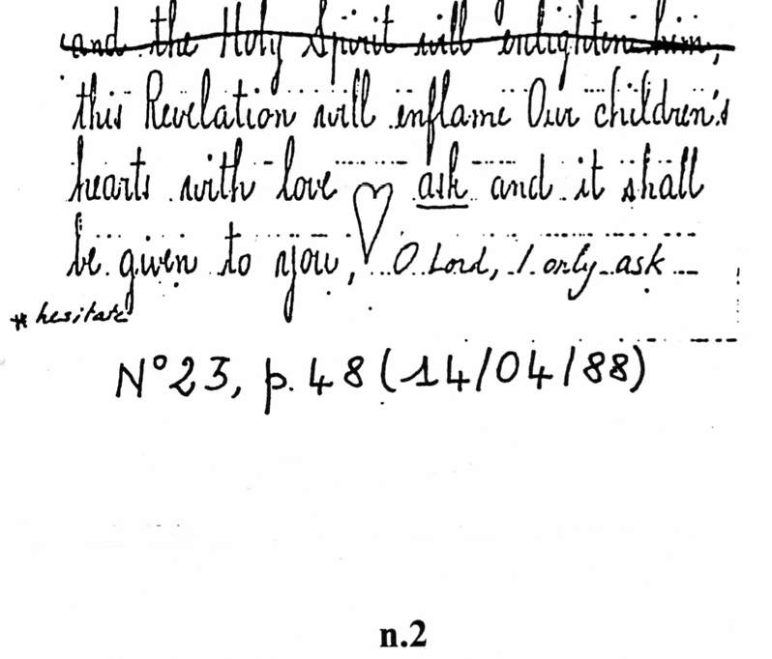
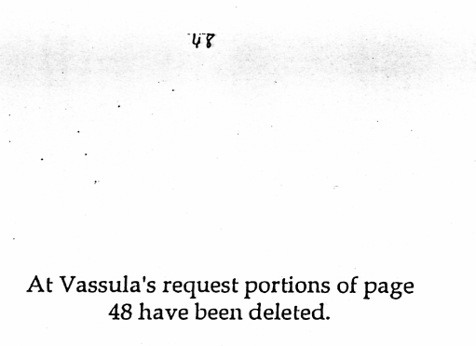
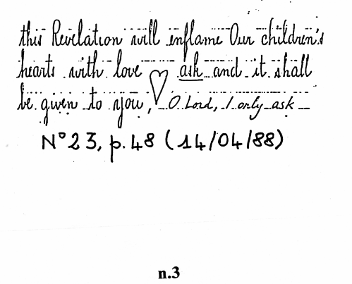
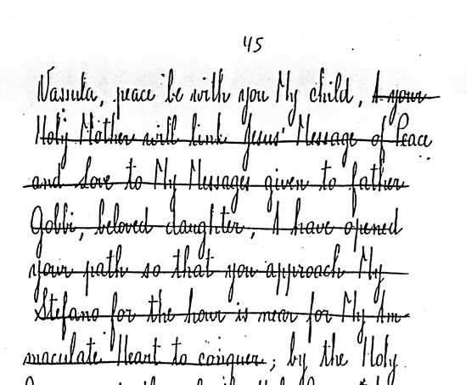
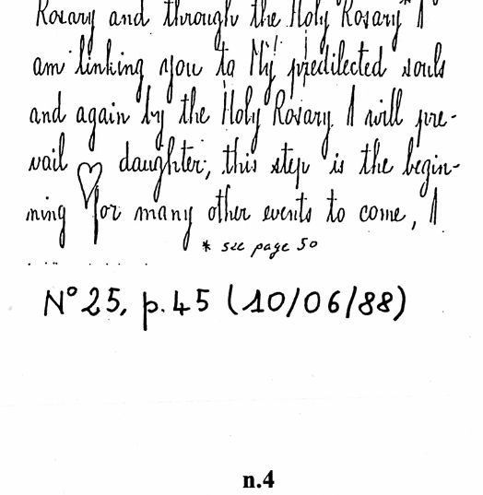
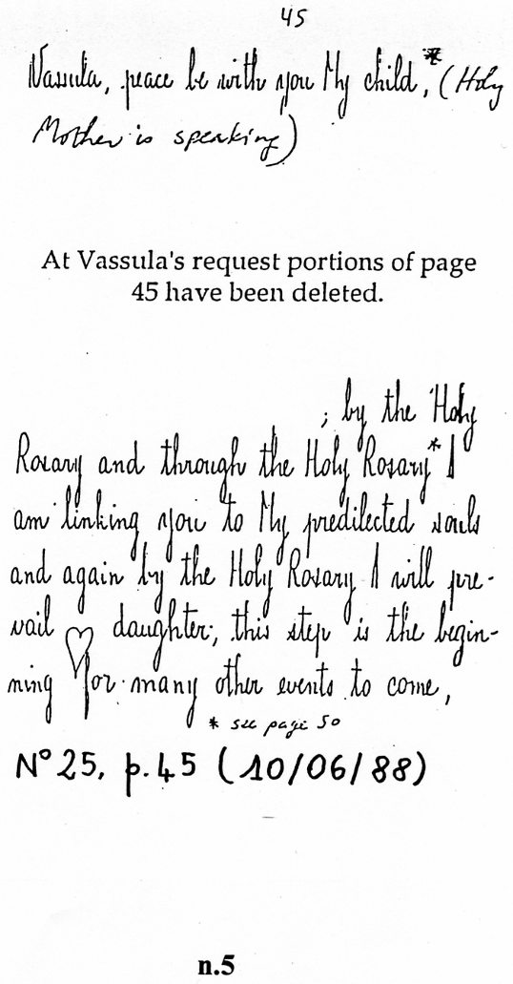
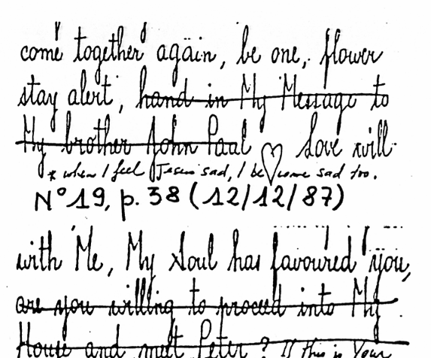

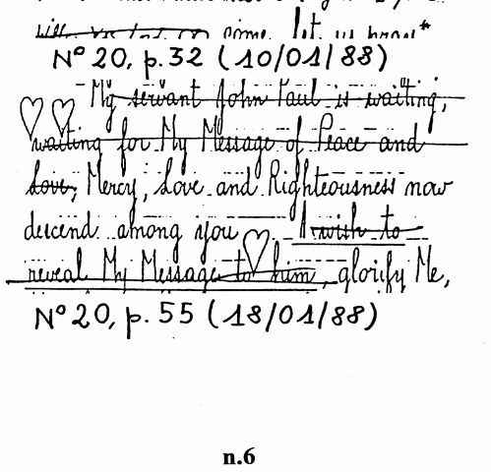
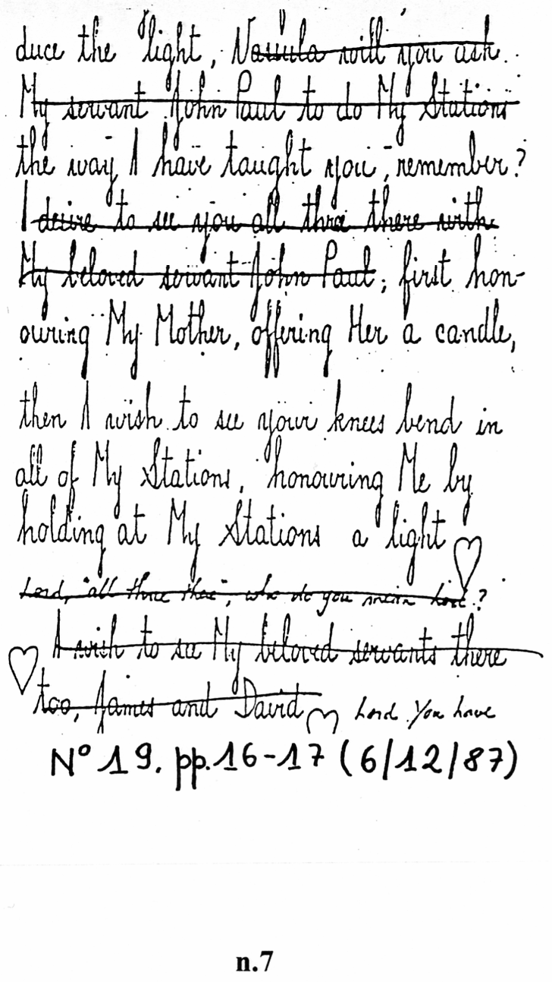

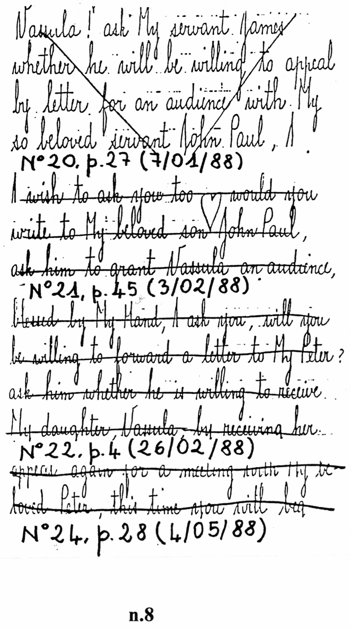
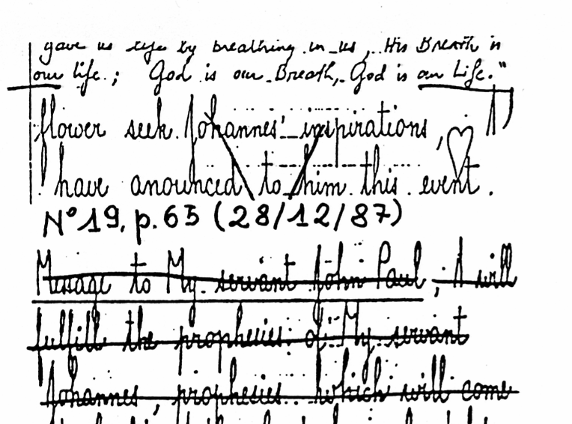
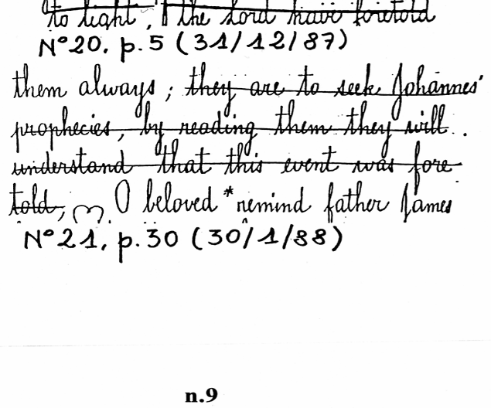
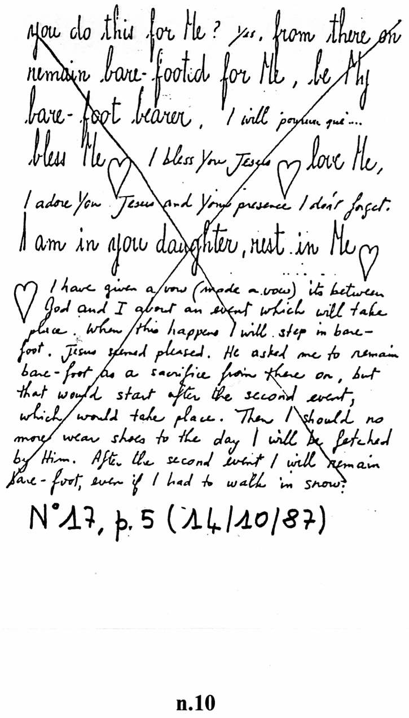
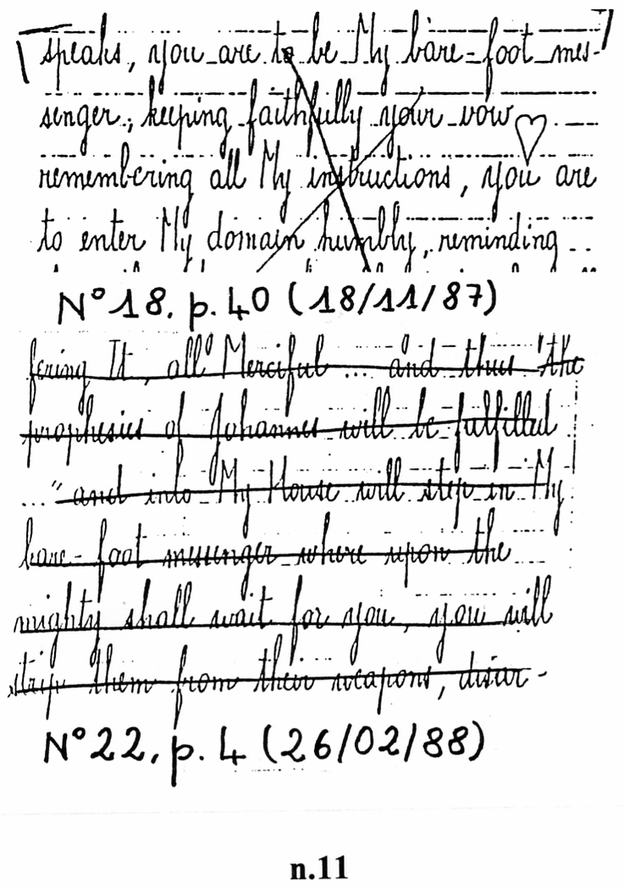

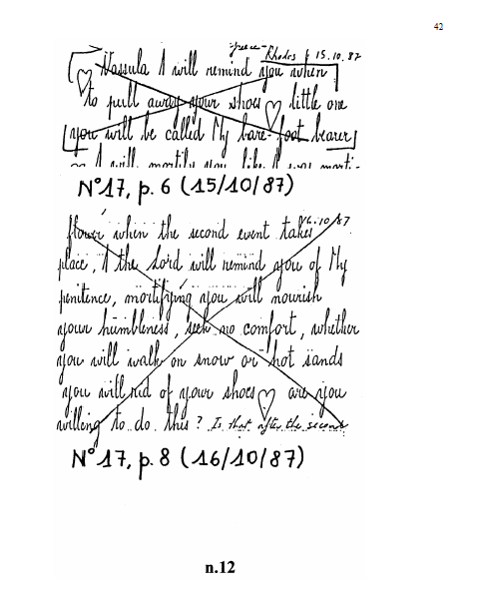

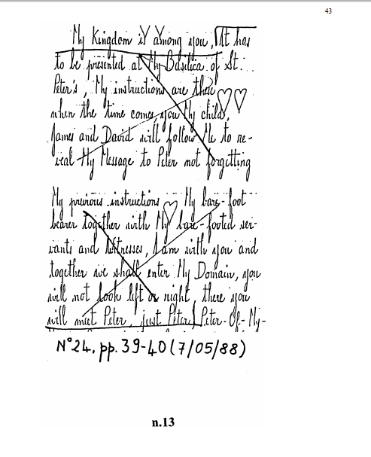

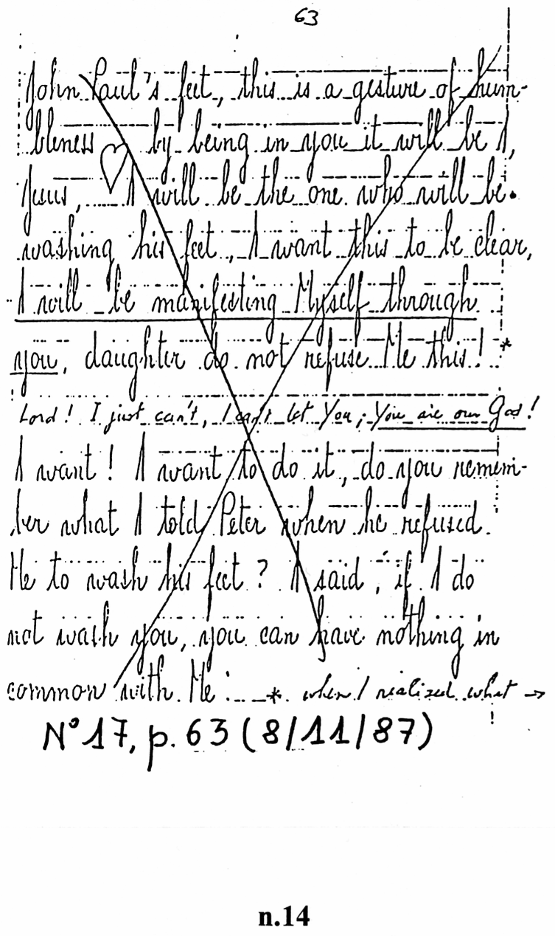
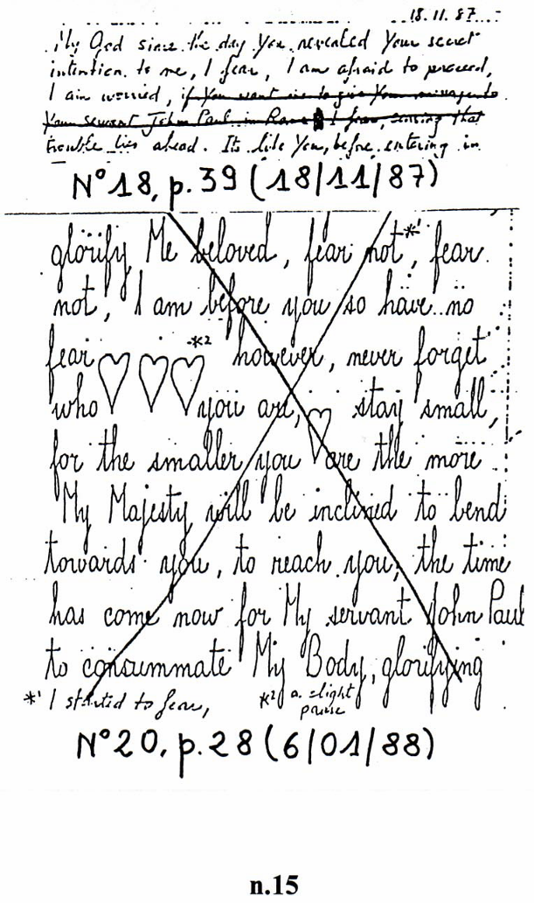

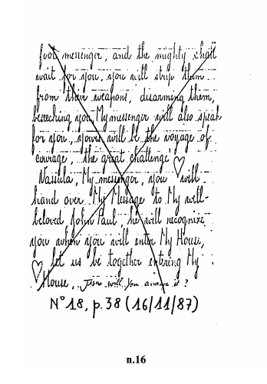

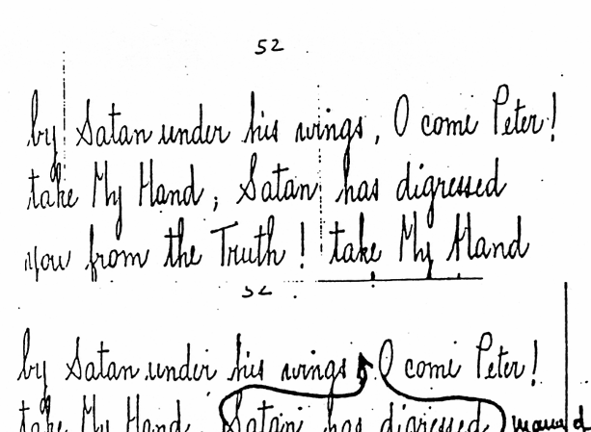
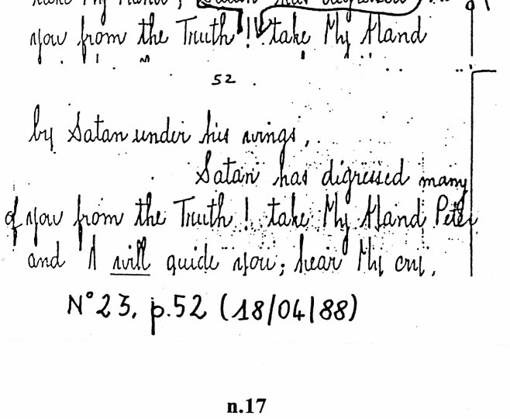
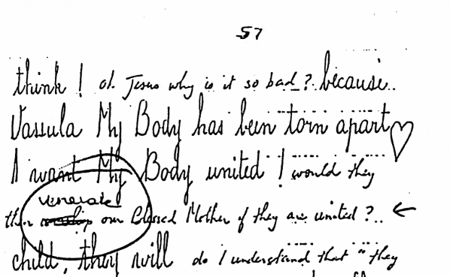
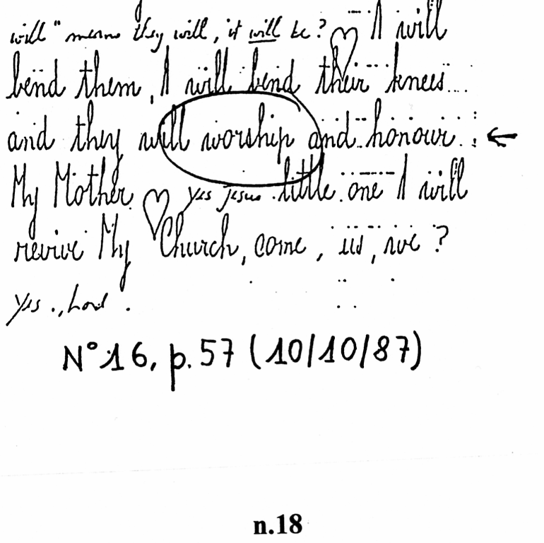
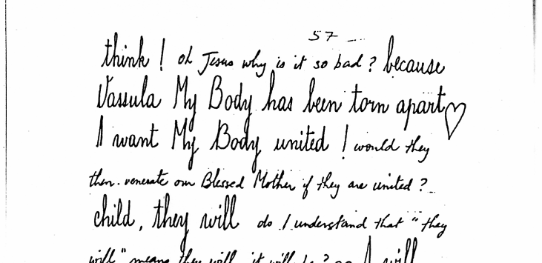
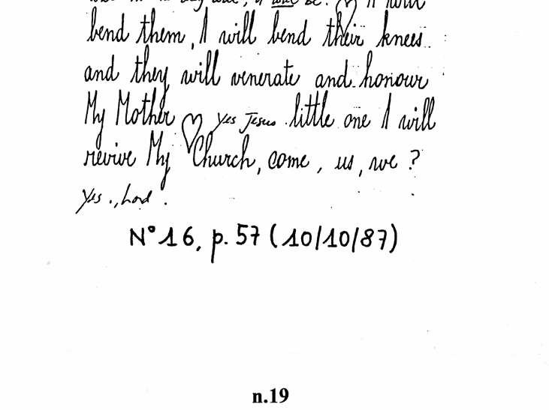
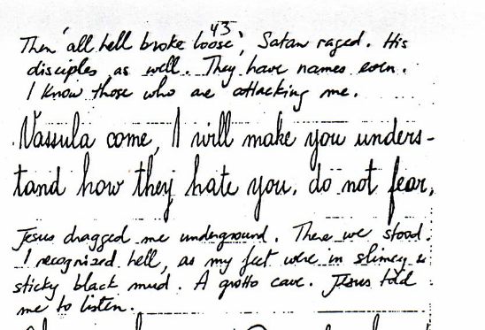
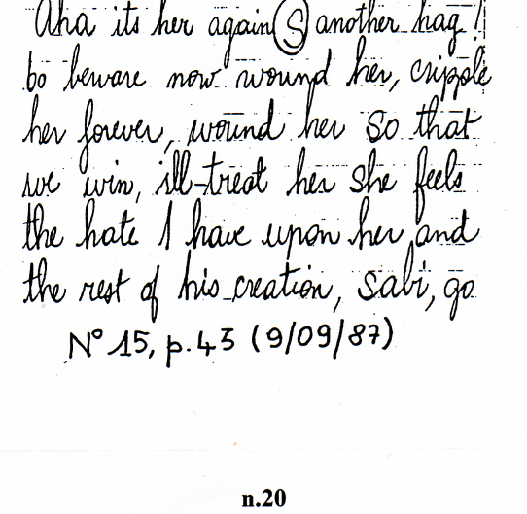

From: Maria Laura Pio To: infovassularyden_english@yahoogroups.com Sent: Thursday, January 24, 2008 6:30 PM
Subject: [infovassularyden_english] Vassula Ryden: the reasons of the Church, by Father Dermine
Dear Friends,
I have just posted on my website the newest article written specifically for the Internet by father François-Marie Dermine O.P. and titled "Vassula Rydén: the reasons of the Church" (link: www.infovassula.ch/dermine.htm)
Father Dermine is considered an expert in mysticism and alternative religious forms. He is professor of moral theology, member of the executive council of GRIS (a research group on religious phenomena, consultant to the Italian Bishops' Conference) and official exorcist of his diocese. In 1995 he published Vassula Rydén – Indagine Critica, a detailed study of the TLIG messages.
In this new article Father Dermine returns on some of the many reasons why Vassula Rydén's messages have not been recognized as authentic and comments some recent events. He presents for the first time on the Internet the proof of the censuring and modification of the original messages. In the chapter "Disappearance, cancellation, censuring and modification of messages" you will find find photocopies of the original messages with the corrections done by the seer. These documents are part of the famous photocopies circulated by Father Pavich in the 1990s, where it is possible to see the deleted passages and the modification of words and sentences in view of the publication of the messages. You will also find a fax written by Vassula in which she confirms having two sets of notebooks and tries to justify the censuring done to the messages.
I am particularely grateful to Father Dermine for giving me the opportunity to publish his article on my website. I am sure it will contribute significantly to help understand the reasons behind the Church's negative position towards these "revelations". Warmly in Christ, Maria Laura Pio www.infovassula.ch

Vassula Ryden: Theologians and bishops warn the faithful
http://web.archive.org/web/20100414095217/http://www.infovassula.ch/tligtheologians.htm EXTRACT
By Maria Laura Pio

Many are the theologians, bishops, priests and lay persons all over the world who have publicly issued warnings regarding the writings and actions of Mrs. Vassula Ryden, explaining the reasons for a call to prudence and discernment. We present hereunder some examples (all are documented).

ROMAN CATHOLIC CHURCH
Fr. François-Marie Dermine, O.P., theologian, University of Bologna (Italy), author of "Vassula Ryden: Una Indagine Critica" (1995), a critical study of the content of the messages and the seer's background. His conclusions are similar to those of the Notification from the CDF. Moreover, he presents arguments which link the TLIG phenomena to the New Age current (automatic writing, content of messages, etc.) More info... at http://web.archive.org/web/20090425203930/http://www.infovassula.ch/tliginterviewdermine.htm*.

We present hereunder extracts from an interview of Father François-Marie Dermine, O.P., Canadian, Doctor in Theology, professor of Moral Theology at the Theological Faculty of Emilia Romagna and at the Studio Teologico Accademico of Bologna (Italy), which is affiliated to the Philosophy Faculty of the Pontifical University of St. Thomas Aquinas in Rome. He is co-editor of the magazine "Religioni e sette nel mondo" (Religions and sects in the world). He is member of GRIS, an association based in Bologna and recognized by the Italian episcopal conference, which studies and informs about new religious groups and sects.
In 1995, he wrote "Vassula Ryden: Indagine Critica" (Ediz. Elle Di Ci, Leumann, Torino 1995), a critical study of the messages of True Life in God.
In 2002, he published "Mistici, Veggenti e Medium" (Mystics, visionaries and mediums), edited by the Vatican Publishing House (Libreria Editrice Vaticana, Città del Vaticano, www.libreriaeditricevaticana.com). It is a profound analysis of mediumistic phenomena. He mentions the case of Vassula Ryden, in particular in the section about automatic writing. The presentation of the book is written by Cardinal Georges Cottier, O.P., theologian of the Pontifical House.
The original interview in Italian was done by Silvana Radoani (Founder and President of the Associazione per lo Studio e l'Aiuto all'Abuso Psicologico - ASAAP) and was published in the magazine "Settimana", EDB, 2/06/1996. The translation to English was done by this site. The complete article in Italian may be read at: http://members.xoom.virgilio.it/radoani/vassula.htm or http://www.asaap.org/vassula.doc

*Interview with Fr. Dermine: "Those suspect messages of Vassula Ryden"
http://web.archive.org/web/20090425203930/http://www.infovassula.ch/tliginterviewdermine.htm
By Silvana Radoani
Father François Dermine, professor of theology in Bologna (Italy), is a Dominican who has extensively studied the phenomenon of Vassula Ryden's revelations, even before the Congregation for the Doctrine of the Faith's pronouncement against her. Vassula Ryden and her messages dictated by Jesus have caused a considerable rift inside the Catholic Church, as well as in the Orthodox Church (to which she belongs):

many have taken her side whilst others have rejected her without discernment. With considerable patience, Father Dermine has reconstructed Vassula Ryden's messages and life (in a book: "Vassula Ryden: Indagine Critica", Ed. Elle Di Ci), laying the basis for a fundamental clarification of her views and issuing a warning to all those who have been blinded by the sensationalism and the inscrutable, of which Vassula appears to be the reliable and indisputable bearer.
Let's ask some questions which summarize the phenomena and make it known to people of good will.

Silvana Radoani: It is a period of great confusion even inside the Church, due to the many pseudo-revelations, pseudo-apparitions or spiritistic phenomena: what importance does this phenomena have inside the Christian community?
Fr. Dermine: "Each case must be studied for itself, because some are authentic phenomena, and others not. In general, a large share of Catholics, in particular those more open to the extraordinary, are very sensitive to all the unusual. If we add to this, the insecurity in which people find themselves, or their tiredness of waiting for an end to these situations of uncertainty, plus the rationalism in which our faith is lived or at least presented, it is clear that many persons are tempted to turn to this type of messages and to a parallel magisterium (a magisterium that isn't the Church's), provided by these reassuring private revelations, which seem to be more important than the universal Church's teachings.
I also know many priests who have completely rejected the notification of the Congregation for the Doctrine of the Faith regarding Vassula Ryden. Some believe that Vassula is a charismatic, in the word's fullest meaning, and she herself has sought to slip into charismatic circles or in large charismatic demonstrations, but has only achieved it in a modest proportion (more in Canada than in Europe)."

In your book "Vassula Ryden - Indagine Critica" (Ed. Elle Di Ci), you have affirmed that Vassula is a pure New Age prophetess. Why?
She rejoins the New Age current on two essential aspects of that doctrine: 1) in the proclamation of the new age that is about to be established in the world, and which will bring peace, joy, felicity, regeneration, and 2) in the techniques she uses to communicate with Jesus, which are typically New Age (the writing which her defenders call hieratic = sacred, is nothing other than automatic writing).

How are the messages transmitted to her?
Through automatic writing, which she claims to have received against her will, with a phenomenology which put itself into place without warning** (and it may be true, at least in it's initial phase), but to which she later fully adhered, accepting the role of celestial secretary and starting to willingly receive these writings. At the beginning, there was only the phenomena of the automatic writing to which, some time later, the interior voice phenomena was added, interior locutions that accompanied the dictation. She, however, did not write with her writing what the interior locution suggested to her, but both phenomena occurred together; one could be sensed without the other or be simultaneous. She also claims to have witnessed apparitions of many personages (Jesus Christ, the eternal Father, the Virgin, some saints, Padre Pio). She has fully manifested charismatic phenomena, even if automatic writing is what characterizes her almost exclusively.
Above all, several messages have been completely counterfeited or cancelled (as reported in my book): she claims that the Father Himself had communicated to her that, if she felt so, she could change all the messages she did not feel appropriate to manifest. From my point of view, this should be enough to discard the whole phenomena.
The automatic writing instead, from our point of view, is used by the devil: there are in fact pages and pages of Vassula in which the devil steps in explicitly, that is to say that he manifests himself using the same identical writing of the divine messages. The same writing would therefore be used without distinction by God and by the devil, how is it possible?

Can you summarize the content of the messages transmitted by Mrs. Ryden?
She insists very much on global renewal, wants to prompt the churches, in particular the Catholic, Orthodox and Anglican ones, to a renewal that should take them to achieve full unity, a unity however not defined on a doctrinal nor hierarchical level. She declares to be above the churches, and this is most preoccupying, because it pre-announces the coming of a church that would receive instructions directly from heaven and would be directly guided by Jesus Christ and the Holy Spirit, prescinding from a hierarchy or an institution; a church very much spiritualized, where each one will let the Holy Spirit guide him/her. (*)
She is particularly violent against bishops and priests that oppose her, proposing the message that there are dozens or hundreds of bishops inside the Church which belong to the Masonry [Freemasonry –Michael]: in this way, she has created a strong distrust for the Catholic hierarchy. It is impressing to see how many lay people and priests have let themselves be seduced by this lack of confidence in Christ's promise to be always present in His Church until the end of the centuries.
And there is also the teaching of an imminent reign of millenaristic [millennialistic –Michael] type, which would be established on this earth and will bring only good fruit. There are also positive messages, to which her supporters refer, and against which no one has anything to object:

she denounces the rationalism that can be found in many catholic circles, and speaks against faith being presented as an ensemble of ideas or dogmas, and not as a reality which puts us in a personal relationship with God; even though Vassula's relationship with Jesus often stoops to banalities: for instance, when Jesus sits on the couch to speak with her while she is preoccupied about the house, feels a bit bored, starts to look at the clock because she has to prepare dinner and asks Jesus to let her go.

Why is it more often referred to spiritism than to divine revelation in Vassula's case?
Never has automatic writing been present in the story of mysticism. Vassula's supporters often cite the case of Santa Catherina of Sienna, who was illiterate and from one day to another started to write. But she had received the gift to write as if she had always known how to write, and not through guided writing.
**Mystics have always been respected in their humanity and their liberty, and have never been guided by God against their will and forced to do things that they could not achieve otherwise. God uses our humanity without excluding it and without going against it, which was not the case at the beginning with Mrs. Ryden. Some people say that Vassula has remained free, but was given the faculty to write with her hand the messages without herself being responsible for it: but this isn't respect of God for our humanity, a respect that has always characterized His doing.
In the inspiration phenomena, for instance, the Lord always respects the persons' culture, their freedom and their humanity: when a saint writes what God inspires him, he is well aware of what he is writing; his arm is not reacting as a telewriter: if that were the case, God could have also better used an ape. We encounter here a big confusion generated by the New Age, which affirms that our mystics are essentially mediums: no difference is made between spiritism and a real charisma.

Is Vassula's life in accordance with the Gospel and the Church's teachings?
She has a marital record that places her in an irregular situation, at least for the Catholic Church: there are contradicting versions, given by René Laurentin, who gives up to four different ones. She appears to be a divorced/remarried, situation that seems to be admitted in her Orthodox church, but that is not accepted in ours. She claims to be more Catholic than Catholics in doctrinal matters, but does not want to adhere to the Catholic Church to avoid damaging this unifying role she proposes to play between the Orthodox and the Catholic. She claims to be Catholic from a doctrinal point of view, but refuses to submit to any ecclesiastical authority (nor catholic, nor orthodox), remaining substantially on a neutral and irreproachable ground. In spite of this very irregular situation, she has felt the duty to accede to all the Catholic Church's Sacraments, although remaining legally speaking an Orthodox and in spite of being a divorced/remarried.

Why do so many priests let themselves be involved in these facts?
Many of these priests, yet being good priests, feel the need to be comforted: though being reliable, attentive and obedient to the Church, the Pope and their ministry, they feel discouraged by a world that every day moves farther away from them. This is why they feel the need for a call that works as a strong reference point for a profound renewal, and offers certainties to their doubts.
Vassula offered a return to the Church of the origins, to the Pope, to the Rosary; she opposed reincarnation, and therefore seemed traditional in her teachings. The priests who were already faithful to these points, found a great affinity with Vassula's thought and God's personal comfort (because she seemed to be speaking in the name of God, encouraging them to continue doing what they were already doing, while waiting for something that would come and completely shake the world, harvesting the fruit of their submissiveness).

However, I seem to understand that, in spite of the clarification given by the Congregation for the Doctrine of the Faith, the Ryden phenomena continues to subsist?
The Congregation has been very clear and specific in its pronouncement: this means that no bishop or priest can invite Mrs. Ryden for a public conference and this implies that effectively her activities have been almost completely reduced. I believe that bishops and priests that do not obey these dispositions risk ecclesiastical disciplinary actions.
Exception made of some sporadic episodes of priests who still support Vassula Ryden, the phenomena seems to have greatly diminished, and on the other hand, it is in her interest to remain quiet and prove her good will and her obedience (something never done before).
(*) Note added by this website: This point clearly refers to a world religion, which is what the New Age proposes. That "Jesus" is not different from the New Age Cosmic Christ.
The original text is in Italian. The translation to English was done by this website. The complete article in Italian may be read at: http://members.xoom.virgilio.it/radoani/vassula.htm or http://www.asaap.org/vassula.doc

See
VASSULA RYDEN-PROBLEMS WITH ROME BUT WELCOME IN INDIA
http://ephesians-511.net/docs/VASSULA_RYDEN-PROBLEMS_WITH_ROME_BUT_WELCOME_IN_INDIA.doc
VASSULA RYDEN-THE REASONS FOR THE CHURCH'S NEGATIVE REACTION
http://ephesians-511.net/docs/VASSULA_RYDEN-THE_REASONS_FOR_THE_CHURCHS_NEGATIVE_REACTION.doc
VASSULA RYDEN-FR MITCH PACWA
http://ephesians-511.net/docs/VASSULA_RYDEN-FR_MITCH_PACWA.doc
VASSULA RYDEN-MARK WATERINCKX
http://ephesians-511.net/docs/VASSULA_RYDEN-MARK_WATERINCKX.doc
VASSULA RYDEN-TESTIMONIES
http://ephesians-511.net/docs/VASSULA_RYDEN_TESTIMONIES.doc
VASSULA RYDEN-A CRITIQUE-DIALOGUE CENTRE INTERNATIONAL
http://ephesians-511.net/docs/VASSULA_RYDEN-A_CRITIQUE-DIALOGUE_CENTRE_INTERNATIONAL.doc
VASSULA RYDEN-RICHARD SALBATO
http://ephesians-511.net/docs/VASSULA_RYDEN-RICHARD_SALBATO.doc
VASSULA RYDEN-EWTN
http://ephesians-511.net/docs/VASSULA_RYDEN-EWTN.doc

