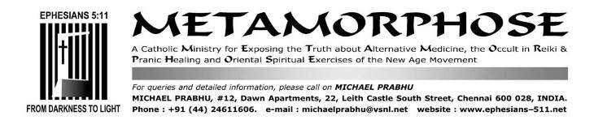
SEPTEMBER 6, 2019

Jesuit Fr. Menino Gonsalves’ church is a Hindu temple.
Belgaum Bishop Derek Fernandes says “Mass” there
In Karnataka, a church that is also a temple
https://www.thehindu.com/news/national/karnataka/in-karnataka-a-church-that-is-also-a-temple/article24542424.ece
By Rishikesh Bahadur Desai, July 28, 2018
Hindus attend mass at the Snanika Arulappanavara Virakta Mutt in Belagavi that has a Siva lingam, Jesus and Mary idols

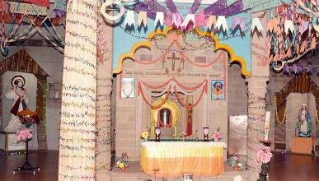

About 28 km from Belagavi in north Karnataka, in a picturesque village called Deshanur, stands the impressive stone building of Snanika Arulappanavara Virakta Mutt, or the Church of Saint John the Baptist.
The structure, built in the Banarasi Nagara style, is seen as an example of syncretism: it has a Siva lingam, flanked by the idols of Jesus and Mary. Its walls are adorned with the sayings of the saint-poet-reformer Basaveshwara, the icon of the Lingayat movement, poet-musician Purandara Dasa, and also the Bible.
The Jesuit priest who runs the Church, Menino Gonsalves alias Sri Menino Swamy, wears saffron robes and a rudraksha mala with a cross. He performs pooja with aarathi during mass, and claims to be an Ayurvedic healer. He has visited Rishikesh and Haridwar and also the Vatican. He speaks eight languages and conducts mass in Kannada. In a village that has no Christians, the church has full attendance during Sunday mass.
“Nothing I do makes me uncomfortable or is alien to my faith,” says Sri Menino. “I call this assimilation of cultures. I don’t force my beliefs on anyone. In fact, preaching is only a small part of my routine. Most of my time is spent teaching, healing and in social work.”
The assimilation began with the founding father of the Mutt, Armado Alvares, who called himself Sri Animananda Swamy. His ancestors hailed from Goa, but he was born in Africa — where his father was a government officer — in 1903. He moved to Goa for his studies and worked as a teacher in Belagavi for some years before settling in Deshanur, arriving a few months after independence in 1947. He started a home for destitute boys in 1950 and a Kannada-medium school for girls in 1953. Now, the destitute home has 50 boys; while the school has become a co-educational one, with 350 boys and girls.
Giving full credit to the villagers for the survival of this decades-old church-temple, Sri Menino says, “If the villagers have allowed us to serve them despite the difference in faith, it is because they are large-hearted.”
The villagers use hybrid terminology to describe the institution and its branches. The convent is called Padri Mutt and the temple, Church Gudi. The entire village comes together to celebrate Makara Sankranti and Christmas, on the model of village fairs.

Sri Menino says, “Jesus Christ wants us all to be better human beings. We want Hindus to be better Hindus, Muslims to be better Muslims and Christians to be better Christians. I have never advocated conversion. I have advised a Hindu girl who wanted to marry a Christian boy to stay a Hindu and marry under the Special Marriages Act. It is not religion that ensures a lasting marriage — it is love.”

In A Village in Karnataka, there exists a Temple that is also a Church
https://chaaipani.com/templealsoachurch/
August 7, 2018

Around 28 km from Belagavi in north Karnataka, is a village named Deshanur. In this village is the beautiful stone building of Snanika Arulappanavara Virakta Mutt, or the Church of Saint John the Baptist. Yes, you read that right. A temple and a church coexist in the village. This temple is one of its kind. Built in Banarasi Nagara style, this religious building is an example of syncretism. It has a Siva lingam flanked by the idols of Jesus and Mary.
Menino Gonsalves alias Sri Menino Swamy, is the priest who runs the church. He dresses in saffron robes and wears a rudraksha mala with a cross. Not only does he conduct mass but also performs pooja and aarti during mass.
He pays visits to Haridwar, Rishikesh and Vatican. Deshanur is a village with no Christians, and they yet all attend the Sunday mass.
The priest makes a conscious effort to not force his believes on anyone. An Ayurvedic healer by profession, the priest believes and accepts different ideologies. He focuses his energy on social work and spends a lot of his time teaching. He credits this harmony to the villagers. He credits the villagers for having such a big heart as they allow him to serve them despite the difference in faith.
This village is unique. They get together to celebrate Makar Sankranti and Christmas together. The biggest religion of the people of the village is unity and harmony. Menino Gonsalves doesn’t force conversion on people. In fact he wants people to be more true to their religion and follow their religion more whole heartedly.
“Jesus Christ wants us all to be better human beings. We want Hindus to be better Hindus, Muslims to be better Muslims and Christians to be better Christians. I have never advocated conversion”, says Sri Menino.
After all, how we live our religion is more important than what we say about our religion, right?

Belgundi Church Celebrate Annual Feast
https://indiancatholicmatters.org/karnataka-belgundi-church-celebrate-annual-feast/
By Louis Rodrigues, January 27, 2019
Belgundi parish which lies about 10 km. towards west of Belgaum city comes under Diocese of Belgaum has about 100 Catholic families of Goan origin and a century-year old church. – Our Lady of Piety or ‘Piedade Saibinn’ as she is identified locally is the village patroness.
In his homily eminent Jesuit priest Fr Menino Gonsalves emphasised on the importance of a mother in each one’s life. “Jesus too performed his first miracle on the direction of Mother Mary, hence we too must respect our mother and take special care of our mother,” Fr Menino said. Parish priest Fr John Fernandes, assisted by Fr Thomas Lobo and villagers had made elaborate arrangements for the feast.

MY COMMENTS
1. First, know that Bishop Derek Fernandes of Belgaum approves of this temple-church with the bastardized “Mass”. He celebrates “Mass” there.
In pictures 3 and 4 below, he is in the centre, sporting the Hindu tilak on his forehead.
At least three of the priests in the pictures are wearing Hindu saffron-coloured (or “kavi”) robes. The other four priests (in cassocks) have saffron shawls draped over their shoulders.
They concelebrate “Mass” in the temple-church (image no. 2, 3 and images on pages 6 to 9).

2. Such Hindu dress, or wearing of the saffron shawl over the cassock, is a grave liturgical abuse:
FR. BRYAN LOBO SJ AND FR. NEELAM LOPES SJ AND THEIR SAFFRON SHAWL-SQUATTING MASSES
MAY PRIESTS WEAR A SHAWL WHILE CELEBRATING HOLY MASS 44 pages
http://ephesians-511.net/docs/MAY_PRIESTS_WEAR_A_SHAWL_WHILE_CELEBRATING_HOLY_MASS.doc
PRIESTS WEARING SHAWLS OVER CIVILIAN CLOTHES TO CELEBRATE LITURGY IS PROHIBITED: CCBI 7
http://ephesians-511.net/docs/PRIESTS_WEARING_SHAWLS_OVER_CIVILIAN_CLOTHES_TO_CELEBRATE_LITURGY_IS_PROHIBITED.doc
THE TWELVE POINTS OF ADAPTATION AND THE INDIAN RITE MASS ARE ABROGATED 7 pages
http://ephesians-511.net/docs/THE_TWELVE_POINTS_OF_ADAPTATION_AND_THE_INDIAN_RITE_MASS_ARE_ABROGATED.doc

In September 2016, the Conference of Catholic Bishops of India (CCBI) abrogated the “Indian rite” squatting shawl “Mass” and banned the wearing of the shawl by priests in their 84-page “Directives for the Celebration of the Liturgy”.

Jesuit Fr. Bryan Lobo is the Director of the Department of Theology of Religions, part of the faculty of Missiology at the Gregorian University Rome. He wore the saffron shawl over civilian clothes to say Mass.
The “shawl-squatting Mass”* is the Indian rite of the “Mass”** of the heretical Catholic Ashrams movement*** and encourages a number of aberrations apart from those “approved” (read as “fraudulently obtained from”****) by the Vatican. It has spawned some variations such as the “shawl” Mass in which priests do not squat but are not vested according to the liturgical requirements*****.

*THE SQUATTING INDIAN RITE MASS 18 pages
http://ephesians-511.net/docs/THE_SQUATTING_INDIAN_RITE_MASS.doc
**NBCLC-HARBINGER OF THE INDIAN RITE MASS AND LITURGICAL ABUSE 37 pages
http://ephesians-511.net/docs/NBCLC-HARBINGER_OF_THE_INDIAN_RITE_MASS_AND_LITURGICAL_ABUSE.doc
***CATHOLIC ASHRAMS 96 pages + several related files
http://ephesians-511.net/docs/CATHOLIC_ASHRAMS.doc,
****THE TWELVE POINTS OF ADAPTATION FOR THE INDIAN RITE MASS-WAS A FRAUD PERPETRATED ON INDIAN CATHOLICS? 27 pages
http://ephesians-511.net/docs/THE_TWELVE_POINTS_OF_ADAPTATION_FOR_THE_INDIAN_RITE_MASS-WAS_A_FRAUD_PERPETRATED_ON_INDIAN_CATHOLICS.doc
*****PRIESTS VESTMENTS AND THEIR MEANINGS 20 pages
http://ephesians-511.net/docs/PRIESTS_VESTMENTS_AND_THEIR_MEANINGS.doc

I researched into what the shawl (called a ponnadai in Tamil and chaddar in Hindi) and the colour saffron signify in Indian culture and Hinduism.
Saffron, also called “ochre”, is not a Catholic liturgical colour. Neither is a shawl a liturgical vestment.
The saffron colour and shawl are exclusive to Hinduism and Buddhism. Jains and Muslims wear white. So do Brahmin priests. It is only the ascetics who wear saffron. Sikhs wear orange (they generally prefer not to call it saffron), or blue and white.
Radical Hindus are described as “saffronised”. So, wearing a saffron shawl is not Indian culture. It is Hindu or “Hinduisation” of Catholicism.
There seems to be no doubt that saffron is the sacred colour of the Hindu religion, but a shawl is not in common use as most sants (“saints”), gurus, babas and holy men are either bare-bodied or saffron-robed.
There are some really occult explanations (as per Hinduism) for the shawl -- such as at the Hindu dharma site: http://hindudharmaforums.com/showthread.php?9683-Prayer-shawl-scarf,
https://www.quora.com/Why-is-the-color-Saffron-so-important-in-Hinduism-as-well-as-otherwise, etc.

A priest may NOT wear a saffron shawl, ANY shawl, while celebrating Holy Mass:
To: Michael Prabhu From: CCBI Secretariat ccbisecretariat@gmail.com Date: Tue, 11 Oct 2016 18:07:28 +0530
Subject: (1) USE OF A SHAWL BY PRIESTS AT MASS (2) PLACING OF OFFERINGS/GIFTS
Your email has been directed to me as secretary of the Liturgy Commission, by Fr. Stephen Alathara.
Well, there was never a time in the Church when priests were permitted to celebrate Mass or the Sacraments without liturgical dress. In other words, no priest can celebrate liturgy with a shawl or a stole on civilian clothes.
The CCBI has just published "Directives for the Celebration of the Liturgy". It was released on the 20 September, 2016 at St. John's, Bangalore.
The vestments for Mass are an alb, cincture, stole and chasuble. The shawl takes the place of the chasuble. Concelebrants too put on the sacred vestments they customarily wear when celebrating Mass individually. However should a just cause arise (e.g. a more considerable number of concelebrants or a lack of vestments), they may omit the chasuble but never the Stole (RS 123, 126); (GIRM 209; GIRM 335; GIRM 345; Redemptionis Sacramentum 124).
Do not use only the stole over the monastic cowl or the common habit of religious or ordinary clothes, the abuse is reprobated (RS 126); Liturgicae Instaurationes, n. 8c: AAS 62 (1970), p.701
Offerings of the People: Besides Bread and wine, other gifts including the money are to be kept in a suitable place at the side and not on the Altar or at the foot of the Altar. The Chalice is never to be carried in the offertory procession.
You could order from the CCBI, the Directives.
Thank you for your interest in matters liturgical and may God Bless you!
Fr. Ayres Fernandes, Secretary of the Liturgy Commission of the Conference of Catholic Bishops of India, Bangalore (as instructed by Fr. Stephen Alathara, Deputy Secretary General, CCBI)

3. The edifice is not erected in the tradition of Catholic churches, but according to the Hindu “Banarasi Nagara” style. See pictures 2, 3. So, it very probably embraces occult “vaastu” principles.

4. The red Hindu marking on the foreheads of Bishop Derek Fernandes and Menino Gonsalves SJ and four priests (who probably include John Fernandes and Thomas Lobo) is the tilak:
BINDI OR TILAK MARK ON THE FOREHEAD-INDIAN OR HINDU? 58 pages
http://ephesians-511.net/docs/BINDI_OR_TILAK_MARK_ON_THE_FOREHEAD-INDIAN_OR_HINDU.doc

5. The individual to the left of the Bishop in pictures 1, 3 is Sri Menino Swamy alias Fr. Menino Gonsalves SJ, the “parish priest” of the “church” which is supposed to be dedicated to St. John the Baptist. More about him as we proceed.

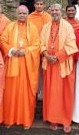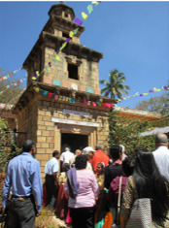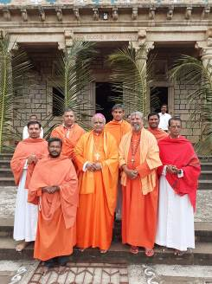

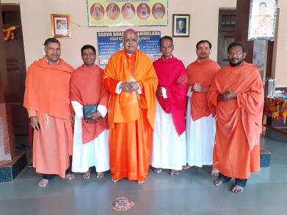
1, 2, 3, 4. The portraits are those of Pope Francis (L) and Jesuit Superior General Sosa (R)

6. The feet of the Bishop and his crew are shod when outside the temple (1, 3) but sans footwear inside (4). They do not practice this in a regular Catholic church. Apparently, they consider this hybrid place of worship “holy ground” and do not want to hurt the sentiments of Hindus.

7. The news stories on pages 1 (with image) and 2 report that the temple-church has a Siva-lingam (the sexual organ of the Hindu deity Siva). It is in fact the “Tabernacle” where Jesus is supposed to be reposed.

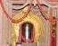

SHIVALINGA AND THE HINDU DEITY SHIVA 15 pages
http://ephesians-511.net/docs/SHIVALINGA_AND_THE_HINDU_DEITY_SHIVA.doc
SHIVALINGA TABERNACLE OF JESUIT PRIEST SHILANANDAS CHURCH 14 pages
http://ephesians-511.net/docs/SHIVALINGA_TABERNACLE_OF_JESUIT_PRIEST_SHILANANDAS_CHURCH.doc

8. Siva’s lingam is reportedly flanked by “idols of Jesus and Mary”. What else can one expect in a temple? Catholics and their churches have statues. Hindus and their temples keep idols.

9. Not only is the architecture an excellent example of religious syncretism (fusion of religious beliefs) -- as the news stories report -- but also the religious rituals and outfits of the Catholic clerics including that of Sri Menino Swamy.
He visits the holiest of Hindu sites like Haridwar and Rishikesh as casually as he visits the Vatican.
In the vernacular, his travesty of a church is called a “mutt” or “math” (Sanskrit) which means an institution attached to a Hindu temple.
Menino wears a rudraksha mala or garland and performs arati during the Liturgy of his “Mass”.
The former is associated with the Hindu god Siva and the latter is indisputably a Hindu practice that got included using fraudulent tactics in the 12 points of the now-abrogated Indian rite Mass.
RUDRAKSHA BEADS AND THE HINDU DEITY SHIVA 6 pages
http://ephesians-511.net/docs/RUDRAKSHA_BEADS_AND_THE_HINDU_DEITY_SHIVA.doc
CATHOLIC MISAPPROPRIATION OF THE HINDU RUDRAKSHA MALA
http://ephesians-511.net/recent/docs/CATHOLIC_MISAPPROPRIATION_OF_THE_HINDU_RUDRAKSHA_MALA.doc
ARATI IN THE LITURGY-INDIAN OR HINDU? 76 pages
http://ephesians-511.net/recent/docs/ARATI_IN_THE_LITURGY-INDIAN_OR_HINDU.doc
THE TWELVE POINTS OF ADAPTATION FOR THE INDIAN RITE MASS-WAS A FRAUD PERPETRATED ON INDIAN CATHOLICS? 27 pages
http://ephesians-511.net/docs/THE_TWELVE_POINTS_OF_ADAPTATION_FOR_THE_INDIAN_RITE_MASS-WAS_A_FRAUD_PERPETRATED_ON_INDIAN_CATHOLICS.doc

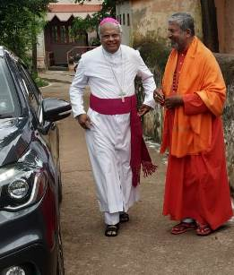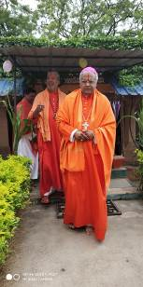
With Menino Swamy, Bishop Derek Fernandes before… and after saffronising.

10. Lighting the ubiquitous Hindu oil lamp.
WHAT DOES THE KUTHU VILAKKU OIL LAMP SIGNIFY? 18 pages + several related files
http://ephesians-511.net/recent/docs/WHAT_DOES_THE_KUTHU_VILAKKU_OIL_LAMP_SIGNIFY.doc

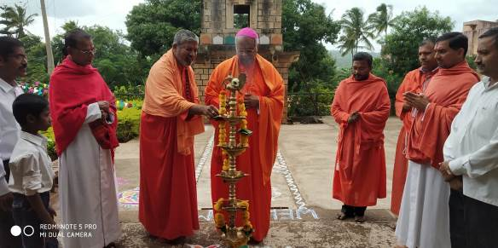

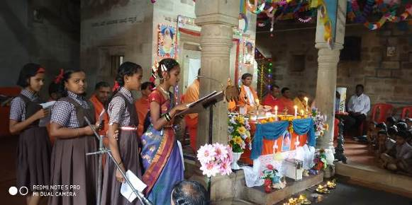

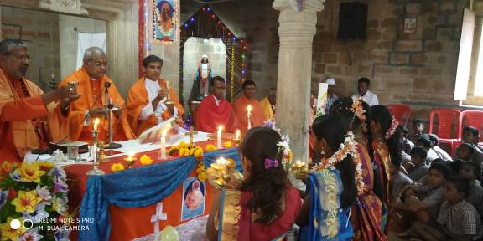
Arati (aarti)

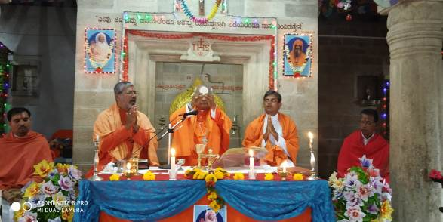

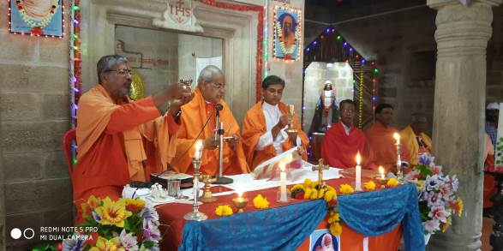

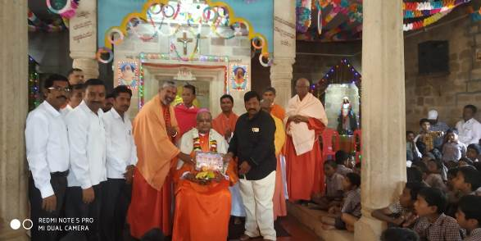

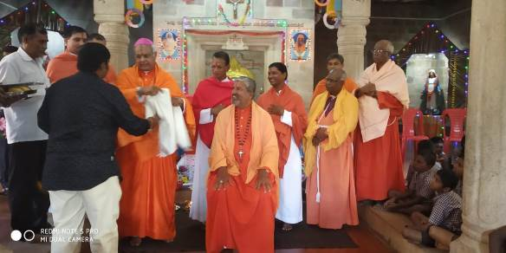

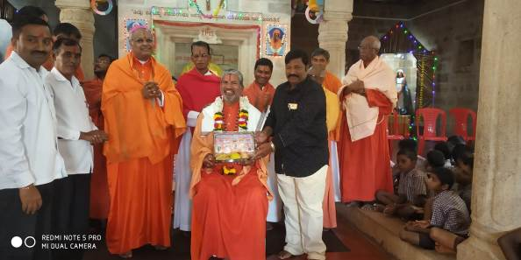

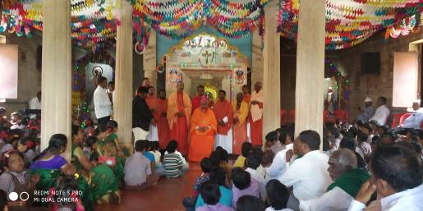

11. If one examines the images, the irreverence of the typical Novus Ordo Mass is apparent.
A man can be seen using his cell phone, immediately above, far right corner. The “sanctuary” area is utilised for multiple activities, apparently non-liturgical, backs to the lingam-tabernacle and accompanied by discussions, presentation ceremonies, posing and grinning priests.

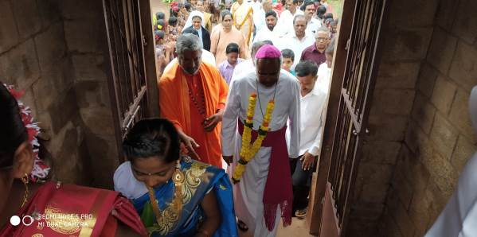

12. Jesuit Superior-General Fr. Arturo Sosa visits, blesses, endorses the temple-church. The Jesuits describe this Hinduisation as the “Indianization” of the Gospel:

The “Indianization” of the Gospel
Jesuit Menino Gonsalvez (sic) makes himself Sri Menino Swami
https://sjcuria.global/en/more-travels/469-the-indianization-of-the-gospel
March 5, 2019

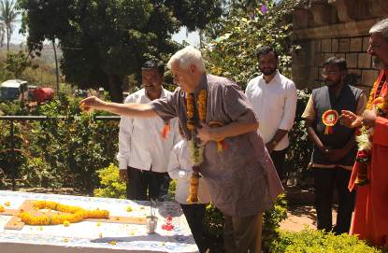
Fr. Sosa honoring the tomb of the founder Fr. Armado Alvares alias Sri Animananda Swamy

A small church in the village of Deshanur, India is built and decorated in the tradition of Hindu temples. Of a few hundred inhabitants, less than twenty are Catholics, with the remainder being Hindu or Muslim. But all of them meet around the swami, their spiritual animator, Fr. Menino. The church is full; people sing, they pray. This is the practice of interreligious relations. Look at the photos [https://www.flickr.com/photos/jesuitsglobal/albums/72157690158513493/] and listen to Fr. Menino who talks about the universal relationship of love he has with the people of his village.
Listen to Fr. Menino SJ

Images at Jesuits Global https://www.flickr.com/photos/jesuitsglobal/albums/72157690158513493/:

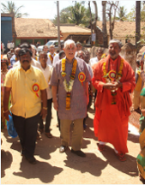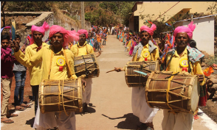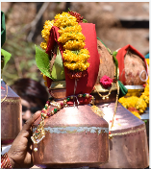

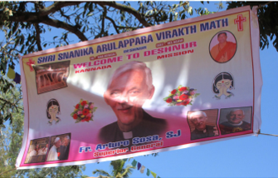

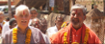
Jesuit Superior General Fr. Arturo Sosa sporting the Hindu tilak along with Menino Swamy SJ

JESUIT FR ARTURO SOSA MARXIST-BUDDHIST BLACK POPE REINTERPRETING JESUS AND SATAN
http://ephesians-511.net/docs/JESUIT_FR_ARTURO_SOSA_MARXIST-BUDDHIST_BLACK_POPE_REINTERPRETING_JESUS_AND_SATAN.doc
JESUS WORDS AGAINST DIVORCE ARE RELATIVE-JESUIT SUPERIOR GENERAL
http://ephesians-511.net/recent/docs/JESUS_WORDS_AGAINST_DIVORCE_ARE_RELATIVE-JESUIT_SUPERIOR_GENERAL.doc
JESUIT SUPERIOR GENERAL DOES NOT BELIEVE SATAN IS A REAL PERSON
http://ephesians-511.net/recent/docs/JESUIT_SUPERIOR_GENERAL_DOES_NOT_BELIEVE_SATAN_IS_A_REAL_PERSON.doc
JESUIT SUPERIOR GENERAL SAYS SATAN NOT A REAL PERSON. CHURCH’S EXORCISM RITE BELIES HIM http://ephesians-511.net/recent/docs/JESUIT_SUPERIOR_GENERAL_SAYS_SATAN_NOT_A_REAL_PERSON-CHURCHS_EXORCISM_RITE_BELIES_HIM.doc

13. Apparently, there has never been a single conversion to Christianity in the village of Deshanur.
There never was an intention to proselytize or even to witness to Christ. At Deshanur, Christ is one of many gods. Deshanur’s faux Catholicism simply appeals to the Hindus’ syncretistic mindset and worldview. They are not challenged to accept the unicity of Christ because they are not aware of it.

Today, across the spectrum of the Indian church, not just with the Jesuits, there is zero active evangelisation. Along with the syncretised approach, there is an almost total emphasis on social work. Find below some extracts from the two secular news stories included upfront:
(In Deshanur,) he [the founder] started a home for destitute boys in 1950 and a Kannada-medium school for girls in 1953.
Sri Menino says, “Jesus Christ wants us all to be better human beings. We want Hindus to be better Hindus, Muslims to be better Muslims and Christians to be better Christians. I have never advocated conversion. I have advised a Hindu girl who wanted to marry a Christian boy to stay a Hindu and marry under the Special Marriages Act. It is not religion that ensures a lasting marriage — it is love.”
“Nothing I do makes me uncomfortable or is alien to my faith,” says Sri Menino. “I call this assimilation of cultures. I don’t force my beliefs on anyone. In fact, preaching is only a small part of my routine. Most of my time is spent teaching, healing and in social work.”
They get together to celebrate Makar Sankranti and Christmas together. The biggest religion of the people of the village is unity and harmony. Menino Gonsalves doesn’t force conversion on people. In fact he wants people to be more true to their religion and follow their religion more whole heartedly.
The priest (Menino) believes and accepts different ideologies. He focuses his energy on social work.
Menino lies. Jesus was not incarnated as man in order for us “to be better human beings”. I suppose that it would be pointless for us to draw the attention of Bishop Derek Fernandes and Fr. Menino Gonsalves and their ilk to the Great Commission, Matthew 28:16-20. Also see:
SOCIAL WORK IS NOT THE PRIMARY MISSION OF THE CATHOLIC CHURCH
http://ephesians-511.net/recent/docs/SOCIAL_WORK_IS_NOT_THE_PRIMARY_MISSION_OF_THE_CATHOLIC_CHURCH.doc

14. The portrait of this tilak/bindi-sporting dead Jesuit Amalananda Swamy is found all over the joint at Deshanur temple-church, even to the right of the “tabernacle” (see images on page 7) and on the altar cloth (last image on page 6) [The portrait on the other side of the “tabernacle” is probably that of the dead founder of Deshanur, Armado Alvares SJ (Sri Animananda Swamy). Innovative “church”, this.]

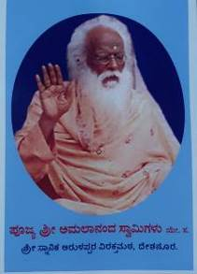
Poojya Amalananda Swamigalu ye. sa. (Fr. Amalananda Swamy S.J.)
Shri Snanika Arulappara Virakthamata, Deshanura.

Belgaum: Swami Amalananda (Fr Antony Felix Mathias) No More
https://www.daijiworld.com/printArticles.aspx?sectionID=50667&sectionName=news
September 4, 2008

Fr Antony Felix Mathias, a devout Jesuit priest popularly known as Swami Amalananda, passed away recently. The 89-year-old priest was a firm believer in humanity, who lived life committed to the Lord both in deeds and words, and was instrumental in building a church at his mission center in Deshanur. The church built in 1976, is reminiscent of traditional Indian temple architecture. He was born in January 1919 to Dominic Paul Mathias and Serapine Colaco, at Belman, in Dakshina Kannada district. Swami Amalananda was the seventh of nine children and did his initial schooling at Milagres School, Kallianpur.

After his studies, he left for Mumbai where he worked briefly as an Income Tax Officer (ITO) from 1944 to 1946. He joined the Jesuit seminary in 1946 and was ordained a priest in 1957 at Pune, and was sent to a remote village called Deshanur. Thereafter he came to be known as Swami Amalananda (a true disciple of St John Baptist) and his ashram was called ‘Snaanik Arulappara Ashrama’. He led a simple life, was a strict vegetarian, and meditated and fasted on Fridays. Fr Mathias also built an orphanage for the destitute and poor, besides administering traditional medicines to patients affected by snake bites. Coincidentally, he breathed his last on the feast of his patron St John Baptist.
At this Daijiworld article, homages and tributes from Fr. Lawrence D’Mello OCD, Fr. Stan Rodrigues OCD, Fr. Gerry Lobo OFM Cap., Fr. Roque D’Souza, and ex-Jesuit priest Philip Lobo.
The spiritual corruption of the clergy in North as well as Dakshina Karnataka seems to be complete.
CATHOLIC WORSHIP OF ELEPHANT GOD GANESH IN MANGALORE (OCD PRIESTS)
http://ephesians-511.net/docs/CATHOLIC_WORSHIP_OF_ELEPHANT_GOD_GANESH_IN_MANGALORE.doc
DIVINE RETRIBUTION? CATHOLIC JERRY D’SOUZA DIES SINGING AT GANESHOTSAV - MANGALORE
http://ephesians-511.net/recent/docs/DIVINE_RETRIBUTION-CATHOLIC_JERRY_DSOUZA_DIES_SINGING_AT_GANESHOTSAV.doc
BONDEL ST. LAWRENCE CHURCH WELCOMES HINDU COW YATRA - MANGALORE
http://ephesians-511.net/recent/docs/BONDEL_ST_LAWRENCE_CHURCH_WELCOMES_HINDU_COW_YATRA.doc

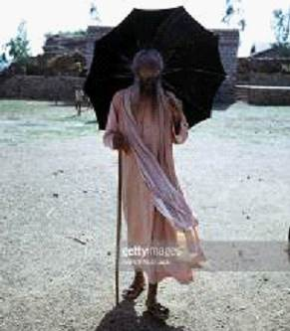
The Indian Jesuit Amalananda Swamy

15. Menino Swamy is a professional Ayurvedic practitioner.
Classical Ayurveda is both New Age and Hindu. One has got to believe in Hindu philosophies that undergird the preparation and application of Ayurvedic medicines to be a practitioner of it. These philosophies are antithetical to Christian beliefs.
AYURVEDA
http://ephesians-511.net/docs/AYURVEDA.doc
AYURVEDA AND SEX-KERALA CHURCH
http://ephesians-511.net/recent/docs/AYURVEDA_AND_SEX-KERALA_CHURCH.doc
AYURVEDA AND YOGA COMMON ORIGINS
http://ephesians-511.net/docs/AYURVEDA_AND_YOGA_COMMON_ORIGINS.doc
AYURVEDA-ANKERBERG AND WELDON
http://ephesians-511.net/docs/AYURVEDA-ANKERBERG_AND_WELDON.doc
AYURVEDA AND YOGA-DR EDWIN A NOYES
http://ephesians-511.net/docs/AYURVEDA_AND_YOGA-DR_EDWIN_A_NOYES.doc
AYURVEDIC REMEDIES CAN BE DANGEROUS FOR HEALTH
http://ephesians-511.net/docs/AYURVEDIC_REMEDIES_CAN_BE_DANGEROUS_FOR_HEALTH.doc
AYURVEDIC REMEDIES CAN BE DANGEROUS FOR THE SOUL [BABA RAMDEV, PATANJALI AYURVED]
http://ephesians-511.net/docs/AYURVEDIC_REMEDIES_CAN_BE_DANGEROUS_FOR_THE_SOUL.doc
AYUSH-THE NEW AGE DANGERS OF
http://ephesians-511.net/docs/AYUSH-THE NEW AGE DANGERS OF.doc

POISON IN AYURVEDIC DRUGS
http://ephesians-511.net/docs/POISON_IN_AYURVEDIC_DRUGS.doc
AYURVEDA AND AYUSH-MICHAEL PRABHU
http://ephesians-511.net/recent/docs/AYURVEDA_AND_AYUSH-MICHAEL_PRABHU.doc
ANAESTHETIC ETC FOUND IN AYURVEDIC POTENCY PILLS
http://ephesians-511.net/recent/docs/ANAESTHETIC_ETC_FOUND_IN_AYURVEDIC_POTENCY_PILLS.doc
AFFINITY TOWARD AYURVEDA AND YOGA IN THE KERALA CHURCH AND THE MALAYALAM BIBLE
http://ephesians-511.net/recent/docs/AFFINITY_TOWARD_AYURVEDA_AND_YOGA_IN_THE_KERALA_CHURCH_AND_THE_MALAYALAM_BIBLE.doc

THREAT OF LEGAL ACTION AGAINST CATHOLIC MAGAZINE FOR CONDEMNING HOMOEOPATHY AND AYURVEDA
http://ephesians-511.net/docs/THREAT_OF_LEGAL_ACTION_AGAINST_CATHOLIC_MAGAZINE_FOR_CONDEMNING_HOMOEOPATHY_AND_AYURVEDA.doc
DIVINE RETREAT CENTRE ERRORS-09 – AYURVEDA AND HOMOEOPATHY PROMOTED
http://ephesians-511.net/docs/DIVINE_RETREAT_CENTRE_ERRORS-09.doc
NEW AGE GURUS 01-SRI SRI RAVI SHANKAR-THE 'ART OF LIVING'
http://ephesians-511.net/docs/NEW_AGE_GURUS_01-SRI_SRI_RAVI_SHANKAR-THE_ART_OF_LIVING.doc

SOME RELATED FILES
I. THE JESUITS
Fr. Menino Gonsalves is a Jesuit. So, his syncretised spiritual depravity comes as no surprise.
And, of course, Pope Francis is a Jesuit. That explains his horribly disastrous Pontificate:
POPE FRANCIS FILES AT THIS MINISTRYS WEBSITE 500~ FILES
http://ephesians-511.net/recent/docs/POPE_FRANCIS_FILES_AT_THIS_MINISTRYS_WEBSITE.doc

RETURN OF THE GNOSTIC JESUITS
http://ephesians-511.net/docs/RETURN_OF_THE_GNOSTIC_JESUITS.doc
POPE FRANCIS CONFIDANTE JESUIT FR ANTONIO SPADARO ATTACKS CATHOLIC MINISTRY
http://ephesians-511.net/docs/POPE_FRANCIS_CONFIDANTE_JESUIT_FR_ANTONIO_SPADARO_ATTACKS_CATHOLIC_MINISTRY.doc
JESUIT COLLEGE HIRES HINDU PRIEST AS CHAPLAIN
http://ephesians-511.net/docs/JESUIT_COLLEGE_HIRES_HINDU_PRIEST_AS_CHAPLAIN.doc
SHIVALINGA TABERNACLE OF JESUIT PRIEST SHILANANDAS CHURCH
http://ephesians-511.net/docs/SHIVALINGA_TABERNACLE_OF_JESUIT_PRIEST_SHILANANDAS_CHURCH.doc
NEW AGE COURSES AT ASHIRVAD-THE JESUIT CENTRE IN BANGALORE
http://ephesians-511.net/docs/NEW_AGE_COURSES_AT_ASHIRVAD-THE_JESUIT_CENTRE_IN_BANGALORE.doc
JESUIT FR ANTHONY DE MELLO-WRITINGS BANNED BY THE CHURCH
http://ephesians-511.net/docs/FR_ANTHONY_DE_MELLO-WRITINGS_BANNED_BY_THE_CHURCH.doc
JESUIT FR PRASHANT OLALEKAR-INTERPLAY AND LIFE POSITIVE
http://ephesians-511.net/docs/FR_PRASHANT_OLALEKAR-INTERPLAY_AND_LIFE_POSITIVE.doc
JESUIT FR RONNIE PRABHU-NEW AGE PRIEST
http://ephesians-511.net/docs/FR_RONNIE_PRABHU-NEW_AGE_PRIEST.doc
JESUIT FR PAUL VAZ-ENNEAGRAM WORKSHOPS AND EARTH CENTRED HEALING RETREATS
http://ephesians-511.net/docs/FR_PAUL_VAZ-ENNEAGRAM_WORKSHOPS_AND_EARTH_CENTRED_HEALING_RETREATS.doc
INDIAN JESUIT THEOLOGIAN FR MICHAEL AMALADOSS UNDER INVESTIGATION BY ROME
http://ephesians-511.net/docs/INDIAN_JESUIT_THEOLOGIAN_FR_MICHAEL_AMALADOSS_UNDER_INVESTIGATION_BY_ROME.doc
CARNATIC MUSIC PERFORMANCE DESECRATES JESUITS CHURCH – IN CHENNAI
http://ephesians-511.net/recent/docs/CARNATIC_MUSIC_PERFORMANCE_DESECRATES_JESUITS_CHURCH.doc
THREE-IN-ONE CRESCENT CROSS OM AT JESUIT CENTRE ARUL KADAL IN CHENNAI-ALEX BENZIGER
http://ephesians-511.net/recent/docs/THREE-IN-ONE_CRESCENT_CROSS_OM_AT_JESUIT_CENTRE_ARUL_KADAL_IN_CHENNAI-ALEX_BENZIGER.doc
SCRAP THE JESUITS AND START OVER
http://ephesians-511.net/recent/docs/SCRAP_THE_JESUITS_AND_START_OVER.doc

DISMISSED JESUIT JOHN DEARS CAMPAIGN AGAINST JUST WAR
http://ephesians-511.net/recent/docs/DISMISSED_JESUIT_JOHN_DEARS_CAMPAIGN_AGAINST_JUST_WAR.doc

HOMOSEXUALIST JESUIT FR JAMES MARTIN IS A HERETIC
http://ephesians-511.net/docs/HOMOSEXUALIST_JESUIT_FR_JAMES_MARTIN_IS_A_HERETIC.doc
HOMOSEXUALIST JESUIT FR JAMES MARTIN IS A PROTAGONIST OF YOGA
http://ephesians-511.net/docs/HOMOSEXUALIST_JESUIT_FR_JAMES_MARTIN_IS_A_PROTAGONIST_OF_YOGA.doc
JESUIT RADIO STATION PROMOTES ABORTION
http://ephesians-511.net/recent/docs/JESUIT_RADIO_STATION_PROMOTES_ABORTION.doc
JESUIT FR THOMAS REESE AGAINST TRANSUBSTANTIATION
http://ephesians-511.net/recent/docs/JESUIT_FR_THOMAS_REESE_AGAINST_TRANSUBSTANTIATION.doc

WARNING REGARDING THE WRITINGS OF JESUIT FR TEILHARD DE CHARDIN SACRED CONGREGATION OF THE HOLY OFFICE JUNE 30, 1962/JULY 20, 1981
http://ephesians-511.net/recent/docs/WARNING_REGARDING_THE_WRITINGS_OF_FR_TEILHARD_DE_CHARDIN.doc
GENESIS THROUGH THE EYES OF THE SAINTS-REBUTTING TEILHARD DE CHARDIN
http://ephesians-511.net/recent/docs/GENESIS_THROUGH_THE_EYES_OF_THE_SAINTS-REBUTTING_TEILHARD_DE_CHARDIN.pdf
TEILHARD DE CHARDIN-THE FALSE PROPHET OF A NEW CHRISTIANITY
http://ephesians-511.net/recent/docs/TEILHARD_DE_CHARDIN-THE_FALSE_PROPHET_OF_A_NEW_CHRISTIANITY.doc
TEILHARD DE CHARDIN-FATHER OF THE NEW AGE-MICHAEL PRABHU
http://ephesians-511.net/recent/docs/TEILHARD_DE_CHARDIN-FATHER_OF_THE_NEW_AGE-MICHAEL_PRABHU.doc
Teilhardian thought exercises a great influence on the Instrumentum Laboris (Working Document) of the forthcoming Pan-Amazon Synod scheduled to be held in October 2019. According to eminent Cardinals and Bishops, the IL is heretical, and the Synod portends apostasy in the Catholic Church.
Almost 150 files on the coming Pan-Amazonian Synod already at this ministry’s web site.

II. CATHOLIC WORSHIP OF GANESH (IN CHRONOLOGICAL ORDER)
MUMBAI: CARDINAL IVAN DIAS LIGHTS A LAMP FOR THE HINDU DEITY GANESHA JULY 2011 (1997)
http://ephesians-511.net/docs/CARDINAL_IVAN_DIAS_LIGHTS_A_LAMP_FOR_THE_HINDU_DEITY_GANESHA.doc
VATHAPI GANAPATHIM-OBEISANCE TO GANESHA BY THE CONFERENCE OF CATHOLIC BISHOPS OF INDIA 7 JANUARY 2017 (2011)
http://ephesians-511.net/docs/VATHAPI_GANAPATHIM-OBEISANCE_TO_GANESHA_BY_THE_CONFERENCE_OF_CATHOLIC_BISHOPS_OF_INDIA.doc
MUMBAI: THE ST PIUS X SEMINARY CELEBRATES HINDU DEITY GANESHA 9 FEBRUARY 2013
http://ephesians-511.net/docs/THE_ST_PIUS_X_SEMINARY_CELEBRATES_HINDU_DEITY_GANESH.doc
TAMIL NADU CLERGY VENERATE THE HINDU DEITY GANESHA 22 FEBRUARY 2014
http://ephesians-511.net/docs/TAMIL_NADU_CLERGY_VENERATE_THE_HINDU_DEITY_GANESHA.doc
GOA: PILAR PRIEST FR PETER CARDOZO VENERATES THE HINDU DEITY GANESHA FEBRUARY 2015
http://ephesians-511.net/docs/PILAR_PRIEST_FR_PETER_CARDOZO_VENERATES_THE_HINDU_DEITY GANESHA.doc
INDIAN CLERGY OBSESSED WITH THE HINDU DEITY GANESHA FEBRUARY 2015
http://ephesians-511.net/docs/INDIAN_CLERGY_OBSESSED_WITH_THE_HINDU_DEITY_GANESHA.doc
CATHOLIC WORSHIP OF ELEPHANT GOD GANESH IN MANGALORE 7/14/30 SEPTEMBER 2016 (OCD PRIESTS)
http://ephesians-511.net/docs/CATHOLIC_WORSHIP_OF_ELEPHANT_GOD_GANESH_IN_MANGALORE.doc
MUMBAI: FR JOE PEREIRA YOGA GURU CELEBRATES NAVRATRI AND GANESHOTSAV 8 SEPTEMBER 2016
http://ephesians-511.net/docs/FR_JOE_PEREIRA_YOGA_GURU_CELEBRATES_NAVRATRI_AND_GANESHOTSAV.doc
VASAI PRIEST FR THOMAS DSOUZA WORSHIPS GANESHA 15 SEPTEMBER 2016
http://ephesians-511.net/docs/VASAI_PRIEST_FR_THOMAS_DSOUZA_WORSHIPS_GANESHA.doc
SPANISH BISHOP APOLOGIZES FOR HONOURING GANESHA-WILL INDIAN BISHOPS FOLLOW SUIT? 30 AUGUST/1 SEPTEMBER 2017
http://ephesians-511.net/docs/SPANISH_BISHOP_APOLOGIZES_FOR_HONOURING_GANESHA-WILL_INDIAN_BISHOPS_FOLLOW_SUIT.doc
CATHOLIC PRIESTS WORSHIP PAGAN GOD GANESHA-YET AGAIN 27 SEPTEMBER 2018 VASAI
http://ephesians-511.net/recent/docs/CATHOLIC_PRIESTS_WORSHIP_PAGAN_GOD_GANESHA-YET_AGAIN.doc
ANGLICAN PRIEST WORSHIPS GANESHA, CONVERTS TO HINDUISM 13 AUGUST 2019 KERALA
http://ephesians-511.net/recent/docs/ANGLICAN_PRIEST_WORSHIPS_GANESHA_CONVERTS_TO_HINDUISM.doc
INDIAN CATHOLIC YOUTH MOVEMENT CELEBRATES GANESH FESTIVAL 3 SEPTEMBER 2019 KULUR, MANGALORE
http://ephesians-511.net/recent/docs/INDIAN_CATHOLIC_YOUTH_MOVEMENT_CELEBRATES_GANESH_FESTIVAL.doc
DIVINE RETRIBUTION? CATHOLIC JERRY D’SOUZA DIES SINGING AT GANESHOTSAV 4 SEPTEMBER 2019 MANGALORE
http://ephesians-511.net/recent/docs/DIVINE_RETRIBUTION-CATHOLIC_JERRY_DSOUZA_DIES_SINGING_AT_GANESHOTSAV.doc

III. BHARATANATYAM DANCE AND CARNATIC MUSIC
BHARATANATYAM-I
http://ephesians-511.net/docs/BHARATANATYAM-I.doc
BHARATANATYAM AT HOLY MASS AT CATHEDRAL OF ST THOMAS IN MADRAS-MYLAPORE ARCHDIOCESE
http://ephesians-511.net/docs/BHARATANATYAM_AT_HOLY_MASS_AT_CATHEDRAL_OF_ST_THOMAS_IN_MADRAS-MYLAPORE_ARCHDIOCESE.doc
DANCING AND BHARATANATYAM IN THE MASS
http://ephesians-511.net/docs/DANCING_AND_BHARATANATYAM_IN_THE_MASS.doc
HINDUS PROSCRIBE TEMPLE DANCE WHILE CATHOLICS DANCE AT HOLY MASS
http://ephesians-511.net/docs/HINDUS_PROSCRIBE_TEMPLE_DANCE_WHILE_CATHOLICS_DANCE_AT_HOLY_MASS.doc
SHOULD CATHOLICS PERFORM BHARATANATYAM-SUSAN BRINKMANN
http://ephesians-511.net/docs/SHOULD_CATHOLICS_PERFORM_BHARATANATYAM-SUSAN_BRINKMANN.doc
SOCIETY OF THE DIVINE WORD PROVINCIAL PERFORMS BHARATANATYAM
http://ephesians-511.net/docs/SOCIETY_OF_THE_DIVINE_WORD_PROVINCIAL_PERFORMS_BHARATANATYAM.doc
THE HINDUISATION OF THE CATHOLIC CHURCH-IMAGES
http://ephesians-511.net/docs/THE_HINDUISATION_OF_THE_CATHOLIC_CHURCH-IMAGES.doc
WHAT DO MUDRAS CONVEY?
http://ephesians-511.net/docs/WHAT_DO_MUDRAS_CONVEY.doc
THE HINDUISATION OF MUSIC IN THE CATHOLIC CHURCH [CARNATIC MUSIC]
http://ephesians-511.net/docs/THE_HINDUISATION_OF_MUSIC_IN_THE_CATHOLIC_CHURCH.doc
CARNATIC MUSIC PERFORMANCE DESECRATES JESUITS CHURCH
http://ephesians-511.net/recent/docs/CARNATIC_MUSIC_PERFORMANCE_DESECRATES_JESUITS_CHURCH.doc
CARNATIC MUSIC IS HINDU SAY HINDUS
http://ephesians-511.net/recent/docs/CARNATIC_MUSIC_IS_HINDU_SAY_HINDUS.doc

IV. INTERRELIGIOUS DIALOGUE AND SYNCRETISM – Selected files
A DOCUMENT ON HUMAN FRATERNITY FOR WORLD PEACE AND LIVING TOGETHER FRANCIS, FEBRUARY 4, 2019
http://ephesians-511.net/recent/docs/A_DOCUMENT_ON_HUMAN_FRATERNITY_FOR_WORLD_PEACE_AND_LIVING_TOGETHER.doc
QUO VADIS PAPA FRANCISCO 90-PLURALISM AND DIVERSITY OF RELIGIONS IS WILLED BY GOD – THE ABU DHABI DECLARATION
http://ephesians-511.net/recent/docs/QUO_VADIS_PAPA_FRANCISCO_90-PLURALISM_AND_DIVERSITY_OF_RELIGIONS_IS_WILLED_BY_GOD.doc
VATICAN IS BETRAYING “JESUS CHRIST AS ONLY SAVIOUR”-BISHOP SCHNEIDER
http://ephesians-511.net/recent/docs/VATICAN_IS_BETRAYING_JESUS_CHRIST_AS_ONLY_SAVIOUR-BISHOP_SCHNEIDER.doc

FATHERS OF THE SVD CONGREGATION WITHOUT ZEAL OR HOPE
http://ephesians-511.net/docs/FATHERS_OF_THE_SVD_CONGREGATION_WITHOUT_ZEAL_OR_HOPE.doc
FOCOLARE, 'THE WORK OF MARY'-IS IT GOOD FOR CATHOLICS?
http://ephesians-511.net/docs/FOCOLARE_THE_WORK_OF_MARY-IS_IT_GOOD_FOR_CATHOLICS.doc
INTERRELIGIOUS DIALOGUE 01-POPE BENEDICT XVI
http://ephesians-511.net/docs/INTERRELIGIOUS_DIALOGUE_01-POPE_BENEDICT_XVI.doc
INTERRELIGIOUS DIALOGUE 02-GOA CATHOLICS OPPOSE
http://ephesians-511.net/docs/INTERRELIGIOUS_DIALOGUE_02-GOA_CATHOLICS_OPPOSE.doc
INTERRELIGIOUS DIALOGUE 03-THE FALSE KIND
http://ephesians-511.net/docs/INTERRELIGIOUS_DIALOGUE_03-THE_FALSE_KIND.doc
RELATIONSHIP TO NON-CHRISTIAN RELIGIONS
http://ephesians-511.net/docs/RELATIONSHIP_TO_NON_CHRISTIAN_RELIGIONS.doc
SPIRIT OF ASSISI
http://ephesians-511.net/docs/SPIRIT_OF_ASSISI.doc
THE WILFUL MISINTERPRETATION OF CHURCH DOCUMENTS BY INCULTURATIONIST THEOLOGIANS NOSTRA AETATE #2/ LUMEN GENTIUM #16/EVANGELII NUNTIANDI #53, 80
http://ephesians-511.net/docs/THE_WILFUL_MISINTERPRETATION_OF_CHURCH_DOCUMENTS_BY_INCULTURATIONIST_THEOLOGIANS.doc
WAS JESUS A YOGI? SYNCRETISM AND INTERRELIGIOUS DIALOGUE-ERROL FERNANDES
http://ephesians-511.net/docs/WAS_JESUS_A_YOGI_SYNCRETISM_AND_INTERRELIGIOUS_DIALOGUE-ERROL_FERNANDES.doc
DIALOGUE AND THE NON-CONFRONTATIONAL CHURCH OF NICE
http://ephesians-511.net/recent/docs/DIALOGUE_AND_THE_NON-CONFRONTATIONAL_CHURCH_OF_NICE.doc

CARMELITE PRIESTS DIALOGUE WITH HINDU SWAMI
http://ephesians-511.net/recent/docs/CARMELITE_PRIESTS_DIALOGUE_WITH_HINDU_SWAMI.doc
THE TYRANNY OF DIALOGUE
http://ephesians-511.net/recent/docs/THE_TYRANNY_OF_DIALOGUE.doc

ALL RELIGIONS ARE NOT EQUAL
http://ephesians-511.net/recent/docs/ALL_RELIGIONS_ARE_NOT_EQUAL.doc
ALL RELIGIONS ARE NOT EQUAL FR AUBREY MASCARENHAS
http://ephesians-511.net/recent/docs/ALL_RELIGIONS_ARE_NOT_EQUAL_FR_AUBREY_MASCARENHAS.doc
ELEMENTS SEARCHINGS SEEDS RAYS OF OTHER RELIGIONS VS THE FULLNESS OF CHRISTIAN REVELATION – FALSE JUSTIFICATION OF RELIGIOUS PLURALISM AND DIALOGUE
http://ephesians-511.net/recent/docs/ELEMENTS_SEARCHINGS_SEEDS_RAYS_OF_OTHER_RELIGIONS_VS_THE_FULLNESS_OF_CHRISTIAN_REVELATION.doc
RELIGIOUS PLURALISM
http://ephesians-511.net/recent/docs/RELIGIOUS_PLURALISM.doc
WHY ALL RELIGIONS CAN’T BE RIGHT-NICHOLAS LABANCA
http://ephesians-511.net/recent/docs/WHY_ALL_RELIGIONS_CANT_BE_RIGHT-NICHOLAS LABANCA.doc
THE TRUTH OF THE CHURCH-ALL RELIGIONS ARE NOT EQUAL
http://ephesians-511.net/recent/docs/THE_TRUTH_OF_THE_CHURCH-ALL_RELIGIONS_ARE_NOT_EQUAL.doc
INDIFFERENTISM
http://ephesians-511.net/recent/docs/INDIFFERENTISM.doc
ARE ALL RELIGIONS EQUAL?
http://ephesians-511.net/recent/docs/ARE_ALL_RELIGIONS_EQUAL.doc

V. INCULTURATION – Selected files
HINDUS STILL BELIEVE THAT INCULTURATION IS A CATHOLIC PLOY TO CONVERT THEM
http://ephesians-511.net/docs/HINDUS_STILL_BELIEVE_THAT_INCULTURATION_IS_A_CATHOLIC_PLOY_TO_CONVERT_THEM.doc
INCULTURATION OF THE LITURGY AND SACROSANCTUM CONCILIUM-JON ANDERSON-AND MY RESPONSE
http://ephesians-511.net/docs/INCULTURATION_OF_THE_LITURGY_AND_SACROSANCTUM_CONCILIUM-JON_ANDERSON-AND_MY_RESPONSE.doc
IS THE SYRO MALABAR CHURCH NOW OPENLY PROMOTING ITS HINDUISATION?
http://ephesians-511.net/docs/IS_THE_SYRO-MALABAR_CHURCH_NOW_OPENLY_PROMOTING_ITS_HINDUISATION.doc
LITURGICAL ABUSES IN THE SYRO-MALABAR CHURCH-ORIGINS
http://ephesians-511.net/docs/LITURGICAL_ABUSES_IN_THE_SYRO-MALABAR_CHURCH-ORIGINS.doc
HINDUISER OF LITURGY FR LOUIS MALIEKAL CMI DIES
http://ephesians-511.net/docs/HINDUISER_OF_LITURGY_FR_LOUIS_MALIEKAL_CMI_DIES.doc
JESUS THE YOGI AND THE DANCING JESUS
http://ephesians-511.net/docs/JESUS_THE_YOGI_AND_THE_DANCING_JESUS.doc
LOTUS AND THE CROSS-THE HINDUISATION OF THE CATHOLIC CHURCH IN INDIA
http://ephesians-511.net/docs/LOTUS_AND_THE_CROSS-THE_HINDUISATION_OF_THE_CATHOLIC_CHURCH_IN_INDIA.doc
NBCLC-HARBINGER OF THE INDIAN RITE MASS AND LITURGICAL ABUSE
http://ephesians-511.net/docs/NBCLC-HARBINGER_OF_THE_INDIAN_RITE_MASS_AND_LITURGICAL_ABUSE.doc
RELATIONSHIP TO NON-CHRISTIAN RELIGIONS
http://ephesians-511.net/docs/RELATIONSHIP_TO_NON_CHRISTIAN_RELIGIONS.doc
THE PAGANISATION OF THE LITURGY IN INDIA-C B ANDRADE
http://ephesians-511.net/docs/THE_PAGANISATION_OF_THE_LITURGY_IN_INDIA-C_B_ANDRADE.doc
THE PAGANIZED CATHOLIC CHURCH IN INDIA-VICTOR J F KULANDAY
http://ephesians-511.net/docs/THE_PAGANIZED_CATHOLIC_CHURCH_IN_INDIA-VICTOR_J_F_KULANDAY.doc
WHAT IS THE SIGNIFICANCE OF NAMASTE AND ANJALI HASTA?
http://ephesians-511.net/docs/WHAT_IS_THE_SIGNIFICANCE_OF_NAMASTE_AND_ANJALI_HASTA.doc
WHAT DOES THE KUTHU VILAKKU OIL LAMP SIGNIFY?
http://ephesians-511.net/recent/docs/WHAT_DOES_THE_KUTHU_VILAKKU_OIL_LAMP_SIGNIFY.doc

VI. MISCELLANEOUS – Selected files
ARCHBISHOP FERRAO OF GOA LIGHTS THE HINDU OIL LAMP
http://ephesians-511.net/recent/docs/ARCHBISHOP_FERRAO_OF_GOA_LIGHTS_THE_HINDU_OIL_LAMP.doc
AFFINITY TOWARD AYURVEDA AND YOGA IN THE KERALA CHURCH AND THE MALAYALAM BIBLE
http://ephesians-511.net/recent/docs/AFFINITY_TOWARD_AYURVEDA_AND_YOGA_IN_THE_KERALA_CHURCH_AND_THE_MALAYALAM_BIBLE.doc

AFTER YOGA MOTHER TERESAS NUNS INTO BHARATANATYAM DANCE
http://ephesians-511.net/docs/AFTER_YOGA_MOTHER_TERESAS_NUNS_INTO_BHARATANATYAM_DANCE.doc
CARDINAL OSWALD GRACIAS’ SPIRITUALLY PERVERTED GYAN ASHRAM [SVD PRIESTS]
http://ephesians-511.net/recent/docs/CARDINAL_OSWALD_GRACIAS_SPIRITUALLY_PERVERTED_GYAN_ASHRAM.doc
CARMELITE PRIEST PERFORMS HINDU POOJA RITUAL
http://ephesians-511.net/docs/CARMELITE_PRIEST_PERFORMS_HINDU_POOJA_RITUAL.doc
CATHOLIC ASHRAMS-REVISITED
http://ephesians-511.net/docs/CATHOLIC_ASHRAMS-REVISITED.doc
CATHOLIC BECOMES PRIEST OF SHIVA TEMPLE
http://ephesians-511.net/docs/CATHOLIC_BECOMES_PRIEST_OF_SHIVA_TEMPLE.doc
CATHOLICS CAPITULATE OVER CHRIST NOT SANTA CLAUS
http://ephesians-511.net/docs/CATHOLICS_CAPITULATE_OVER_CHRIST_NOT_SANTA_CLAUS.doc
CATHOLIC PRIEST WORSHIPS HINDU DEITY IN KERALA TEMPLE
http://ephesians-511.net/recent/docs/CATHOLIC_PRIEST_WORSHIPS_HINDU_DEITY_IN_KERALA_TEMPLE.doc
CHAKRAS-ERIKA GIBELLO
http://ephesians-511.net/docs/CHAKRAS-ERIKA_GIBELLO.doc
CHAKRA THERAPY
http://ephesians-511.net/docs/CHAKRA_THERAPY.doc
DWAJASTHAMBA IN CHURCHES-INDIAN OR HINDU?
http://ephesians-511.net/recent/docs/DWAJASTHAMBA_IN_CHURCHES-INDIAN_OR_HINDU.doc
FR ANTHONY DE MELLO-WRITINGS BANNED BY THE CHURCH
http://ephesians-511.net/docs/FR_ANTHONY_DE_MELLO-WRITINGS_BANNED_BY_THE_CHURCH.doc
FR JEGATH GASPAR RAJ-IN PRAISE OF SHIVA-PRIEST INVESTS RS 15 MILLION, FLOATS COMPANY WORTH RS 100 CRORES
http://ephesians-511.net/docs/FR_JEGATH_GASPAR_RAJ-IN_PRAISE_OF_SHIVA-PRIEST_INVESTS_RS_15_MILLION_FLOATS_COMPANY_WORTH_RS_100_CRORES.doc
HABEMUS PAPAM INDIANUM-WE HAVE AN INDIAN PONTIFF
http://ephesians-511.net/docs/HABEMUS_PAPAM_INDIANUM-WE_HAVE_AN_INDIAN_PONTIFF.doc
HINDU FLAG POLE AT CATHEDRAL OF ST THOMAS IN MADRAS-MYLAPORE ARCHDIOCESE
http://ephesians-511.net/docs/HINDU_FLAG_POLE_AT_CATHEDRAL_OF_ST_THOMAS_IN_MADRAS-MYLAPORE_ARCHDIOCESE.doc
HINDUISM-FR FINBARR FLANAGAN
http://ephesians-511.net/recent/docs/HINDUISM-FR_FINBARR_FLANAGAN.doc
HINDUISM-VISHAL MANGALWADI
http://ephesians-511.net/docs/HINDUISM-VISHAL_MANGALWADI.doc
HINDU TEMPLE-TYPE CEREMONIES AT SALESIAN LITURGICAL CELEBRATION IN BANGALORE
http://ephesians-511.net/docs/HINDU_TEMPLE-TYPE_CEREMONIES_AT_SALESIAN_LITURGICAL_CELEBRATION_IN_BANGALORE.doc
INDIAS NATIONAL SONG-THE VANDE MATARAM CONTROVERSY
http://ephesians-511.net/recent/docs/INDIAS_NATIONAL_SONG-THE_VANDE_MATARAM_CONTROVERSY.doc
INDIAN JESUIT THEOLOGIAN FR MICHAEL AMALADOSS UNDER INVESTIGATION BY ROME
http://ephesians-511.net/docs/INDIAN_JESUIT_THEOLOGIAN_FR_MICHAEL_AMALADOSS_UNDER_INVESTIGATION_BY_ROME.doc
IS HOLY COMMUNION EQUIVALENT TO PRASADAM-IS IT SAFE FOR CATHOLICS TO CONSUME PRASADAM?
http://ephesians-511.net/docs/IS_HOLY_COMMUNION_EQUIVALENT_TO_PRASADAM-IS_IT_SAFE_FOR_CATHOLICS_TO_CONSUME_PRASADAM.doc
IS SAT-CIT-ANANDA THE EQUIVALENT OF THE HOLY TRINITY
http://ephesians-511.net/docs/IS_SAT-CIT-ANANDA_THE_EQUIVALENT_OF_THE_HOLY_TRINITY.doc
KERALA PARISH CELEBRATES CHURCH FEAST JOINTLY WITH HINDU TEMPLE FESTIVAL
http://ephesians-511.net/docs/KERALA_PARISH_CELEBRATES_CHURCH_FEAST_JOINTLY_WITH_HINDU_TEMPLE_FESTIVAL.doc
MANGALSUTRA-INDIAN OR HINDU?
http://ephesians-511.net/docs/MANGALSUTRA-INDIAN_OR_HINDU.doc
MATA AMRITANANDAMAYI-THE HUGGING GODWOMAN
http://ephesians-511.net/recent/docs/MATA_AMRITANANDAMAYI-THE_HUGGING GODWOMAN.doc
MAY CATHOLICS CELEBRATE THE FESTIVAL OF HOLI?
http://ephesians-511.net/docs/MAY_CATHOLICS_CELEBRATE_THE_FESTIVAL_OF_HOLI.doc
MAY CATHOLICS CELEBRATE THE HARVEST FESTIVAL OF ONAM?
http://ephesians-511.net/docs/MAY_CATHOLICS_CELEBRATE_THE_HARVEST_FESTIVAL_OF_ONAM.doc
MAY CATHOLICS CELEBRATE THE HARVEST FESTIVAL OF PONGAL?
http://ephesians-511.net/docs/MAY_CATHOLICS_CELEBRATE_THE_HARVEST_FESTIVAL_OF_PONGAL.doc

MORE INSIGHTS INTO THE HINDUISATION OF THE CATHOLIC CHURCH-WITH IMAGES
http://ephesians-511.net/recent/docs/MORE_INSIGHTS_INTO_THE_HINDUISATION_OF_THE_CATHOLIC_CHURCH-WITH_IMAGES.doc
MOTHER TERESA AT PRAYER IN A BUDDHIST TEMPLE
http://ephesians-511.net/docs/MOTHER_TERESA_AT_PRAYER_IN_A_BUDDHIST_TEMPLE.doc
PAGANIZATION OF THE CHURCH IN INDIA 01
http://ephesians-511.net/docs/PAGANIZATION_OF_THE_CHURCH_IN_INDIA_01.doc
PAGANIZATION OF THE CHURCH IN INDIA 02
http://ephesians-511.net/docs/PAGANIZATION_OF_THE_CHURCH_IN_INDIA_02.doc
PAGANIZATION OF THE CHURCH IN INDIA-RESPONSES
http://ephesians-511.net/docs/PAGANIZATION_OF_THE_CHURCH_IN_INDIA-RESPONSES.doc
PILAR PRIESTS CELEBRATE INTERNATIONAL YOGA DAY-GOA ARCHBISHOP ENDORSES
http://ephesians-511.net/docs/PILAR_PRIESTS_CELEBRATE_INTERNATIONAL_YOGA_DAY-GOA_ARCHBISHOP_ENDORSES.doc
PILAR SEMINARY, GOA-SYNCRETISM AND NEW AGE
http://ephesians-511.net/docs/PILAR_SEMINARY_GOA-SYNCRETISM_AND_NEW_AGE.doc
PRITISH NANDY DEBUNKS GODMAN CHANDRA SWAMIS THIRD EYE CLAIM
http://ephesians-511.net/docs/PRITISH_NANDY_DEBUNKS_GODMAN_CHANDRA_SWAMIS_THIRD_EYE_CLAIM.doc
QUO VADIS BEDE GRIFFITHS-FR FINBARR FLANAGAN
http://ephesians-511.net/recent/docs/QUO_VADIS_BEDE_GRIFFITHS-FR_FINBARR_FLANAGAN.doc
RANGOLI AND KOLAM DRAWINGS ARE BASED ON SUPERSTITIOUS BELIEFS
http://ephesians-511.net/docs/RANGOLI_AND_KOLAM_DRAWINGS_ARE_BASED_ON_SUPERSTITIOUS_BELIEFS.doc
SONIA GANDHI-CATHOLIC OR HINDU?
http://ephesians-511.net/docs/SONIA_GANDHI-CATHOLIC_OR_HINDU.doc
SRI SATYA SAI BABAS CATHOLIC DEVOTEES
http://ephesians-511.net/docs/SRI_SATYA_SAI_BABAS_CATHOLIC_DEVOTEES.doc
ST SEBASTIANS HINDUISED CHURCH WITH RESURREXIFIX ARCHDIOCESE OF BOMBAY
http://ephesians-511.net/recent/docs/ST_SEBASTIANS_HINDUISED_CHURCH_WITH_RESURREXIFIX_ARCHDIOCESE_OF_BOMBAY.doc
THE GOLDEN SHEAF-A COLLECTION OF ARTICLES DEALING WITH ECCLESIASTICAL ABERRATIONS
http://ephesians-511.net/docs/THE_GOLDEN_SHEAF-A_COLLECTION_OF_ARTICLES_DEALING_WITH_ECCLESIASTICAL_ABERRATIONS.doc
THE ONGOING ROBBERY OF FAITH-FR P K GEORGE
http://ephesians-511.net/docs/THE_ONGOING_ROBBERY_OF_FAITH-FR_P_K_GEORGE.doc
THE SIGNIFICANCE OF 108 IN HINDUISM
http://ephesians-511.net/recent/docs/THE_SIGNIFICANCE_OF_108_IN_HINDUISM.doc
THE THIRD EYE
http://ephesians-511.net/docs/THE_THIRD_EYE.doc
VAASTU SHASTRA OR VEDIC GEOMANCY
http://ephesians-511.net/docs/VAASTU_SHASTRA_OR_VEDIC_GEOMANCY.doc
WHY INDIAN CATHOLICS DO NOT WANT AN INDIAN POPE
http://ephesians-511.net/docs/WHY_INDIAN_CATHOLICS_DO_NOT_WANT_AN_INDIAN_POPE.doc
YOGA GURUS V L REGO AND CARMELITE FR GREGORY DSOUZA RYSHIVANA MANGALORE
http://ephesians-511.net/recent/docs/YOGA_GURUS_V_L_REGO_AND_CARMELITE_FR_GREGORY_DSOUZA_RYSHIVANA_MANGALORE.doc

VII. YOGA
YOGA FILES AT THIS MINISTRYS WEBSITE AS ON 13 JULY 2019
http://ephesians-511.net/recent/docs/YOGA_FILES_AT_THIS_MINISTRYS_WEBSITE.doc
194 FILES: 81 REPORTS + 63 ARTICLES/COLLATIONS + 2 YOGA-RELATED VATICAN DOCUMENTS + 48 YOGA TESTIMONIES OF FORMER PRACTITIONERS

VIII. MANTRAS AND “OM” CHANTING
CARDINAL OSWALD GRACIAS SAYS THAT CATHOLICS MAY NOT CHANT THE OM MANTRA
http://ephesians-511.net/docs/CARDINAL_OSWALD_GRACIAS_SAYS_THAT_CATHOLICS_MAY_NOT_CHANT_THE_OM_MANTRA.doc
CHANTING OF MANTRAS
http://ephesians-511.net/recent/docs/CHANTING_OF_MANTRAS.doc
EXORCISTS WARN AGAINST USE OF YOGA MANTRAS
http://ephesians-511.net/docs/EXORCISTS_WARN_AGAINST_USE_OF_YOGA_MANTRAS.doc

HINDUISMS PRANAVA-THE OM
http://ephesians-511.net/recent/docs/HINDUISMS_PRANAVA-THE_OM.doc
MANTRAS AND MANDALAS-ANKERBERG AND WELDON
http://ephesians-511.net/recent/docs/MANTRAS_AND_MANDALAS-ANKERBERG_AND_WELDON.doc
MANTRAS, 'OM' OR 'AUM' AND THE GAYATRI MANTRA
http://ephesians-511.net/docs/MANTRAS_OM_OR_AUM_AND_THE_GAYATRI_MANTRA.doc
MUSLIMS AND THE GAYATRI MANTRA
http://ephesians-511.net/recent/docs/MUSLIMS_AND_THE_GAYATRI_MANTRA.doc
MANTRAS YOGA WCCM CHRISTIAN MEDITATION ETC-EDDIE RUSSELL
http://ephesians-511.net/docs/MANTRAS_YOGA_WCCM_CHRISTIAN_MEDITATION_ETC-EDDIE_RUSSELL.doc
NEW COMMUNITY BIBLE 26-RESPONSES TO REVISED EDITION NOT RECOMMENDED FOR CATHOLICS
http://ephesians-511.net/docs/NEW_COMMUNITY_BIBLE_26-RESPONSES_TO_REVISED_EDITION_NOT_RECOMMENDED_FOR_CATHOLICS.doc
RENUNCIATION OF YOGA SURYANAMASKAR OM-CORINNA CRAFT
http://ephesians-511.net/docs/TESTIMONY_OF_DELIVERANCE_FROM_A_DEMON_OF_YOGA-CORINNA_CRAFT.doc
CHARISINDIA ERRORS-17 USE OF HINDU “OM” MANTRA IN PRAISE THE LORD HYMN BOOKS
http://ephesians-511.net/docs/CHARISINDIA_ERRORS-17.doc

