
JANUARY 20, 2018

ERRORS IN CHARISINDIA - 11

Rampant use of the Hindu oil lamp by the Catholic Charismatic Renewal at inaugural ceremonies

"CHARISINDIA is a monthly magazine, published on behalf of the National Catholic Charismatic Renewal Services (NCCRS) which has been recognised by the Catholic Bishops’ Conference of India (CBCI) as the principal coordinating agency of the CCR* in India." -CHARISINDIA *Catholic Charismatic Renewal

THE REASONS FOR OUR CONTINUING THIS SERIES ON CHARISINDIA/THE CCR
1a. It has been my observation for a very long time that the Catholic Charismatic Renewal in India has been the propagator of errors and abuses especially in the liturgy of the Mass, something that, as an apologist, I now find impossible to ignore.
I admit participating in most if not all of them at one time or another for several reasons, the chief among them being ignorance; moreover, no one objected to them and almost every charismatic priest, religious and lay leader practised them.
However, circumstances -- and the personal counsel of some good CCR leaders who would like to see these abuses and errors stopped -- make it imperative that they be now exposed.
1b. It has been my experience -- when I have pointed out these abuses and errors on certain occasions -- that most "charismatics" are not very receptive to correction of any sort. Their responses have ranged from indulgence to hostility.
My pointing out that I am only repeating the teaching of the Church has not saved me from being labeled "anti-charismatic".
It is almost as if "charismatics" are "superior" to other Catholics and have a licence to modify the rubrics of the liturgy.
No one is above the liturgy, not any priest and not any bishop. The rubrics must be followed by the Church to the letter.
Since my antecedents are not known to many who visit our web site, I proudly affirm that my spirituality is charismatic.
One of my spiritual directors, a holy and orthodox French Benedictine priest, actually finds it impossible to reconcile my "conservative" ministry with my being "charismatic". To him it’s an oxymoron. To me, it seems a natural thing.
1c. My wife and I helped plant several prayer groups in New Delhi starting 1982 and I was a founder-member of the very first Service Team of the CCR in New Delhi. As a life member and benefactor of CHARISINDIA, a stockist of the magazine in the 'mid 80s, and possessing back issues of CHARISINDIA almost from its inception, I have a relationship with the magazine that cannot be deterred either by criticism or by the ignoring of my letters by those who now run the magazine.
I invite the reader to read pages 2 to 4, especially the section sub-titled "Errors and excesses" on page 4 of my April 2011 article
CATHOLIC CHARISMATIC RENEWAL http://ephesians-511.net/docs/CATHOLIC_CHARISMATIC_RENEWAL.doc.
The article will give the reader an idea of what to expect in this series on CHARISINDIA and the CCR in India.
In this series, I will name names. I am constrained to do so because, over the 36 years of my sojourn in the Renewal, I have seen the condition of things deteriorate, while at the same time not one single prophetic voice has been raised in protest.
My scores of letters to the senior-most leadership have either elicited unfulfilled assurances or been studiously ignored.
I must stress here on one point that I mention under point 5 on page 3 of my above-cited April 2011 article: the loyalty of too many rank and file charismatics is to their leadership instead of to the teaching authority of the Church.
If the reader dismisses my statements as generalizations, the true incidents that I will record in the articles in this series -- justifying my having to name certain people -- should convince him that this is not so.

2. The immediate reason for this series on CHARISINDIA/the CCR is the CHARISINDIA July 2012 issue.
A pro-contraception article authored by a Protestant was published. On learning of it, I personally contacted the CCR’s Episcopal Advisor Most Rev. Francis Kalist, the bishop of Meerut by 'phone and by email. He was cordial and expressed his thanks and appreciation of my initiative on the 'phone as well as in writing*. However, all subsequent letters to the bishop have remained unanswered.

Furthermore, all letters from me to Constantine Fernandez, the publisher of CHARISINDIA, its Chief Editor Cyril John, and to the National Charismatic Office [NCO] staff, Gilbert Faria and K.P. Shaji were also completely ignored by them. While I had spoken on the 'phone to Fernandez, Faria and Shaji, Cyril John simply declined to take my many calls or call me back. The August and September 2012 CHARISINDIA issues had no correction of the error. See our report CHARISINDIA ERRORS-01.

The July 2012 CHARISINDIA also carried a story on the funeral of Fr Rufus Pereira. I detected in that story what I believe to be an error: eulogies given during the Mass.
See the report CHARISINDIA ERRORS-02 http://ephesians-511.net/docs/CHARISINDIA_ERRORS-02.doc.

3. Between July 13 and August 8, I had written four letters to the CCR’s Episcopal Advisor Most Rev. Francis Kalist, but the Bishop terminated correspondence with me after responding to the first letter. The first three emails concerned the pro-contraception article. I reproduce the fourth letter immediately below as published in my report CHARISINDIA ERRORS-01 http://ephesians-511.net/docs/CHARISINDIA_ERRORS-01.doc*.
*My first email & the Bishop’s response are copied here.

4. I wrote to Bishop Francis Kalist and the CHARISINDIA/NCO team once again on January 4, 2013 in connection with errors in the January 2013 issue. Since there was no response as usual, the information is partly reported in CHARISINDIA ERRORS-04 at http://ephesians-511.net/docs/CHARISINDIA_ERRORS-04.doc, and the rest of it in others.
The update to the January 4 letter was emailed to Bishop Francis Kalist and the CHARISINDIA/NCO team on January 30, 2013.

5. On January 29, 2013, this ministry emailed Bishop Francis Kalist and the CHARISINDIA/NCO team about an error in the September 2012 issue of CHARISINDIA. CHARISINDIA ERRORS-03 http://ephesians-511.net/docs/CHARISINDIA_ERRORS-03.doc.

6. On January 31, 2013, and again on February 1, 2013, I sent a 17-page preview with a follow-up letter to Bishop Francis Kalist and the CHARISINDIA/NCO team, of my report CHARISINDIA ERRORS-05 concerning the issue of my being banned from attending the XV National Catholic Charismatic Convention in Goa, November 12-15, 2012. The completed 26-page report at http://ephesians-511.net/docs/CHARISINDIA_ERRORS-05.doc was mailed to them the same evening.

7. Report CHARISINDIA ERRORS-06 concerns the newly-introduced “Prophetic Intercession” and the “Jericho March”.
http://ephesians-511.net/docs/CHARISINDIA_ERRORS-06.doc.
We can see the utter failure of one such “prophecy” made during the 2014 Jericho March in CHARISINDIA ERRORS-09.

8. The report CHARISINDIA ERRORS-07 http://ephesians-511.net/docs/CHARISINDIA_ERRORS-07.doc chronicles errors and problems with CHARISINDIA/the CCR in the past, some of which were taken up with the NCCRS/NST/NCO, and some of which were not. Most were from Cyril John’s tenure as Chairman of the NST and publisher of CHARISINDIA and during the term of Most Rev. Valerian D’Souza, Bishop of Poona [the predecessor of Bishop Francis Kalist of Meerut] as the CCR’s Episcopal Advisor. More will be added on as and when I come across them in my files.
For that reason, the documenting of those issues in CHARISINDIA ERRORS-07 is not chronological.

9. The report CHARISINDIA ERRORS-08 records the utter carelessness with which the magazine continues to be edited/published despite my series of reports which I expected would ensure greater vigilance by the CHARISIDIA team. It concerns the chairmanship of Fr. A.J. Thamburaj, SJ in the February 2013 CHARISINDIA issue.
See CHARISINDIA ERRORS-08 http://ephesians-511.net/docs/CHARISINDIA_ERRORS-08.doc.

10. Report CHARISINDIA ERRORS-09 is about the false prophecies recorded in the April 2014 issue.
As a result of that report, a female member of the Renewal’s Intercessory Network in Mumbai broke off correspondence with me. We had also spoken a few times over the ‘phone. She had blessed my ministry with her tithes. But after the release of the report which concerned her ministry of intercession, I have not received any response to my emails to her.
My sin appears to have been in criticizing the intercession ministry in which she is a leader. She had however never found a problem with any of my earlier reports. This is a situation that I have encountered earlier and repeats itself fairly regularly. All is fine as long as the target is far from home. But when issues hit very close to individuals, their loved ones or their prayer groups, it’s unacceptable. I guess I will lose a few “friends” after this one too! I keep repeating that too many Catholics’ loyalties are not to the Truth and Righteousness, or to Christ and the teachings of His Church, but to their prayer groups, their pious organizations and retreat centres, leaders and “elders”, however much in error they may be.
See CHARISINDIA ERRORS-09 http://ephesians-511.net/docs/CHARISINDIA_ERRORS-09.doc.
If ay recipient of the report agrees, disagrees with me or has any other perspective, please send me your take on the "prophecies". I will include your input in this report as an update without your name and email address. In case my views can be proved to be judgemental and misinformed, I can be convinced to pull this report from my web site.

11. The report CHARISINDIA ERRORS-10 concerns the cover page of the January 2016 CHARISINDIA issue.
The occasion was the 16th National Catholic Charismatic Convention held at St. Ursula’s High School grounds, Nigdi, Pune, from 11 to 14 November 2015. Present too were the delegates to the parallel-running Youth Convention, Kairos 2015.
The two oil lamps on the dais at the inaugural ceremony are being lit by the Apostolic Nuncio Archbishop Salvatore Pennacchio, with Baselios Cardinal Cleemis, the President of the Catholic Bishops’ Conference of India (to his right).
Other Bishops who were present/spoke at the Convention were Bishop Thomas Dabre of Poona, Bishop Francis Kalist, the Episcopal Advisor to the National Service Team (NST), Bishop Raphael Thattil, the Auxiliary Bishop of Trichur, and Bishop emeritus Valerian D’Souza, former Episcopal Advisor to the NST. A number of charismatic priests and nuns were present.


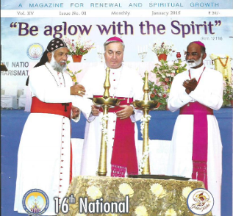
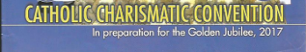
CHARISINDIA JANUARY 2016

A photograph of the lamp-lighting ceremony is in the same CHARISINDIA issue at the top of page 18. In that picture, one can see several other national lay leaders, a couple of other clerics, and former long-time chairman Cyril John who is presently Chairman of the ISAO and Chief Editor of CHARISINDIA.
High-level lay charismatic leaders and preachers from other states and cities like Kerala, Mumbai, Goa, Vasai and Bangalore were also present. Apparently not one of them had an issue with the lamp-lighting inaugural ceremony.

The lamps in the picture above are only used by Hindus in temples, in their puja rooms, and to inaugurate all functions where they have to placate, appease and worship their deities so that the devotees will be blessed auspiciously.
They are not used by Indian Muslims or any other religious community in India because of the Hindu religious connotations that are associated with them.
See WHAT DOES THE KUTHU VILAKKU OIL LAMP SIGNIFY
http://ephesians-511.net/docs/WHAT_DOES_THE_KUTHU_VILAKKU_OIL_LAMP_SIGNIFY.doc.
Catholics have not lagged behind in adapting these Hindu lamps along with many other Hindu traditions (which I have written about), and the ubiquitous kuthuvilakku or nilavilakku may be found in most Indian chapels, convents, Catholic campuses and Cathedrals. It’s been a long time since I attended an inaugural charismatic function so this was new to me.
Even if the leaders of the Catholic Charismatic Renewal (CCR) defend their use of these lamps by claiming them to be Indian or of cultural significance (which they are NOT; they are from Hindu tradition), I would like to ask them, especially the Pune Service Team who organized the event, if they just had to do what everyone else in the Indian Church is doing today in the name of inculturation.
Most Bishops and priests today do not know whether they are coming or going, but … the Charismatic Renewal? Are they no different from other non-charismatic Catholics?
And may I ask them what prevented the CCR from organizing a nice, good ole CATHOLIC ceremony for the inauguration?
What’s the problem with using traditional Catholic wax candles?
What prevented them from at least substituting the phallus on top of the lamp with a cross or a dove (to represent the Holy Spirit)? I wouldn’t accept that either, but at least I could have avoided writing this report.

I can cite very relevant and unsettling Scripture passages for these charismatics from the Old Testament in relation to the issue at hand but shall refrain from doing so because charismatic leaders know their Bibles as well as I do.
If the rot has reached to the very top of the Catholic Charismatic Renewal in India, one can imagine the state of the rest of the Church as far as its ongoing Hinduisation is concerned!
But Jerusalem kills all her prophets. I was banned from attending the XVth National Convention in 2012 (CHARISINDIA ERRORS-05). Now you know why. I wonder if I will be around still to attend future conventions and if they will let me in … or put the word out like they did in 2012, to ensure that my attempt to register is unsuccessful.

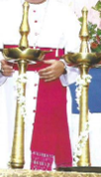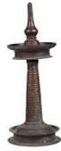
The lamps lit at the convention (L) and a regular Hindu lamp (R)

Below: images from the WHAT DOES THE KUTHU VILAKKU OIL LAMP SIGNIFY file
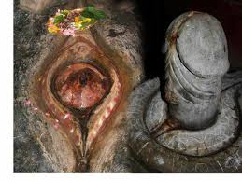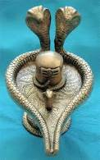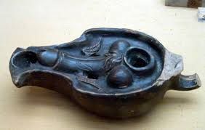

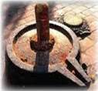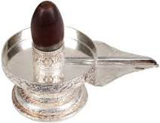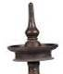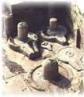

Oil lamps with the lingam (penis); the oil reservoir is shaped to resemble a yoni which is Sanskrit for vagina

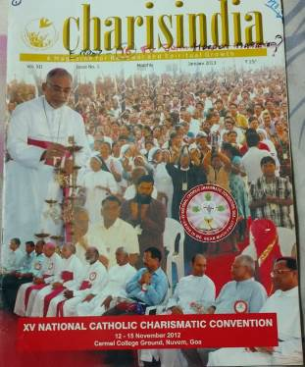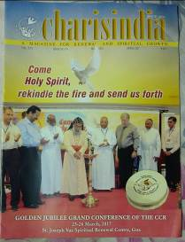
CHARISINDIA JANUARY 2013/ CHARISINDIA APRIL 2017

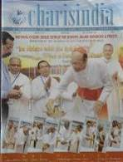
CHARISINDIA DECEMBER 2017

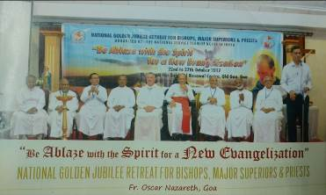
CHARISINDIA DECEMBER 2017

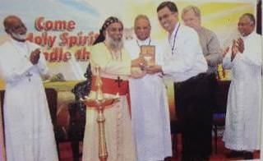
CHARISINDIA APRIL 2017

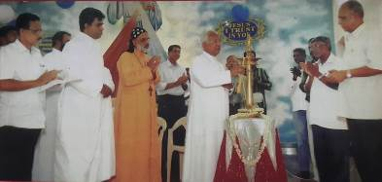
CHARISINDIA JANUARY 2015

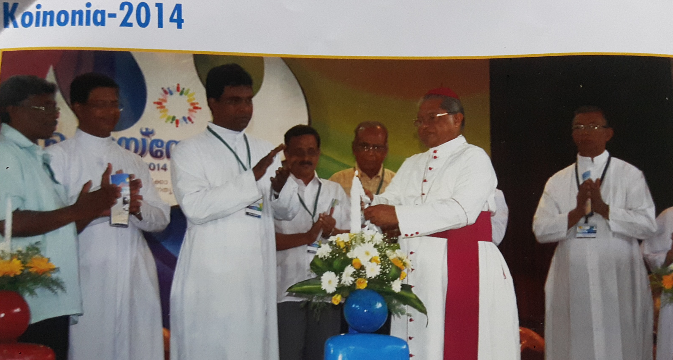
The good old days of inauguration with the Roman Catholic wax candle, CHARISINDIA NOVEMBER 2014

CHARISINDIA ERRORS-01 - PRO-CONTRACEPTION ARTICLE
http://ephesians-511.net/docs/CHARISINDIA_ERRORS-01.doc
CHARISINDIA ERRORS-02 - EULOGIES AT FR. RUFUS’ FUNERAL MASS
http://ephesians-511.net/docs/CHARISINDIA_ERRORS-02.doc
CHARISINDIA ERRORS-03 - ERRORS ABOUT FRANCIS MACNUTT
http://ephesians-511.net/docs/CHARISINDIA_ERRORS-03.doc
CHARISINDIA ERRORS-04 - ARTICLE AUTHORSHIP WRONGLY ATTRIBUTED
http://ephesians-511.net/docs/CHARISINDIA_ERRORS-04.doc
CHARISINDIA ERRORS-05 - BANNED FROM THE NATIONAL CHARISMATIC CONVENTION
http://ephesians-511.net/docs/CHARISINDIA_ERRORS-05.doc
CHARISINDIA ERRORS-06 - PROPHETIC INTERCESSION AND JERICHO MARCH
http://ephesians-511.net/docs/CHARISINDIA_ERRORS-06.doc
CHARISINDIA ERRORS-07 - ERRORS IN BACK ISSUES OF CHARISINDIA
http://ephesians-511.net/docs/CHARISINDIA_ERRORS-07.doc
CHARISINDIA ERRORS-08 - ERRORS ABOUT FR. THAMBURAJ AS CHAIRMAN
http://ephesians-511.net/docs/CHARISINDIA_ERRORS-08.doc
CHARISINDIA ERRORS-09 - AMBIGUOUS PROPHECIES?
http://ephesians-511.net/docs/CHARISINDIA_ERRORS-09.doc
CHARISINDIA ERRORS-10 - USE OF KUTHU VILAKKU/NILAVILAKKU AT NATIONAL CONVENTION
http://ephesians-511.net/docs/CHARISINDIA_ERRORS-10.doc

