
JANUARY 21, 2018

ERRORS IN CHARISINDIA - 12

Charismatic Seminar under the auspices of the yogic Jesus

"CHARISINDIA is a monthly magazine, published on behalf of the National Catholic Charismatic Renewal Services (NCCRS) which has been recognised by the Catholic Bishops’ Conference of India (CBCI) as the principal coordinating agency of the CCR* in India." -CHARISINDIA *Catholic Charismatic Renewal

THE REASONS FOR OUR CONTINUING THIS SERIES ON CHARISINDIA/THE CCR
1a. It has been my observation for a very long time that the Catholic Charismatic Renewal in India has been the propagator of errors and abuses especially in the liturgy of the Mass, something that, as an apologist, I now find impossible to ignore.
I admit participating in most if not all of them at one time or another for several reasons, the chief among them being ignorance; moreover, no one objected to them and almost every charismatic priest, religious and lay leader practised them.
However, circumstances -- and the personal counsel of some good CCR leaders who would like to see these abuses and errors stopped -- make it imperative that they be now exposed.
1b. It has been my experience -- when I have pointed out these abuses and errors on certain occasions -- that most "charismatics" are not very receptive to correction of any sort. Their responses have ranged from indulgence to hostility.
My pointing out that I am only repeating the teaching of the Church has not saved me from being labeled "anti-charismatic".
It is almost as if "charismatics" are "superior" to other Catholics and have a licence to modify the rubrics of the liturgy.
No one is above the liturgy, not any priest and not any bishop. The rubrics must be followed by the Church to the letter.
Since my antecedents are not known to many who visit our web site, I proudly affirm that my spirituality is charismatic.
One of my spiritual directors, a holy and orthodox French Benedictine priest, actually finds it impossible to reconcile my "conservative" ministry with my being "charismatic". To him it’s an oxymoron. To me, it seems a natural thing.
1c. My wife and I helped plant several prayer groups in New Delhi starting 1982 and I was a founder-member of the very first Service Team of the CCR in New Delhi. As a life member and benefactor of CHARISINDIA, a stockist of the magazine in the 'mid 80s, and possessing back issues of CHARISINDIA almost from its inception, I have a relationship with the magazine that cannot be deterred either by criticism or by the ignoring of my letters by those who now run the magazine.
I invite the reader to read pages 2 to 4, especially the section sub-titled "Errors and excesses" on page 4 of my April 2011 article
CATHOLIC CHARISMATIC RENEWAL http://ephesians-511.net/docs/CATHOLIC_CHARISMATIC_RENEWAL.doc.
The article will give the reader an idea of what to expect in this series on CHARISINDIA and the CCR in India.
In this series, I will name names. I am constrained to do so because, over the 36 years of my sojourn in the Renewal, I have seen the condition of things deteriorate, while at the same time not one single prophetic voice has been raised in protest.
My scores of letters to the senior-most leadership have either elicited unfulfilled assurances or been studiously ignored.
I must stress here on one point that I mention under point 5 on page 3 of my above-cited April 2011 article: the loyalty of too many rank and file charismatics is to their leadership instead of to the teaching authority of the Church.
If the reader dismisses my statements as generalizations, the true incidents that I will record in the articles in this series -- justifying my having to name certain people -- should convince him that this is not so.

2. The immediate reason for this series on CHARISINDIA/the CCR is the CHARISINDIA July 2012 issue.
A pro-contraception article authored by a Protestant was published. On learning of it, I personally contacted the CCR’s Episcopal Advisor Most Rev. Francis Kalist, the bishop of Meerut by 'phone and by email. He was cordial and expressed his thanks and appreciation of my initiative on the 'phone as well as in writing*. However, all subsequent letters to the bishop have remained unanswered.

Furthermore, all letters from me to Constantine Fernandez, the publisher of CHARISINDIA, its Chief Editor Cyril John, and to the National Charismatic Office [NCO] staff, Gilbert Faria and K.P. Shaji were also completely ignored by them. While I had spoken on the 'phone to Fernandez, Faria and Shaji, Cyril John simply declined to take my many calls or call me back. The August and September 2012 CHARISINDIA issues had no correction of the error. See our report CHARISINDIA ERRORS-01.

The July 2012 CHARISINDIA also carried a story on the funeral of Fr Rufus Pereira. I detected in that story what I believe to be an error: eulogies given during the Mass.
See the report CHARISINDIA ERRORS-02 http://ephesians-511.net/docs/CHARISINDIA_ERRORS-02.doc.

3. Between July 13 and August 8, I had written four letters to the CCR’s Episcopal Advisor Most Rev. Francis Kalist, but the Bishop terminated correspondence with me after responding to the first letter. The first three emails concerned the pro-contraception article. I reproduce the fourth letter immediately below as published in my report CHARISINDIA ERRORS-01 http://ephesians-511.net/docs/CHARISINDIA_ERRORS-01.doc*.
*My first email & the Bishop’s response are copied here.

4. I wrote to Bishop Francis Kalist and the CHARISINDIA/NCO team once again on January 4, 2013 in connection with errors in the January 2013 issue. Since there was no response as usual, the information is partly reported in CHARISINDIA ERRORS-04 at http://ephesians-511.net/docs/CHARISINDIA_ERRORS-04.doc, and the rest of it in others.
The update to the January 4 letter was emailed to Bishop Francis Kalist and the CHARISINDIA/NCO team on January 30, 2013.

5. On January 29, 2013, this ministry emailed Bishop Francis Kalist and the CHARISINDIA/NCO team about an error in the September 2012 issue of CHARISINDIA. CHARISINDIA ERRORS-03 http://ephesians-511.net/docs/CHARISINDIA_ERRORS-03.doc.

6. On January 31, 2013, and again on February 1, 2013, I sent a 17-page preview with a follow-up letter to Bishop Francis Kalist and the CHARISINDIA/NCO team, of my report CHARISINDIA ERRORS-05 concerning the issue of my being banned from attending the XV National Catholic Charismatic Convention in Goa, November 12-15, 2012. The completed 26-page report at http://ephesians-511.net/docs/CHARISINDIA_ERRORS-05.doc was mailed to them the same evening.

7. Report CHARISINDIA ERRORS-06 concerns the newly-introduced “Prophetic Intercession” and the “Jericho March”.
http://ephesians-511.net/docs/CHARISINDIA_ERRORS-06.doc.
We can see the utter failure of one such “prophecy” made during the 2014 Jericho March in CHARISINDIA ERRORS-09.

8. The report CHARISINDIA ERRORS-07 http://ephesians-511.net/docs/CHARISINDIA_ERRORS-07.doc chronicles errors and problems with CHARISINDIA/the CCR in the past, some of which were taken up with the NCCRS/NST/NCO, and some of which were not. Most were from Cyril John’s tenure as Chairman of the NST and publisher of CHARISINDIA and during the term of Most Rev. Valerian D’Souza, Bishop of Poona [the predecessor of Bishop Francis Kalist of Meerut] as the CCR’s Episcopal Advisor. More will be added on as and when I come across them in my files.
For that reason, the documenting of those issues in CHARISINDIA ERRORS-07 is not chronological.

9. The report CHARISINDIA ERRORS-08 records the utter carelessness with which the magazine continues to be edited/published despite my series of reports which I expected would ensure greater vigilance by the CHARISIDIA team. It concerns the chairmanship of Fr. A.J. Thamburaj, SJ in the February 2013 CHARISINDIA issue.
See CHARISINDIA ERRORS-08 http://ephesians-511.net/docs/CHARISINDIA_ERRORS-08.doc.

10. Report CHARISINDIA ERRORS-09 is about the false prophecies recorded in the April 2014 issue.
As a result of that report, a female member of the Renewal’s Intercessory Network in Mumbai broke off correspondence with me. We had also spoken a few times over the ‘phone. She had blessed my ministry with her tithes. But after the release of the report which concerned her ministry of intercession, I have not received any response to my emails to her.
My sin appears to have been in criticizing the intercession ministry in which she is a leader. She had however never found a problem with any of my earlier reports. This is a situation that I have encountered earlier and repeats itself fairly regularly. All is fine as long as the target is far from home. But when issues hit very close to individuals, their loved ones or their prayer groups, it’s unacceptable. I guess I will lose a few “friends” after this one too! I keep repeating that too many Catholics’ loyalties are not to the Truth and Righteousness, or to Christ and the teachings of His Church, but to their prayer groups, their pious organizations and retreat centres, leaders and “elders”, however much in error they may be.
See CHARISINDIA ERRORS-09 http://ephesians-511.net/docs/CHARISINDIA_ERRORS-09.doc.
If ay recipient of the report agrees, disagrees with me or has any other perspective, please send me your take on the "prophecies". I will include your input in this report as an update without your name and email address. In case my views can be proved to be judgemental and misinformed, I can be convinced to pull this report from my web site.

11. The report CHARISINDIA ERRORS-10 concerns the cover page of the January 2016 CHARISINDIA issue.
The occasion was the 16th National Catholic Charismatic Convention held at St. Ursula’s High School grounds, Nigdi, Pune, from 11 to 14 November 2015. Present too were the delegates to the parallel-running Youth Convention, Kairos 2015.
The two oil lamps on the dais at the inaugural ceremony are being lit by the Apostolic Nuncio Archbishop Salvatore Pennacchio, with Baselios Cardinal Cleemis, the President of the Catholic Bishops’ Conference of India (to his right).
Other Bishops who were present/spoke at the Convention were Bishop Thomas Dabre of Poona, Bishop Francis Kalist, the Episcopal Advisor to the National Service Team (NST), Bishop Raphael Thattil, the Auxiliary Bishop of Trichur, and Bishop emeritus Valerian D’Souza, former Episcopal Advisor to the NST. A number of charismatic priests and nuns were present.
See WHAT DOES THE (HINDU) KUTHU VILAKKU OIL LAMP SIGNIFY
http://ephesians-511.net/docs/WHAT_DOES_THE_KUTHU_VILAKKU_OIL_LAMP_SIGNIFY.doc.

12. In the report CHARISINDIA ERRORS-11, I record a number of instances when the major charismatic events were inaugurated with the lighting of the Hindu nilavilakku or kuthuvilakku, instead of an invoking an outpouring of the Holy Spirit on the gathering, the reading of the Bible, or even the lighting of a traditional wax candle.
Below is yet another photograph from CHARISINDIA taken at a Bible Convention in Delhi. Circled in the script are the names of Archbishop Anil Couto and Monsignor Susai Sebastian.
When we planted the first English language prayer groups in Delhi in the 1980s, Fr. Susai Sebastian was the Archbishop (Angelo Fernandes)-appointed Spiritual Director for all Renewal activities in the Archdiocese. We worked as a close-knit team for many years. Never was there a question of an inaugural ceremony with a Hindu oil lamp.
At that time, Fr. Anil Couto was our confessor and Assistant Parish Priest. Never once did he drop in at our weekly prayer meeting that was conducted in his parish house.

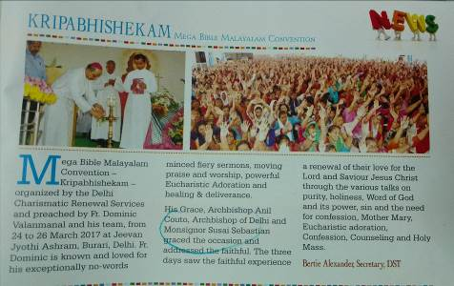

13. In the present report CHARISINDIA ERRORS-12, please take in the picture below.
“Charismatic” Mass is being celebrated against the backdrop of what appears to be Jesus seated in a yogic posture.

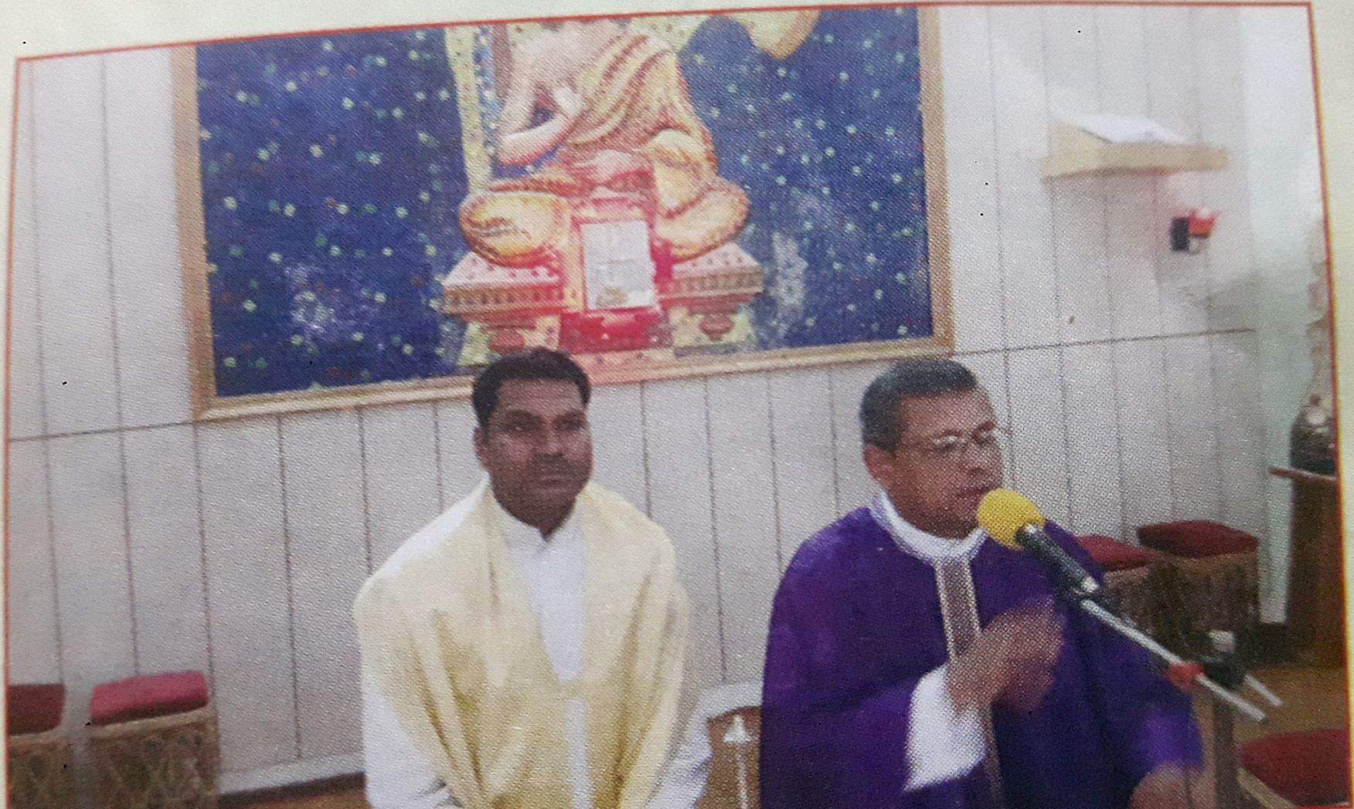
CHARISINDIA JUNE 2015

The caption reads, “Feasts of the Gifts of the Holy Spirit” March 10-17, at Masih Vidyapeeth in Agra; it was attended by 69 religious brothers from 19 dioceses. In another photograph on the same page, there is not even a crucifix on the table (I hesitate to call it an altar).

RELATED FILES
WAS JESUS A YOGI? SYNCRETISM AND INTERRELIGIOUS DIALOGUE-ERROL FERNANDES
http://ephesians-511.net/docs/WAS_JESUS_A_YOGI_SYNCRETISM_AND_INTERRELIGIOUS_DIALOGUE-ERROL_FERNANDES.doc
JESUS THE YOGI AND RESURREXIFIXES AT LITURGICAL CENTRE OF CATHEDRAL OF ST THOMAS
http://ephesians-511.net/docs/JESUS_THE_YOGI_AND_RESURREXIFIXES_AT_LITURGICAL_CENTRE_OF_CATHEDRAL_OF_ST_THOMAS.doc
JESUS THE YOGI AND THE DANCING JESUS
http://ephesians-511.net/docs/JESUS_THE_YOGI_AND_THE_DANCING_JESUS.doc
INDIAN PRIME MINISTER PUBLICLY ACKNOWLEDGES HINDU GOD SHIVA AS THE FIRST YOGI
http://ephesians-511.net/docs/INDIAN_PRIME_MINISTER_PUBLICLY_ACKNOWLEDGES_HINDU_GOD_SHIVA_AS_THE_FIRST_YOGI.doc

CHARISINDIA ERRORS-01 - PRO-CONTRACEPTION ARTICLE
http://ephesians-511.net/docs/CHARISINDIA_ERRORS-01.doc
CHARISINDIA ERRORS-02 - EULOGIES AT FR. RUFUS’ FUNERAL MASS
http://ephesians-511.net/docs/CHARISINDIA_ERRORS-02.doc
CHARISINDIA ERRORS-03 - ERRORS ABOUT FRANCIS MACNUTT
http://ephesians-511.net/docs/CHARISINDIA_ERRORS-03.doc
CHARISINDIA ERRORS-04 - ARTICLE AUTHORSHIP WRONGLY ATTRIBUTED
http://ephesians-511.net/docs/CHARISINDIA_ERRORS-04.doc
CHARISINDIA ERRORS-05 - BANNED FROM THE NATIONAL CHARISMATIC CONVENTION
http://ephesians-511.net/docs/CHARISINDIA_ERRORS-05.doc
CHARISINDIA ERRORS-06 - PROPHETIC INTERCESSION AND JERICHO MARCH
http://ephesians-511.net/docs/CHARISINDIA_ERRORS-06.doc
CHARISINDIA ERRORS-07 - ERRORS IN BACK ISSUES OF CHARISINDIA
http://ephesians-511.net/docs/CHARISINDIA_ERRORS-07.doc
CHARISINDIA ERRORS-08 - ERRORS ABOUT FR. THAMBURAJ AS CHAIRMAN
http://ephesians-511.net/docs/CHARISINDIA_ERRORS-08.doc
CHARISINDIA ERRORS-09 - AMBIGUOUS PROPHECIES?
http://ephesians-511.net/docs/CHARISINDIA_ERRORS-09.doc
CHARISINDIA ERRORS-10 - USE OF KUTHU VILAKKU/NILAVILAKKU AT NATIONAL CONVENTION
http://ephesians-511.net/docs/CHARISINDIA_ERRORS-10.doc
CHARISINDIA ERRORS-11 - RAMPANT USE OF KUTHU VILAKKU IN THE CCR AT INAUGURAL CEREMONIES
http://ephesians-511.net/docs/CHARISINDIA_ERRORS-11.doc

