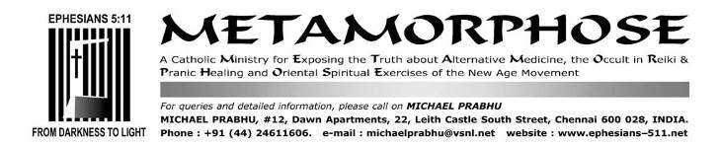
FEBRUARY 15/22, 2017/NOVEMBER 2021

MoreLove’s and Ethos Institute’s Dominic Dixon of Bangalore convicted, sentenced and fined in the USA, deported from Canada for sexual molestation of relatives’ minor son

Our other files on or related to Dominic Dixon in chronological order:
1. MORELOVE-HOLYSPIRITINTERACTIVE*-SOUL TIES AND ETHOS INSTITUTE 31 JANUARY/ 12/15/17/18/22/23 MARCH, 6/8/16/26/29 APRIL/JULY/DECEMBER 2013/18 NOVEMBER 2015
http://ephesians-511.net/docs/MORELOVE-HOLYSPIRITINTERACTIVE-SOUL_TIES_AND_ETHOS_INSTITUTE.doc
2. HOLYSPIRITINTERACTIVE ANEEL ARANHA* AND NEW AGE 9 MAY 2013
http://ephesians-511.net/docs/HOLYSPIRITINTERACTIVE_ANEEL_ARANHA_AND_NEW_AGE.doc
3. HOLYSPIRITINTERACTIVE*-WARNING ALERT ISSUED BY CATHOLICCULTURE.ORG 19 MAY/5 JUNE 2013
http://ephesians-511.net/docs/HOLYSPIRITINTERACTIVE-WARNING_ALERT_ISSUED_BY_CATHOLICCULTURE.ORG.doc
4. THE PRAKASH LASRADOS, THE JOHNSON SEQUEIRAS AND THE DOMINIC DIXONS 28 JULY 2013/15 FEBRUARY 2017
http://ephesians-511.net/docs/THE_PRAKASH_LASRADOS_THE_JOHNSON_SEQUEIRAS_AND_THE_DOMINIC_DIXONS.doc
5. DOMINIC DIXON AND MORELOVE-MORE UNHOLINESS 4 AUGUST 2013
http://ephesians-511.net/docs/DOMINIC_DIXON_AND_MORELOVE-MORE_UNHOLINESS.doc
6. DOMINIC DIXON CONTINUES TO DECEIVE CATHOLICS 24 OCTOBER 2014
http://ephesians-511.net/docs/DOMINIC_DIXON_CONTINUES_TO_DECEIVE_CATHOLICS.doc
7. FLAME MINISTRIES INTERNATIONAL YOGA AND ANEEL ARANHA* 29 JANUARY 2016
http://ephesians-511.net/docs/FLAME_MINISTRIES_INTERNATIONAL_YOGA_AND_ANEEL_ARANHA.doc

Aneel Aranha of HolySpiritInteractive (HSI) is a major associate in the “ministries” of Dominic Dixon.
Dominic Dixon is active in various Catholic “ministries” in the archdiocese of Bangalore.
In the city of Bangalore, he runs an organization called MoreLove and another called Ethos Institute.
Dixon enjoys the blessings and the patronage of the Archbishop of Bangalore Most Rev. Bernard Moras despite our sending several letters and reports to the Archbishop, none of which were ever acknowledged.
Catholic colleges in Bangalore have invited him to present programmes to their students and he has been on the panels of national television shows, the theme almost always being on issues of sexual morality.
Also, despite our seven earlier reports exposing Dominic Dixon’s nefarious activities, deceit and blatant lies, false claims, unsubstantiated claims of high overseas educational qualifications, contradictions, blackmail and threatening telephone calls made to this ministry, other Catholic ministries and a couple of priests (using local hoodlums and fake email ids), he is supported by high level leaders of the Bangalore Catholic Charismatic Renewal and by a few priests some of who will be identified in this report. [In referring herein to issues already reported/recorded, I will provide the above serial numbers of the related 7 reports.]
But, unknown to all, Dominic Dixon is a convicted sexual predator and serial pedophile.
Sometime last year, I had received a call from Australia from a Charles Tilaka and his wife Charmaine who is the sister of Dominic Dixon. They reported that he had molested one or both of their two children when he had recently gone to Australia and stayed with them. They also alleged that Dixon is uneducated, and not a Ph.D. as claimed by him. Two or three years ago, we received a call purporting to be from one of the Gulf States making similar claims. Both parties did not follow up the telecon with documentary evidence or even an email letter to make a written record and consequently I could not put the information in my reports.
In this present report, we are finally able to produce evidence of one of his sexual molestations of a minor which we had known about for at least three years but could not report till now without documentation.
The affected family is a third cousin of Dominic Dixon and her husband Bruce P. and the assault occurred in Des Moines, Iowa, USA in February 1995. They have corresponded in detail with me as well as with one of our web masters in Bangalore and have also spoken at length with him over the ‘phone from where they now reside in Dallas, Texas 75056 [Cell numbers: 214.436.2672, 214.303.9938].

Link to Dominic Dixon’s deportation from Canada by a Court Order of the Canadian Government:
http://decisions.fct-cf.gc.ca/fc-cf/decisions/en/item/47307/index.do?r=AAAAAQANZG9taW5pYyBkaXhvbgE

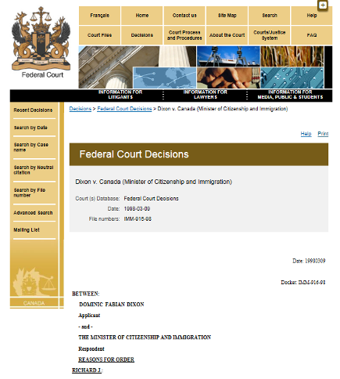

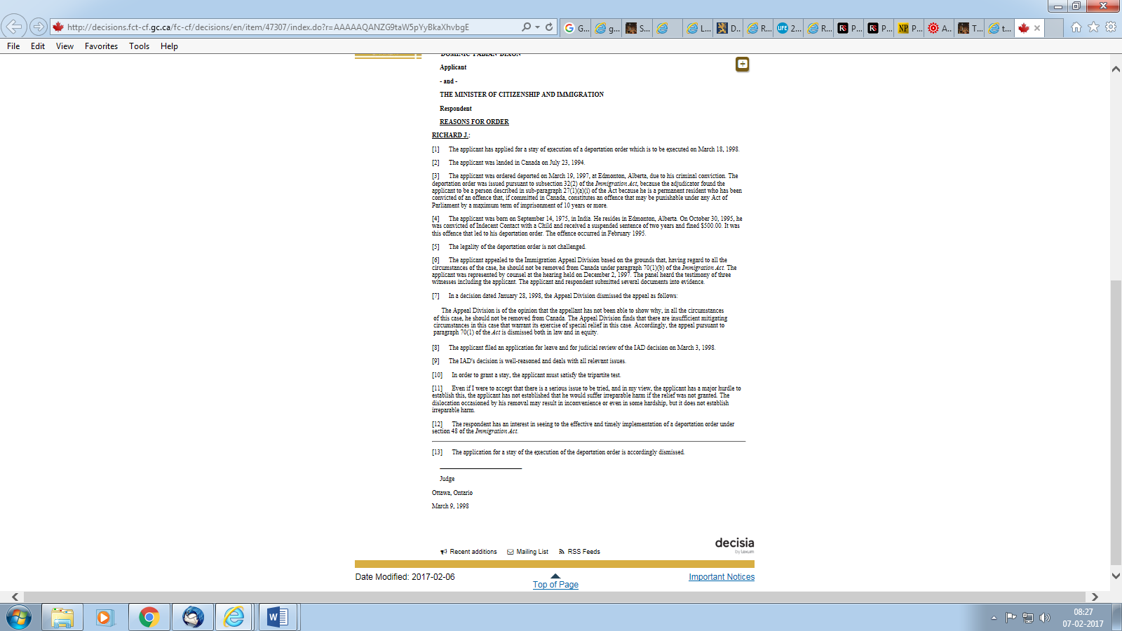

Dominic Dixon born in Chennai, India on September 14, 1975, can never re-enter either the USA or Canada.
He reached Canada with his parents Brian and Germaine Dixon and his brother Wilfred on July 23, 1994 and became a permanent resident of Canada.
During a visit to his cousin in Des Moines, Iowa, in the US in February 1995, he sexually assaulted their minor son who was then only nine. In the words of the boy’s father, “We all hate him after he molested my nine year old son. He was sentenced and jailed for Child Molestation. He was then DEPORTED from the USA. He was in the USA for not even 3 complete months before he was arrested and deported. [Emphases his] So, if he was in the USA less than 3 months living in my house, under my direct supervision with no money, how did he do all those fictitious degrees that he claims on his website? As he is a Child Molester he will never be allowed back into the USA or Canada, so where did he study? He is a total Con Man that even his own relations do not want to have anything to do with.
Recently he repeated the same thing in Australia with his sister’s child. He needs to be stopped and put in jail.
I cannot understand how people in India have not yet found out about this criminal and are still letting him come into contact with young children in God’s Name. This is shameful!
Do you know which Police Inspector or Police Department was investigating him? If so please let me know as I would like to contact them with the information that I have about Dominic Dixon.
After the molestation occurred in Des Moines, Iowa, I asked Dixon to return to his home in Edmonton, Canada. I bought him a ticket on a Greyhound bus. After I reported the case to the US Police in Des Moines, Iowa, where the molestation took place the US Police extradited Dominic Dixon back from Canada to the USA to stand trial. After the trial he was deported back to Canada. From Canada he stood trial for his immigration status and was deported because of the child molestation mentioned in Paragraph 4. DD was extradited in 1998 because he appealed his deportation in Canada. If you read carefully you will see that this document is a dismissal of his appeal to stay in Canada.”

Read point no. 4 of the court order on the previous page:
On October 30, 1995, Dominic Dixon was convicted of the crime of “Indecent Contact with a Child” (in a US Court).
He received a suspended sentence of two years and was fined USD 500 (a huge amount in 1995).
In Edmonton, Alberta, he was ordered deported from Canada on March 19, 1997 on the basis of his “criminal conviction” in the USA with the Canadian Court stating that, as a permanent resident, if the same offence was repeated in Canada, the offence may be punishable by “a maximum term of imprisonment of 10 years or more.”
Dominic Dixon was thereby deemed to be a potential threat to little boys in Canada.
Dixon’s counsel represented him at a hearing in Canada on December 2, 1997.
He filed an appeal for a review (with the Canadian Immigration Appeal Division) of his deportation on March 3, 1998. The Appeal was dismissed and he was deported to India from Canada on March 18, 1998 as per the Court Order of March 9, 1998.

Concerning Dominic Dixon’s educational background and qualifications, this is what Bruce P. wrote to me: “When I knew him he was in St. Mary’s Anglo Indian High School in Broadway, Chennai. He had FAILED his 6th standard. This can be verified by the Principal at that time Father John Peter, with whom I spent many hours trying to get Dominic Dixon a fake 8th Standard pass which was the minimum requirement for Dominic to get into the Vocational Training School (Salesian Institute of Graphic Arts, SIGA), for studying Printing, Chennai. After I helped him to get into the Vocational School (SIGA Printing Press) I even arranged his Board and lodge in this institution.
Please review his Website for his numerous educational achievements such as Oxford, Harvard etc. I am not sure how he afforded so many such prestigious expensive institutions that most normal people cannot afford.”
Fr. John Peter SDB is a priest known to our family as we all studied under the Salesians in Chennai and it would be a simple matter for us to check out Dominic Dixon’s tenure at St. Mary’s as well as at SIGA.

This is what Dixon claims about his educational background (http://www.dominicdixon.net/files/Download/Dom-bio.pdf):
EDUCATION:
Dominic was expelled from school at the age of 15. His education was discontinued not because of him (sic) being unintelligent but due to poverty, a delinquent and hazardous family environment and a victim of child sexual abuse. He continued his education via full time technical education and then distant (sic) learning.
Considering that he has a background that boasts of Georgetown University (Washington DC), Harvard and Oxford, and that he studied in Canada (despite his having been kicked out from there), his English (spelling, grammar, syntax) is atrociously poor. [In the above quote, it should be “his” and not “him”; “distance”, not “distant”. He speaks of “alternate” sexuality which correctly put is “alternative” sexuality, “retret” for “retreat” in a headline on his Facebook page, “ruppes” for “rupees”, etc. Look out for the numerous “sics” in extracts from his website and blog pages on the following pages of our report.

Dr. Dominic F. Dixon
Profile
http://www.dominicdixon.net/files/Download/Dom-bio.pdf
Dr. Dominic F. Dixon
D. Psych, Phil (Oxford), REL (Harvard) MC Justice (Harvard) Bio-Ethics (KIE, U of Georgetown)
Dominic F. Dixon, a Catholic Evangelist based in Bangalore, under the authority of the Catholic Church. He is the Founder and Director of MORELOVE.IN, VERITAS TV, MORELOVERADIO and a Director of Holy Spirit Interactive, a Lay Catholic Apostolate recognized as an Association of Faith and Outreach (Canon 312, 2/ 314/ 317, 1) by Bishop Paul Hinder of the Vicariate Apostolic of Southern Arabia. He is the Provost of Ethos Institute and the Chairman of MORE TRUST. Dominic has reached out to several hundred thousand youth around the world who have been abused, addicts, alcoholics, and the outcast including gangsters.
Dominic is a leading voice in India for Pro-Life and is a disciple for the teachings of the Catholic Church. He is also an ecumenical person of love to bring the Church in total unity which granted him appreciation by international Christian leaders of all denominations. One Shepherd, One flock.
Websites: http://holyspiritinteractive.net | http://ethosinstitute.org | htttp://MoreLoveRadio.com | http://VeritasTV.net | http://MoreLove.in |
To know more, visit: www.DominicDixon.net

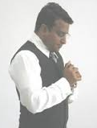
EDUCATION:
Dominic was expelled from school at the age of 15. His education was discontinued not because of him being unintelligent but due to poverty, a delinquent and hazardous family environment and a victim of child sexual abuse. He continued his education via full time technical education and then distant (sic) learning. He earned his P. Tech and continued his studies in Canada. He has done extensive research studies in Psychology of Emotions and earned his doctorate in Counselling Psychology, and furthered research studies in Philosophy of Ethics at Oxford University | Religion at the University of Harvard, US | Bio-ethics at the Kennedy Institute of Ethics at Georgetown University, US | Masters Certificate in Justice at the University of Harvard, US. MEDIA: Dominic is one of the most interviewed Christian Evangelist (sic) in India having been interviewed by CNN, NDTV, India Today, Times of India, Headlines Today, Agence France Presse and other International News channels and projected in over 100 Provinces worldwide in regards to his work amongst the youth.

PRESENTATIONS & PAPERS:
Dominic has presented a research paper on 'Homosexuality' to the Prime Minister of India and a research paper to the President of India on 'Youth Psychology & Sociology' This paper was endorsed by Fr. Dominic Emmanuel*, Dir. Communications, Delhi Archdiocese.
He has presented two papers at Oxford University on (1) Moral Absolutism (2) Can Utilitarianism respect rights?

AUTHORSHIP:
Books: (1) The Beautiful Christian Mind - released by Archbishop Bernard Moras
(2) Living for the Audience of One - released by Bishop Camila Ballin, Vicariate of Kuwait
(3) I’m a Teenager, plz understand me! - Released by Ms. Wanda Paul, retired teacher.
(4) A Journey to Holiness – released by Archbishop Bernard Moras
Audio: 5 volumes on Freedom in Christ
Purpose of Lifes (sic) events
Audio: "When innocence is stolen" for the nun who was gang raped in Orissa. This song was highly appreciated around the world and was endorsed by Archbishop Raphael Cheenath of Orissa.
Video: Produced a short film on abstinence from pre-marital sex.
Dominic F. Dixon does not claim to be of high standing or of great merit, but journeys only by the grace of God. His humble cry to the Lord is: Lord Jesus, give me the YOUTH of this world or I will die! Dictum: The Truth shall set you free!
Bio prepared by team Holy Spirit Interactive (HSI)

*Note: Fr. Dominic Emmanuel SVD is a liberal priest.
IS CHURCH SPOKESPERSON FR DOMINIC EMMANUEL SVD A LIBERAL?
http://ephesians-511.net/docs/IS_CHURCH_SPOKESPERSON_FR_DOMINIC_EMMANUEL_SVD_A_LIBERAL.doc

Fr. Dominic Emmanuel SVD, like Dominic Dixon, is also a sexual predator. See pages 4-6 of my report
SEXUAL ABUSE OF NUNS BY INDIAN MALE RELIGIOUS
http://ephesians-511.net/docs/SEXUAL_ABUSE_OF_NUNS_BY_INDIAN_MALE_RELIGIOUS.doc

Dr. Dominic F. Dixon
http://ethosinstitute.org/institute1/DominicDixon.html
Dr. Dominic F. Dixon (Psychologist), is a Catholic Evangelist in the Archdiocese of Bangalore, under the authority of the Catholic Church and is a member of the International Association for Deliverance. This has been debunked by the Secretary of the IAD, see pages 12, 13.
He is the Founder & Director of MORELOVE.IN, VERITAS TV, HSI MORELOVERADIO and a Director of Holy Spirit Interactive, a Lay Catholic Apostolate recognized as an Association of Faith and Outreach (Canon 312, 2/ 314/ 317, 1) by Bishop Paul Hinder the Apostolic Vicar of Southern Arabia.
He is the Provost of Ethos Institute. He has done extensive research studies in Psychology of Emotions and earned his doctorate in Counselling Psychology, and furthered research studies in Philosophy of Ethics at Oxford University, UK and Religion at Harvard University, US.
Please visit this site for more information: http://dominicdixon.net.

Profile
Dr. Dominic F. Dixon
http://domdix.wixsite.com/dominic/about
The titles associated with most of the positions of Dr. Dixon are not paralleled in monitory or materialistic compensation or value, but in positions of influence to bring healing to a hurting world, especially to orphans and widows and to victims of communal and political conflict. His work and publications have been recognized by the international community and widely covered by the media, worldwide.

Education:
​Dr. Dominic was expelled from school at the age of 15. His education was discontinued due to poverty, a delinquent and hazardous family environment and a victim of child sexual abuse. He continued his studies via full time technical education and then distant learning in the midst of hardships and poverty. Today, he stands as a role model to the millions of youth in India, while being recognized by the State and Central governments for his contribution to the nation of India.
​Dr. Dixon is a life long (sic) learner and is presently engaged in international studies via distance and online education.

Present Responsibilities:
- Chairman, MORE TRUST – Centre for Reconcillation (sic)
- Provost, Ethos Institute
- Director, VERITAS TV & HSI Radio
​
Presentations & Research:
- Research to the Prime Minister Narendra Modi (Pornography & its devastating consequences of the Youth & Women in the nation of India)
- Research to the Prime Minister Manmohan Singh (Youth behavioural)
- Research to President Prathibha Patil (Adolescent Sociology & Psychology)
- Research to Governor of Karnataka, Hans Raj Bharwdwaj (sic)
- Research to Governor of Tamilnadu, Dr. K. Rosaiah
- Research to Chief Minister of Karnataka, BS Yeddurappa (sic)
- Presentation to Cyber Crime, Interpol on legal processes
- Research on the Juvenile Justice System in Bangalore

Academic Authorship
- Author of seven books, 5 on youth in conflict
- Paper on Communal harmony and understanding of ideologies
- Authored several text books on Psychology & Emotions
- Author of six Audio volumes on Holistic Counselling
- Research to University of Oxford, Utilitarianism & Human Rights
- Research to University of Oxford, Moral Absolutisms

Media: - Dr. Dixon has been widely interviewed in over 36 countries & over 100 Provinces by CNN, Headlines Today, US Politics, Agence France Presse, Khaleej Times Dubai, Times Now, NDTV, Yahoo, India Today, Family Mantra, Charis Times, Times of India, Saudi, News 9, News X and others.

Recent International Delegation: Australia, Thailand, Canada, America, Nepal, Sri Lanka, Israel, Dubai, Muscat, Palestine, Kuwait, Lebanon, India, Egypt, Jordan…

In Dominic Dixon’s August 5, 2015 letter to the Prime Minister of India on “Child Pornography Simulation”, (a term self-admittedly coined by him), these are the academic qualifications under his name:
Dr. Dominic F Dixon (Psychologist) Provost, Ethos Institute D. Psych, Phil (Oxford), MC Justice (Harvard), REL (Harvard) Forensics Science & Criminal Justice (Exeter, UK), International Law (UCL, Belgium)
Exeter, UK, and Belgium are new additions.
In the letter to the PM, he decries the sexual abuse of minors (the very crime for which he was arrested, sentenced, fined and jailed in the USA and then deported!)
He beseeches the PM, “It is my appeal to ban pornographic websites that insinuates (sic) child pornography.”

Dominic Dixon downloads from the Internet and uses the seal/logo of Oxford University on one of his web pages. Please Google “image of seal of Oxford University” and find that it’s the very first image on the page!
http://domdix.wixsite.com/dominic/publications:
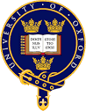

To support that he has written a two-page research paper “Can a Utilitarian respect rights?” at/for (?) Oxford in 2013, he uses (http://media.wix.com/ugd/39e6a1_16acff0db61748958ede981895dd6fb6.pdf) another image which too can be downloaded and copy-pasted from the Internet as I have done:


Another 2013 paper on “Moral Absolutism” at
http://media.wix.com/ugd/39e6a1_9cc47ff3f6c24913b7918874c7294755.pdf also carries the Oxford seal and logo.

DOMINIC DIXON’S ASSOCIATES SUPPORTERS
"MoreLove" is an organization founded and operated by Dr. Dominic F. Dixon who signs his communications as "psychologist". He is the author of "The Beautiful Christian Mind-Deliverance from Mental Illness" (the contents of the book were ridiculed in a critique in The New Leader, August 16-31, 2007, by Dr. Fr. M. A. Emmanuel Arockiam, SJ., who did his Ph. D. in Counseling Psychology from the U.S.), Asian Trading, 2006; "Living for the Audience of One", More Love, 2008; and "A Journey to Holiness", 2013.
The first and third books were public released by Archbishop Bernard Moras of Bangalore.

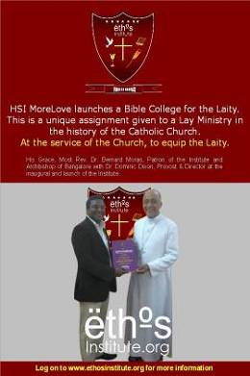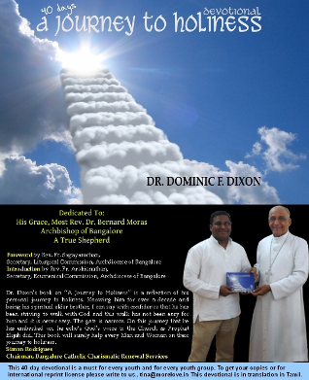

"The Beautiful Christian Mind-Deliverance from Mental Illness" (http://domdix.wixsite.com/dominic/publications):
The book was “endorsed by the Vice Chairma (sic) of Exorcism of the Vatican, realsed (sic) by Archbishop Bernard Moras and presented at the Asian Mission Congresss (sic) in Thailand.”
There is NO such thing as “Vice Chairman of Exorcism of the Vatican”. The book was written in 2006. The IAD was only recognised as an Association by the Vatican in June 2012, one month after the demise of Fr. Rufus Pereira of Mumbai who was its longtime Vice-Chairman.

He also wrote I’m a Teenager, plz understand me! - Claretian Publications.

The second book was released by Bishop Camillo Ballin MCCJ, the Apostolic Vicar of Kuwait who also supports the ministry of Aneel Aranha, the leading ministry associate of Dominic Dixon. See
BISHOP CAMILLO BALLIN DODGES CORRESPONDENCE ON PASTORAL ISSUES
http://ephesians-511.net/docs/BISHOP_CAMILLO_BALLIN_DODGES_CORRESPONDENCE_ON_PASTORAL_ISSUES.doc

“A Journey to Holiness”
This is what Simon Rodrigues, Chairman of the Bangalore Charismatic Renewal Services had to say, likening Dixon to the prophet Elijah (http://domdix.wixsite.com/dominic/publications):
Dr. Dixon’s book on “A Journey to Holiness” is a reflection of his personal journey to holiness. Knowing him for over a decade and being his spiritual elder brother, I can say with confidence that he has been striving to walk with God and this walk has not been easy for him and it is never easy. The gate is narrow. On this journey that he has embarked on, he echo’s God’s voice to the Church as Prophet Elijah did. This book will surely help every Man and Woman on their journey to holiness.

Dixon’s organization’s finances are audited by Simon Rodrigues, the Chairman of the Bangalore Catholic Charismatic Renewal Services (who is also an auditor of the Archbishop of Bangalore).
http://ethosinstitute.org/institute1/aboutus.html:
As a Ministry, we duly submit our audited financial reports to the Chairman of the BCCRS.

"Living for the Audience of One"
Aneel Aranha of HolySpiritInteractive pays a glowing tribute to book and its author. See http://domdix.wixsite.com/dominic/publications.

Dixon’s favourite topics for writing “research papers” are “sexting”, sexual integrity and pornography.
He is a leading contributor (as seen in the following extract) to Aneel Aranha’s HolySpiritInteractive.

Aneel Aranha
Dr. Dominic Dixon
Dixon excels in boastful and exaggerated self-promotion, much of which this ministry has exposed as false.
http://www.holyspiritinteractive.net/columns/dominicdixon/:
Dr. Dominic Dixon is a leading voice on pro-life issues in India and is an international representative for the cause.

ETHOS Institute has been formed in response to Blessed John Paul II's call to "Christian Ethos". Ethos Institute is an initative (sic) of lay Catholic missionaries, with the blessings of Archbishop Bernard Moras, the Archbishop of Bangalore. The institution is not an official academic program of the Catholic Church but an Association of Faith under Holy Spirit Interactive Ministries … We encourage self-restraint all the time: don’t steal, don't vandalized (sic), etc. So the Church is teaching this world the true value of human life.
These, and a great multitude of other restraints, are considered normal and healthy. But why do people cry “pathology” as soon as someone suggests restraint for the sexual appetite? At this Institute, we aim at countering the quasi manifestation of concupiscence with equipping the Laity with the knowledge of Moral Theology and Christian Ethos. ETHOS Institute aims at honoring the Magisterium, Tradition and Ethos of our faith and to enlighten the faithful in a new dimension as John Paul II says "The new dimension of ethos is always linked with ... the liberation of the heart from 'concupiscence'".

Dixon touts himself as a “nation builder”, social reformer, evangalist (sic), civil liberties expert, “practitioner for civil liberties and social justice”, “the first Indian Christian to represent the views of the Church worldwide in the context of Youth Issues”, crusader against rape and pedophilia, and of course, “psychologist”.

“Dr. Dominic F Dixon was recipient of the St. Maximilian Kolbe award for “Excellence in Communication” INDIA, 2015, awarded by Living Bread Publications” (http://www.dominicdixon.net/index.html)
My enquiries reveal that no one has any knowledge about this Living Bread Publications award to Dixon.
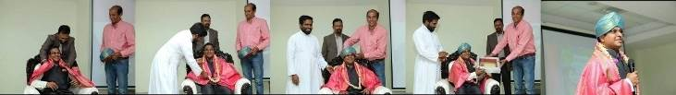

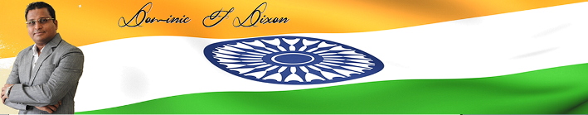

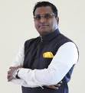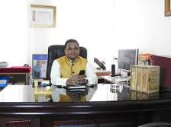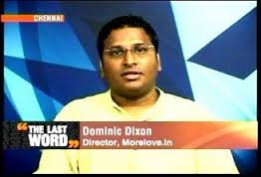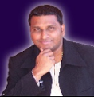

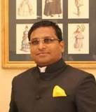
Dominic Dixon wears a clerical collar!

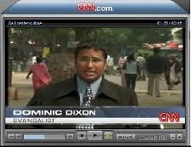


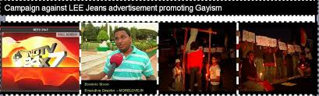

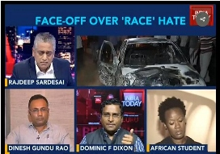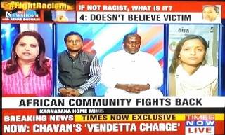

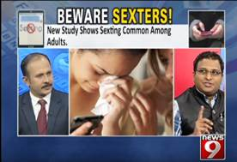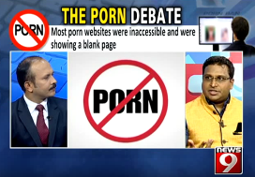

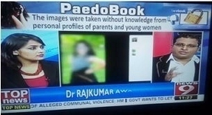

He features often on TV9, a Bangalore channel (Bansy Kalappa is no more with TV9 since February 1, 2017).
See BANSY KALAPPAS SYNCRETISTIC TV SHOW-CHRISTIAN AND HINDU HELLS OUT-OF-BODY EXPERIENCES AND NEAR-DEATH EXPERIENCES 21/26 DECEMBER 2016
http://ephesians-511.net/docs/BANSY_KALAPPAS_SYNCRETISTIC_TV_SHOW-CHRISTIAN_AND_HINDU_HELLS_OUT-OF-BODY_EXPERIENCES_AND_NEAR-DEATH_EXPERIENCES.doc

Retret (sic) at St. Francis College for Women, Secunderabad
https://www.facebook.com/media/set/?set=a.563289080396447.1073741831.507264919332197&type=3:
Dr. Dominic Dixon ministered along with Fr. Christuraj, Founder of Holy Spirit Congregation. 1100 Non Christian (sic) girls!
Fr. Christuraj James was a priest of the Society of the Divine Word (SVD). He is a good, greatly gifted and holy priest. He founded the Divine Word Retreat Centre in Muthangi, outside of Secunderabad, Andhra Pradesh, in 1996. However, following a dispute with his superiors over his being transferred and the management of the Retreat Centre, he left the religious order and formed his own congregation, the Society of the Holy Spirit. A Fr. K. Sahaya Cyril Doss, Fr. P. Joji and Fr. Jojappa, and a couple of nuns form their core team. Their Holy Spirit Centre is at Moinabad, Hyderabad, and Kristu Jyothi Ashram in Warangal.
The Bishop’s Houses of Secunderabad, Warangal and Nalgonda assured me that there is no problem with Catholics attending the retreats of Fr. Christuraj. The new Society is expected to be regularised.
This inclusion is for the information of those who are confused about the status of Fr. Christuraj (who happens to be a friend of mine).

Dominic Dixon runs five- and nine-week schools at his Ethos Institute (http://ethosinstitute.org/institute1/index.html/http://ethosinstitute.org/institute1/pcp.html/http://ethosinstitute.org/institute1/tob.html):
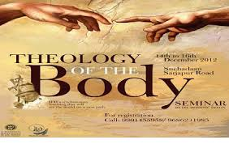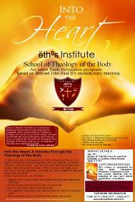

Such intensive schools costs about Rs.1,50,000 (One Lakh, Fifty Thousand Ruppes (sic), almost one thousand five hundred (sic) dollars.) But we're subsidsing (sic) these modules so the student pays Rs. 2500/- towards infrastructure rental, lectures, guest speakers, and materials. This cost also covers snacks and refreshments.

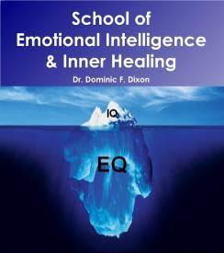

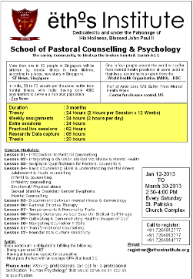

Extract from my report number 1 (from a letter addressed by me to Fr. Faustine Lobo):
I am recording a lot of information from the MoreLove/HSI flyer http://veritastv.net/TOB-MAILER.jpg referred above in case it is pulled from the Internet in the event of an inquiry from you.
It states that the TOB program would be "presented by renowned Catholic Evangelist, author and Ambassador of Theology of the Body, Dr. Dominic Dixon and his team."
The "team", according to the same flyer, under the heading of "Teaching Faculty" consists of
i) Dr. Dominic Dixon, Director HSI More Love/TOB India, IAD Vatican
Please see Mr. Francis Lobo's email further below; the http://veritastv.net/TOB-MAILER.jpg flyer also states that HolySpiritInteractive is "under the IAD, Vatican". (IAD=International Association of Deliverance)
ii) Rev. Fr. A. Sagayanathan, Parish Priest, St. Patrick's Church, Author: Blessed John Paul the Great
iii) Rev. Fr. Faustine Lobo, Director, Pontifical Mission, Vatican, whereas your true and correct designation would be "National Director, Pontifical Mission Societies, Bangalore, India".
iv) Bro. Simon Rodrigues, Chairman, Bangalore Catholic Charismatic Renewal Service [sic]

Dominic Dixon wrote on his Facebook page
http://www.facebook.com/photo.php?fbid=492107197483226&set=a.101994159827867.4433.100000518512851&type=1
"HSI School of Theology of the Body" for the first time in India and for the first time in the world as a School. TOB is based on the teaching of Blessed John Paul II. TOB is based on Pope John Paul VI Encyclical "Humanae Vitae" HSI is now the official Ambassador of the Vatican's official Encyclical. Please see attachment. To get a better view of this post, log on to http://veritastv.net/TOB-MAILER.jpg."

Is it true that TOB is being taught "for the first time in India" as claimed by HSI/MoreLove? I believe that Fr. Sagayanathan himself knows a U.S.-trained couple from Goa who teaches "Theology of the Body". I have attended one of their Seminars.

The statement "HSI School of Theology of the Body" for the first time in India and for the first time in the world as a School" is subtly misleading. The key word is "School". There are Catholic lay ministries that teach TOB in other formats such as seminars. Most readers will assume that the HSI/MoreLove TOB is exclusive and original apart from being "Vatican certified/authorized" as repeatedly stated.

There appears to be a lot of name-dropping and misuse of names of contacts in this HSI/MoreLove affair.
When I attended his talk on November 4, I listened to Dr. Dixon referring at regular intervals to how much approval and endorsements he receives from different archbishops.
Apart from that, there is the frequent [mis]use of the "Vatican" word. He is a self-declared "official Ambassador of the Vatican's official Encyclical [Humanae Vitae]", "an ambassador for the views of the Holy Father" and "an ecumenical ambassador" [http://www.dominicdixon.net/about_dom1.htm] and "Ambassador of Theology of the Body".
One wonders how these titles were assumed and what they are meant to convey.

The use of the term "veritas" in the Dr. Dixon/Mr. Aneel Aranha-owned Veritas TV http://veritastv.net/TOB-MAILER.jpg appears to be unethical.
As you yourself immediately noted, the word "veritas" at once brings to one's mind a certain Vatican media ministry, and this would happen with any visitor to a blog or web site using that name. Mr. Aneel Aranha and Dr. Dixon declare themselves as Vatican ambassadors or give the impression that their ministries as Vatican-associated/approved on Facebook and then provide links to their own site "VeritasTV" where they themselves ratify their claim and endorse their own selves.

Dr. Dixon "is a member of the International Association for Deliverance under the Vatican Council" [http://www.dominicdixon.net/about_dom1.htm]. [What "Vatican Council"?].
He is "Director HSI More Love/TOB India, IAD Vatican" according to the flyer which also states that HSI is "under the IAD, Vatican".
This again appears to be misleading. Whether any type of recognition has been given to MoreLove and HSI by the "IAD Vatican" needs to be ascertained.
Ms. Erika Gibello, Secretary-General of the IAD [International Association for Deliverance] and former Secretary for the English-speaking members of the AIE [Association of Exorcists International] can give you the correct information. [Note added on March 15: Her response to this false claim of Dixon is on page 13]
The use of "IAD" in conjunction with "Vatican" is itself a question mark.

"Dr. Dixon has represented the Church of India at parlimentary [sic] levels, as an advisor to the President and Prime Minister of India on various issues." http://www.dominicdixon.net/about_dom1.htm

AGAINST DOMINIC DIXON’S “VATICAN-APPROVED” REFRAIN, AN UNSOLICITED CLARIFICATION FROM THE FORMER SECRETARY OF THE AIE
Comments for http://ephesians511blog.com/2013/10/06/morelove-holyspiritinteractivesoul-ties-and-ethos-institute-july-2013/ submitted on 2013/12/06 at 1:52 am
Neither AIE, the International Association of Exorcists, nor IAD, the International Association for Deliverance are as yet Vatican approved. After the death of the President and Vice president, the new President and new Vice President (2012) of AIE have decided to apply for this association to come under the umbrella of the Liturgical Commission of the Vatican. No such plans are possible or desired for IAD. The fact the main office of AIE in based in Rome and its members recognised Exorcists or retired Exorcists does not confirm any canonical approval by the Vatican. Membership of both associations is not automatically ongoing, but has to be annually renewed by payment of the membership fee, and the ongoing recognition of the members by their Bishops or clerical superiors in case of monks.
Mrs. Erika Gibello (retired AIE secretary for English speaking members and active secretary for IAD) 6th Dec.2013
erika gibello
https://plus.google.com/112425590874513424530
erikagibello36@gmail.com
2.29.155.126

http://ethosinstitute.org/
Dedicated to and under the Patronage of His Holiness, Blessed John Paul II
http://ethosinstitute.org/team.html/, http://ethosinstitute.org/institute1/team.html
CHIEF PATRON
His Grace Most Rev. Dr. Bernard Moras, Archbishop of Bangalore, DD.
Family Council
Simon Rodrigues, CA
Leadership Development
Colin Calmiano, Dir. Spread your wings
From: prabhu To: Colin Calmiano Sent: Saturday, December 15, 2012 4:26 AM
Subject: FW: CATHOLIC BIBLE COLLEGE FOR THE LAITY
Dear Colin, Can you please confirm to me whether or not you are -- as Dr. Dixon advertises -- "Leadership Development
Colin Calmiano, Dir. Spread your wings" at his new BIBLE COLLEGE? Thank you, Michael
From: Colin Calmiano To: prabhu Sent: Saturday, December 15, 2012 8:14 AM
Subject: Re: FW: CATHOLIC BIBLE COLLEGE FOR THE LAITY
Yes Michael, I was requested by Dominic. God bless, Colin
[Colin Calmiano: SPREAD YOUR WINGS (Institute for Growth & Development), Bangalore, leads the People of Praise Covenant Community which is affiliated to Sword of the Spirit, an international community.]
On December 19, I wrote a cautionary letter about Dixon to Colin Calmiano who declined to respond.

http://ethosinstitute.org/aboutus.html EXTRACT:
MoreLove is under the authority of the Archdiocese of Bangalore.
Seemingly, the Church has somehow skipped the chapter of Academics for the Laity [??], to respond to a more profound understanding of the mystery of salvation in Christ. This urgently calls for higher studies and scholarship. ETHOS Institute aims at complimenting [sic] the Church in conducting such
studies in accordance with Catholic doctrine as held by the Magisterium of the Catholic Church.

UPDATES MARCH 12/15, 2013
Criminal behaviour of the “official Ambassador of the Vatican's official Encyclical”, “ambassador for the views of the Holy Father” and Catholic ministry “under the authority of the Archdiocese of Bangalore”
PHONE-TAPPING, GANGSTER-HIRING AND ARREST-WARRANT THREATS

As I had forecast, Mr. Dixon quickly made some modifications to one of his web sites on finding my report:
http://ethosinstitute.org/team.html, http://ethosinstitute.org/institute1/team.html EXTRACT
Due to their hectic clergy responsibilities, Fr. Faustine Lobo and Fr. Arul Raj could not be a part of our team as initially requested and desired.
MORAL ADVISORS
Rev. Fr. Franklin D’Souza - National Director - ICYM
Rev. Fr. Dominic Emmanuel - Director - Delhi Catholic Archdiocese Communication Bureau
Alex Anthony- Mentor, Jesus Youth India
We may recall that Fr. Franklin D’Souza, National Director, ICYM, Fr. Faustine Lobo and Fr. Arul Raj disassociated with MoreLove and Dixon after reading this report.

From: Michael Prabhu To: Arch bishop moras Cc: ccbi@airtelmail.in ; cbcisec@gmail.com
Sent: Wednesday, March 13, 2013 12:34 PM with MORELOVE document
Subject: CRIMINAL ACTS OF MR. DOMINIC DIXON OF MORELOVE/ETHOS INSTITUTE, BANGALORE ARCHDIOCESE
MOST REV. BERNARD MORAS, ARCHBISHOP OF BANGALORE
Dear Archbishop Bernard Moras…
May I also inform you that the "recognition" of Mr. Dixon's activities by the International Association of Deliverance, a private association and NOT A VATICAN BODY AS DIXON FALSELY CLAIMS, has been withdrawn as communicated to me.

ON MARCH 14 AT 6:00 PM, I RECEIVED A CALL FROM AN 'INSPECTOR OF POLICE'. SPEAKING IN KANNADA, HE INFORMED ME THAT AN ARREST WARRANT HAS BEEN ISSUED AGAINST ME FOR "HARASSMENT". THE CALLER DEMANDED PERSONAL INFORMATION FROM ME WHICH I PROVIDED. MEANWHILE MR. FRANCIS LOBO RECEIVED A SERIES OF THREATENING ANONYMOUS CALLS, OBVIOUSLY ORCHESTRATED BY DOMINIC DIXON, ACCUSING HIM OF UNSPECIFIED CRIMINAL ACTS.

From: Michael Prabhu To: Arch bishop moras Cc: pmsindia66@gmail.com ; Faustine Lobo
Sent: Saturday, March 16, 2013 10:55 AM Subject: UPDATED DOMINIC DIXON REPORT WITH LATEST CRIMINAL THREATS: AN IMMINENT DANGER LOOMS: COMMUNAL VIOLENCE

The revised [after Mr. Dixon read this report] ëthos team is given at http://ethosinstitute.org/team.html, http://ethosinstitute.org/institute1/team.html as:
Executive Team
Aneel Aranha - Chairman
Dr. Dominic Dixon - Executive Director/ Provost
Elders
Simon Rodrigues - Chairman, Bangalore Catholic Charismatic Renewal Service
Alex Anthony- Mentor, Jesus Youth India
ACADEMIC ADVISORS
Dr. Fr. Edayadiyil George CMI, M. Sc., M.A. (M.G.), L. Th., Th. D. (Angelicum, Rome) (World Religion)
Dr. Fr. Kochuthara Shaji George CMI, L. Th., Th. D. (Alphonsianum, Rome) (Moral Theology)
MORAL ADVISORS
Rev. Fr. Dominic Emmanuel - Director - Delhi Catholic Archdiocese Communication Bureau

MORE ministry
http://www.saint-mike.net/qa/sw/viewanswer.asp?QID=914
February 21, 2009
I was just wondering what your thoughts are on the MORE Ministry and if you are familiar with Dr. Dominic Dixon and his ministry in India. Apparently this is a Catholic Ministry and they are under the Magisterium of Rome. –Marion
I do not know anything about the man and his ministry other than a quick look on his website. It looks okay, but in the section about "Accept Christ" he gives a "sinner's prayer" with an appeal to seek out a local Church with no mention of Baptism. Without Baptism one is not a Christian. This is odd for someone claiming to be an evangelist. He is billed as a "Christian evangelist". I can see no reference to him being Catholic. Much of the site is very Protestant in presentation.
As for being under Rome there is no indication of that on his site, nor is there any indication that I can find that he or his ministry is Catholic. –Bro. Ignatius Mary OMSM

Extract from my report number 5.
My own recent conclusions [see the first two documents listed with links on the previous page] were that Dominic Dixon is Protestant-influenced and his ministries are Protestant-oriented or "ecumenical" despite his bandying the Vatican word with suspicious frequency.
Dominic Dixon has modified his web site many times over during the past years, more especially with this ministry’s recent exposés of his false claims, especially those of his having some special recognition from the "International Association for Deliverance [IAD] under the Vatican council" -- to cite just one of those misleading claims -- and a similar statement in 2004 on the MORELOVE web site must have been the reason for Marion to seek Bro. Ignatius Mary’s confirmation that MORELOVE is "under the Magisterium of Rome".
"Under the Magisterium of Rome", while devoid of any sense, is typical Dominic Dixon-speak, and there are several examples of this in my earlier reports. Such phrases are cunningly inserted to impress and deceive gullible visitors to his site. It is not simply interesting but crucial to note that Bro. Ignatius Mary was hard put to conclude that Dominic Dixon’s web site had any approval from Rome or that his ministry was Catholic!

Despite only a cursory glance at the MORELOVE site, he was able to inform Marion, "I can see no reference to him being Catholic. Much of the site is very Protestant in presentation." Note also his analysis of the Dominic Dixon’s "sinner’s prayer" and his related appeal. What Bro. Ignatius Mary did not either notice or come across was that Dominic Dixon emphasises on the "ecumenical" spirit of his ministry.
This was one of the several factors that contributed to catholicculture.org publishing the 2012 alert on the dubious Catholicity of the Dominic Dixon-Aneel Aranha MORELOVE-HolySpiritInteractive combine.
If Bro. Ignatius Mary had only dug deeper, he would have uncovered more dirt.

On the following page, one sees that the Archbishop of Bangalore Bernard Moras continues* to support the so-called ministry of Dominic Dixon. Dominic Dixon has written a book on… of all things… "Holiness"!!!!!
The promotion was done by HolySpiritInteractive:
From: HSI MoreLove To: michaelprabhu@vsnl.net Sent: Thursday, July 11, 2013 10:28 AM
Subject: Book Release - A Journey to Holiness
Simon Rodrigues, the Chairman of the Bangalore Service Team of the Catholic Charismatic Renewal has unabashedly provided a glowing tribute to Dominic Dixon's latest novel "A Journey to Holiness".
*If, as Rodrigues claims, the book is indeed a "reflection of Dominic Dixon’s personal journey to holiness… and striving to walk with God", he is an aider, abettor and accomplice in the criminal acts of Dominic Dixon.
The Archbishop and Rodrigues have both been apprised of the most unholy conduct of Dominic Dixon in respect of certain Catholic ministries and individuals as chronicled in my referred reports.

Dominic Dixon's latest such criminal behaviour, the very anti-thesis of holiness, coincided with the time of the release of his novel "A Journey to Holiness".
I received a telephone call from an anonymous female speaking in Tamil and using a mobile telephone.
The woman addressed me as "Father" Michael Prabhu. I said that I was a lay man in ministry. She said that she had been requested by the parish priest of St Francis Xavier’s Cathedral in Bangalore, on whose behalf she was speaking, to ask me if I would deliver a "message" at their night vigil on July 13. I enquired as to what "message" was expected of me. She replied that I could preach on any subject. Her telephone number, as did an earlier call in Kannada language purporting to be from the Karnataka police who claimed that they had obtained an arrest warrant for me for slandering the name of a preacher in Bangalore [see earlier reports] was visible on the display screen of my instrument, but I asked her for her contact details to have her request verified. Assuring me that she would get back to me the following Tuesday, she hung up and never got back to me. So how do I know for certain that this is the work of Dominic Dixon? Frankly, I don’t.
But, if I lodge a police complaint in Bangalore and provide their sleuths with these and other numbers used to threaten me and intimidate an associate as well as his employers in Bangalore, not forgetting the written admission [by email] of Dominic Dixon that he had tapped all of our phones including that of a priest and was in possession of transcripts of our exchanges [which incidentally exist only in Dominic Dixon's fertile, evil imagination], there would be no surprises as to who the cops would ferret out at the end of the trail.
The telephone call from the female was received by me within 48 hours of Dominic Dixon's being informed by the Jesus Youth ministry leaders that their invitation to him to minister to them at their forthcoming night vigil was withdrawn. Holding me responsible for that decision taken by the Jesus Youth leadership, Dominic Dixon attempted, unsuccessfully of course, to engineer a similar punishment for me. Holiness?
One can only be amazed that Archbishop of Bangalore Bernard Moras and Simon Rodrigues, the Chairman of the Bangalore Service Team of the Catholic Charismatic Renewal have soiled their reputations -- not that they were clean in the first place -- by their steadfast solidarity with a criminal like Dixon even after being in receipt of our ministry’s reports exposing his malpractices, slanderous campaigns and intimidatory activities. To me, it is blasphemous that the Chairman of the Bangalore Service Team of the Catholic Charismatic Renewal promotes "A Journey to Holiness" when the author of the book is the epitome of unholiness.
It is also an indictment of a spiritual corruption that since long pervades the Catholic Charismatic Renewal.
I once again place on record that Simon Rodrigues is himself more Protestant than he is Catholic which partly explains his affinity for the likes of Dominic Dixon and Johnson Sequeira and their "ministries".

Extract from my report number 6.
After I exposed Dixon, he made several changes in his blogs and web sites which carried exaggerations (tall claims) as well as downright lies (false claims); several people including priests who were his advisors asked him to remove their names from his blogs and sites after reading my reports, and I have letters from them.
People with whom he has stayed with in the Gulf have accused Dixon of sexual impropriety with their relatives.
A couple claiming to be his own immediate family rang me up very recently from Australia, introduced themselves and spoke against him for more than half an hour. They said that some of his educational claims are false and they explained to me his entire family background and antecedents. They repeatedly insisted that Dixon was not a psychologist but a psychopath.

At the links http://www.dominicdixonblog.org/ and http://www.dominicdixon.net/ you will read, as on today, the following, along with several other testimonials and photographs of Dixon posing with Church leaders:
1. Dr. Dixon is actively involved with the Church and Society at large, in helping with his tireless efforts for the youth. And I love and respect him for the passion he puts in defending the Christian principles before the public without any fear whatsoever. Dr. Dixon is a respected Evangelist. May God continue to bless his efforts!
Rev. Fr. Dr. Dominic Emmanuel, Spokesperson & Director, Delhi Archdiocese

Fr. Dominic Emmanuel SVD is no longer the spokesperson of the Delhi archdiocese. But I have corresponded with him when he was. At http://ethosinstitute.org/team.html he is listed as a 'Moral Advisor' to Dixon’s Ethos Institute. I wrote to him about Dixon on March 13, 2013, see http://ephesians-511.net/docs/MORELOVE-HOLYSPIRITINTERACTIVE-SOUL_TIES_AND_ETHOS_INSTITUTE.doc, but he did not respond. I sent him a reminder on November 25 of that year. He replied that he was very busy and could not respond before January 2014.
He finally wrote on January 14, 2014, that he had read part of my report on Dominic Dixon; and that was it.

In the meantime, I had received a bunch of papers from New Delhi. The pages were either handwritten in English or in Hindi, or they were printouts of sexually-explicit email correspondences between Fr. Emmanuel and a woman. Some of it makes disgusting reading.
The letter written in Hindi by a nun details her now-ended sexual affair with Fr Dominic Emmanuel SVD. In it she accuses him of sexual exploiting her and other nuns and school teachers whom she names.
Some papers are copies of email correspondence between Fr. Emmanuel and another nun sister; they admit to a sordid sexual affair, as well as his having unnatural sex with her. Times and places are mentioned.
There seem to be at least three women who this priest has exploited/had affairs with.
When I wrote and asked him for his explanation about these records of his sexual escapades, he wrote:
Thanks again for your mail, this time with a smell of threat in it with some information you have about an individual and me. Let me also inform you that this totally fabricated information has been around now for nearly four years and has been thoroughly investigated by all and sundry. It also reached my own SVD General in Rome. So much for the threat.
The above is an extract from his December 5, 2013 letter to me.

Now Fr. Emmanuel is noted for his regular appearance on TV debates defending the Church’s position on homosexuality and unnatural sex among other things. Given the secular and permissive culture of the times, he was always on the receiving end of the other panelists' ire. One can imagine what his position – and that of the Catholic Church’s -- would have been if the nun had sent the bunch of papers to these TV channels.
Such a priest is "Moral Advisor" and testimonial-giver to Dominic Dixon’s Ethos Institute!
[http://ephesians-511.net/docs/SEXUAL_ABUSE_OF_NUNS_BY_INDIAN_MALE_RELIGIOUS.doc]

Some web sites and blogs of Dominic Dixon and Aneel Aranha:
http://MoreLove.in, http://ethosinstitute.org, http://VeritasTV.net, www.dominicdixon.net, http://www.moreloveradio.com/, http://www.moreloveradio.com/mlplayer.html, http://www.morelove.in/index.php, http://www.dominicdixon.net, http://www.holyspiritinteractive.net/, http://www.holyspiritinteractive.org/, http://holyspiritinteractive.blogspot.in/, http://aneelaranha.blogspot.in/,

The following telephone numbers are the only ones available at Dominic Dixon’s web pages.
80-640-7777, 0 720401 2777, 0 720401 3777, 0 720401 4777 - St. Patrick’s Church, Brigade Road, Saturday 6:00-7:30 PM prayer meeting
Dominic Dixon: 0 98805-36501
I have tried all of them repeatedly several times on different days at different times of day. The call does not go through or I am informed that the number does not exist.

On February 18 and 20, 2017, I wrote a short exploratory email from an alternative gmail id to Dominic Dixon and a number of his associates excluding the Archbishop of Bangalore and the Vicariate of Arabia:
Why was Canadian citizen Mr. Dixon now in Bangalore deported from Canada where he lived with his parents after extradition to/from the United States of America?
Why was he tried and convicted, and sentenced and jailed in the U.S?
If Mr. Dixon was debarred from the U.S. and deported from Canada, how did he take academic degrees from Harvard, Washington DC and Canada?
Not one responded (as expected).
On February 22, 2017, I sent the above information as a Word document attachment by email to the many email ids of Dominic Dixon and Aneel Aranha under copy to the Archbishop of Bangalore, and by Bcc to most of the priests and individuals in India and the Bishops of the Vicariate of Arabia who have been closely associated with them in the past (several priests have distanced themselves from him after reading my initial reports but others remain). This report will be further updated if responses are received.

UPDATE:
DOMINIC DIXON CONVICTED IN USA DEPORTED FROM CANADA FOR SEXUAL MOLESTATION OF BOY 02 13 JUNE 2017 5 PAGES
http://ephesians-511.net/docs/DOMINIC_DIXON_CONVICTED_IN_USA_DEPORTED_FROM_CANADA_FOR_SEXUAL_MOLESTATION_OF_BOY_02.doc
UNITED NATIONS AGENCY DISTANCES ITSELF FROM DOMINIC DIXON 13 JUNE 2017 9 PAGES
http://ephesians-511.net/docs/UNITED_NATIONS_AGENCY_DISTANCES_ITSELF_FROM_DOMINIC_DIXON.doc
CONVICTED PEDOPHILE DOMINIC DIXON TRIES TO SILENCE THIS MINISTRYS EXPOSES OF HIM 17 JUNE 2017 11 PAGES
http://ephesians-511.net/docs/CONVICTED_PEDOPHILE_DOMINIC_DIXON_TRIES_TO_SILENCE_THIS_MINISTRYS_EXPOSES_OF_HIM.doc
CONVICTED PEDOPHILE DOMINIC DIXON TRIES TO SILENCE THIS MINISTRYS EXPOSES OF HIM 02 31 AUGUST 2017 8 PAGES
http://ephesians-511.net/docs/CONVICTED_PEDOPHILE_DOMINIC_DIXON_TRIES_TO_SILENCE_THIS_MINISTRYS_EXPOSES_OF_HIM_02.doc
CONVICTED PEDOPHILE DOMINIC DIXON TRIES TO SILENCE THIS MINISTRYS EXPOSES OF HIM 03 15 NOVEMBER 2017 8 PAGES
http://ephesians-511.net/docs/CONVICTED_PEDOPHILE_DOMINIC_DIXON_TRIES_TO_SILENCE_THIS_MINISTRYS_EXPOSES_OF_HIM_03.doc
US CITIZEN BRUCE PHILLIPOWSKY EXPOSES DOMINIC DIXON 27 NOVEMBER 2017 14 PAGES
http://ephesians-511.net/docs/US_CITIZEN_BRUCE_PHILLIPOWSKY_EXPOSES_DOMINIC_DIXON.doc
CONVICTED PEDOPHILE DOMINIC DIXON TRIES TO SILENCE THIS MINISTRYS EXPOSES OF HIM 04 8 MARCH 2021 6 PAGES
http://ephesians-511.net/recent/docs/CONVICTED_PEDOPHILE_DOMINIC_DIXON_TRIES_TO_SILENCE_THIS_MINISTRYS_EXPOSES_OF_HIM_04.doc

BISHOP PAUL HINDER OF SOUTHERN ARABIA REVOKES RECOGNITION GIVEN BY HIM TO ANEEL ARANHA-HOLY SPIRIT INTERACTIVE MINISTRY 29 APRIL 2021 21 PAGES
http://ephesians-511.net/recent/docs/BISHOP_PAUL_HINDER_OF_SOUTHERN_ARABIA_REVOKES_RECOGNITION_GIVEN_BY_HIM_TO_ANEEL_ARANHA-HOLY_SPIRIT_INTERACTIVE_MINISTRY.doc
CDL. OSWALD GRACIAS’ BAN ON ANEEL ARANHA-HOLY SPIRIT INTERACTIVE MINISTRY PRECEDES THAT OF BISHOP HINDER 7 JUNE 2021 3 PAGES
http://ephesians-511.net/recent/docs/CDL_OSWALD_GRACIAS_BAN_ON_ANEEL_ARANHA-HOLY_SPIRIT_INTERACTIVE_MINISTRY_PRECEDES_THAT_OF_BISHOP_HINDER.doc

PREDATOR PRIEST FR DOMINIC EMMANUEL POSTED IN AUSTRIA 24 OCTOBER 2019
http://ephesians-511.net/recent/docs/PREDATOR_PRIEST_FR_DOMINIC_EMMANUEL_POSTED_IN_AUSTRIA.doc

