
NOVEMBER 15, 2017

More insights into the Hinduisation of the Catholic Church in India, with images

Why are churches in South India installing Dwajasthambams like Hindu Temples?
https://www.quora.com/Why-are-churches-in-South-India-installing-Dwajasthambams-like-Hindu-Temples [edited]
By Arun Mohan
I will answer the question purely from a Kerala perspective.
For many parts of India, Christianity came after Portuguese entry into India in 1500s, through Catholic missionaries.
Later, it was mainly through evangelism of various missionaries, both Catholic and Protestant. Christianity spread across the nation, bringing a lot of European concepts into the faith. Now that experience is untrue for Kerala, which had Christianity much before the religion got acceptance in Europe. In fact, Christian communities in Kerala were already part of local life, when in Rome they were thrown into the arenas of the Colosseum to hungry lions, just for holding to their faith
Christianity reached Kerala shores around 52 AD. Myths and beliefs say that St. Thomas the Apostle, one among 12 disciples of Jesus Christ, brought Christianity to Kerala which isn’t anyway a historically documented event. The 7 and a half churches believed to be established by St. Thomas is symbol of much native Christianity, much ahead of its spread to many countries in Europe.
In this period, Christianity like any other religious faiths in the land, wasn’t an organized religion as such. It was one of the several philosophies that been followed locally. The concept of religion as such is more of a Western idea, while in India, it was just philosophies and faithful subscribe to one set of philosophy. In short, it was just seen equal to sects, rather than different religions as such. In that era, there wasn’t even Hinduism as a religion, rather mere multiple sects subscribing to certain philosophies which didn’t go well with others. It was a time when Shiva was fighting against Vishnu through their devotees (Shaivites and Vaishnavites) in South India.
In Kerala, early Christians were following certain philosophies as promulgated by Jesus, but their lifestyle was as common as anyone else in Kerala. They lived in the same type of houses, ate the same type of food, wore the same clothing etc. Naturally their churches were much similar to existing temples in the land.
For example, Kadamattom Church built in 800 AD has several elements of a Hindu temple. In fact, the current facade has under gone slight modifications in the 15th and 17th centuries to include some Levant-Christian architecture inspired from Christian structures in Damascus, retaining the old structure which is almost a ditto of any temple, sans the tantric construction codes associated with temple architecture.

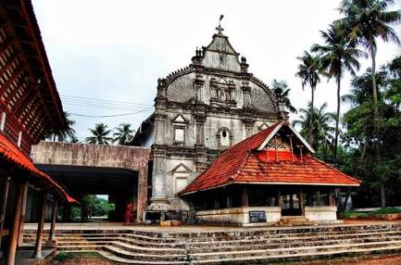

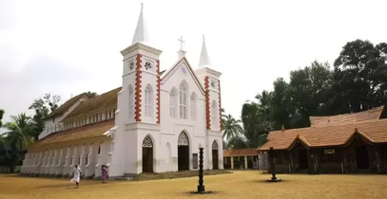
Arthat Church with its original Kerala Hindu temple like Chapel on its side believed to one of the oldest in India. One can see temple like Stone lamps in this church

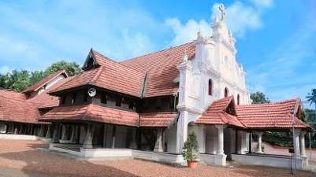
Kalloopara St Mary’s Orthodox Church, built in AD 1339 also maintains a traditional Kerala architectural style

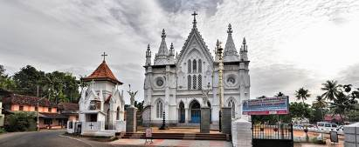
The Kottakkavu Church, believed to be established in 1st Century AD. The current church building is a new one, hence designed to modern tastes, but essentially they retained every tradition of past including old altars, flag staff and customs as similar to Hindu temples

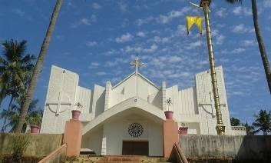
St. Mary’s Church in Kottayam with the festival flag similar to Hindu temple festival flags raised on the flag staff.

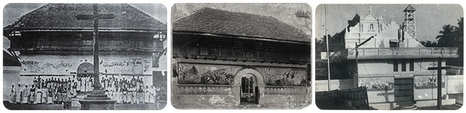
Image of old Kanjoor Church which resembles any Hindu temple and the newer church on its right with European design

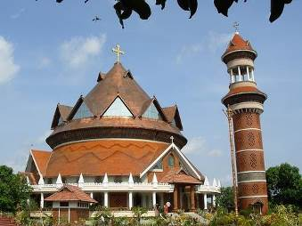
The Thiruvalla St. John’s Cathedral is designed in classical Kerala Buddhist/Hindu architecture; the church follows the ancient Syro-Malankara rites. The church has a history associated with ancient era. Hence when they commissioned the new structure, they decided to incorporate lot of classical Kerala temple designs with a neo-Buddhist stupa concept.

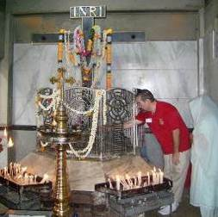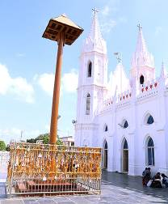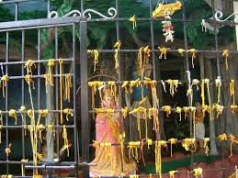
(L)The historic Coonan Cross, where native Christians vowed in 1653 that they would never adopt Catholic rites or submit their faith to European ones. The cross is worshiped almost like a Hindu style with flower garlands and traditional lamps as in any Kerala temple, and it’s a constant reminder that native Christians of Kerala weren’t ready to follow European customs
(C) The Hindu temple-style grille outside Our Lady of Good Health Basilica in Vailankanni, Tamil Nadu
(R) The superstitious Hindu temple-type grill at Annai Vailankanni Church in Besant Nagar, Chennai (TN). Devotees make vows and tie their prayer requests (usually for a marriage partner or to have a child) or “sacred threads” or affix metal locks on the bars of the grille.

Early Christians had borrowed a lot of concepts from others. For example, the wearing of saffron-coloured clothing among early Hindus/Buddhists/Jains was a symbol of renunciation. In Kerala, especially among Hindus, it’s a sign of leaving all worldly pleasures. In the olden days, there was a Malayalam phrase that was used when we saw people wearing saffron robes: “nee entha sannyasikkan povukkayanno?” (Are you going to take sannyas?). It was uncommon for Hindus to wear it as a normal civil dress (unlike today where many people may wear saffron-coloured mundu as casual dress). So early Christians who took extreme fasting for Lent wore saffron robes and then climbed the Malayatoor Mount where they believe St. Thomas apostle got enlightenment (a concept taken from Buddhists). Even now, it is a Christian tradition to wear saffron robes to climb this peak.

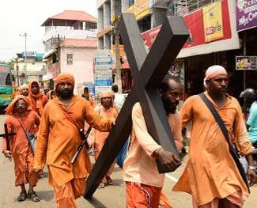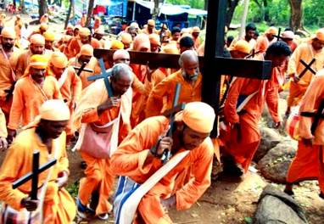

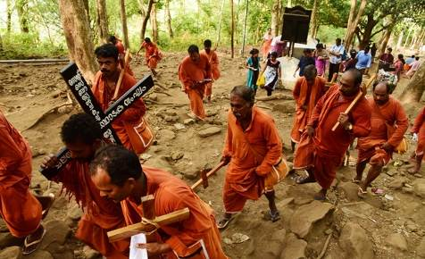
The Malayatoor Pilgrimage where Christians renounce all worldly pleasures and climb the mountain with cross wearing saffron robes to testify they have renounced all for the Lord

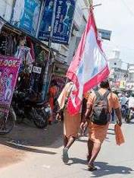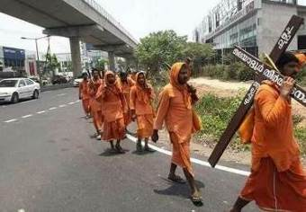

In fact in Kerala, we call churches and mosques Palli, a term historically used for Buddhist monasteries and Jain temples, because with rise of Vedic Brahminical culture, Palli was a standard term used for all places of worship outside Hindu temples which were called Kshetrams (Sanskritized Malayalam) or Ambalam (Normal Malayalam).
Early Christianity adopted several features of Buddhist monasteries of that time as well as Hindu elements.
In Kerala, Dwajasthambhams was common for Hindu and Buddhist temples, associated with Tantric customs. The purpose of Dwajasthambhams was to fly festival flags. Unlike in North India, in Kerala, temples aren’t allowed to fly flags on normal days. Flags were strictly meant to indicate that the temple was celebrating an occasion. And in most cases, the temple celebrates its consecration day as period of festival (symbolically referred as birthday of the deity), locally referred as Ulstavam (Festival).

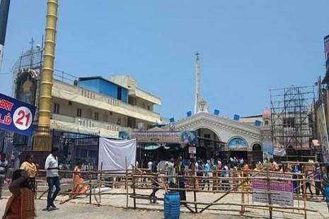
The Hindu temple-modelled dwajasthamba at Annai Vailankanni Church in Besant Nagar, Chennai (TN)

Churches of Kerala, also imbibed the same concept, as they too celebrate the consecration day of the church which they call thirunal (Sacred day). As Early Christians followed almost similar customs of Hindus, concepts like Seeveli (taking the idol outside its consecrated place) also came in many Kerala churches, which they call Nagarapradikshanam. In that era, Christians used to celebrate it the same way as Hindus celebrate festivals, using elephants, torches, umbrellas etc.
And all churches were required to have a flag staff with fluttering flags to indicate, they are in celebrations. It may not be a full-fledged Dwajasthamba like the latter’s which had tantric designs. But mandatorily, all traditional churches had the concept of hosting flags for festivals.

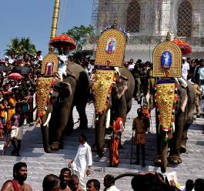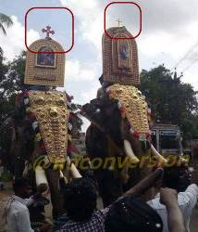
Syro Malabar Rite churches using elephants for festivals similar to Hindu temple-style

Many of these churches used to have large stone lamps like any Hindu temple, as candles didn’t exist in that era and people worshipped using oil lamps. In short, early Christians of Kerala had almost all symbols as that of any Hindu temple as there weren’t any social distinction based on religion concept. Many such old churches used to have mural paintings to draw their concepts as they didn’t have western style images of Jesus or Mary, etc.

Another example of shared concepts was Kadamattathu Kathanar* who was a Jacobite priest but an exponent of Tantric rituals who mixed with Christian concepts for exorcism. And there are several temples in Kerala, where Kathanar has tied up Yakshis and evil spirits and worshiped. It’s a classic example how in that period, concepts were shared.

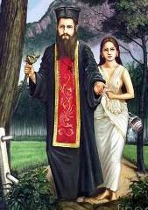
*Kadamattathu Kathanar after taming Neeli Yakshi who is extensively worshiped in Kerala temples

Almost all major Eastern (native) Churches of Kerala have Dwajasthambam in their churches due to their shared worship concepts as like any Hindu or Buddhist rituals of that era.
Catholic churches that followed eastern rites (Syro Malabar Catholic Church) also had such concepts due to same reason. They have historically adopted a lot of Hindu elements for their festivities, which were reduced in 18th and 19th centuries due to displeasure of the Pope over such. However by 20th century, many churches revived the old customs as part of promoting its traditional legacies. For these churches, flag staffs are very common, almost same like Hindu ones (probably with a cross on top) and hoisting flags on festival days.
Roman Catholic churches, and Latin Catholic churches as well as CSI Churches of Kerala do not have the concept of Dwajasthambam as majority of their rites were influenced from European concepts.
Roman Catholic churches now have a policy of maximum assimilation to adopt visual symbols, which don’t violate their rites or rituals. This is partly for evangelistic reasons as some believe. However one key reason is that many of its members proudly consider their ancestry originated from Namboothiri or similar high Hindu castes. Due to their supposed to be higher caste origins theory and attitude, they always have enthusiasm to adopt symbols associated with Hindu higher castes. So some Roman Catholic churches do have Hindu-styled things in their church, some do not.
The Latin Churches on other hand do not have similar enthusiasms to adopt such symbols. And CSI churches due to their association with English Church oppose any sort of adoption of such things into their church, which they consider a wrong tendency.
Certain evangelistic groups in Tamil Nadu and other parts of India have tried to extensive portray Jesus in Hindu robes or adopt Hindu concepts as such to appeal lower caste Hindus solely for purpose of evangelism.
From Kerala’s viewpoint, such things are not much relatable as majority of Churches in Kerala have a history as equal to their Hindu counterparts and pride themselves on such shared history, due to which it’s never a method for evangelism, but rather because of a shared past.

*

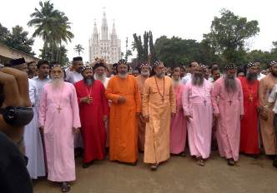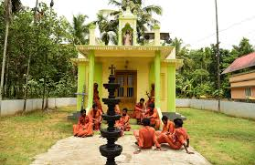
Saffron robes have replaced cassocks and liturgical vestments

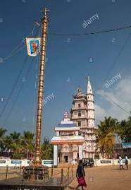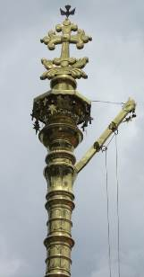
Hindu flag pole
DWAJASTHAMBA IN CHURCHES-INDIAN OR HINDU?
http://ephesians-511.net/docs/DWAJASTHAMBA_IN_CHURCHES-INDIAN_OR_HINDU.doc

*
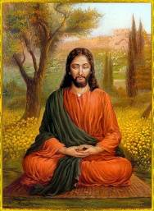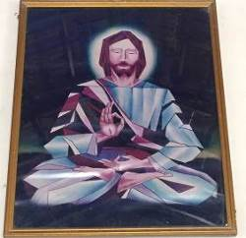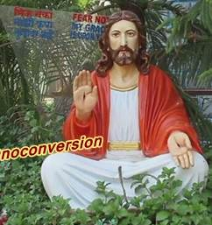
The ubiquitous yogic Jesus

JESUS THE YOGI AND RESURREXIFIXES AT LITURGICAL CENTRE OF CATHEDRAL OF ST THOMAS
http://ephesians-511.net/docs/JESUS_THE_YOGI_AND_RESURREXIFIXES_AT_LITURGICAL_CENTRE_OF_CATHEDRAL_OF_ST_THOMAS.doc
JESUS THE YOGI AND THE DANCING JESUS
http://ephesians-511.net/docs/JESUS_THE_YOGI_AND_THE_DANCING_JESUS.doc
WAS JESUS A YOGI? SYNCRETISM AND INTERRELIGIOUS DIALOGUE-ERROL FERNANDES
http://ephesians-511.net/docs/WAS_JESUS_A_YOGI_SYNCRETISM_AND_INTERRELIGIOUS_DIALOGUE-ERROL_FERNANDES.doc

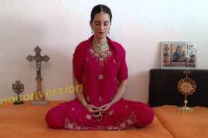

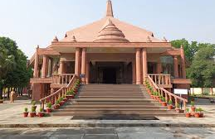
A Catholic church in Bareilly diocese, Uttar Pradesh

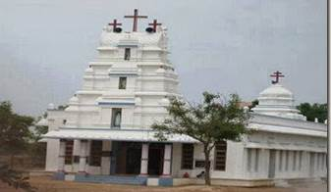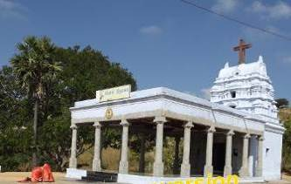

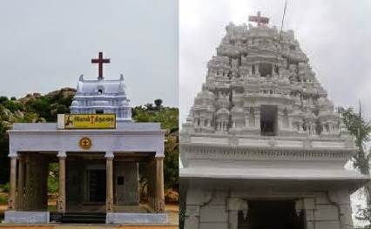

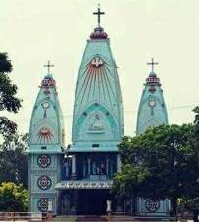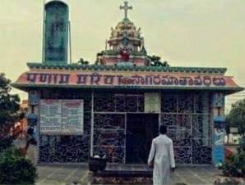
Two Hindu-style Catholic churches in Andhra Pradesh

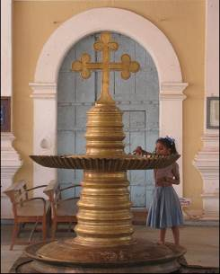
Hindu-style oil lamp redesigned as a holy water font

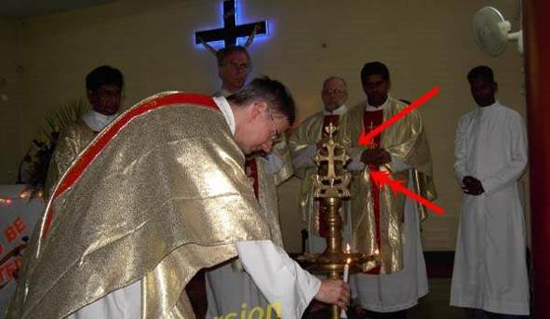
The Hindu-style oil lamp in a Catholic church
WHAT DOES THE KUTHU VILAKKU OIL LAMP SIGNIFY?
http://ephesians-511.net/docs/WHAT_DOES_THE_KUTHU_VILAKKU_OIL_LAMP_SIGNIFY.doc

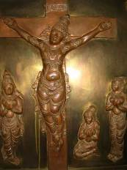 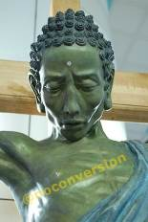 Buddhic crucified Jesuses

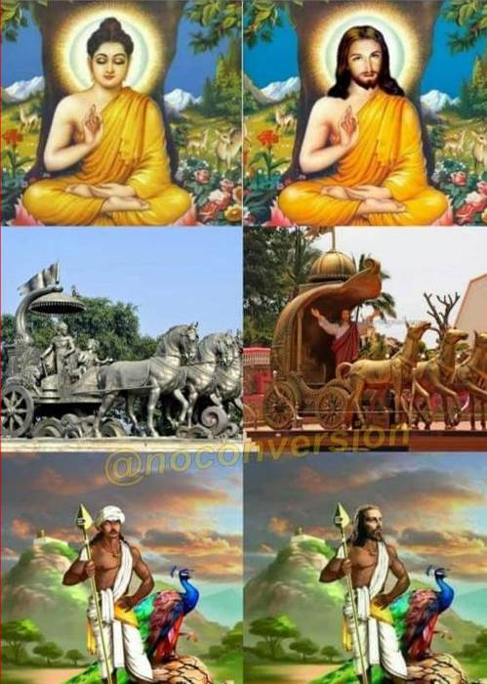

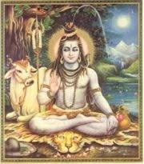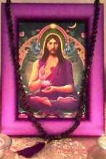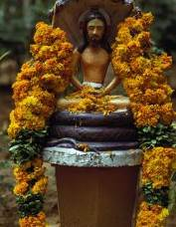
“Inculturation” – Original (L)/plagiarized (R)

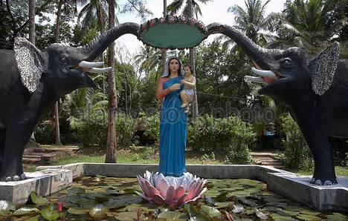 Mary as the goddess Lakshmi

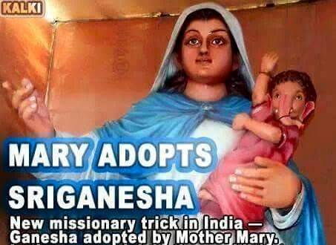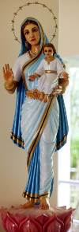

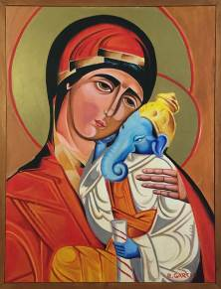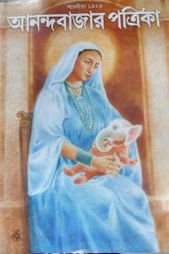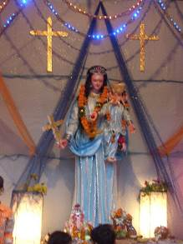
Jesus out, Ganesha in – Mary with little Lord Ganesh

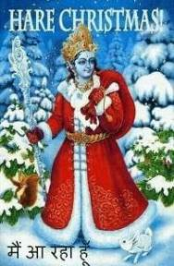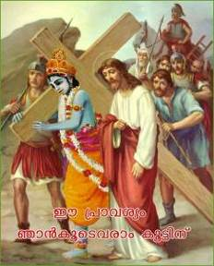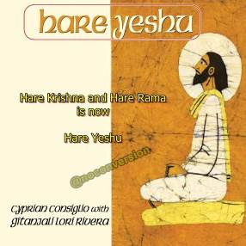

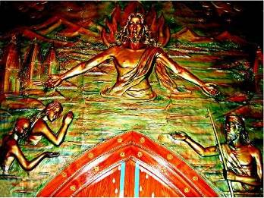
A mural at an ashram “church” in Rishikesh shows Jesus bathing in the Ganges

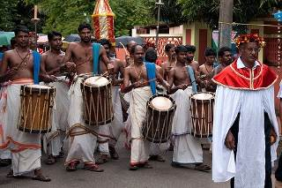

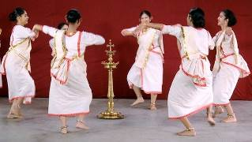

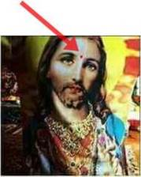
BINDI OR TILAK MARK ON THE FOREHEAD-INDIAN OR HINDU?
http://ephesians-511.net/docs/BINDI_OR_TILAK_MARK_ON_THE_FOREHEAD-INDIAN_OR_HINDU.doc

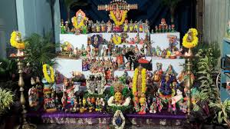

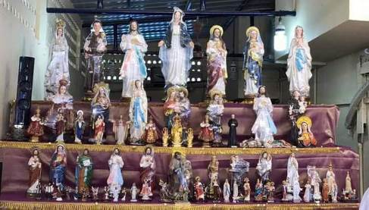
Bommai Kolu/Bomma Golu/Bombe Habba is a doll and statue display celebrated during the Hindu festival of Navratri (worship of Durga) in the states of Tamil Nadu, Karnataka and Andhra Pradesh. Imitated

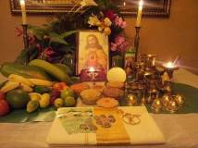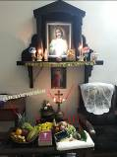
Hindu puja-type set-up of home altars

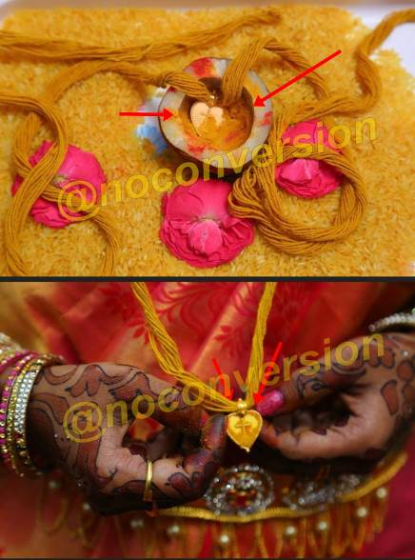
Christianising the Hindu marriage “thali”

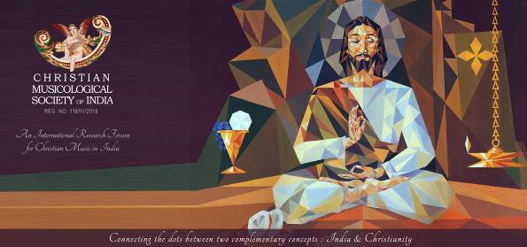
Fr. Joseph J. Palackal. The CMCI, Aluva, Kerala, promotes Carnatic music and Hindu Bharatanatyam dance

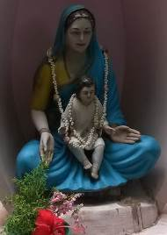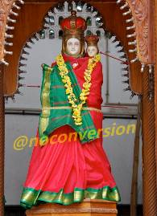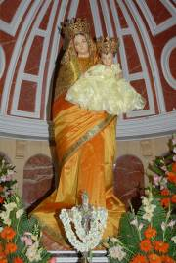
The sari-clad Mary

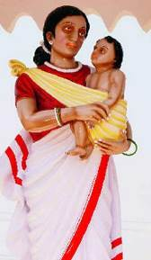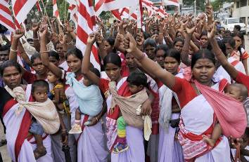
The tribal sari-clad Mary, Jharkhand. It had to be removed after protests by tribals

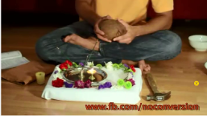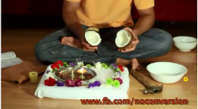

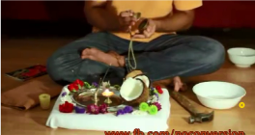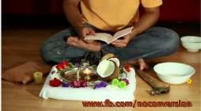
http://video.genfb.com/1922387751374742 10:45
Yeshu puja - a how-to guide for Hindus to worship Jesus in a culturally relevant way

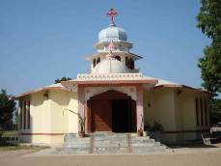
The Hinduised Our Lady of Perpetual Succour church, Kalol, Gandhi Nagar, Gujarat

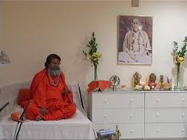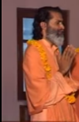
Spot the difference: (L) A Hindu yogi; (R) Fr. Anil Dev IMS, Catholic yogi

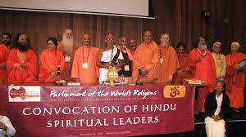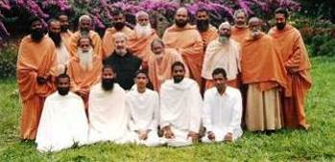
Spot the difference: (L) Hindu, the originals; (R) Catholic priests, the imitators (see also page 6)

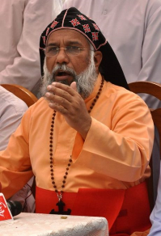
https://bharatabharati.wordpress.com/2018/01/19/cultural-misappropriation-a-rosary-of-rudraksha-beads-g-c-shekar/
The caption is “Cultural Misappropriation: A rosary of rudraksha beads”. However, it is not a rosary that Cardinal Baselios Mar Cleemis wears but a “mala” of Hindu rudraksha beads***.

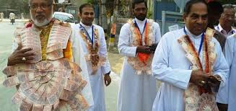
Cardinal George Alencherry and his priests sport malas of banknotes

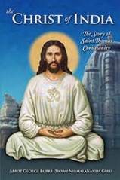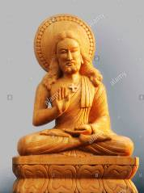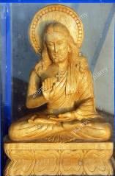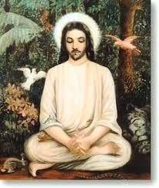
Jesus-the-yogi continued

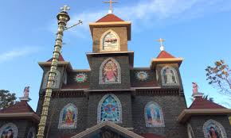
Hindu flag pole at St. Thomas’ Syro-Malankara Church, Mynagappally

SOME RELATED FILES
HINDU FLAG POLE AT CATHEDRAL OF ST THOMAS IN MADRAS-MYLAPORE ARCHDIOCESE
http://ephesians-511.net/docs/HINDU_FLAG_POLE_AT_CATHEDRAL_OF_ST_THOMAS_IN_MADRAS-MYLAPORE_ARCHDIOCESE.doc

IS THE SYRO MALABAR CHURCH NOW OPENLY PROMOTING ITS HINDUISATION?
http://ephesians-511.net/docs/IS_THE_SYRO-MALABAR_CHURCH_NOW_OPENLY_PROMOTING_ITS_HINDUISATION.doc
KERALA PARISH CELEBRATES CHURCH FEAST JOINTLY WITH HINDU TEMPLE FESTIVAL
http://ephesians-511.net/docs/KERALA_PARISH_CELEBRATES_CHURCH_FEAST_JOINTLY_WITH_HINDU_TEMPLE_FESTIVAL.doc
MAY CATHOLICS CELEBRATE THE HARVEST FESTIVAL OF ONAM?
http://ephesians-511.net/docs/MAY_CATHOLICS_CELEBRATE_THE_HARVEST_FESTIVAL_OF_ONAM.doc
AFFINITY TOWARD AYURVEDA AND YOGA IN THE KERALA CHURCH AND THE MALAYALAM BIBLE
http://ephesians-511.net/docs/AFFINITY_TOWARD_AYURVEDA_AND_YOGA_IN_THE_KERALA_CHURCH_AND_THE_MALAYALAM_BIBLE.doc
AYURVEDA AND SEX-KERALA CHURCH
http://ephesians-511.net/docs/AYURVEDA_AND_SEX-KERALA_CHURCH.doc

ARATI IN THE LITURGY-INDIAN OR HINDU?
http://ephesians-511.net/docs/ARATI_IN_THE_LITURGY-INDIAN_OR_HINDU.doc
ARCHBISHOP FERRAO OF GOA LIGHTS THE HINDU OIL LAMP
http://ephesians-511.net/docs/ARCHBISHOP_FERRAO_OF_GOA_LIGHTS_THE_HINDU_OIL_LAMP.doc
AFTER YOGA MOTHER TERESAS NUNS INTO BHARATANATYAM DANCE
http://ephesians-511.net/docs/AFTER_YOGA_MOTHER_TERESAS_NUNS_INTO_BHARATANATYAM_DANCE.doc
BHARATANATYAM-I
http://ephesians-511.net/docs/BHARATANATYAM-I.doc
BHARATANATYAM AT HOLY MASS AT CATHEDRAL OF ST THOMAS IN MADRAS-MYLAPORE ARCHDIOCESE
http://ephesians-511.net/docs/BHARATANATYAM_AT_HOLY_MASS_AT_CATHEDRAL_OF_ST_THOMAS_IN_MADRAS-MYLAPORE_ARCHDIOCESE.doc
CARDINAL IVAN DIAS LIGHTS A LAMP FOR THE HINDU DEITY GANESHA
http://ephesians-511.net/docs/CARDINAL_IVAN_DIAS_LIGHTS_A_LAMP_FOR_THE_HINDU_DEITY_GANESHA.doc
CARMELITE PRIEST PERFORMS HINDU POOJA RITUAL
http://ephesians-511.net/docs/CARMELITE_PRIEST_PERFORMS_HINDU_POOJA_RITUAL.doc
CATHOLIC BECOMES PRIEST OF SHIVA TEMPLE
http://ephesians-511.net/docs/CATHOLIC_BECOMES_PRIEST_OF_SHIVA_TEMPLE.doc
CATHOLICS CAPITULATE OVER CHRIST NOT SANTA CLAUS
http://ephesians-511.net/docs/CATHOLICS_CAPITULATE_OVER_CHRIST_NOT_SANTA_CLAUS.doc
CATHOLIC WORSHIP OF ELEPHANT GOD GANESH IN MANGALORE
http://ephesians-511.net/docs/CATHOLIC_WORSHIP_OF_ELEPHANT_GOD_GANESH_IN_MANGALORE.doc
CHAKRAS-ERIKA GIBELLO
http://ephesians-511.net/docs/CHAKRAS-ERIKA_GIBELLO.doc
DANCING AND BHARATANATYAM IN THE MASS
http://ephesians-511.net/docs/DANCING_AND_BHARATANATYAM_IN_THE_MASS.doc
FR ANTHONY DE MELLO-WRITINGS BANNED BY THE CHURCH
http://ephesians-511.net/docs/FR_ANTHONY_DE_MELLO-WRITINGS_BANNED_BY_THE_CHURCH.doc
FR JEGATH GASPAR RAJ-IN PRAISE OF SHIVA-PRIEST INVESTS RS 15 MILLION, FLOATS COMPANY WORTH RS 100 CRORES
http://ephesians-511.net/docs/FR_JEGATH_GASPAR_RAJ-IN_PRAISE_OF_SHIVA-PRIEST_INVESTS_RS_15_MILLION_FLOATS_COMPANY_WORTH_RS_100_CRORES.doc
HABEMUS PAPAM INDIANUM-WE HAVE AN INDIAN PONTIFF
http://ephesians-511.net/docs/HABEMUS_PAPAM_INDIANUM-WE_HAVE_AN_INDIAN_PONTIFF.doc
HINDUISM-FR FINBARR FLANAGAN
http://ephesians-511.net/docs/HINDUISM-FR_FINBARR_FLANAGAN.doc
HINDUISM-VISHAL MANGALWADI
http://ephesians-511.net/docs/HINDUISM-VISHAL_MANGALWADI.doc
HINDUS STILL BELIEVE THAT INCULTURATION IS A CATHOLIC PLOY TO CONVERT THEM
http://ephesians-511.net/docs/HINDUS_STILL_BELIEVE_THAT_INCULTURATION_IS_A_CATHOLIC_PLOY_TO_CONVERT_THEM.doc
INDIAN JESUIT THEOLOGIAN FR MICHAEL AMALADOSS UNDER INVESTIGATION BY ROME
http://ephesians-511.net/docs/INDIAN_JESUIT_THEOLOGIAN_FR_MICHAEL_AMALADOSS_UNDER_INVESTIGATION_BY_ROME.doc
INTERRELIGIOUS DIALOGUE 01-POPE BENEDICT XVI
http://ephesians-511.net/docs/INTERRELIGIOUS_DIALOGUE_01-POPE_BENEDICT_XVI.doc
INTERRELIGIOUS DIALOGUE 02-GOA CATHOLICS OPPOSE
http://ephesians-511.net/docs/INTERRELIGIOUS_DIALOGUE_02-GOA_CATHOLICS_OPPOSE.doc
INTERRELIGIOUS DIALOGUE 03-THE FALSE KIND
http://ephesians-511.net/docs/INTERRELIGIOUS_DIALOGUE_03-THE_FALSE_KIND.doc
INCULTURATION OF THE LITURGY AND SACROSANCTUM CONCILIUM-JON ANDERSON-AND MY RESPONSE
http://ephesians-511.net/docs/INCULTURATION_OF_THE_LITURGY_AND_SACROSANCTUM_CONCILIUM-JON_ANDERSON-AND_MY_RESPONSE.doc
IS HOLY COMMUNION EQUIVALENT TO PRASADAM-IS IT SAFE FOR CATHOLICS TO CONSUME PRASADAM?
http://ephesians-511.net/docs/IS_HOLY_COMMUNION_EQUIVALENT_TO_PRASADAM-IS_IT_SAFE_FOR_CATHOLICS_TO_CONSUME_PRASADAM.doc
IS SAT-CIT-ANANDA THE EQUIVALENT OF THE HOLY TRINITY
http://ephesians-511.net/docs/IS_SAT-CIT-ANANDA_THE_EQUIVALENT_OF_THE_HOLY_TRINITY.doc
LOTUS AND THE CROSS-THE HINDUISATION OF THE CATHOLIC CHURCH IN INDIA
http://ephesians-511.net/docs/LOTUS_AND_THE_CROSS-THE_HINDUISATION_OF_THE_CATHOLIC_CHURCH_IN_INDIA.doc
MANGALSUTRA-INDIAN OR HINDU?
http://ephesians-511.net/docs/MANGALSUTRA-INDIAN_OR_HINDU.doc

MATA AMRITANANDAMAYI-THE HUGGING GODWOMAN
http://ephesians-511.net/docs/MATA_AMRITANANDAMAYI-THE_HUGGING GODWOMAN.doc
MAY CATHOLICS CELEBRATE THE FESTIVAL OF HOLI?
http://ephesians-511.net/docs/MAY_CATHOLICS_CELEBRATE_THE_FESTIVAL_OF_HOLI.doc
MAY CATHOLICS CELEBRATE THE HARVEST FESTIVAL OF PONGAL?
http://ephesians-511.net/docs/MAY_CATHOLICS_CELEBRATE_THE_HARVEST_FESTIVAL_OF_PONGAL.doc
MAY PRIESTS WEAR A SHAWL WHILE CELEBRATING HOLY MASS
http://ephesians-511.net/docs/MAY_PRIESTS_WEAR_A_SHAWL_WHILE_CELEBRATING_HOLY_MASS.doc
MOTHER TERESA AT PRAYER IN A BUDDHIST TEMPLE
http://ephesians-511.net/docs/MOTHER_TERESA_AT_PRAYER_IN_A_BUDDHIST_TEMPLE.doc
NBCLC-HARBINGER OF THE INDIAN RITE MASS AND LITURGICAL ABUSE
http://ephesians-511.net/docs/NBCLC-HARBINGER_OF_THE_INDIAN_RITE_MASS_AND_LITURGICAL_ABUSE.doc
PAGANIZATION OF THE CHURCH IN INDIA 01
http://ephesians-511.net/docs/PAGANIZATION_OF_THE_CHURCH_IN_INDIA_01.doc
PAGANIZATION OF THE CHURCH IN INDIA 02
http://ephesians-511.net/docs/PAGANIZATION_OF_THE_CHURCH_IN_INDIA_02.doc
PAGANIZATION OF THE CHURCH IN INDIA-RESPONSES
http://ephesians-511.net/docs/PAGANIZATION_OF_THE_CHURCH_IN_INDIA-RESPONSES.doc
PILAR PRIEST FR PETER CARDOZO VENERATES THE HINDU DEITY GANESHA
http://ephesians-511.net/docs/PILAR_PRIEST_FR_PETER_CARDOZO_VENERATES_THE_HINDU_DEITY GANESHA.doc
PILAR PRIESTS CELEBRATE INTERNATIONAL YOGA DAY-GOA ARCHBISHOP ENDORSES
http://ephesians-511.net/docs/PILAR_PRIESTS_CELEBRATE_INTERNATIONAL_YOGA_DAY-GOA_ARCHBISHOP_ENDORSES.doc
PILAR SEMINARY, GOA-SYNCRETISM AND NEW AGE
http://ephesians-511.net/docs/PILAR_SEMINARY_GOA-SYNCRETISM_AND_NEW_AGE.doc
PRITISH NANDY DEBUNKS GODMAN CHANDRA SWAMIS THIRD EYE CLAIM
http://ephesians-511.net/docs/PRITISH_NANDY_DEBUNKS_GODMAN_CHANDRA_SWAMIS_THIRD_EYE_CLAIM.doc
QUO VADIS BEDE GRIFFITHS-FR FINBARR FLANAGAN
http://ephesians-511.net/docs/QUO_VADIS_BEDE_GRIFFITHS-FR_FINBARR_FLANAGAN.doc
RANGOLI AND KOLAM DRAWINGS ARE BASED ON SUPERSTITIOUS BELIEFS
http://ephesians-511.net/docs/RANGOLI_AND_KOLAM_DRAWINGS_ARE_BASED_ON_SUPERSTITIOUS_BELIEFS.doc
***RUDRAKSHA BEADS AND THE HINDU DEITY SHIVA
http://ephesians-511.net/docs/RUDRAKSHA_BEADS_AND_THE_HINDU_DEITY_SHIVA.doc
SHIVALINGA AND THE HINDU DEITY SHIVA
http://ephesians-511.net/docs/SHIVALINGA_AND_THE_HINDU_DEITY_SHIVA.doc
SHIVALINGA TABERNACLE OF JESUIT PRIEST SHILANANDAS CHURCH
http://ephesians-511.net/docs/SHIVALINGA_TABERNACLE_OF_JESUIT_PRIEST_SHILANANDAS_CHURCH.doc
SHOULD CATHOLICS PERFORM BHARATANATYAM-SUSAN BRINKMANN
http://ephesians-511.net/docs/SHOULD_CATHOLICS_PERFORM_BHARATANATYAM-SUSAN_BRINKMANN.doc
SOCIETY OF THE DIVINE WORD PROVINCIAL PERFORMS BHARATANATYAM
http://ephesians-511.net/docs/SOCIETY_OF_THE_DIVINE_WORD_PROVINCIAL_PERFORMS_BHARATANATYAM.doc
SONIA GANDHI-CATHOLIC OR HINDU?
http://ephesians-511.net/docs/SONIA_GANDHI-CATHOLIC_OR_HINDU.doc
SRI SATYA SAI BABAS CATHOLIC DEVOTEES
http://ephesians-511.net/docs/SRI_SATYA_SAI_BABAS_CATHOLIC_DEVOTEES.doc
ST SEBASTIANS HINDUISED CHURCH WITH RESURREXIFIX ARCHDIOCESE OF BOMBAY
http://ephesians-511.net/docs/ST_SEBASTIANS_HINDUISED_CHURCH_WITH_RESURREXIFIX_ARCHDIOCESE_OF_BOMBAY.doc
TAMIL NADU CLERGY VENERATE THE HINDU DEITY GANESHA
http://ephesians-511.net/docs/TAMIL_NADU_CLERGY_VENERATE_THE_HINDU_DEITY_GANESHA.doc
THE GOLDEN SHEAF-A COLLECTION OF ARTICLES DEALING WITH ECCLESIASTICAL ABERRATIONS
http://ephesians-511.net/docs/THE_GOLDEN_SHEAF-A_COLLECTION_OF_ARTICLES_DEALING_WITH_ECCLESIASTICAL_ABERRATIONS.doc
THE HINDUISATION OF MUSIC IN THE CATHOLIC CHURCH
http://ephesians-511.net/docs/THE_HINDUISATION_OF_MUSIC_IN_THE_CATHOLIC_CHURCH.doc
THE HINDUISATION OF THE CATHOLIC CHURCH-IMAGES
http://ephesians-511.net/docs/THE_HINDUISATION_OF_THE_CATHOLIC_CHURCH-IMAGES.doc
THE ONGOING ROBBERY OF FAITH-FR P K GEORGE
http://ephesians-511.net/docs/THE_ONGOING_ROBBERY_OF_FAITH-FR_P_K_GEORGE.doc
THE PAGANISATION OF THE LITURGY IN INDIA-C B ANDRADE
http://ephesians-511.net/docs/THE_PAGANISATION_OF_THE_LITURGY_IN_INDIA-C_B_ANDRADE.doc

THE PAGANIZED CATHOLIC CHURCH IN INDIA-VICTOR J F KULANDAY
http://ephesians-511.net/docs/THE_PAGANIZED_CATHOLIC_CHURCH_IN_INDIA-VICTOR_J_F_KULANDAY.doc
THE SIGNIFICANCE OF 108 IN HINDUISM
http://ephesians-511.net/docs/THE_SIGNIFICANCE_OF_108_IN_HINDUISM.doc
THE SQUATTING INDIAN RITE MASS
http://ephesians-511.net/docs/THE_SQUATTING_INDIAN_RITE_MASS.doc
THE ST PIUS X SEMINARY CELEBRATES HINDU DEITY GANESH
http://ephesians-511.net/docs/THE_ST_PIUS_X_SEMINARY_CELEBRATES_HINDU_DEITY_GANESH.doc
THE TWELVE POINTS OF ADAPTATION FOR THE INDIAN RITE MASS-WAS A FRAUD PERPETRATED ON INDIAN CATHOLICS?
http://ephesians-511.net/docs/THE_TWELVE_POINTS_OF_ADAPTATION_FOR_THE_INDIAN_RITE_MASS-WAS_A_FRAUD_PERPETRATED_ON_INDIAN_CATHOLICS.doc
THE TWELVE POINTS OF ADAPTATION AND THE INDIAN RITE MASS ARE ABROGATED
http://ephesians-511.net/docs/THE_TWELVE_POINTS_OF_ADAPTATION_AND_THE_INDIAN_RITE_MASS_ARE_ABROGATED.doc
THE WILFUL MISINTERPRETATION OF CHURCH DOCUMENTS BY INCULTURATIONIST THEOLOGIANS
http://ephesians-511.net/docs/THE_WILFUL_MISINTERPRETATION_OF_CHURCH_DOCUMENTS_BY_INCULTURATIONIST_THEOLOGIANS.doc
VAASTU SHASTRA OR VEDIC GEOMANCY
http://ephesians-511.net/docs/VAASTU_SHASTRA_OR_VEDIC_GEOMANCY.doc
VASAI PRIEST FR THOMAS DSOUZA WORSHIPS GANESHA
http://ephesians-511.net/docs/VASAI_PRIEST_FR_THOMAS_DSOUZA_WORSHIPS_GANESHA.doc
WHAT IS THE SIGNIFICANCE OF NAMASTE AND ANJALI HASTA?
http://ephesians-511.net/docs/WHAT_IS_THE_SIGNIFICANCE_OF_NAMASTE_AND_ANJALI_HASTA.doc
WHAT DO MUDRAS CONVEY?
http://ephesians-511.net/docs/WHAT_DO_MUDRAS_CONVEY.doc
WHY INDIAN CATHOLICS DO NOT WANT AN INDIAN POPE
http://ephesians-511.net/docs/WHY_INDIAN_CATHOLICS_DO_NOT_WANT_AN_INDIAN_POPE.doc

WORSHIP OF GANESHA IN THE INDIAN CHURCH - FILES IN CHRONOLOGICAL ORDER
MUMBAI: CARDINAL IVAN DIAS LIGHTS A LAMP FOR THE HINDU DEITY GANESHA JULY 2011 (1997)
http://ephesians-511.net/docs/CARDINAL_IVAN_DIAS_LIGHTS_A_LAMP_FOR_THE_HINDU_DEITY_GANESHA.doc
VATHAPI GANAPATHIM-OBEISANCE TO GANESHA BY THE CONFERENCE OF CATHOLIC BISHOPS OF INDIA 7 JANUARY 2017 (2011)
http://ephesians-511.net/docs/VATHAPI_GANAPATHIM-OBEISANCE_TO_GANESHA_BY_THE_CONFERENCE_OF_CATHOLIC_BISHOPS_OF_INDIA.doc
MUMBAI: THE ST PIUS X SEMINARY CELEBRATES HINDU DEITY GANESHA 9 FEBRUARY 2013
http://ephesians-511.net/docs/THE_ST_PIUS_X_SEMINARY_CELEBRATES_HINDU_DEITY_GANESH.doc
TAMIL NADU CLERGY VENERATE THE HINDU DEITY GANESHA 22 FEBRUARY 2014
http://ephesians-511.net/docs/TAMIL_NADU_CLERGY_VENERATE_THE_HINDU_DEITY_GANESHA.doc
GOA: PILAR PRIEST FR PETER CARDOZO VENERATES THE HINDU DEITY GANESHA FEBRUARY 2015
http://ephesians-511.net/docs/PILAR_PRIEST_FR_PETER_CARDOZO_VENERATES_THE_HINDU_DEITY GANESHA.doc
INDIAN CLERGY OBSESSED WITH THE HINDU DEITY GANESHA FEBRUARY 2015
http://ephesians-511.net/docs/INDIAN_CLERGY_OBSESSED_WITH_THE_HINDU_DEITY_GANESHA.doc
CATHOLIC WORSHIP OF ELEPHANT GOD GANESH IN MANGALORE 7/14/30 SEPTEMBER 2016 (OCD PRIESTS)
http://ephesians-511.net/docs/CATHOLIC_WORSHIP_OF_ELEPHANT_GOD_GANESH_IN_MANGALORE.doc
MUMBAI: FR JOE PEREIRA YOGA GURU CELEBRATES NAVRATRI AND GANESHOTSAV 8 SEPTEMBER 2016
http://ephesians-511.net/docs/FR_JOE_PEREIRA_YOGA_GURU_CELEBRATES_NAVRATRI_AND_GANESHOTSAV.doc
VASAI PRIEST FR THOMAS DSOUZA WORSHIPS GANESHA 15 SEPTEMBER 2016
http://ephesians-511.net/docs/VASAI_PRIEST_FR_THOMAS_DSOUZA_WORSHIPS_GANESHA.doc
SPANISH BISHOP APOLOGIZES FOR HONOURING GANESHA-WILL INDIAN BISHOPS FOLLOW SUIT? 30 AUGUST/1 SEPTEMBER 2017
http://ephesians-511.net/docs/SPANISH_BISHOP_APOLOGIZES_FOR_HONOURING_GANESHA-WILL_INDIAN_BISHOPS_FOLLOW_SUIT.doc

CATHOLIC ASHRAMS MOVEMENT
CATHOLIC ASHRAMS
http://ephesians-511.net/docs/CATHOLIC_ASHRAMS.doc
CATHOLIC ASHRAMS AND THE CAMALDOLESE BENEDICTINES
http://ephesians-511.net/docs/CATHOLIC_ASHRAMS_AND_THE_CAMALDOLESE_BENEDICTINES.doc

CATHOLIC ASHRAMS AND THE CATHOLIC CHARISMATIC RENEWAL
http://ephesians-511.net/docs/CATHOLIC_ASHRAMS_AND_THE_CATHOLIC_CHARISMATIC_RENEWAL.doc
CATHOLIC ASHRAMS-LETTERS FROM BISHOPS IN RESPONSE TO THE REPORT
http://ephesians-511.net/docs/CATHOLIC_ASHRAMS-LETTERS_FROM_BISHOPS_IN_RESPONSE_TO_THE_REPORT.doc
CATHOLIC ASHRAMS-REVISITED
http://ephesians-511.net/docs/CATHOLIC_ASHRAMS-REVISITED.doc
CATHOLIC ASHRAMS-SANNYASINS OR SWINDLERS-SITA RAM GOEL
http://ephesians-511.net/docs/CATHOLIC_ASHRAMS-SANNYASINS_OR_SWINDLERS-SITA_RAM_GOEL.doc
CATHOLIC ASHRAMS-SUMMARY
http://ephesians-511.net/docs/CATHOLIC_ASHRAMS-SUMMARY.doc
CATHOLIC ASHRAMS-SUMMARY IN FRENCH
http://ephesians-511.net/docs/CATHOLIC_ASHRAMS-SUMMARY_IN_FRENCH.doc
CATHOLIC ASHRAMS-SUMMARY IN SPANISH
http://ephesians-511.net/docs/CATHOLIC_ASHRAMS-SUMMARY_IN_SPANISH.doc
CATHOLIC ASHRAMS-SUMMARY-MARIA LAURA PIO
http://ephesians-511.net/docs/CATHOLIC_ASHRAMS-SUMMARY-MARIA_LAURA_PIO.doc
IN PICTURES-THE HINDUISED CATHOLIC ASHRAMS
http://ephesians-511.net/docs/IN_PICTURES-THE_HINDUISED_CATHOLIC_ASHRAMS.doc
NEW COMMUNITY BIBLE 02-THE PAPAL SEMINARY, PUNE, INDIAN THEOLOGIANS, AND THE CATHOLIC ASHRAMS
http://ephesians-511.net/docs/NEW_COMMUNITY_BIBLE_02-THE_PAPAL_SEMINARY_PUNE_INDIAN_THEOLOGIANS_AND_THE_CATHOLIC_ASHRAMS.doc
NEW COMMUNITY BIBLE 17-EXTOLLED BY CAMALDOLESE BENEDICTINE OBLATE
http://ephesians-511.net/docs/NEW_COMMUNITY_BIBLE_17-EXTOLLED_BY_CAMALDOLESE_BENEDICTINE_OBLATE.doc

CARDINAL OSWALD GRACIAS’ SPIRITUALLY PERVERTED GYAN ASHRAM
http://ephesians-511.net/docs/CARDINAL_OSWALD_GRACIAS_SPIRITUALLY_PERVERTED_GYAN_ASHRAM.doc
FATHERS OF THE SVD CONGREGATION WITHOUT ZEAL OR HOPE
http://ephesians-511.net/docs/FATHERS_OF_THE_SVD_CONGREGATION_WITHOUT_ZEAL_OR_HOPE.doc
JOHN MARTIN SAHAJANANDAS HERETICAL AND NEW AGE TEACHINGS-SACCIDANANDA ASHRAM
http://ephesians-511.net/docs/JOHN_MARTIN_SAHAJANANDAS_HERETICAL_AND_NEW_AGE_TEACHINGS-SACCIDANANDA_ASHRAM.doc
JYOTI SAHI AND HIS NEW AGE ART ASHRAM IN BANGALORE
http://ephesians-511.net/docs/JYOTI_SAHI_AND_HIS_NEW_AGE_ART_ASHRAM_IN_BANGALORE.doc

DHARMA BHARATHI-LETTER TO THE BISHOP OF SRINAGAR
http://ephesians-511.net/docs/DHARMA_BHARATHI-LETTER_TO_THE_BISHOP_OF_SRINAGAR.doc
DHARMA BHARATHI-LETTER TO THE CARDINAL, ERNAKULAM-ANGAMALY
http://ephesians-511.net/docs/DHARMA_BHARATHI-LETTER_TO_THE_CARDINAL_ERNAKULAM_ANGAMALY.doc
DHARMA BHARATHI-LETTER TO THE CATHOLIC BISHOPS' CONFERENCE OF INDIA
http://ephesians-511.net/docs/DHARMA_BHARATHI-LETTER_TO_THE_CATHOLIC_BISHOPS_CONFERENCE_OF_INDIA.doc
DHARMA BHARATHI-NEW AGE IN CATHOLIC EDUCATIONAL INSTITUTIONS
http://ephesians-511.net/docs/DHARMA_BHARATHI-NEW_AGE_IN_CATHOLIC_EDUCATIONAL_INSTITUTIONS.doc
FR VARGHESE ALENGADEN-UNIVERSAL SOLIDARITY MOVEMENT
http://ephesians-511.net/docs/FR_VARGHESE_ALENGADEN-UNIVERSAL_SOLIDARITY_MOVEMENT.doc

NBCLC-HARBINGER OF THE INDIAN RITE MASS AND LITURGICAL ABUSE
http://ephesians-511.net/docs/NBCLC-HARBINGER_OF_THE_INDIAN_RITE_MASS_AND_LITURGICAL_ABUSE.doc

