
MAY 1, 2019

Pope Francis carries witches’ stang at 2018 World Youth Day opening Mass

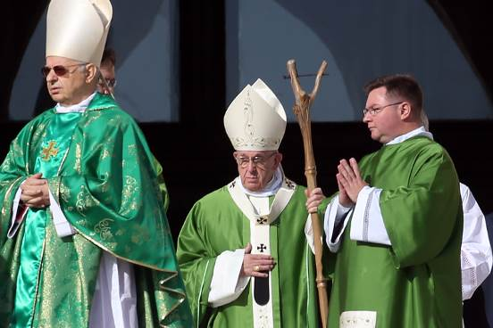

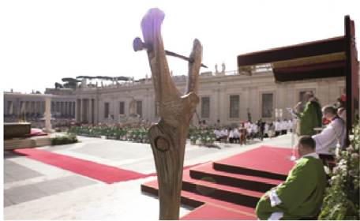
L'Osservatore Romano (October 4, 2018, p. 8)

Satanism manifesting: Antipope Bergoglio Carries a Stang – the Ritual Staff of Witchcraft
https://www.barnhardt.biz/2018/10/04/satanists-manifesting-antipope-bergoglio-carries-a-stang-the-ritual-staff-of-witchcraft/
October 4, 2018

As I have said and written before, one of satan’s most clever moves has been to foment, encourage and push mentally ill and demonically oppressed people to LOUDLY broadcast insane, ridiculous, totally false “conspiracy theories”. We all know the types and categories. Mind control beams, “chem trails”, shape shifting lizards, underground civilizations, flat earthers, the list goes on and on and on.
What this has done is make it almost impossible to point out, discuss, and warn about ACTUAL sinister goings-on and actual, honest-to-goodness conspiracies that are very real. We all know that the word “Freemasonry” in the U.S. is automatically lumped into the above category, even though in Europe Freemasonry is largely understood to be the extremely powerful and influential socio-political entity that it is, and many Europeans further understand that the core of Freemasonry is the desire to exterminate the Catholic Church and replace it with the one-world secular humanist political religion of Freemasonry.
Trying to warn about such things as the musloid political system gets one lumped in with “conspiracy theorists”, as does trying to warn about the massive infiltration, influence, power and agenda of the sodomite cabal, both in the secular realms of politics and entertainment, AND in terms of the infiltration of the Institutional Church.
Perhaps the most difficult actual conspiracy to discuss without being dismissed out of hand is the actual cult worship of satan. But, it is real, and it is manifesting before our eyes, so someone has to call these things out knowing full well that to do so means that 99.9999% of the populace will instantly call one a “crazy fool”. That’s fine. If fitting in to this culture constitutes sanity, then please God, let me never be sane.
It is a MORAL CERTAINTY that the stick that Antipope Bergoglio tried to pass off as a ferula yesterday in the Mass opening the Sin-nod on Sodomy is a “STANG”. Antipope Bergoglio said is was a “gift” from “young people” who SPECIFICALLY REQUESTED that he use it in the opening Mass of the Sodo-synod. That story right there by itself is DAMN PECULIAR.
A Stang is a witch/warlock’s ceremonial staff. It is always forked, and always has an iron nail driven through it. Ideally it has a human form carved or integrated into it somehow. The Stang signifies several things, the first being a satan himself. Read the quote below from a witchcraft blog:
“Gary describes the Stang as primarily a symbolic tool rather than a working one, and as such it stands in for the Devil himself, holding his power and his dual nature. The Devil and the Stang is often less about strict duality and more about the transgressing of boundaries, The Devil being a spirit I often think of as non-binary and difficult to define in terms of absolutes.”
Almost like a… “god of surprises?”
Sounds familiar, eh? Like every Casa Santa Marta sermon, and every airplane presser? Yeah. That’s mild compared to this quote from the same article:
“The witch is bound to no dogma. This makes them a threat to a Christianity established on doctrine. The witch insists everything in creation has its place. The Church insisted on two contrary substances God and The Devil. The witch strives for synthesis.”
Nicholaj De Mattos Frisvold- Craft of the Untamed.
G.W.F. Hegel, please dial “666” on a white courtesy telephone….
Let us revisit the quote of the Canadian faggot priest Tom Rosica, who is, once again, the English language press spokesman for this Sodo-synod from just a few weeks ago:
“Pope Francis (sic) breaks Catholic traditions whenever he wants because he is “free from disordered attachments.” Our Church has indeed entered a new phase: with the advent of this first Jesuit pope (sic), it is openly ruled by an individual rather than by the authority of Scripture alone or even its own dictates of tradition plus Scripture. “
-Fr. Tom Rosica, Vatican press spokesman
Anyway, the iron nail in the Stang symbolizes multiple things, including a phallus/coitus, a mocking of the Crucifixion of Our Lord, and is the triple motif of the threefold serpentine, telluric and cainic “powers”.
The “serpentine” meaning is obvious – the devil himself, in the garden, “gifting” Adam and Eve with the “liberating” and “enlightening” words, “No, you shall not die the death. For God doth know that in what day soever you shall eat thereof, your eyes shall be opened: and you shall be as Gods, knowing good and evil.”
The word “telluric” refers to earthly power, whose source and symbol is “the serpent”, “deep in the earth”.
The third motif symbolized by the iron nail in the Stang is the Cainic “powers”. Now, hold on to your hats. Here’s the opening from the Wiki article on “Cainism”, and remember folks, we are talking about Cain, whose sacrifice God rejected and he thus murdered his brother Abel because as St. John teaches, “Cain slew Abel because his works were evil, while those of his brother were just (1 John 3:12), and we read in Hebrews that “by faith Abel offered to God a more excellent sacrifice than Cain” (Hebrews 11:4).”
——
The oldest source is to be found in Irenaeus, adv. Haer. i. 31.
Cain and Abel
He tells us that the Cainites regarded Cain as derived from the higher principle. They claimed fellowship with Esau, Korah, the men of Sodom, and all such people, and regarded themselves as on that account persecuted by the Creator. But they escaped injury from Him, for Sophia used to carry away from them to herself that which belonged to her.

——
One thing I learned in researching the actual cult worship of satan once I learned about and confirmed that the Vatican is the nexus of satanism in the world today, is the fact that satanists are commanded, at some point once they have sufficient power, to openly MANIFEST their satanism.
If the Bergoglian antipapacy doesn’t constitute “having sufficient power”, then I don’t know what would.
I am morally certain that Antipope Bergoglio’s carrying of a Stang with the iron nail so prominently positioned, into the opening of a farce synod whose entire agenda is the ratification of sodomy, is a clear case of manifestation of satanism.
And if that makes me a conspiracy theorist, so be it. Some conspiracies are real.
St. Michael the Archangel, defend us in battle, be our protection against the wickedness and snares of the devil. May God rebuke him, we humbly pray, and do thou, O prince of the Heavely Host, by the power of God, cast into hell satan and all evil spirits who prowl throughout the world seeking the ruin of souls. Amen.
Links:
“How to Use a Stang”
Wikipedia article on Cainism (must read)
“The Stang and the Devil at the Crossroads”

Why is Pope Francis carrying that stick?
https://aleteia.org/2018/10/04/why-is-pope-francis-carrying-that-stick/
October 4, 2018

Those who have seen photos of Pope Francis carrying a rough-hewn, forked stick with a nail running through it that looks like something out of Lord of the Rings, may be wondering, “What’s up with that?”
The short answer: it was a gift from some young Italians attending the Synod on Youth Faith and Vocational Discernment, the month-long meeting of Catholic bishops that began on October 3.
The longer explanation: It’s a ferula (Latin for “rod”), which the pope carries during liturgical celebrations. Unlike an episcopal crosier, which is bent at the top like a shepherd’s crook, a ferula is capped with a cross. Popes carried crosiers until the 13th century, when the practice was phased out.
While Pope Francis normally alternates between Pope Paul VI and Benedict XVI’s ferulae, he sometimes carries different ones for special occasions.
When he visited the island of Lampasas in Italy in July 2013, for example, he used a ferula made from migrant boats.
This particular ferula was given to the pope by a group of young people attending the inauguration ceremony of the Synod last August.
“We have found that each path requires its own staff and on this special occasion we give you a ferula carved in wood,” explained a young Italian on behalf of all the other pilgrims, according to an iMedia report.
“It would be nice if this ferola accompanies you during the synod of young people,” she added. All of us gathered here could feel that we are at your side and connect our heart and our memory to this extraordinary meeting,” she said.
“Holy Father, we have come here to tell you that we love you very much and we want to walk forward together,” she added.

Pope Francis and the Stang: The image that sumarises the LGBT “Youth” Synod
https://catholicismpure.wordpress.com/2018/10/05/pope-francis-and-the-stang-the-image-that-summarises-the-lgbt-youth-synod/
October 5, 2018

As stated by RORATE CAELI yesterday. Could it also be called the image that summarises this Pontificate? Excerpt:
”In his opening address, the Pope attacked “clericalism” — as if he were not the most clericalist man in the world, refusing to respond to the Viganò accusations that he protected and promoted Ted McCarrick. He also railed against “blogs”, meaning we are doing our job right.
The symbol of this Synod that no one asked for and that will have no legitimacy (since its composition was carefully manipulated to avoid any resistance to the Pope’s pro-LGBT agenda) is the ferula Francis chose to use: not the Cross of Our Lord Jesus Christ, but this contraption.”
The “contraption” was in fact a “stang”. Why, do you think, would the pope prefer to hold a stang, with the sinister evil this thing symbolises, rather than a crozier with a Crucifix, the symbol of our redemption?
And a h/t to JH for alerting us to the indomitable Ann Barnhardt’s post on this latest scandal: “Satanists Manifesting: Antipope Bergoglio Carries a Stang – the Ritual Staff of Witchcraft”.
There was another one from her today about the woman who handed him the wtches’ stang.
Should we not all be up in arms at this latest horror from Pope Francis?
Maybe we might simply have to admit that Catholics are becoming inured to the horrors we have been subjected to under Francis coming, as they are, thicker and faster than ever before these days. Certainly, in general, we no longer demonstrate the shock and anger such an outrageous deed as this one really deserves.

Jeepers, creepers, where’d you get that stang?
http://mahoundsparadise.blogspot.com/2018/10/jeepers-creepers-whered-you-get-that.html
October 5, 2018

The man they call Pope Francis was roundly mocked for the bizarre ferula he wielded for the opening of the Synod on Youth on Wednesday.
He was Gandalf. It was a slingshot, etc.
Some wag even modified a photograph to use the fork as a "V" for Vigano.
As far as I know, Catholic commentator Ann Barnhardt was the first to identify it as a stang or Wiccan forked staff.
The stang as such seems to have been invented by mid-20th English occultist Robert Cochrane. Cochrane led the life of an English eccentric, though it would end tragically. He founded two covens (the first broke up due to factional infighting), and maintained an ongoing feud with a rival pagan sect leader. Later he got into a tiff with his family over a claim that he came from a long line of magicians. His Wikipedia entry includes this priceless line:
His nephew, Martin Lloyd, has refuted that the family were ever Witches, insisting that they were Methodists.
Cochrane cheated on his witch-wife, who then threatened to hex him. A few months later he committed suicide by ingesting belladonna on Midsummer Eve. He was thirty-five.
But I digress.
Sarah Anne Lawless, a contemporary self-proclaimed witch, describes the construction of a stang as follows:
Many make a stang according to Cochrane’s instructions – a tall forked piece of Ash wood with an iron nail in the base, two arrows crossed at near the top and a wreath circling them. This is tradition specific, a stang can be made from any type of wood and instead of being naturally forked one could top a staff with a goat or deer skull or bind antlers or bull horns to the top with rawhide to create the fork. A stang can be any height – from three feet to six feet. I use a three-foot three-pronged Hawthorn staff myself.
To give it an added function, some witches put a candle between the tines or screw a hook into the wood to hang a lantern from. This is practical as well as representing the light of cunning and wisdom.
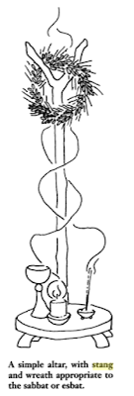
From Green Witchcraft III: The Manual, Volume 3

The Bergoglio stang incorporates the requisite iron nail as a crosspiece at the top. Perhaps it could be used to hang a lantern from, representing the light of cunning and wisdom.
Where did he get that stang?
Francis claims that it was a gift from "youth" to be used at the Synod on the same.
Miss Barnhardt posted a picture apparently verifying this (see page 6).
But if you look carefully, there's another interesting detail. The woman on the left (who according to reports is a not so young thirty years of age) is wearing a red string bracelet, which Barnhardt describes "as a very common talisman in witchcraft/Wicca and Kabbalah, which is basically a hybrid of Talmudic Judaism and witchcraft."

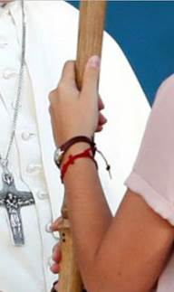

Apparently, it's worn by all the youths.
Is Bergoglio a Satanist? I don't know. I mean it's not like he performs religious rituals wielding a stang or anything.
But to be serious, while in the face of this wicked circus, it's often healthy to laugh, it would be foolish to laugh this off. If the Catholic faith is true, and thus Satan and Satanism exists, if heresy and heretical prelates are on the move, and if Satan is ultimately behind this, as the Catholic Church teaches, why wouldn't we now be seeing such a link?
What do you think heretical antipopes do?
Or, more to the point, what does Satan do with them?
Read the two recent pieces by Ann Barnhardt here and here.
I think she gets it precisely right:
As I have said and written before, one of satan’s most clever moves has been to foment, encourage and push mentally ill and demonically oppressed people to LOUDLY broadcast insane, ridiculous, totally false “conspiracy theories”. We all know the types and categories. Mind control beams, “chem trails”, shape shifting lizards, underground civilizations, flat earthers, the list goes on and on and on.
What this has done is make it almost impossible to point out, discuss, and warn about ACTUAL sinister goings-on and actual, honest-to-goodness conspiracies that are very real . . .
I am morally certain that Antipope Bergoglio’s carrying of a Stang with the iron nail so prominently positioned, into the opening of a farce synod whose entire agenda is the ratification of sodomy, is a clear case of manifestation of satanism.
And if that makes me a conspiracy theorist, so be it. Some conspiracies are real.

Youth Synod starts under the symbol of witchcraft
https://www.traditioninaction.org/RevolutionPhotos/A802-Stang.htm
October 7, 2018

It was shocking to see the photo in the news report in the Vatican organ L'Osservatore Romano [page 1] showing the Mass inaugurating the Youth Synod in Rome. The ceremony is staged as if the strange staff in the foreground were the lenses through which we should interpret it. The photographer captured the power of that symbol quite well.
That forked staff was given to Francis on August 11, 2018, during a meeting with youth he held at the Circus Maximus, below, at left. He chose to use it at the opening Mass of the Youth Synod, below, at right.
At first glance, we could think that this is just another progressivist extravaganza. However, when we examine the forked staff carefully, we see that it is very similar to the staff used in witchcraft, which is called a stang.
Further below, we posted photos of several stangs used in witchcraft so that the reader can evaluate how similar they are to Francis' staff.
So, we have the progressivist Pope making another of his insinuations. This time, however, it contains an implicit approval of witchcraft, that is, the cult to the Devil. We know that it is not completely verified that Francis is aware of all the implications of the use if this symbol. But then, with this Pope what is entirely clear?
This is another episode that lets us wonder whether he is the Vicar of Christ or the vicar of the Archenemy of Christ.

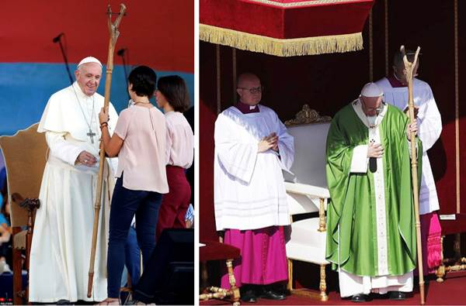

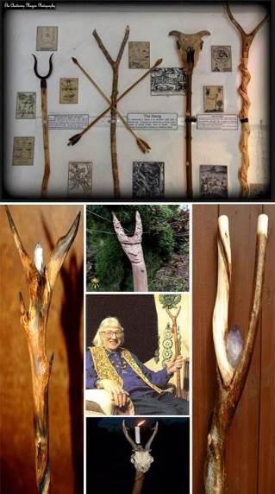

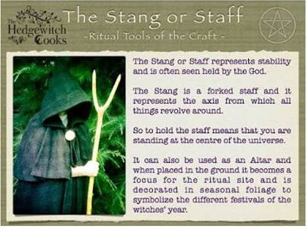

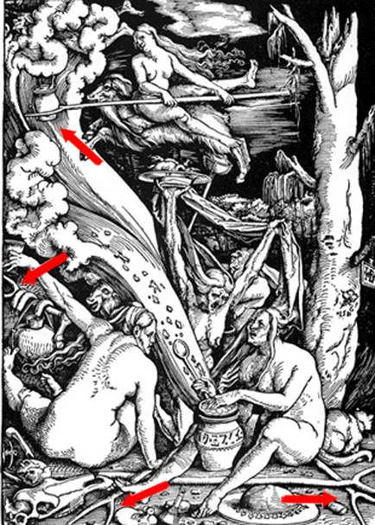

It’s a stang: Pope Francis opened Vatican Youth Synod with Sorcerer’s Staff
https://novusordowatch.org/2018/10/stang-francis-synod-sorcerers-staff/
October 10, 2018

A few days ago we reported on Francis’ opening of the Youth Synod in the Vatican, which is scheduled to conclude on Oct. 28. The pastoral staff, called a ferula, that Francis used represented a new low in post-Vatican II liturgical absurdity. We commented that it looked like a hybrid between a slingshot and a barbecue fork, and indeed it does. However, research by others has now brought to light that this “thing” is more than just another Modernist piece of junk — in fact, it is downright Satanic.
To get straight to the point: The staff Francis used is a so-called stang. A stang is basically a sorcerer’s ritual staff used in modern-day witchcraft (Wicca). It had been presented to him on Aug. 11 of this year during a meeting with young Italians at Rome’s Circus Maximus. The video of the occasion is embedded here (the stang is presented to him beginning at the 15:19 min mark):

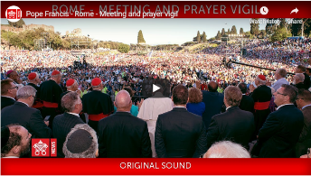
2:24:51 https://youtu.be/gjAiPAYN1VM

The following is a close-up of the top of the staff, taken from the video above. It looks as though there is a face carved into the bump, and there clearly are engravings in the two horns.

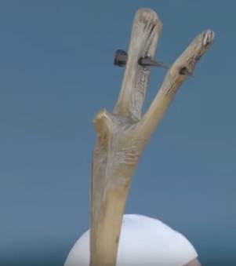

The following links demonstrate the connection with witchcraft, with plenty of pictures and more information:
“Satanists Manifesting: Antipope Bergoglio Carries a Stang – the Ritual Staff of Witchcraft”(Barnhardt)
“Wiccan Stang Given to Antipope Bergoglio By Woman Wearing Wiccan Red String Bracelet”(Barnhardt)
“Youth Synod starts under the symbol of witchcraft” (Tradition in Action)
“So…Did the Pope Carry the Satanic Stang at the Opening Mass of the Youth Synod?” (Les Femmes – The Truth)
“Jeepers, Creepers, Where’d you get That Stang?” (Mahound’s Paradise)
“Sobre el Báculo de Bergoglio el Brujo” (Miles Christi)
“The Stang” (Patheos: By Athame & Stang - caution, this is a Wiccan blog)

Here we must give kudos specifically to Ann Barnhardt, who was apparently the first to identify this as a stang. We have many disagreements with Miss Barnhardt but want to give credit where credit is due (cf. Rom 13:7).
One very important detail that is not to be glossed over is that the young woman who gave the stang to Francis on Aug. 11 was wearing a red wristband, another occult symbol, as shown in Barnhardt’s second post linked above.
Of course, many people will now say that we cannot assume that Francis knowingly used a Wiccan wizard’s staff for a ferula. Aside from the fact that no one in his right mind would use such a piece of sinister-looking junk in place of the Cross of Christ, it is Francis’ obligation to know what he is using. The burden rests on him to ensure he acts in accordance with the Faith at all times, not on everyone else to constantly find excuses for him. Even more importantly, however, we must point out that for Francis to knowingly use a witches’ staff in the liturgy totally fits the pattern we have seen from him over the years.
Let’s review: Francis has said he has so much energy because instead of going to the doctor, he goes “to the witch”; he has literally stated, “I am the devil”; when receiving a Pagan sorceress at the Vatican, he allowed her to work some of her magick on him; he has stated that his favorite exorcist is a Lutheran layman; he has received a large number of “medical” treatments by a practitioner of Taoism; he has said that Jesus Christ “made Himself the devil” for us; he has given a manuscript of the life of Buddha as a gift to the president of Myanmar; he is on record saying that Pagans “meet God in different ways”; he has kissed a sinister-looking crucifix with occult symbolism; he has paid a visit to Buddhist “relics”; decades ago he sought prolonged professional help from a Jewish psychoanalyst; he continually holds audiences before the blasphemous “Resurrection” sculpture in the Paul VI audience hall; he cracks blasphemous jokes; and he has declared the ultimate Witchdoctor of the Novus Ordo Church, “Pope” John Paul II of Voodoo, cow dung, Koran-kissing, and Assisi interfaith prayer infamy, to be a “saint” worthy of Catholics’ veneration and imitation.
The real question, therefore, is: Why wouldn’t he use a Wiccan stang?
At this point, the Great Apostasy is so far advanced that the “Pope” can use a two-horned staff that is clearly linked to witchcraft, and except for a select few bloggers, practically nobody cares. If soon there is open Satanism being practiced in the Vatican, it will barely elicit a yawn. For his next “Mass”, expect to see a pitchfork or a broomstick.
Two-thousand years ago, St. Paul asked rhetorically: “And what concord hath Christ with Belial?” (2 Cor 6:15). But then again, that was before Vatican II.

What is the meaning of Pope Francis’s new gesture?
https://www.tfp.org/what-is-the-meaning-of-pope-franciss-new-gesture/
By Luiz Sérgio Solimeo, October 17, 2018

Since the Middle Ages, Popes have used a ferula, a metal rod topped by a cross, to symbolize their authority.
However, at the inauguration of the Youth Synod, on October 3, the Holy Father presented himself with a new papal ferula: a forking bamboo-like staff. The cross disappeared.
Paying close attention, one notices a carved face at the base of the fork, which would be Our Lord’s. According to some, the fork is supposed to represent the arms of the Savior.
This singular ferula was given to the Pope at the Youth Meeting in the Circus Maximus on August 11.
This new symbol aptly suits the kind of religion you see in photographs of this meeting: countless boys appear shirtless, and girls without a blouse, wearing only a revealing bra and tight shorts.¹
Back to the new symbol used by Francis, which caused no small commotion in the Catholic world,² this aberrant replacement of the cross with a fork has even more serious aspects.
The staff topped by a fork is related to witchcraft and Wicca, and in the United States, it is called a stang. Significantly, one of the girls who delivered the staff to Francis wore a “red string on the wrist . . . something from Wicca.”³
As one occultist author explains, “The Stang is adored by many modern Traditional Witches, myself included. It’s a tool whose use powerfully evokes a sense of connection to something old and primitive. In its simplest form, a forked staff, Witches use the Stang in various ways including representing the Horned One, aiding in spirit flight, and directing energy.”⁴
Why did the Pope abandon the Cross of Christ, replacing it with an ambiguous forked staff? And what led him to use a staff that could be interpreted as an occultist stang?
Since, as Saint Robert Bellarmine states, “the whole Church always taught in words and examples,”⁵ what did the Pontiff intend to teach through this gesture? That all religions are good, even those that worship “The Horned One”?
Did he intend to consecrate, in a symbolic fashion, the naturalist-ecologist doctrine contained in his encyclical Laudato Si,⁶ in which he affirmed that the Son of God has “united himself to this earth,”⁷ that the Holy Spirit is “present at the very heart of the universe,”⁸ and that the Holy Eucharist is “a fragment of matter”?⁹
This is not the first time that Pope Francis sends ambiguous symbolic messages, through acts, gestures, and attitudes, to the point that one could ask whether, given these messages’ ambiguity (many examples could be mentioned), Francis is not abandoning his Petrine mission to confirm his brothers in the faith.¹⁰For the truth—which can be taught by words and by acts, gestures, and attitudes¹¹—must have a clarity that does not allow ambiguities.
That is why the Divine Master ordered His Apostles to be entirely accurate: “Let your speech be yea, yea: no, no: and that which is over and above these, is of evil” (Matt. 5:37).
May the Virgin Mother of Jesus Christ, the Mother of the Church, His Mystical Body, obtain from her Son that the passion the Church is going through may end as soon as possible.

Footnotes
1. See “Settantamila giovani al Circo Massimo per il Papa: ‘Non lasciatevi rubare i sogni,’” Il Tempo, Aug. 11, 2018, https://www.iltempo.it/roma-capitale/2018/08/11/news/roma-papa-francesco-circo-massimo-giovani-raggi-1081743/; Chiara Sarra, “Il Papa incontra i giovani: in migliaia all’incontro al Circo Massimo,” Il Giornale, Aug. 11, 2018, http://www.ilgiornale.it/news/cronache/papa-incontra-i-giovani-migliaia-allincontro-circo-massimo-1564095.html; Debbie White, “Pope idol! Adoring young fans mob Francis as pontiff resembles a rock star on stage at 70,000-strong youth festival in Rome” Daily Mail, Aug. 11, 2018, https://www.dailymail.co.uk/news/article-6050877/Pope-Francis-mobbed-adoring-fans-70-000-gather-youth-festival-Rome.html.
2. See, for example, Fr. John Zuhlsdorf, “What is that? #Synod2018 – UPDATED – EXPLAINED and EXPLAINED MORE,” Fr. Z’s Blog, Oct. 5, 2018, http://wdtprs.com/blog/2018/10/what-is-that-synod2018/; Susan Matthiesen, “Is Francis’ Stang a Laudato Si/Sr Dorothy Stang Stang?” Les Femmes – The Truth, Oct. 6, 2018, https://lesfemmes-thetruth.blogspot.com/2018/10/is-francis-stang-laudato-sisr-dorothy.html.
3. Zuhlsdorf, “What is that? #Synod2018.”
4. Kelden, “The Stang,” Patheos, Aug. 20, 2016, http://www.patheos.com/blogs/byathameandstang/2016/08/the-stang/.
5. St. Robert Bellarmine, On Laymen or Secular People (Indianapolis: Liberty Fund, 2012), 54.
6. See Arnaldo Vidigal Xavier da Silveira, “Notes on the Unacceptable Philosophy and Theology of Laudato Si’,” TFP.org, Aug. 2, 2017, https://www.tfp.org/notes-unacceptable-philosophy-theology-laudato-si/.
7. Francis, Encyclical Laudato Si’, May 24, 2015, no. 238, http://w2.vatican.va/content/francesco/it/encyclicals/documents/papa-francesco_20150524_enciclica-laudato-si.html.
8. Ibid.
9. Ibid., no. 236.
10. “Confirm thy brethren” (Luke 22:32).
11. See Arnaldo Vidigal Xavier da Silveira, “Acts, Gestures, Attitudes and Omissions Can Characterize a Heretic,” in Can Documents of the Magisterium of the Church Contain Errors? Can the Catholic Faithful Resist Them? translated John R. Spann and José Aloisio A. Schelini (Spring Grove, Penn.: The American Society for the Defense of Tradition, Family and Property—TFP, 2015).

POPE FRANCIS FILES AT THIS MINISTRYS WEBSITE 400+ FILES
http://ephesians-511.net/recent/docs/POPE_FRANCIS_FILES_AT_THIS_MINISTRYS_WEBSITE.doc

