
APRIL 3, 2018

Rape and sexual abuse of nuns (and lay women and boys) by Indian priests-23
FR. JOBY KACHAPPILLY RAPE CASE-NATIONAL COMMISSION FOR WOMEN WRITES TO DIRECTOR GENERAL OF POLICE, BENGALURU

This file is the 23rd in the series on the Vincentian rapist-priest who is still at loose despite his entire Congregation being aware of his serial molestation of young girls spanning several years.
RAPE AND SEXUAL ABUSE BY INDIAN PRIESTS-CHURCH FAILS TO PUNISH GUILTY 01 MARCH 2015/24, 26 OCTOBER 2016/24 JANUARY/28 FEBRUARY/4 MARCH 2017 (General)
http://ephesians-511.net/docs/RAPE_AND_SEXUAL_ABUSE_BY_INDIAN_PRIESTS-CHURCH_FAILS_TO_PUNISH_GUILTY_01.doc
RAPE AND SEXUAL ABUSE BY INDIAN PRIESTS-CHURCH FAILS TO PUNISH GUILTY 02 17/22 JUNE 2017 (General continued)
http://ephesians-511.net/docs/RAPE_AND_SEXUAL_ABUSE_BY_INDIAN_PRIESTS-CHURCH_FAILS_TO_PUNISH_GUILTY_02.doc
RAPE AND SEXUAL ABUSE BY INDIAN PRIESTS-CHURCH FAILS TO PUNISH GUILTY 03 18 JUNE 2017 (FR. ROBIN VADAKKUNCHERIL)
http://ephesians-511.net/docs/RAPE_AND_SEXUAL_ABUSE_BY_INDIAN_PRIESTS-CHURCH_FAILS_TO_PUNISH_GUILTY_03.doc
RAPE AND SEXUAL ABUSE BY INDIAN PRIESTS-CHURCH FAILS TO PUNISH GUILTY 04 22/28 JUNE/2 JULY 2017 (CORRESPONDENCE RELATED TO RAPE COMMITTED BY FR. JOBY KACHAPPILLY VC)
http://ephesians-511.net/docs/RAPE_AND_SEXUAL_ABUSE_BY_INDIAN_PRIESTS-CHURCH_FAILS_TO_PUNISH_GUILTY_04.doc
RAPE AND SEXUAL ABUSE BY INDIAN PRIESTS-CHURCH FAILS TO PUNISH GUILTY 05 (PROFILE OF FR. JOBY KACHAPPILLY, THE ABSCONDING RAPIST PRIEST HIDING IN ROME)
http://ephesians-511.net/docs/RAPE_AND_SEXUAL_ABUSE_BY_INDIAN_PRIESTS-CHURCH_FAILS_TO_PUNISH_GUILTY_05.doc
RAPE AND SEXUAL ABUSE BY INDIAN PRIESTS-CHURCH FAILS TO PUNISH GUILTY 06 (FINAL NOTIFICATION TO THE INDIAN CHURCH) JULY 10, 2017
http://ephesians-511.net/docs/RAPE_AND_SEXUAL_ABUSE_BY_INDIAN_PRIESTS-CHURCH_FAILS_TO_PUNISH_GUILTY_06.doc
RAPE AND SEXUAL ABUSE BY INDIAN PRIESTS-CHURCH FAILS TO PUNISH GUILTY 07 (INTIMIDATION AND BLACKMAIL OF RAPE SURVIVOR BY FR JOHN PUTHANPURACKAL VC) JULY 10, 2017
http://ephesians-511.net/docs/RAPE_AND_SEXUAL_ABUSE_BY_INDIAN_PRIESTS-CHURCH_FAILS_TO_PUNISH_GUILTY_07.doc
RAPE AND SEXUAL ABUSE BY INDIAN PRIESTS-CHURCH FAILS TO PUNISH GUILTY 08 (RELUCTANCE TO COOPERATE IN EXPOSING RAPE BY PRIESTS AND ACTIVE HOMOSEXUALITY IN THE SEMINARIES) JULY 10, 2017
http://ephesians-511.net/docs/RAPE_AND_SEXUAL_ABUSE_BY_INDIAN_PRIESTS-CHURCH_FAILS_TO_PUNISH_GUILTY_08.doc
RAPE AND SEXUAL ABUSE BY INDIAN PRIESTS-CHURCH FAILS TO PUNISH GUILTY 09 (PROPOSED RETREAT BY RAPIST-PRIEST FR. JOBY KACHAPPILLY VC AT ST. MICHAEL’S CATHOLIC CHURCH, SHARJAH, SEPTEMBER 2-4, 2017) AUGUST 2, 2017
http://ephesians-511.net/docs/RAPE_AND_SEXUAL_ABUSE_BY_INDIAN_PRIESTS-CHURCH_FAILS_TO_PUNISH_GUILTY_09.doc
RAPE AND SEXUAL ABUSE BY INDIAN PRIESTS-CHURCH FAILS TO PUNISH GUILTY 10 (RETREAT BY FR. JOBY KACHAPPILLY VC AT ST. MICHAEL’S CATHOLIC CHURCH, SHARJAH, CANCELLED) AUGUST 3, 2017
http://ephesians-511.net/docs/RAPE_AND_SEXUAL_ABUSE_BY_INDIAN_PRIESTS-CHURCH_FAILS_TO_PUNISH_GUILTY_10.doc

RAPE AND SEXUAL ABUSE BY INDIAN PRIESTS-CHURCH FAILS TO PUNISH GUILTY 11 (FR. JOBY KACHAPPILLY VC IN HIDING IN ROME CONTINUES TO CONDUCT RETREATS OVERSEAS WITH SUPPORT FROM HIS CONGREGATION - 01) 8 AUGUST 2017
http://ephesians-511.net/docs/RAPE_AND_SEXUAL_ABUSE_BY_INDIAN_PRIESTS-CHURCH_FAILS_TO_PUNISH_GUILTY_11.doc
RAPE AND SEXUAL ABUSE BY INDIAN PRIESTS-CHURCH FAILS TO PUNISH GUILTY 12 (COMPLAINT AGAINST RAPIST FR. JOBY KACHAPPILLY VC LODGED WITH NATIONAL COMMISSION FOR WOMEN) 20 AUGUST 2017
http://ephesians-511.net/docs/RAPE_AND_SEXUAL_ABUSE_BY_INDIAN_PRIESTS-CHURCH_FAILS_TO_PUNISH_GUILTY_12.doc
RAPE AND SEXUAL ABUSE BY INDIAN PRIESTS-CHURCH FAILS TO PUNISH GUILTY 13 (BANGALORE MEETING WITH VINCENTIAN PRIESTS AND CHURCH REPRESENTATIVE IN FR. JOBY KACHAPPILLY VC CASE) 20 AUGUST 2017
http://ephesians-511.net/docs/RAPE_AND_SEXUAL_ABUSE_BY_INDIAN_PRIESTS-CHURCH_FAILS_TO_PUNISH_GUILTY_13.doc
RAPE AND SEXUAL ABUSE BY INDIAN PRIESTS-CHURCH FAILS TO PUNISH GUILTY 14 (FR. JOBY KACHAPPILLY VC IN HIDING IN ROME CONTINUES TO CONDUCT RETREATS OVERSEAS WITH SUPPORT FROM HIS CONGREGATION - 02) 27 AUGUST 2017
http://ephesians-511.net/docs/RAPE_AND_SEXUAL_ABUSE_BY_INDIAN_PRIESTS-CHURCH_FAILS_TO_PUNISH_GUILTY_14.doc
RAPE AND SEXUAL ABUSE BY INDIAN PRIESTS-CHURCH FAILS TO PUNISH GUILTY 15 (SOME EVIDENCE AGAINST THE CRIMINAL PRIEST FR. JOBY KACHAPPILLY VC AND HIS ASSOCIATES) 28 AUGUST 2017
http://ephesians-511.net/docs/RAPE_AND_SEXUAL_ABUSE_BY_INDIAN_PRIESTS-CHURCH_FAILS_TO_PUNISH_GUILTY_15.doc
RAPIST PRIEST FR JOBY KACHAPPILLY-THE CATHOLIC CHURCHS GURMEET RAM RAHIM SINGH 28 AUGUST 2017
http://ephesians-511.net/docs/RAPIST_PRIEST_FR_JOBY_KACHAPPILLY-THE_CATHOLIC_CHURCHS_GURMEET_RAM_RAHIM_SINGH.doc
RAPE AND SEXUAL ABUSE BY INDIAN PRIESTS-CHURCH FAILS TO PUNISH GUILTY 17 (VINCENTIAN PRIEST FR. SAM KOONAMPLACKIL OF LOGOS RETREAT CENTRE MOLESTS WOMEN) 30 AUGUST 2017
http://ephesians-511.net/docs/RAPE_AND_SEXUAL_ABUSE_BY_INDIAN_PRIESTS-CHURCH_FAILS_TO_PUNISH_GUILTY_17.doc
RAPE AND SEXUAL ABUSE BY INDIAN PRIESTS-CHURCH FAILS TO PUNISH GUILTY 18 (COMPLAINT RECEIVED AGAINST FR. JACOB VELLIAN AND HIS ARCHBISHOP) 3 SEPTEMBER 2017
http://ephesians-511.net/docs/RAPE_AND_SEXUAL_ABUSE_BY_INDIAN_PRIESTS-CHURCH_FAILS_TO_PUNISH_GUILTY_18.doc
RAPE AND SEXUAL ABUSE BY INDIAN PRIESTS-CHURCH FAILS TO PUNISH GUILTY 19 (FR. JOBY KACHAPPILLY VC IN HIDING IN ROME CONTINUES TO CONDUCT RETREATS OVERSEAS WITH SUPPORT FROM HIS CONGREGATION - 03) 14 SEPTEMBER 2017
http://ephesians-511.net/docs/RAPE_AND_SEXUAL_ABUSE_BY_INDIAN_PRIESTS-CHURCH_FAILS_TO_PUNISH_GUILTY_19.doc
RAPE AND SEXUAL ABUSE BY INDIAN PRIESTS-CHURCH FAILS TO PUNISH GUILTY 20 (FR. JOBY KACHAPPILLY VC IN HIDING IN ROME CONTINUES TO CONDUCT RETREATS OVERSEAS WITH SUPPORT FROM HIS CONGREGATION - 04) 27 SEPTEMBER 2017
http://ephesians-511.net/docs/RAPE_AND_SEXUAL_ABUSE_BY_INDIAN_PRIESTS-CHURCH_FAILS_TO_PUNISH_GUILTY_20.doc
RAPE AND SEXUAL ABUSE BY INDIAN PRIESTS-CHURCH FAILS TO PUNISH GUILTY 21 (VEDIKA PEREIRA SPEAKS UP FOR RAPIST FR. JOBY) 27 SEPTEMBER 2017
http://ephesians-511.net/docs/RAPE_AND_SEXUAL_ABUSE_BY_INDIAN_PRIESTS-CHURCH_FAILS_TO_PUNISH_GUILTY_21.doc
RAPE AND SEXUAL ABUSE BY INDIAN PRIESTS-CHURCH FAILS TO PUNISH GUILTY 22 (NATIONAL COMMISSION FOR WOMEN WRITES TO COMMISSIONER OF POLICE) 30 SEPTEMBER/3 OCTOBER 2017
http://ephesians-511.net/docs/RAPE_AND_SEXUAL_ABUSE_BY_INDIAN_PRIESTS-CHURCH_FAILS_TO_PUNISH_GUILTY_22.doc

On March 27, I received another snail mail from the National Commission for Women (NCW), Delhi.

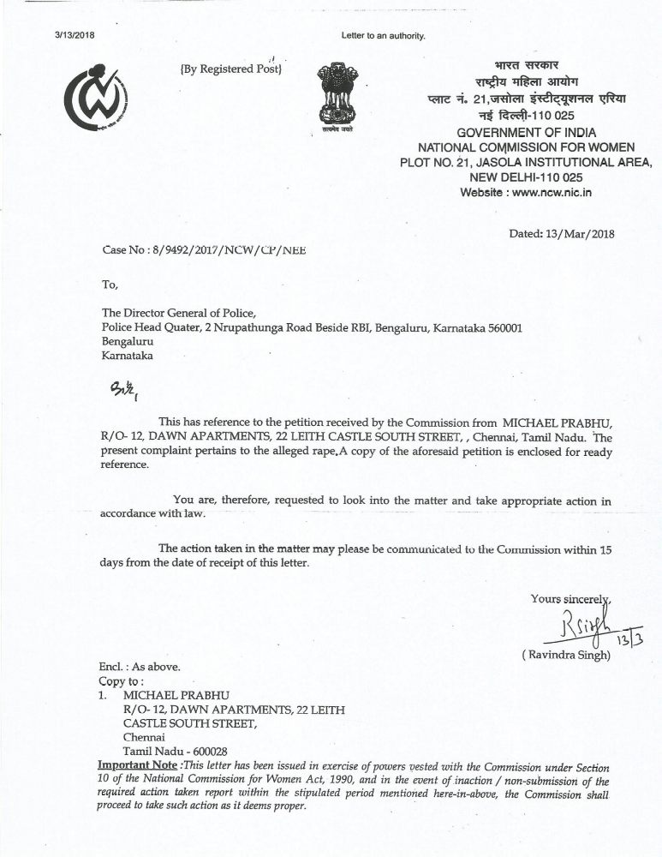

Against the receipt of that letter, I wrote to the Director General of Police, Bengaluru, under copy to the NCW:

To, The Director General of Police,
Police Headquarters,
2, Nrupathunga Road, beside RBI,
Bengaluru 560001
KARNATAKA

April 3, 2018

Dear Sir,

This is with reference to the letter to you, copy attached, reference/case no. 8/9492/2017/NCW/CP/NEE dated March 13, 2018 from Ravindra Singh of the National Commission for Women, New Delhi.

Please be advised concerning the developments in the case and our original complaint:
1) The accused rapist Catholic priest Fr. Joby Kachappilly SVD had fled to Europe, aided and abetted by his Superiors in his religious order.
His Superiors have not cooperated with us despite our numerous letters to them, a meeting with their representative committee in Bengaluru, and over 20 reports posted on our web site (www.ephesians-511.net), the last of which was:
RAPE AND SEXUAL ABUSE BY INDIAN PRIESTS-CHURCH FAILS TO PUNISH GUILTY 22 (NATIONAL COMMISSION FOR WOMEN WRITES TO COMMISSIONER OF POLICE) 30 SEPTEMBER/3 OCTOBER 2017
http://ephesians-511.net/docs/RAPE_AND_SEXUAL_ABUSE_BY_INDIAN_PRIESTS-CHURCH_FAILS_TO_PUNISH_GUILTY_22.doc

2) The raped victims are unwilling/unable to testify in the absence from India of the rapist.

This is for your kind information please.

Michael Prabhu (Complainant)
12 Dawn Apartments
22 Leith Castle South Street
Chennai 600028
TAMIL NADU
Tel: 044 2461 1606

COPY TO: NCW, NEW DELHI

