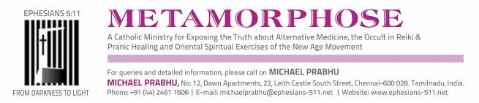

MICHAEL PRABHU, NOVEMBER 22, 2020

Jesus Youth Rex Band coordinator Shelton Pinheiro OK’s Hindu temple origin Bharatanatyam dance for Catholics

The Jesus Youth Movement (JY) is an Indian Catholic charismatic organization that has a global presence.
JY prayer groups meet for praise and worship in villages, towns and cities all over the world.
Centred in Kochi, Kerala, its music ministry is named the Rex Band. They describe themselves as “a contemporary spiritual band”. http://eng.kairos.global/?p=6579
Shelton Pinheiro is its coordinator and lead vocalist.



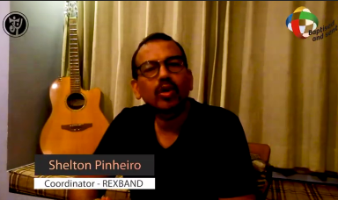

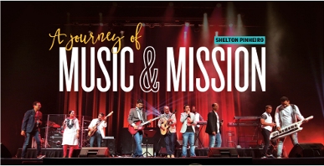

Shelton Pinheiro:
Copywriter, Creative Director in Advertising. Currently works on a set of interesting brands as Executive Creative Director for Stark Communications. Have led creative teams in Mudra Communications, FCB and MAA Bozell among others. Reads. Writes poetry and songs. https://in.linkedin.com/in/shelton-pinheiro-a369394
Shelton Pinheiro is one of Malayalam film industry’s few English songwriters…
In the past, he’s written ‘Super Mom’ and ‘Michael Jackson’ both from the film Mummy and Me (2010) and also written and sung the rap portions of ‘Kandille’ from Cinema Company (2012), and ‘Hip-hop’ from the Mammootty hit Big-B (2007) …

Shelton’s inclination towards music began young, influenced by his Anglo-Indian family from the Vypeen Islands. His own preferences range from the jazz greats — Diana Krall, Frank Sinatra — to alternative rock bands (Mumford and Sons, Oasis, Coldplay),Gregorian chants, Taize music, the Sufi poets and Asian Underground artistes such as Karsh Kale…
The variety is reflected in his long-term association with the Rex Band, an ethnic spiritual band which began in 1991 during his years at Sacred Heart College, Thevara, where he met, now music director, Alphons Joseph. Over two decades, Shelton wrote close to 60 songs for Rex Band for their 12 albums and has toured the world several times over with them. “Rex Band is made up of 15 members with very different musical instincts.
https://www.thehindu.com/features/friday-review/music/hooked-to-words/article5096570.ece, June 2, 2016

Three months ago, a JY member sent me the link to a JY media ministry video livestreamed August 8 https://www.youtube.com/watch?v=0ARxNZQ_KaY 1:18:30, disturbed by Pinheiro’s apparent endorsement of Bharatanatyam dance and asked me to check it out and revert.
On watching the video, I found Pinheiro recommending Bharatanatyam dance to Catholic viewers.
It is very unfortunate because he has been on my mailing list since 2007 but never ever responded. If he had visited my web site, he would have known better.

THE TRANSCRIPT OF THE RELATED SECTION OF THE VIDEO, WITH MY COMMENTS:
Shelton Pinheiro, in reply to a question on whether Catholics should "learn" "art forms ... like Bharatanatyam dancing... where we might end up worshiping other gods ... another religion .. is practicing art forms like that OK?" answers "Should we learn art forms like that? ... My opinion is ... YES DEFINITELY WE SHOULD because we are part of that culture, it is our culture ... God has placed us in the middle of this culture ... Our language --- everything we draw from our culture ... YES, YES, we have to be part of our art forms that are part of our culture". Then Pinheiro rambles on quite meaninglessly and confusingly, and repetitively, not providing any clear basis for his assertions or enlightening the listener/viewer about anything even faintly related to the Hindu temple dance and how performing it is/can be detrimental to our Catholic faith and a violation of one of God's Ten Commandments. Pinheiro talks about his discussions on such issues with other Christian musicians/ministries. Try as I might, I found no sense in anything of what he continued to talk about in his attempt to answer the original question. He explained that he learned that "... from another religion ... many of these exercises were created from a deep yearning for God ... a yearning for Jesus ... a kind of very spiritual yearning that I can reflect in my faith". He ended opining that "my larger feeling is that this is also a call for more of us to be part of these art forms so that the ... content evolves ... more Catholic musicians, more Catholic dancers, more Catholic practitioners of these art forms should emerge so that the contents will reflect the faith of the Catholic (inaudible)."

This is what happens when Catholics in "ministry" pontificate on matters that they know absolutely nothing about. I am very apprehensive about attempting to watch the rest of Pinheiro's "expert" answers to questions like these that were to be addressed by him on the show:
"Is listening to heavy metal music good? Will it harm me spiritually/ have a black magic effect on me?", "Is listening to bands that are openly satanic bad, even if it improves our music knowledge?", "Being a video content creator, I recently did a video related to Bangalore Ganesha Utsav, which promotes Lord Ganesha*. Being a professional, am I doing the wrong thing?" and "I'm someone who enjoys belly dance, as an art form. Is that wrong in a Catholic perspective?"

Bharatanatyam is a Hindu temple dance. Fr. Rufus Pereira, exorcist, in a Francis McNutt book from which I have cited in a report detailed how, during a charismatic national convention, he delivered a Mumbai Catholic girl from the demonic spirit of Nataraja, the dancing aspect of the deity Shiva, that took possession of her when she went for Bharatanatyam classes.
*I have written several documented reports on the Ganesh Utsav pandemic in the Indian Catholic Church.
I have researched and reported on this Hindu temple dance form for over a decade:

BHARATANATYAM DANCE AND CARNATIC MUSIC: (IN ALPHABETICAL ORDER)
AFTER YOGA MOTHER TERESA'S NUNS INTO BHARATANATYAM DANCE
http://ephesians-511.net/docs/AFTER_YOGA_MOTHER_TERESAS_NUNS_INTO_BHARATANATYAM_DANCE.doc
BHARATANATYAM-I (2011) 140 PAGES
http://ephesians-511.net/docs/BHARATANATYAM-I.doc
BHARATANATYAM AT HOLY MASS AT CATHEDRAL OF ST THOMAS IN MADRAS-MYLAPORE ARCHDIOCESE
http://ephesians-511.net/docs/BHARATANATYAM_AT_HOLY_MASS_AT_CATHEDRAL_OF_ST_THOMAS_IN_MADRAS-MYLAPORE_ARCHDIOCESE.doc
BHARATANATYAM DANCING JESUIT FR SAJU GEORGE
http://ephesians-511.net/recent/docs/BHARATANATYAM_DANCING_JESUIT_FR_SAJU_GEORGE.doc
DANCING AND BHARATANATYAM IN THE MASS
http://ephesians-511.net/docs/DANCING_AND_BHARATANATYAM_IN_THE_MASS.doc

HINDUS PROSCRIBE TEMPLE DANCE WHILE CATHOLICS DANCE AT HOLY MASS
http://ephesians-511.net/docs/HINDUS_PROSCRIBE_TEMPLE_DANCE_WHILE_CATHOLICS_DANCE_AT_HOLY_MASS.doc
SHOULD CATHOLICS PERFORM BHARATANATYAM-SUSAN BRINKMANN
http://ephesians-511.net/docs/SHOULD_CATHOLICS_PERFORM_BHARATANATYAM-SUSAN_BRINKMANN.doc
SOCIETY OF THE DIVINE WORD PROVINCIAL PERFORMS BHARATANATYAM
http://ephesians-511.net/docs/SOCIETY_OF_THE_DIVINE_WORD_PROVINCIAL_PERFORMS_BHARATANATYAM.doc
THE HINDUISATION OF THE CATHOLIC CHURCH-IMAGES
http://ephesians-511.net/docs/THE_HINDUISATION_OF_THE_CATHOLIC_CHURCH-IMAGES.doc
WHAT DO MUDRAS CONVEY?
http://ephesians-511.net/docs/WHAT_DO_MUDRAS_CONVEY.doc
THE HINDUISATION OF MUSIC IN THE CATHOLIC CHURCH [CARNATIC MUSIC]
http://ephesians-511.net/docs/THE_HINDUISATION_OF_MUSIC_IN_THE_CATHOLIC_CHURCH.doc
CARNATIC MUSIC PERFORMANCE DESECRATES JESUITS CHURCH
http://ephesians-511.net/recent/docs/CARNATIC_MUSIC_PERFORMANCE_DESECRATES_JESUITS_CHURCH.doc
CARNATIC MUSIC IS HINDU SAY HINDUS
http://ephesians-511.net/recent/docs/CARNATIC_MUSIC_IS_HINDU_SAY_HINDUS.doc

I wrote to a couple of very senior JY leaders who are familiar with my ministry, one of them since the year 2000, and who are in regular touch with me. The email exchanges were copied to Pinheiro. Both JY leaders responded, confident that Pinheiro would do the right thing. One wrote:
Thank you. Shelton is the national creative director of a leading Media company and has won many national awards. He is a very strong and committed Catholic too. He is one of the well-respected media professionals in our country and he has his own views about all these art forms. I hope he will respond to your mail.
The big problem is that Bharatanatyam is not an “art form”.
Cardinal Müller …on… an Indian theology, “which says that, regardless of the unique and ultimate Revelation of God in Jesus Christ, we could establish, based on the thinking or myths of the natives, a whole new approach to understanding the world. In my opinion, this is completely exaggerated and essentially theologically wrong.”
July 9, 2020, https://www.lifesitenews.com/blogs/cardinal-mueller-critiques-communism-indian-theology
I sent all of the above information to Pinheiro and the JY leaders.

Shelton Pinheiro responded:
From: Shelton Pinheiro <spinheiro@gmail.com>
Date: Thu, Oct 1, 2020 at 1:40 PM
Subject: Re: MICHAEL PRABHU HERE-BHARATANATYAM ON JY VIDEO
Dear Brother Michael,
Thank you so much for your analysis and your perspective on my interaction in Catholic Chai. And further, thank you for all the reference links you have shared. I will try and go through those in the coming days. Peace. Shelton
Shelton Pinheiro, Executive Creator Director, Stark - Kochi. Thiruvananthapuram. Bengaluru. New Delhi
www.stark.in https://shelspace.com
Instagram, Twitter: @shelspace
Photographs: https://1x.com/member/shelshots
"To die as much as necessary, without going too far, To grow back as much as needed, from the remnant that survives.”
-Wislava Szymborska

I learnt from the above that Pinheiro is a leading influencer both in the advertising and media world as well as in the Catholic sphere. If he is in error, he needs to be fraternally corrected.
This is some of what I found at Stark (remember who their Executive Creative Director is) https://www.facebook.com/starkcommunications/photos/:

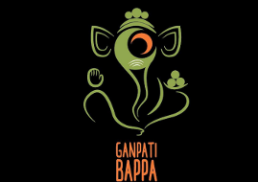

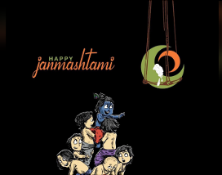





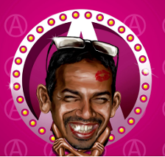
Shelton Pinheiro

I personally know Catholic charismatic musicians who lead praise and worship during the day, perform at rock music shows in the evening and at star hotel bars and discos at night. A few of them are in the film music industry. For most of them it is virtually impossible not to compromise on Christian values. To survive and to climb the ladder, they’ve got to be politically correct. The same goes for celebrities, whether they are actors, cricketers or TV anchors. And for individuals in the limelight in media and event management.
All of a sudden, these individuals are ‘pontificating’, as Pinheiro is, on every subject under the sun, and because of their celebrity status, listeners and viewers blindly accept whatever they say.

Art, Creativity & Spirituality | Episode 07 |The Catholic Chai
A Space where you can ask all your doubts regarding the teachings of the Catholic Church and get your questions answered live on our talkshow! https://chat.whatsapp.com/JjqW2RY7Aw7...

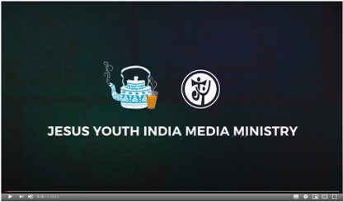

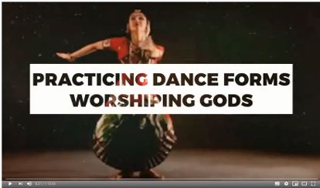

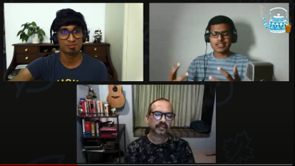
Neil, Johny and Shelton Pinheiro

THE COPY:
Are all art forms good? Wait... is there 'bad' art as such? Where do we draw lines of our creativity, as Catholics? Are such lines even needed actually? Do we have a not-to-do list where creativity and spirituality are concerned? Does art (sacred/secular) and creativity play a role in pulling us closer to God? Questions featured in this episode: 08:40 - How does art (sacred/ secular) help us get closer to God? 15:30 - Are classical art forms like Bharathnatyam (sic), etc. actually about worshipping other Gods? Are we allowed to practise these kind of art forms? 20:44 - While considering a script for plays/ movies, what should I keep in mind as a Catholic artist? 27:20 - Is it okay to do modelling or participate in beauty pageantry? 32:20 - What about the nudity in Church paintings? 37:15 - Is listening to heavy metal music good? Will it harm me spiritually/ have a black magic effect on me? 40:20 - When you began singing for the Lord as a band, did you consecrate yourself? 42:32 - Being a video content creator, I recently did a video related to Bangalore Ganesha Utsav, which promotes Lord Ganesha. Being a professional, am I doing the wrong thing? 46:20 - Should we focus on prayer or studying more? Which is favorable to the Lord? 48:20 - Is listening to bands that are openly satanic bad, even if it improves our music knowledge? 50:15 - What about the glorification of "pain" as a medium to produce art? 51:50 - I'm someone who enjoys belly dance, as an art form. Is that wrong in a Catholic perspective? 54:37 - What about the use of drugs to enhance creativity? 56:57 - We often hear singers like Kester, Cicily giving up secular music and sticking onto sacred music only. Is that required of all Catholic artists? 59:40 - What about the dances which are sensual in nature? 1:04:30 - Is creativity a genetic thing or is it something to be nurtured? 1:07:00 - If art is the expression of oneself, we might produce "dark" stuff when we feel dark. Is that bad? (dark as in themes dealing with anger, sin, death, etc.) 1:10:28 - What about the use of memes to preach Gospel? 1:11:37 - Can you sing a song for us?

Following his October 1 email, I sent Pinheiro these reminders, with no success:
Subject: MICHAEL PRABHU INTERVIEWED BY CHURCHMILITANT.COM ON HINDUISATION OF THE INDIAN CHURCH
Date: Thu, 15 Oct 2020 19:59:41 +0530
Dear Shelton,
Regarding your response to me of October 1, I expected you to come back to me with your decision on these issues as you promised me to "try' to read the links that I sent you. Under normal circumstances, as i expose uncorrected error that is propagated by influential Catholics on any media, by now I would have released one on your/JY's video. Let me know what you decide. Maybe this file will be an additional help to you:
HINDUS CONDEMN CATHOLIC INCULURATION-POPE FRANCIS ACCUSED OF APPROPRIATING INDIGENOUS CULTURES 14 OCTOBER 2020. CHURCH MILITANT TV INTERVIEW WITH MICHAEL PRABHU
http://ephesians-511.net/recent/docs/HINDUS_CONDEMN_CATHOLIC_INCULURATION-POPE_FRANCIS_ACCUSED_OF_APPROPRIATING_INDIGENOUS_CULTURES.doc
God bless you, Michael

Subject: FINAL FRATERNAL REMINDER
Date: Mon, 26 Oct 2020 18:36:37 +0530
From: Michael Prabhu michaelprabhu@ephesians-511.net
To: Shelton Pinheiro spinheiro@gmail.com

Subject: | THE REPORT WILL BE UP ON MY WEB SITE SHORTLY...
Date: | Sun, 22 Nov 2020 16:42:04 +0530
From: | Michael Prabhu michaelprabhu@ephesians-511.net
To: | Shelton Pinheiro spinheiro@gmail.com
...SINCE YOU HAVE NOT CARED TO RESPOND OR TO LET ME HAVE YOUR FINAL DECISION DESPITE FRATERNAL REQUESTS

