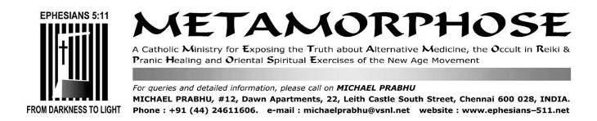
JANUARY 20/SEPTEMBER 25, 30/OCTOBER 11, 2016/NOVEMBER 2018
The religious significance of the kuthuvilakku or nilavilakku oil lamp in Hinduism

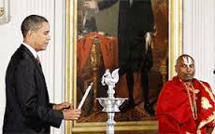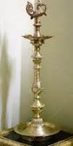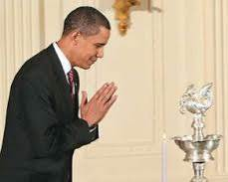
Barack Obama. The kuthuvilakku or nilavilakku is used by adherents of the Hindu religion
Catholics have adopted the Hindu oil lamp and sometimes use it with a cross replacing the”lingam”
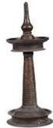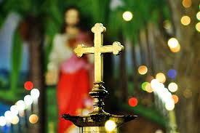

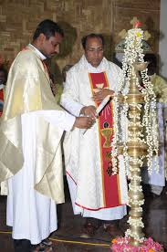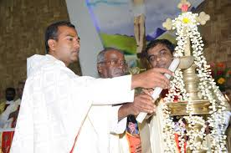

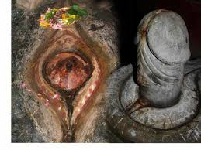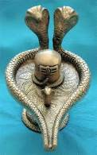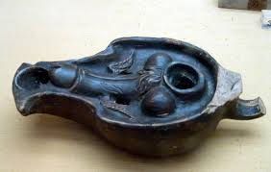

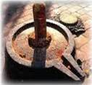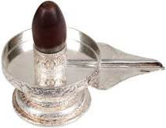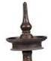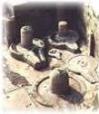

Oil lamps with the lingam (penis); the oil resevoir is shaped to resemble a yoni which is Sanskrit for vagina

Sita’s daughters…
https://books.google.co.in/books?id=qkchsdDYXbcC&pg=PA165&lpg=PA165&dq=oil+lamp+lingam+yoni&source=bl&ots=9jyduJ4YYn&sig=DqlXn-E6ljjRM53ZOj1YpDz8M94&hl=en&sa=X&ved=0ahUKEwjN6N6gs4bLAhXOTI4KHZu7BPUQ6AEIHzAB#v=onepage&q=oil%20lamp%20lingam%20yoni&f=false EXTRACT
By Swaran Kapoor, 1993
Although Siva is primarily the god of destruction, he is also the god of fertility and is typically represented in Siva temples by a statue of lingam (penis) rising out of the base of the yoni (womb or vagina). Although this image is usually referred to simply as “the lingam”, it always rests on a yoni base.
The yoni is most frequently represented in the shape of an oil lamp with four ridges in the pointed end separated by three grooves. These ridges are described as the four heads of Siva’s serpent or as the labia major and minor. When worshipers pour their offerings of milk or ghee over the lingam, the liquid flows through the yoni into a basin surrounding the figure. The lingam-yoni represents the cosmic union; in its design, the male principle rises out of the female principle.

Shiva: The Wild God of Power and Ecstasy
https://books.google.co.in/books?id=Dvo9ScSbz0IC&pg=PA62&lpg=PA62&dq=oil+lamp+lingam+yoni&source=bl&ots=_ArBK93dI1&sig=zIrTdnpP4ywmP09hOlD5VEQfMuM&hl=en&sa=X&ved=0ahUKEwjN6N6gs4bLAhXOTI4KHZu7BPUQ6AEIIzAC#v=onepage&q=oil%20lamp%20lingam%20yoni&f=false EXTRACT
By Wolf-Dieter Storl, 2004
The flame flickering in the hearth is a lingam and the stone plate that holds it is a yoni.
The brass oil lamp which Keralese Kathakali dancers place on the stage and worship before each performance indicates Shiva’s presence in the form of a fire lingam… The lingam is, of course, plainly and simply, the erect male member.

What is the spiritual significance of Pancha muga Kuthu Vilakku?
https://in.answers.yahoo.com/question/index?qid=20100524014832AALJyu3 EXTRACT
For the benefit of non-Tamilians, Kuthu Vilakku is an oil lamp, lighted in pooja room in front of the deities in every home.
The lamp has its own special place in Sanatan Vaidik Hindu Dharma. It is a form and a symbol of Tej (Absolute fire principle); the lamp leads us from darkness towards light. It burns only to give message of peace and light to the man. This is its greatness. The Agni Puran clearly states that only oil or Ghee (clarified butter) be used in the lamp meant for puja and no other combustible substance. According to the science of spirituality the lamp with clarified butter is more sattvik (spiritually pure) as compared to lamp in which oil is used.
According to yogic path of Kundalini Yog there are seven principle chakras or energy centers in the human being. These chakras influence practically every aspect of human being including physical body, mind and intellect.

The oil lamp is effective in purification of Muladhar and Swadhishthan Chakra only to certain extent but the ghee lamp purifies Manipur and Anahat chakras to a significant extent.
Just as there are seven chakras in the human body, there are paths for the flow of vital energy (chetana). These are called as Nadis or channels. The three principle nadis are Chandra nadi (Moon channel), Surya nadi (Sun channel) and Sushumna nadi.When Chandra nadi is active the person perceives coolness. The activation of Surya nadi imparts energy to the person. The Sushumna nadi is activated when the person starts progressing spiritually. The oil lamp activates the Surya nadi of the person while ghee lamp activates only that nadi which is essential to the worshipper in a particular action.
There are other varieties of the lamps also such as lamp with a single wick and lamp called niranjan wherein five wicks are used. The Niranjan with five wicks is symbolic of duality that is the manifest energy of a deity; whereas the lamp with a single wick attracts sattvik frequencies the lamp with five wicks attracts waves with destroyer property and dominant in raja component.
The niranjan with five wicks denotes the relation of Panchpran (five vital air principles) with the Atmajyoti (flame of soul). Niranjan is used for waving Pancharati. Every single flame of niranjan is symbolic of Atmajyoti. Pancharti means invocation of God with the help of panchparanas.While performing Pancharti we should have such a spiritual emotion that the Atmajyoti is kindled in me with the help of five panchaprans present in the body and I am performing the arti with such flame.
The number of faces (mugam) represent the particular deity and the letters of Beeja Mandram (mantra).
Panchamugam means five face or five split-ed light represents lord Siva the deity who has five face.The basic chanting (Beeja Mandram) is NA MA SI VA YA five letters. When you light the Pancha Muga kuthu vilakku and chant AUM SI VA YA NA MA, then God Siva come there to bless you and the people there.

How the kuthuvilakku is crafted
http://www.thehindu.com/features/friday-review/history-and-culture/the-kuthuvilakku-and-its-many-avatars/article7919306.ece EXTRACT
Among the myriad handcrafted ‘deepams’, the Nachiarkoil’s brass kuthuvilakku stands out. At 8 ft and higher, the elegant kuthuvilakku is the centre of many legends. It is considered a symbol of knowledge as it is cast in the image of a human in ‘dhyana mudra’, the base symbolising his yogic sitting posture, the stem his erect body, the top his face and the five wicks, the panchabutas.
Over time, the classic kuthuvilakku with its typical silhouette topped by a ‘pravar’ or ‘hamsa’, has acquired many avatars such as branch lamps or ‘vriksha deepams,’ hanging lamps, ‘thoonda’ vilakkus, Lakshmi, Ganesha and Saraswati lamps.
As master artisan Kashinath stands beside a magnificent 8 ft high branch lamp, lit with the 108 wicks held by parrots, he shares the process of lamp making…

Why is ghee lamp preferred to oil lamp during puja ritual?
http://www.hindujagruti.org/hinduism/knowledge/article/why-is-ghee-lamp-preferred-to-oil-lamp-during-puja-ritual.html
Agni Puran clearly states that only oil or ghee (clarified butter) be used in the lamp meant for puja and no other combustible substance. According to the science of spirituality the lamp with clarified butter is more sattvik (spiritually pure) as compared to lamp in which oil is used. This is an important aspect which we will try to understand in details. So let us see the difference between the the lamp in which Ghee is used and the one with oil.
Generally the use of oil is more prevalent than that of Ghee. The oil containing lamp kindles longer while the ghee containing lamp kindles for a short period. Now let us see the difference from the spiritual view point.
Ghee lamp has more capacity to attract the sattvik vibrations present in the surrounding atmosphere as compared to oil lamp.
The oil lamp can attract the sattvik vibrations spread over a maximum distance of 1 meter while the ghee lamp can attractsattvik vibrations spread over till Swarga Lok (heaven)
When the oil lamp stops burning the predominance of raja particles in the atmosphere is enhanced and lasts for half an hour. On the other hand when the ghee lamp stops burning the impact of sattvikta (the quality of being sattvik) on the atmosphere is experienced even after four hours.
Now let us see the characteristics of kindled lamps containing oil and ghee from spiritual angle with the help of a subtle drawing. Here we have to take into consideration the fact that while the vibrations of a subtle drawing are three dimensional we see them in the subtle drawing in a two dimensional form. For example the sphere will appear as a circle. Now let us look at the subtle drawing: (omitted)
The yellow coloured circles seen in this drawing emit divine consciousness (chaitanya) in the atmosphere. The red coloured circles are of radiant energy. The burning flame is emitting frequencies full of Tej tattva (absolute fire principle) in the atmosphere. The red particles which you see here are the emitted particles of energy. So you have seen in this drawing how an oil lamp emits energy in the atmosphere. Now let us observe the subtle drawing of ghee lamp. The blue colour just besides the flame is indicative of spiritual emotion (bhav). The yellow circles which you see here are of chaitanya in the form of Tej tattva projecting in the atmosphere. You can also see the red particles and rays consisting of energy projecting into atmosphere.

Effect on the worshipper as per Kundalini Yog
Now let us see the effect of both types of lamp on the worshipper.
The oil lamp generates a subtle armour of inferior quality around the worshipper while ghee lamp generates a subtle armour of superior quality. The subtle frequencies emitted from the oil lamp activate the Mind-energy (Manashakti) of the worshipper whereas the subtle frequencies emanating from the ghee lamp activates soul energy of the worshipper.
According to yogic path of Kundalini Yog there are seven principle chakras or energy centers in the human being. These chakrasinfluence practically every aspect of human being including physical body, mind and intellect. The oil lamp is effective in purification of Muladhar and Swadhishthan Chakra only to certain extent but the ghee lamp purifies Manipur and Anahat chakrasto a significant extent.
Just as there are seven chakras in the human body, there are paths for the flow of vital energy (chetana). These are called asNadis or channels. The three principle nadis are Chandra nadi (Moon channel), Surya nadi (Sun channel) and Sushumna nadi. When Chandra nadi is active the person perceives coolness. The activation of Surya nadi imparts energy to the person. TheSushumna nadi is activated when the person starts progressing spiritually. The oil lamp activates the Surya nadi of the person while ghee lamp activates only that nadi which is essential to the worshipper in a particular action.

2.2 Effect on the subtle sheaths of the worshipper
According to the science of spirituality the body which is visible to our eyes is called Annamaya Kosha or food sheath. Besides this there are four other Koshas namely Pranmaya Kosha or vital air sheath, Manomaya Kosha or the mental sheath, Vidnyanmaya Kosha or sheath of intellect and Anandmaya Kosha or bliss sheath. The Pranmaya kosha is a seat for the Panchapranas (five vital air elements) which provides energy to the gross body. The second Manomaya kosha is the seat of emotions. The third Vidnyanmaya Kosha is the seat of intellect and the fourth Anandamaya Kosha is the seat of Soul which is of the nature of existence, consciousness and bliss (satchidananda). Even these subtle sheaths or koshas are affected by the oil or ghee lamps. The oil lamp imparts power to the raja particles in the Pranamaya kosha which makes the individual restless. The ghee lamp strengthens the sattva particles of Pranamaya kosha and Manomaya Kosha and as a result of this the jiva (individual, embodied soul) becomes peaceful, stable and happy.

2.3 Spiritual experience imparted by oil and ghee lamps
Now let us compare the spiritual experiences obtained due to oil and ghee lamps. But before that let us understand what we mean by Spiritual experience or Anubhuti. We are used to appreciate this world through the media of five sense organs namely nose, ears, eyes, tongue, skin, mind and intellect. This is known as experience. But when we experience something without the participation of all these then it is known as spiritual experience. Now let us compare the spiritual experiences obtained due to oil and ghee lamps. The oil lamp gives us spiritual experience of Pruthvi tattva (absolute earth element) and Aap tattva (absolute water element). For example if we get an experience of fragrance without the actual presence of an object which can impart such fragrance then it is a spiritual experience of subtle fragrance or gandha. The fragrance is related to Pruthvi tattva. The example of spiritual experience of Aap tattva is dwelling sweet taste in the mouth.
When we see subtle light or vision of a deity then it is an example of spiritual experience related to Tej tattva or absolute fire element. When we experience a feeling of touch without any external reason then it is a spiritual experience related to Vayu tattva or absolute air element. The ghee lamp gives spiritual experience of Tej tatva and Vayu tattva to the worshipper.

2.4 Why only ghee prepared from cow’s milk should be used?
Generally any oil lamp emits frequencies consisting of raja particles but the sesame oil emits some sattva frequencies also. Therefore the lamp with sesame oil is comparatively more sattvik. However the ghee lamp emits the sattvik frequencies in maximum amount compared to any oil lamp. Here we have to remember one thing that it is useful to use ghee prepared only from the cow’s milk in the lamp lit in front of Deity. This is because in such ghee the Deities’ principles are already existent. Such a ghee which is dominant in sattva component emits luminous figures in the atmosphere. Such luminous figures are forms of Tej tattva or absolute fire element. Thus even though the use of ghee is recommended because of its capacity to emit maximumsattva frequencies, we can use sesame oil lamp if the use of ghee is not possible because of financial restraints or otherwise.

http://hindudharmaforums.com/archive/index.php/t-1296.html EXTRACT
In Punjab, where I am from originally, the mark of the lord is more in line with the beliefs of shaktas, i.e. it is a representation of the creative force. The word 'lingam' also means the male organ. However, yes, some say that the shape of 'yoni' at the bottom of the lingum is not really yoni but just a shape to allow the milk and water offerings to channel and drop down. But why have that shape anyway, the offerings will drop down anyway.
Ever notice the similarity between a Shiva Lingam pedestal and a diya (oil lamp)?
http://www.indiavarta.com/Shopping/Thejus/images/ALSS-045.jpg
http://indiavilas.tolshop.com/v1/product_images/hsi33_large.jpg.
This is not a coincidence. The Lingam represents the flame in the middle of the oil lamp. Remember the Jyotir-Lingam (Infinite Column of Light), the form of Shiva shown to Brahma and Vishnu? In the Puranic story, Brahma and Vishnu were not able to find the top and bottom, respectively, of the Column of Light. According to some, the Lingam is a representation of that Infinite Jyotir-Lingam.

Basic Points about Vedic Culture/Hinduism: A Short Introduction Part 2
Information Assembled From Various Sources
http://www.stephen-knapp.com/basic_points_about_vedic_culture_hinduism.htm EXTRACT
By Stephen Knapp
THE IMPORTANCE OF DEEPAK (THE SACRED OIL OR GHEE LAMP)
Together with the kalash the lighted deepak is also placed on the pujavedi or altar and worshiped. As a physical object, a deepak or lamp is an earthen (or metallic) saucer-like tiny pot filled with ghee (clarified butter) or refined oil with a twisted cotton tape (ball) immersed in it. It is lighted in every Hindu household and temple in India. The cotton tape keeps sucking the ghee to yield a soothing bright light, a flame. In nature, the flame is considered to be the source of heat and light. The heat of the fire and hence the flame is also a good germicide.
The deepak is worshipped as the symbol of the all-pervading Light of all Lights. Some scientific models and theories today also agree that all matter has emanated from the light of consciousness-force. This great Effulgence is worshipped through the medium of the deepak. Meditation on the standing bright yellow flame of a Deepak during tratak yoga improves mental concentration and induces sublime energy of positive currents emanating from this symbol of cosmic consciousness.
A deepak is also used during arati – the devotional worship and prayer sung at a religious celebration or ritual of worship to the temple deities. The deepak (arati flame) is moved around the deity to symbolize the divine aura and also to help the devotees to have a clear look of the deity. This is usually done with four circles to the feet, two to the waist, four to the head, and seven to the whole body. In the end, as the lamp is passed around, the devotees put their palms on the arati flame to receive the arati aura, symbolizing the acceptance of divine light that can open one’s consciousness.
The standing deepak (Samai or Kuttuvilaku) symbolizes the dispelling of ignorance and awakening of the divine light within us. Its soft glow illumines the temple or the shrine room, keeping the atmosphere pure and serene. The lamp is also a symbol for the Vedic festival of Diwali (Deepavali), an Indian festival of lights. One of many interpretations of Diwali is a celebration of the light of knowledge that chases away the darkness of ignorance.
Visualizing the kalash as a symbol of the cosmos and deepak as a symbol of cosmic energy may not be so easy for us. But we should at least assimilate the teachings apparent from them - the soothing coolness (calmness) and uniformity (impartiality) of the kalash, and the radiance, energy (activeness) and steadfast uprightness of the deepak.

Cardinal Ivan Dias, then (in 1997) Archbishop of Bombay, now in the elite “Group of 9” cardinals in the Vatican, lighting an oil lamp before an idol of Ganesha at an interfaith meeting.
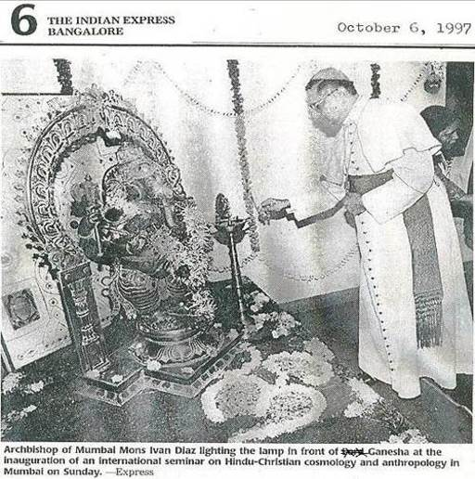

Under the shadow of the “OM” and the Hindu kuthuvilakku or nilavilakku
The ceremonial lighting of the “oil lamp” replaces good old Catholic prayer
A Rich Tribute by Fr. Joe to Late Yogacharya B.K.S. Iyengar in Kripa' latest Newsletter
http://kripafoundation.blogspot.in/2014/10/a-rich-tribute-by-fr-joe-to-late.html
October 20, 2014
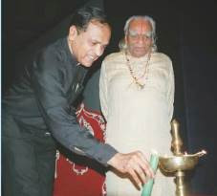

Fr. Joe conducts a Multi-Faith prayer meeting for boat disaster victims-Assam
http://kripafoundation.blogspot.in/2012/05/fr-joe-conducts-multi-faith-prayer.html
May 21, 2012
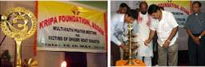

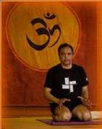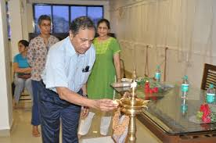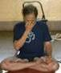
Yoga guru Fr. Joe Pereira of the Archdiocese of Bombay

Archbishop Felix Machado of Vasai and Fr. Joe Pereira of Bombay
Fr. Joe works with Persuasion and Compassion - Says Archbishop (Dr.) Felix Machado @ the release of the 24 hours a day book in Marathi
http://kripafoundation.blogspot.in/2014/01/fr-joe-works-with-persuasion-and.html
January 3, 2014
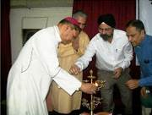
Archbishop Most Rev. Felix Machado of Vasai diocese and Fr. Joe Pereira of the Archdiocese of Bombay

Fr. Joe along with Archbishop Dr. Felix Machado Bishop of Vasai at the opening ceremony of the Programme in Vasai
http://kripafoundation.blogspot.in/2013/02/fr-joe-at-opening-of-advent-programmes.html
February 16, 2013
The programme which is being held from February 17th 2013 to 10thMarch 2013, commenced today with the lighting of the lamp by Archbishop (Dr.) Felix Machado and prominent personalities from the Vasai Diocese including Fr. Joe Pereira, Sr. Anita Chettiyar, Sr. Clara Gonsalvis and Rev. Fr. Francis De Britto.

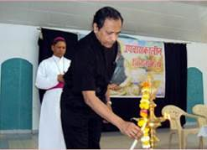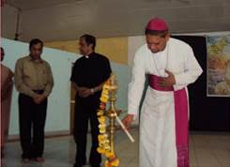

NBCLC honours Art of Living guru Sri Sri Ravi Shankar
http://www.daijiworld.com/news/news_disp.asp?n_id=20020&n_tit=Bangalore
http://www.daijiworld.com/news/news_disp.asp?n_id=20020&n_tit=Bangalore%3A+NBCLC+Honours+Art+of+Living+Guru+Sri+Sri+Ravi+Shankar
By Jessie Rodrigues, April 2, 2006
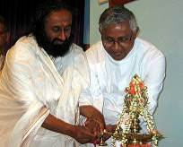

The Catholic Bishops’ Conference of India (CBCI)’s National Biblical Catechetical and Liturgical Centre (NBCLC) director Fr. Thomas D'Sa with Hindu yoga guru Sri Sri Ravi Shankar

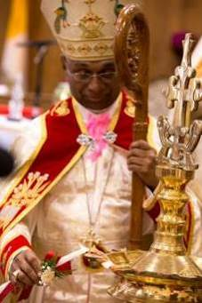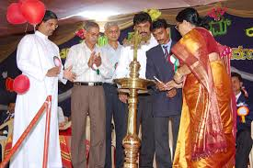

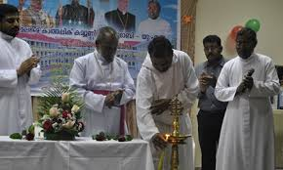

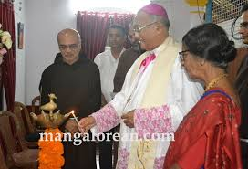
Aloysius Paul D’Souza, Bishop of Mangalore diocese inaugurating the Jyothi Ashram of the Capuchin friars
https://www.mangalorean.com/athma-jyothi-ashram-of-capuchin-friars-launched/

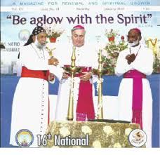
BISHOPS INAUGURATE THE XVI NATIONAL CHARISMATIC CONVENTION (COVER OF CHARISINDIA MAGAZINE JANUARY 2016) WITH LINGAM-SHAPED OIL LAMPS. CONTINUED ON PAGE 12
See CHARISINDIA ERRORS-10 USE OF KUTHU VILAKKU/NILAVILAKKU AT NATIONAL CONVENTION
http://ephesians-511.net/docs/CHARISINDIA_ERRORS-10.doc

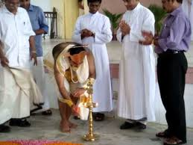
Catholic priests at an Onam celebration in Kerala
MAY CATHOLICS CELEBRATE THE HARVEST FESTIVAL OF ONAM?
http://ephesians-511.net/docs/MAY_CATHOLICS_CELEBRATE_THE_HARVEST_FESTIVAL_OF_ONAM.doc

St Pauls Institute of Communication Education (SPICE) - Mumbai
http://www.alberione.org/100anni/index.php?option=com_content&view=article&id=81%3Aindia-spice&catid=46%3Aindia&Itemid=50&lang=it
August 20, 2011
The three-year preparation for the centenary of the foundation of the Pauline Family was formally inaugurated today in Mumbai, 20 August 2011, with the blessing of ST PAULS INSTITUTE OF COMMUNICATION EDUCATION (SPICE).
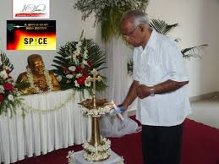
A priest of the St. Pauls congregation

39th LRC Seminar, Diocese of Kalyan, 29-31 July 2011, at Hope Center, Amboli, Andheri (W), Mumbai
Liturgical Research Centre (LRC) conducts a Seminar on “Early Christian Communities of St. Thomas Tradition in India”
http://newindian.activeboard.com/t35398725/stthomas-in-india-fables-continued/?sort=newestFirst&page=3
http://syromalabarfaith.blogspot.com/2011/08/blog-post_16.html

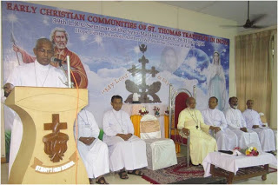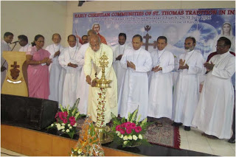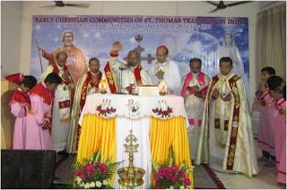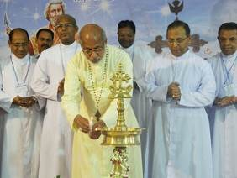

Mar Thomas Elavanal, Bishop of Kalyan; Mar Andrews Thazhath, LRC Chairman, Archbishop of Trichur and Vice-President of the CBCI; Cardinal Mar George Alencherry, Major Archbishop of Ernakilam-Angamaly
Note that the crucifix, mandatory as per the rubrics of the GIRM, is missing from both, the altar at which Holy Mass is being concelebrated by the Bishop, as well as behind the altar. What is only prominent are crosses on the ambo, the poster backdrop and the kuthuvilakku or oil lamp adopted from Hinduism.

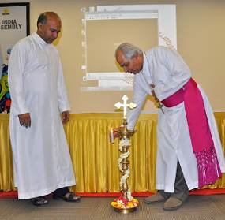
Bishop Godfrey Rosario and Fr. Joachim Fernandez SDB

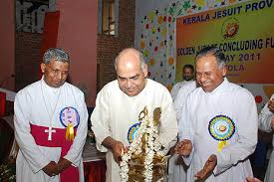
http://www.ucanews.com/news/judge-urges-jesuits-to-fight-corruption/16968 Justice Cyriac Joseph and Archbishop Maria Calist Soosapakiam of Trivandrum, May 17, 2011 at the golden jubilee celebrations of the Kerala Jesuit province

ICRDCE, The Indian Centre for Research and Development of Community Education, run by the Jesuits
http://www.icrdce.com/communitycollege.html
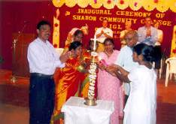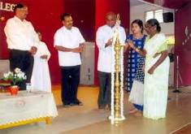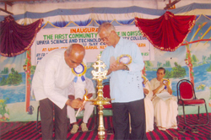
Sharon Community College Salem, July 2006/Assisi Community College, Ashok Nagar, Chennai, August 2006/ UPAYA Science and Technology Community College, Rajgangpur, May 2005

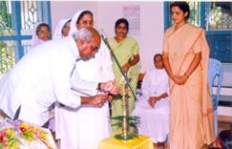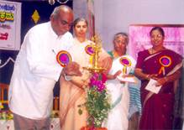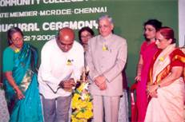
St. Ann’s Community College, Arilova, Vishakaptinam, August 2005/Bethany Community College (Rosa Mystica Campus), Mangalore, January 2006/Gulburga Community College, Gulbarga, July 2005
It goes without saying that the men in the long-sleeved kurtas lighting the lamps are Jesuit priests

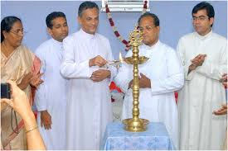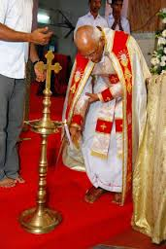
Syro-Malabar priests lighting the nilavilakku
In the Malayalam language, "nilam" means ground and "vilakku" means lamp. This form of lamp is typically used in the Hindu homes of Kerala. The Nilavilakku is also used in Hindu temples as well as during traditional wedding ceremonies.
http://indigenousjesus.blogspot.in/2012/05/brief-history-of-visual.html

Instead of joining our hands in prayer to our God and dedicating the event/institution to Him, we now put our hands together and applaud as can be seen in the images above.

Nirmala Retreat Centre nrckulathuvayal@gmail.com, Kulathuvayal, is located at a distance of 15 km. from Peruvannamuzhi and 45 km. from Calicut.
SHALOM TV, co-founded by Benny Punnathara, before it was incorporated, began as a small prayer group in the Nirmala Retreat Centre campus.
The late Msgr. Rev. Fr. C. J. Varkey (died 2009), founder of the Missionary Sisters of Mary Immaculate (MSMI) congregation in 1962 and which was raised to a Congregation of Pontifical right by Pope John Paul II on October 15, 1988, was the first spiritual director of SHALOM ministries.
Benny Punnathara of SHALOM ministries continues his close association with the Nirmala Retreat Centre.
The Nirmala Retreat Centre has a homoeopathy clinic started by Fr. Varkey and run by the MSMI nuns. And…

http://www.msmi.co/health-care/:
“This apostolate is done by running hospitals - allopathic, ayurvedic, homeopathic, naturopathic* dispensaries, leprosy rehabilitation centre, palliative care clinics and clinics.” *These are New Age

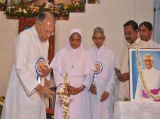
The MSMI nuns even use the Hindu oil lamp (kuthuvilakku or) nilavilakku at their retreat centre as a substitute for, or maybe along with I hope, Catholic blessing and prayer.

See BISHOP OF RAMANATHAPURAM RECOMMENDS YOGA THROUGH SHALOM MINISTRIES
http://ephesians-511.net/docs/BISHOP_OF_RAMANATHAPURAM_RECOMMENDS_YOGA_THROUGH_SHALOM_MINISTRIES.doc

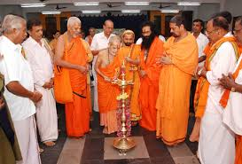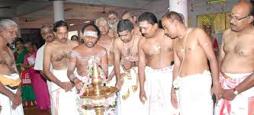
The people that we imitate (look at the images at the top of page 2 before you close this file)

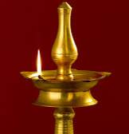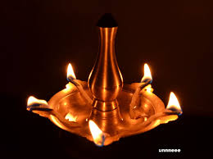

CONTINUED FROM PAGE 8
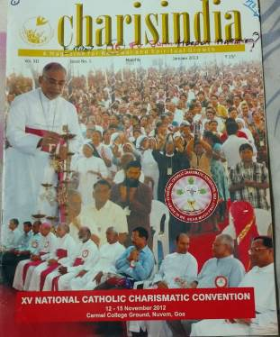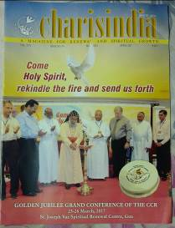
CHARISINDIA COVERS JANUARY 2013/APRIL 2017

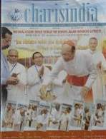
CHARISINDIA COVER DECEMBER 2017

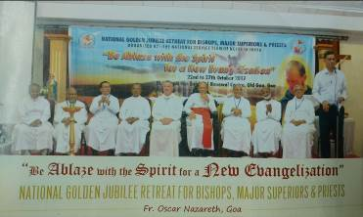
CHARISINDIA DECEMBER 2017. THE HINDU LAMP IS TO THE EXTREME LEFT

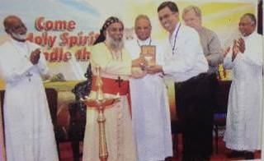
CHARISINDIA APRIL 2017

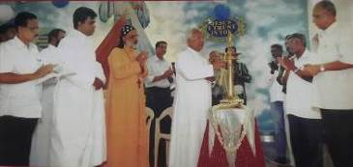
CHARISINDIA JANUARY 2015

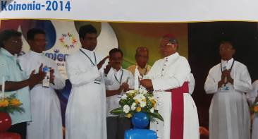
The good old days of inauguration with the Roman Catholic wax candle, CHARISINDIA NOVEMBER 2014

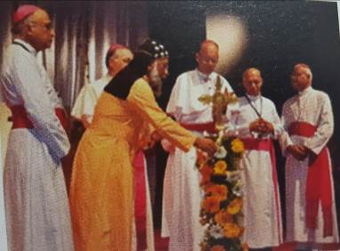
CBCI General Body Meeting, St. John’s National Academy of Health Sciences, Bangalore, February 1-8, 2012. Cardinal Oswald Gracias and a Syro-Malabar bishop

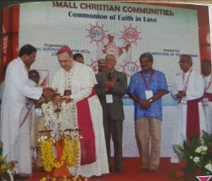
First National Convention of Small Christian Communities, Goa, November 19-21, 2013

SOME RELATED FILES
CHARISINDIA ERRORS-10 USE OF KUTHU VILAKKU/NILAVILAKKU AT NATIONAL CONVENTION
http://ephesians-511.net/docs/CHARISINDIA_ERRORS-10.doc
CHARISINDIA ERRORS-11 RAMPANT USE OF KUTHU VILAKKU IN THE CCR AT INAUGURAL CEREMONIES
http://ephesians-511.net/docs/CHARISINDIA_ERRORS-11.doc
ARCHBISHOP FERRAO OF GOA LIGHTS THE HINDU OIL LAMP
http://ephesians-511.net/docs/ARCHBISHOP_FERRAO_OF_GOA_LIGHTS_THE_HINDU_OIL_LAMP.doc

ARATI IN THE LITURGY-INDIAN OR HINDU
http://ephesians-511.net/docs/ARATI_IN_THE_LITURGY-INDIAN_OR_HINDU.doc
BHARATANATYAM-I
http://ephesians-511.net/docs/BHARATANATYAM-I.doc
BHARATANATYAM AT HOLY MASS AT CATHEDRAL OF ST THOMAS IN MADRAS-MYLAPORE ARCHDIOCESE
http://ephesians-511.net/docs/BHARATANATYAM_AT_HOLY_MASS_AT_CATHEDRAL_OF_ST_THOMAS_IN_MADRAS-MYLAPORE_ARCHDIOCESE.doc
BINDI OR TILAK MARK ON THE FOREHEAD-INDIAN OR HINDU?
http://ephesians-511.net/docs/BINDI_OR_TILAK_MARK_ON_THE_FOREHEAD-INDIAN_OR_HINDU.doc
CARDINAL IVAN DIAS LIGHTS A LAMP FOR THE HINDU DEITY GANESHA
http://ephesians-511.net/docs/CARDINAL_IVAN_DIAS_LIGHTS_A_LAMP_FOR_THE_HINDU_DEITY_GANESHA.doc
CARMELITE PRIEST PERFORMS HINDU POOJA RITUAL
http://ephesians-511.net/docs/CARMELITE_PRIEST_PERFORMS_HINDU_POOJA_RITUAL.doc
CARNATIC MUSIC PERFORMANCE DESECRATES JESUITS CHURCH
http://ephesians-511.net/docs/CARNATIC_MUSIC_PERFORMANCE_DESECRATES_JESUITS_CHURCH.doc
CATHOLIC ASHRAMS
http://ephesians-511.net/docs/CATHOLIC_ASHRAMS.doc
CATHOLIC ASHRAMS-REVISITED
http://ephesians-511.net/docs/CATHOLIC_ASHRAMS-REVISITED.doc
CATHOLIC BECOMES PRIEST OF SHIVA TEMPLE
http://ephesians-511.net/docs/CATHOLIC_BECOMES_PRIEST_OF_SHIVA_TEMPLE.doc
CATHOLIC PRIESTS WORSHIP PAGAN GOD GANESHA-YET AGAIN
http://ephesians-511.net/docs/CATHOLIC_PRIESTS_WORSHIP_PAGAN_GOD_GANESHA-YET_AGAIN.doc
CATHOLICS CAPITULATE OVER CHRIST NOT SANTA CLAUS
http://ephesians-511.net/docs/CATHOLICS_CAPITULATE_OVER_CHRIST_NOT_SANTA_CLAUS.doc
CATHOLIC WORSHIP OF ELEPHANT GOD GANESH IN MANGALORE
http://ephesians-511.net/docs/CATHOLIC_WORSHIP_OF_ELEPHANT_GOD_GANESH_IN_MANGALORE.doc
DANCING AND BHARATANATYAM IN THE MASS
http://ephesians-511.net/docs/DANCING_AND_BHARATANATYAM_IN_THE_MASS.doc
DWAJASTHAMBA IN CHURCHES-INDIAN OR HINDU?
http://ephesians-511.net/docs/DWAJASTHAMBA_IN_CHURCHES-INDIAN_OR_HINDU.doc

FR ANTHONY DE MELLO-WRITINGS BANNED BY THE CHURCH
http://ephesians-511.net/docs/FR_ANTHONY_DE_MELLO-WRITINGS_BANNED_BY_THE_CHURCH.doc
FR JEGATH GASPAR RAJ-IN PRAISE OF SHIVA-PRIEST INVESTS RS 15 MILLION, FLOATS COMPANY WORTH RS 100 CRORES
http://ephesians-511.net/docs/FR_JEGATH_GASPAR_RAJ-IN_PRAISE_OF_SHIVA-PRIEST_INVESTS_RS_15_MILLION_FLOATS_COMPANY_WORTH_RS_100_CRORES.doc
FR JOE PEREIRA INTRODUCES MOTHER TERESAS MISSIONARIES OF CHARITY TO YOGA
http://ephesians-511.net/docs/FR_JOE_PEREIRA_INTRODUCES_MOTHER_TERESAS_MISSIONARIES_OF_CHARITY_TO_YOGA.doc
FR JOE PEREIRA YOGA GURU CELEBRATES NAVRATRI AND GANESHOTSAV
http://ephesians-511.net/docs/FR_JOE_PEREIRA_YOGA_GURU_CELEBRATES_NAVRATRI_AND_GANESHOTSAV.doc
HABEMUS PAPAM INDIANUM-WE HAVE AN INDIAN PONTIFF
http://ephesians-511.net/docs/HABEMUS_PAPAM_INDIANUM-WE_HAVE_AN_INDIAN_PONTIFF.doc
HINDU FLAG POLE AT CATHEDRAL OF ST THOMAS IN MADRAS-MYLAPORE ARCHDIOCESE
http://ephesians-511.net/docs/HINDU_FLAG_POLE_AT_CATHEDRAL_OF_ST_THOMAS_IN_MADRAS-MYLAPORE_ARCHDIOCESE.doc
HINDUS STILL BELIEVE THAT INCULTURATION IS A CATHOLIC PLOY TO CONVERT THEM
http://ephesians-511.net/docs/HINDUS_STILL_BELIEVE_THAT_INCULTURATION_IS_A_CATHOLIC_PLOY_TO_CONVERT_THEM.doc
INDIAN JESUIT THEOLOGIAN FR MICHAEL AMALADOSS UNDER INVESTIGATION BY ROME
http://ephesians-511.net/docs/INDIAN_JESUIT_THEOLOGIAN_FR_MICHAEL_AMALADOSS_UNDER_INVESTIGATION_BY_ROME.doc
INTERRELIGIOUS DIALOGUE 01-POPE BENEDICT XVI
http://ephesians-511.net/docs/INTERRELIGIOUS_DIALOGUE_01-POPE_BENEDICT_XVI.doc
INTERRELIGIOUS DIALOGUE 02-GOA CATHOLICS OPPOSE
http://ephesians-511.net/docs/INTERRELIGIOUS_DIALOGUE_02-GOA_CATHOLICS_OPPOSE.doc
INTERRELIGIOUS DIALOGUE 03-THE FALSE KIND
http://ephesians-511.net/docs/INTERRELIGIOUS_DIALOGUE_03-THE_FALSE_KIND.doc
INCULTURATION OF THE LITURGY AND SACROSANCTUM CONCILIUM-JON ANDERSON-AND MY RESPONSE
http://ephesians-511.net/docs/INCULTURATION_OF_THE_LITURGY_AND_SACROSANCTUM_CONCILIUM-JON_ANDERSON-AND_MY_RESPONSE.doc
INDIAN CLERGY OBSESSED WITH THE HINDU DEITY GANESHA
http://ephesians-511.net/docs/INDIAN_CLERGY_OBSESSED_WITH_THE_HINDU_DEITY_GANESHA.doc
IS HOLY COMMUNION EQUIVALENT TO PRASADAM-IS IT SAFE FOR CATHOLICS TO CONSUME PRASADAM
http://ephesians-511.net/docs/IS_HOLY_COMMUNION_EQUIVALENT_TO_PRASADAM-IS_IT_SAFE_FOR_CATHOLICS_TO_CONSUME_PRASADAM.doc
IS THE SYRO MALABAR CHURCH NOW OPENLY PROMOTING ITS HINDUISATION?
http://ephesians-511.net/docs/IS_THE_SYRO-MALABAR_CHURCH_NOW_OPENLY_PROMOTING_ITS_HINDUISATION.doc
JESUS THE YOGI AND THE DANCING JESUS
http://ephesians-511.net/docs/JESUS_THE_YOGI_AND_THE_DANCING_JESUS.doc
KERALA PARISH CELEBRATES CHURCH FEAST JOINTLY WITH HINDU TEMPLE FESTIVAL
http://ephesians-511.net/docs/KERALA_PARISH_CELEBRATES_CHURCH_FEAST_JOINTLY_WITH_HINDU_TEMPLE_FESTIVAL.doc
LOTUS AND THE CROSS-THE HINDUISATION OF THE CATHOLIC CHURCH IN INDIA
http://ephesians-511.net/docs/LOTUS_AND_THE_CROSS-THE_HINDUISATION_OF_THE_CATHOLIC_CHURCH_IN_INDIA.doc
MAY CATHOLICS CELEBRATE THE FESTIVAL OF HOLI?
http://ephesians-511.net/docs/MAY_CATHOLICS_CELEBRATE_THE_FESTIVAL_OF_HOLI.doc
MAY CATHOLICS CELEBRATE THE HARVEST FESTIVAL OF PONGAL
http://ephesians-511.net/docs/MAY_CATHOLICS_CELEBRATE_THE_HARVEST_FESTIVAL_OF_PONGAL.doc
MAY PRIESTS WEAR A SHAWL WHILE CELEBRATING HOLY MASS 13 OCTOBER 2016
http://ephesians-511.net/docs/MAY_PRIESTS_WEAR_A_SHAWL_WHILE_CELEBRATING_HOLY_MASS.doc
MOTHER TERESA AT PRAYER IN A BUDDHIST TEMPLE
http://ephesians-511.net/docs/MOTHER_TERESA_AT_PRAYER_IN_A_BUDDHIST_TEMPLE.doc
NBCLC-HARBINGER OF THE INDIAN RITE MASS AND LITURGICAL ABUSE
http://ephesians-511.net/docs/NBCLC-HARBINGER_OF_THE_INDIAN_RITE_MASS_AND_LITURGICAL_ABUSE.doc
PAGANIZATION OF THE CHURCH IN INDIA 01
http://ephesians-511.net/docs/PAGANIZATION_OF_THE_CHURCH_IN_INDIA_01.doc
PAGANIZATION OF THE CHURCH IN INDIA 02
http://ephesians-511.net/docs/PAGANIZATION_OF_THE_CHURCH_IN_INDIA_02.doc
PAGANIZATION OF THE CHURCH IN INDIA-RESPONSES
http://ephesians-511.net/docs/PAGANIZATION_OF_THE_CHURCH_IN_INDIA-RESPONSES.doc

PILAR PRIEST FR PETER CARDOZO VENERATES THE HINDU DEITY GANESHA
http://ephesians-511.net/docs/PILAR_PRIEST_FR_PETER_CARDOZO_VENERATES_THE_HINDU_DEITY GANESHA.doc
RANGOLI AND KOLAM DRAWINGS ARE BASED ON SUPERSTITIOUS BELIEFS
http://ephesians-511.net/docs/RANGOLI_AND_KOLAM_DRAWINGS_ARE_BASED_ON_SUPERSTITIOUS_BELIEFS.doc
RUDRAKSHA BEADS AND THE HINDU DEITY SHIVA
http://ephesians-511.net/docs/RUDRAKSHA_BEADS_AND_THE_HINDU_DEITY_SHIVA.doc
SONIA GANDHI-CATHOLIC OR HINDU?
http://ephesians-511.net/docs/SONIA_GANDHI-CATHOLIC_OR_HINDU.doc
TAMIL NADU CLERGY VENERATE THE HINDU DEITY GANESHA
http://ephesians-511.net/docs/TAMIL_NADU_CLERGY_VENERATE_THE_HINDU_DEITY_GANESHA.doc
THE GOLDEN SHEAF-A COLLECTION OF ARTICLES DEALING WITH ECCLESIASTICAL ABERRATIONS
http://ephesians-511.net/docs/THE_GOLDEN_SHEAF-A_COLLECTION_OF_ARTICLES_DEALING_WITH_ECCLESIASTICAL_ABERRATIONS.doc
THE HINDUISATION OF MUSIC IN THE CATHOLIC CHURCH
http://ephesians-511.net/docs/THE_HINDUISATION_OF_MUSIC_IN_THE_CATHOLIC_CHURCH.doc
THE HINDUISATION OF THE CATHOLIC CHURCH-IMAGES
http://ephesians-511.net/docs/THE_HINDUISATION_OF_THE_CATHOLIC_CHURCH-IMAGES.doc
THE ONGOING ROBBERY OF FAITH-FR P K GEORGE
http://ephesians-511.net/docs/THE_ONGOING_ROBBERY_OF_FAITH-FR_P_K_GEORGE.doc
THE PAGANISATION OF THE LITURGY IN INDIA-C B ANDRADE
http://ephesians-511.net/docs/THE_PAGANISATION_OF_THE_LITURGY_IN_INDIA-C_B_ANDRADE.doc
THE PAGANIZED CATHOLIC CHURCH IN INDIA-VICTOR J F KULANDAY
http://ephesians-511.net/docs/THE_PAGANIZED_CATHOLIC_CHURCH_IN_INDIA-VICTOR_J_F_KULANDAY.doc
THE ST PIUS X SEMINARY CELEBRATES HINDU DEITY GANESH
http://ephesians-511.net/docs/THE_ST_PIUS_X_SEMINARY_CELEBRATES_HINDU_DEITY_GANESH.doc
THE TWELVE POINTS OF ADAPTATION FOR THE INDIAN RITE MASS-WAS A FRAUD PERPETRATED ON INDIAN CATHOLICS?
http://ephesians-511.net/docs/THE_TWELVE_POINTS_OF_ADAPTATION_FOR_THE_INDIAN_RITE_MASS-WAS_A_FRAUD_PERPETRATED_ON_INDIAN_CATHOLICS.doc
THE SQUATTING INDIAN RITE MASS
http://ephesians-511.net/docs/THE_SQUATTING_INDIAN_RITE_MASS.doc
VASAI PRIEST FR THOMAS DSOUZA WORSHIPS GANESHA
http://ephesians-511.net/docs/VASAI_PRIEST_FR_THOMAS_DSOUZA_WORSHIPS_GANESHA.doc
WAS JESUS A YOGI? SYNCRETISM AND INTERRELIGIOUS DIALOGUE-ERROL FERNANDES
http://ephesians-511.net/docs/WAS_JESUS_A_YOGI_SYNCRETISM_AND_INTERRELIGIOUS_DIALOGUE-ERROL_FERNANDES.doc
WHY INDIAN CATHOLICS DO NOT WANT AN INDIAN POPE
http://ephesians-511.net/docs/WHY_INDIAN_CATHOLICS_DO_NOT_WANT_AN_INDIAN_POPE.doc

THE THIRD EYE
http://ephesians-511.net/docs/THE_THIRD_EYE.doc
BINDI OR TILAK MARK ON THE FOREHEAD-INDIAN OR HINDU?
http://ephesians-511.net/docs/BINDI_OR_TILAK_MARK_ON_THE_FOREHEAD-INDIAN_OR_HINDU.doc
DIVINE RETREAT CENTRE ERRORS-04 -HINDU BINDI OR TILAK MARK USED
http://ephesians-511.net/docs/DIVINE_RETREAT_CENTRE_ERRORS-04.doc
HINDU RELIGIOUS MARK ON THE FOREHEAD 01-PRIEST WEARS DOMINIC D’ABREO
http://ephesians-511.net/docs/HINDU_RELIGIOUS_MARK_ON_THE_FOREHEAD_01-PRIEST_WEARS.doc
HINDU RELIGIOUS MARK ON THE FOREHEAD 02-PRIEST WEARS ROY MATHEW THOTTAM
http://ephesians-511.net/docs/HINDU_RELIGIOUS_MARK_ON_THE_FOREHEAD_02-PRIEST_WEARS.doc
HINDU RELIGIOUS MARK ON THE FOREHEAD 03-PRIEST WEARS CLEOPHAS DOMINIC FERNANDES
http://ephesians-511.net/docs/HINDU_RELIGIOUS_MARK_ON_THE_FOREHEAD_03-PRIEST_WEARS.doc
HINDU RELIGIOUS MARK ON THE FOREHEAD 04-PRIEST WEARS ANTONY KALLIATH
http://ephesians-511.net/docs/HINDU_RELIGIOUS_MARK_ON_THE_FOREHEAD_04-PRIEST_WEARS.doc
HINDU RELIGIOUS MARK ON THE FOREHEAD 05-PRIEST WEARS THOMAS D’SA
http://ephesians-511.net/docs/HINDU_RELIGIOUS_MARK_ON_THE_FOREHEAD_05-PRIEST_WEARS.doc
HINDU RELIGIOUS MARK ON THE FOREHEAD 06-PRIEST WEARS VALERIAN MENDONCA
http://ephesians-511.net/docs/HINDU_RELIGIOUS_MARK_ON_THE_FOREHEAD_06-PRIEST_WEARS.doc
HINDU RELIGIOUS MARK ON THE FOREHEAD 07-NUN WEARS HERMAN JOSEPH
http://ephesians-511.net/docs/HINDU_RELIGIOUS_MARK_ON_THE_FOREHEAD_07-NUN_WEARS.doc
HINDU RELIGIOUS MARK ON THE FOREHEAD 08-BISHOP WEARS BISHOP AGNELO GRACIAS
http://ephesians-511.net/docs/HINDU_RELIGIOUS_MARK_ON_THE_FOREHEAD_08-BISHOP_WEARS.doc

HINDU RELIGIOUS MARK ON THE FOREHEAD 09-BISHOP WEARS BISHOP HENRY D’SOUZA
http://ephesians-511.net/docs/HINDU_RELIGIOUS_MARK_ON_THE_FOREHEAD_09-BISHOP_WEARS.doc
HINDU RELIGIOUS MARK ON THE FOREHEAD 10-BISHOP WEARS BISHOP ALOYSIUS PAUL D’SOUZA
http://ephesians-511.net/docs/HINDU_RELIGIOUS_MARK_ON_THE_FOREHEAD_10-BISHOP_WEARS.doc
HINDU RELIGIOUS MARK ON THE FOREHEAD 11-CARDINAL WEARS CARDINAL IVAN DIAS
http://ephesians-511.net/docs/HINDU_RELIGIOUS_MARK_ON_THE_FOREHEAD_11-CARDINAL_WEARS.doc
HINDU RELIGIOUS MARK ON THE FOREHEAD 12-THE APOSTOLIC NUNCIO WEARS ARCHBISHOP QUINTANA
http://ephesians-511.net/docs/HINDU_RELIGIOUS_MARK_ON_THE_FOREHEAD_12-THE_APOSTOLIC_NUNCIO_WEARS.doc
HINDU RELIGIOUS MARK ON THE FOREHEAD 13-THE POPE WEARS JOHN PAUL II
http://ephesians-511.net/docs/HINDU_RELIGIOUS_MARK_ON_THE_FOREHEAD_13-THE_POPE_WEARS.doc
HINDU RELIGIOUS MARK ON THE FOREHEAD 14-WOMAN THEOLOGIAN WEARS ASTRID LOBO GAJIWALA
http://ephesians-511.net/docs/HINDU_RELIGIOUS_MARK_ON_THE_FOREHEAD_14-WOMAN_THEOLOGIAN_WEARS.doc
HINDU RELIGIOUS MARK ON THE FOREHEAD 15-WOMEN THEOLOGIANS WEAR
http://ephesians-511.net/docs/HINDU_RELIGIOUS_MARK_ON_THE_FOREHEAD_15-WOMEN_THEOLOGIANS_WEAR.doc
HINDU RELIGIOUS MARK ON THE FOREHEAD 16-CARDINAL OSWALD GRACIAS WEARS
http://ephesians-511.net/docs/HINDU_RELIGIOUS_MARK_ON_THE_FOREHEAD_16-CARDINAL_OSWALD_GRACIAS_WEARS.doc
HINDU RELIGIOUS MARK ON THE FOREHEAD 17-PREFECT OF THE CONGREGATION FOR THE DOCTRINE OF THE FAITH WEARS
http://ephesians-511.net/docs/HINDU_RELIGIOUS_MARK_ON_THE_FOREHEAD_17-PREFECT_OF_THE_CONGREGATION_FOR_THE_DOCTRINE_OF_THE_FAITH_WEARS.doc
HINDU RELIGIOUS MARK ON THE FOREHEAD 18-BHARATANATYAM-DANCING PRIESTS WEAR
http://ephesians-511.net/docs/HINDU_RELIGIOUS_MARK_ON_THE_FOREHEAD_18-BHARATANATYAM-DANCING_PRIESTS_WEAR.doc
HINDU RELIGIOUS MARK ON THE FOREHEAD 19-THE VIRGIN MARY WEARS
http://ephesians-511.net/docs/HINDU_RELIGIOUS_MARK_ON_THE_FOREHEAD_19-THE_VIRGIN_MARY_WEARS.doc
HINDU RELIGIOUS MARK ON THE FOREHEAD 20-THE ARCHBISHOP OF WESTMINSTER WEARS http://ephesians-511.net/docs/HINDU_RELIGIOUS_MARK_ON_THE_FOREHEAD_20-THE_ARCHBISHOP_OF_WESTMINSTER_WEARS.doc
HINDU RELIGIOUS MARK ON THE FOREHEAD 21-JESUS CHRIST WEARS
http://ephesians-511.net/docs/HINDU_RELIGIOUS_MARK_ON_THE_FOREHEAD_21-JESUS_CHRIST_WEARS.doc
HINDU RELIGIOUS MARK ON THE FOREHEAD 22-THE NEW COMMUNITY BIBLE
http://ephesians-511.net/docs/HINDU_RELIGIOUS_MARK_ON_THE_FOREHEAD_22-THE_NEW_COMMUNITY_BIBLE.doc
HINDU RELIGIOUS MARK ON THE FOREHEAD 23-BISHOP THOMAS DABRE WEARS
http://ephesians-511.net/docs/HINDU_RELIGIOUS_MARK_ON_THE_FOREHEAD_23-BISHOP_THOMAS_DABRE_WEARS.doc
HINDU RELIGIOUS MARK ON THE FOREHEAD 24-FR JOE PEREIRA WEARS
http://ephesians-511.net/docs/HINDU_RELIGIOUS_MARK_ON_THE_FOREHEAD_24-FR_JOE_PEREIRA_WEARS.doc

